Finding and Printing 2017 SDSA and SDSA-Alt Scores

Step 1: Log into South Dakota Assessment Portal (SDAP) found here: https://sdap.emetric.net/
Step 2: Click the “Reporting” link 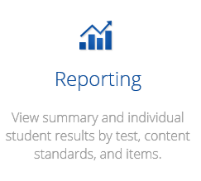
Step 3: Click the first box 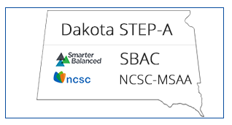
Do not click this box as this is for the no longer used Dakota Step test 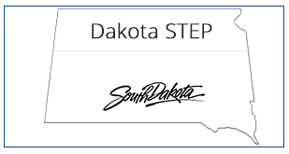

Step 4: Since SBAC is the default choice in the drop down box at the top, select either 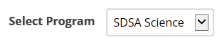or 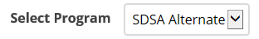
Step 5: To print individual student reports select then
Step 6: Click “Student View” along the banner on top right of the student names
Step 7: Click “Download” and the following box should appear
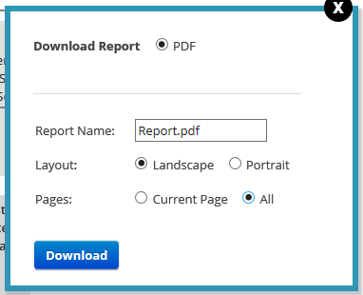
Step 8: Make sure “All” is selected under pages, then click download. All individual student reports for that grade should now be downloaded.

Step 9: You can select “Open” to open all of the reports in Adobe Reader or “Save” to save them to a file

Step 10: If you chose to “Open” them, you can then select the print icon in Adobe Reader. This will print all of the individual student reports in that file. If you chose to “Save” them, you can print them later by opening in Adobe Reader and selecting the print icon

