CONTRACTED SERVICES

School Year 2022-2023

TABLE OF CONTENTS
Purpose 1
Adding Contract SPED by Assignment Code 5
Adding Contract SPED by Classified Staff 8
Reviewing, Editing & Deleting Contract SPED 9

Purpose

How should contracted staff be reported?
Include contracted staff for work that is considered part of the regular operations.

- Do not include individuals who contract directly with a coop or virtual school provider
- Include staff employed by another entity (private or hospital) that is Third Party Contracted to provide work that can be considered part of the district’s special education and/or related services. These staff work within the district but are employees of the entity with which the district contracts. The district does not pay retirement or other benefits.
- Do not include employees of contractors who provide a non-regular service; these are staff furnished by the contractor, on- or off-site, to provide the service. Examples may include carpenters, electricians, etc. working for a firm hired to refurbish a school building.
- In cases where students are receiving services outside the district and tuition is paid, staff would not need to be reported.

The distinction between staff reported and not reported is whether the special education services are part of the district’s regular operation or if it is a non-regular service.

STEP 1: Accessing the Contracted Services Screen

- Open the PRF. Click on Actions, District Information and then Select Contracted Services.
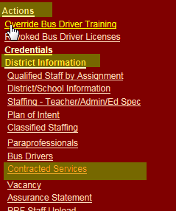

NOTE: Approved Virtual School Providers along with the Coops are now required to enter staff and assignments on the Personnel Record Form.
The Virtual School providers include:
- Black Hills Online Learning Community,
- DIAL,
- NSU Center for eLearning,
- High Plains Alternative School, and
Public and Non-public districts will no longer be required to encode the SD Virtual School Classes. It is still important to check the accuracy of the data. This can be done by going to the “Contracted Services” screen and clicking on the “Services Provided by Coop or Virtual District” to review the services provided by these schools.

The Personnel Record Form allows virtual school providers and cooperatives to encode staff assignments for contracted services to districts. Districts are then able to view the staffing information added by these providers and review to ensure the information is accurate. The system does not have the ability to identify whether this information has been updated for the current year or whether it was rolled forward from the previous school year

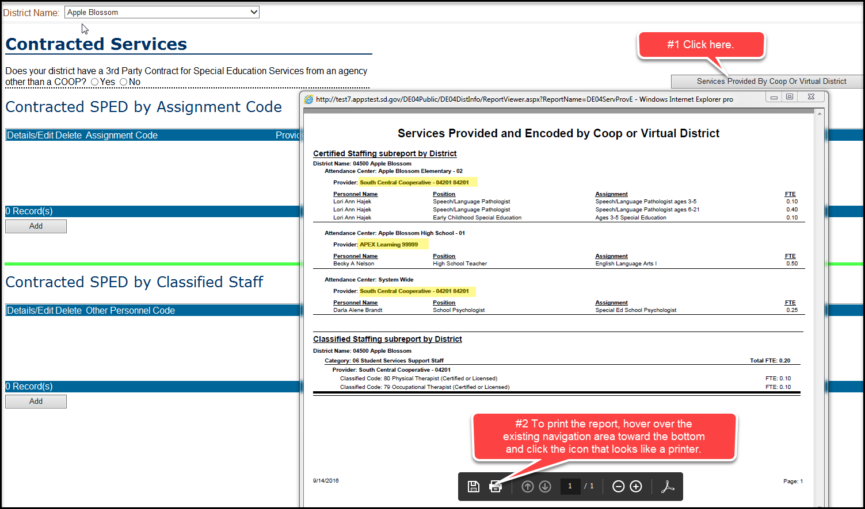

13-33-21. Certificate authorizing distance learning provider to provide courses required. No distance learning provider may provide courses through distance learning to any student in an accredited elementary or secondary school in this state unless the distance learning provider has a certificate issued by the secretary of the Department of Education authorizing the distance learning provider to provide the courses.

13-33-29. Granting of credit for distance learning courses not offered by South Dakota Virtual School prohibited--Exceptions. No school district may grant credit for any course successfully completed through distance learning as defined in § 13-33-20 unless the course is offered through the South Dakota Virtual School.
However, a school district may grant credit for a distance learning course offered through an entity other than the South Dakota Virtual School if any of the following conditions apply:
- The course is provided through an agreement among accredited school districts;
- The course is a university or postsecondary technical institute course taken by a student who is dually enrolled pursuant to the provisions of § 13-28-37;
- The course was previously taken through an accredited high school or other accredited provider by a student who subsequently transferred into the school district; or
- The course is not available through the South Dakota Virtual School and is pre-approved by the secretary of education.

STEP 2: Updating the Contracted Services Screen.

- For the portion that is contracted special education services, the screen must be accessed and the question – “Does your district have a 3rd Party Contract for Special Education Services from an agency other than a COOP?” must be answered. Only report those individuals that are coming into the district to provide those services. For example, if the students are located at Children’s Care Hospital and Advance, then the district is only paying for the services, and not actually paying the employee. You do not report those staff for students that are located at Children’s Care Hospital and Advance.

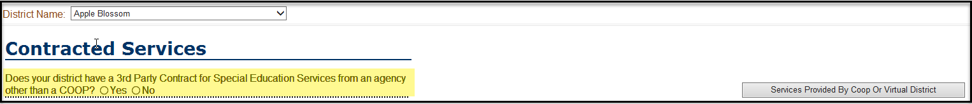

      - This screen is divided into two types of information:

        - Contracted by Assignment Code

        - Contracted by Classified Staffing Code

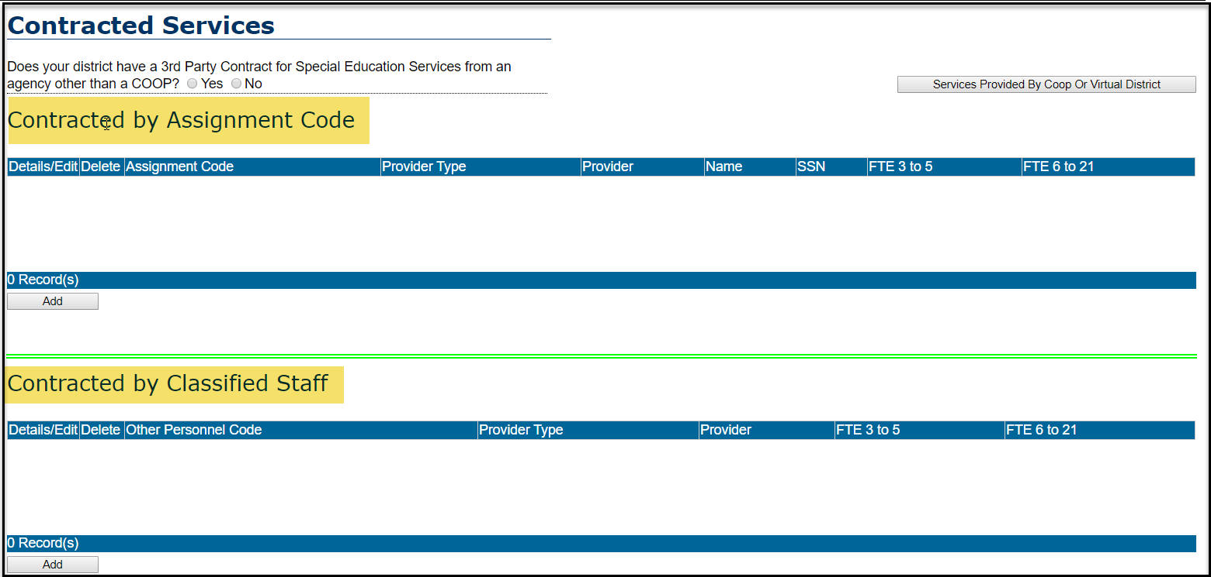

Adding Contracted by Assignment Code

- If you have 3rd Party Contracts by Assignment Code, then click the Add button for this section.
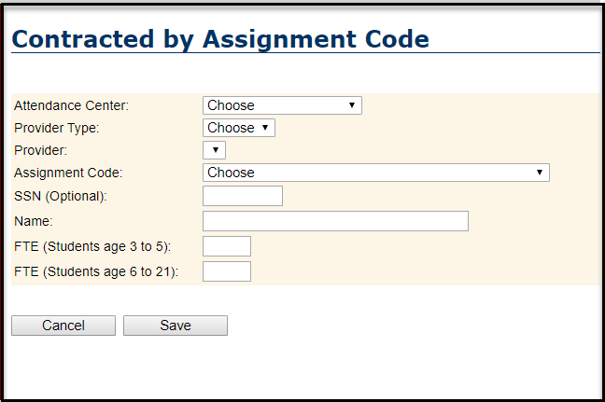

- Select the Attendance Center: Do not to select the attendance center of “System Wide” for instructional services. “System Wide” was setup for those educational specialist positions only (Psychological Examiner, Psychologist, Counselor, Special Education Director) as they serve each attendance center in the district.
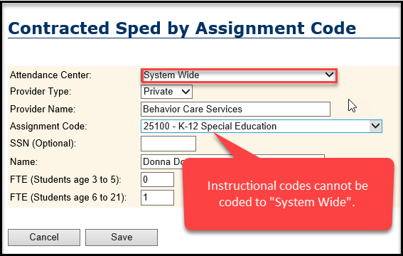

- Select the Provider Type:
        - The options include:

          - Hospital

          - Private

        - If Hospital is selected you will see the following options:

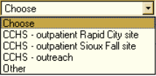

          - If you select Other you will need to complete the Provider Name.

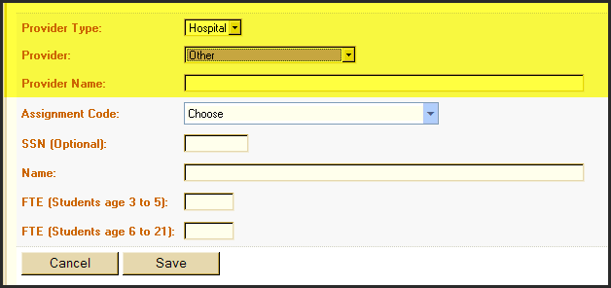

      - Select the Assignment Code
25000 Ages 3-5 Special Education
25002 Birth through Grade Three Special Education
25001 Birth-Age 2 Special Education
25106 K-12 Adapted Physical Education
25100 K-12 Special Education
40501 Psychological Examiner
40401 Regular Ed School Psychologist
40402 Special Ed School Psychologist
40104 Special Education Counselor
40601 Special Education Director
40106 Special Education Student Advisor

- Add the Social Security Number (Optional)

- Add the Name if not pre-populated: If it is a purchased service between the district and the employee, you can list the employee’s name as the provider.
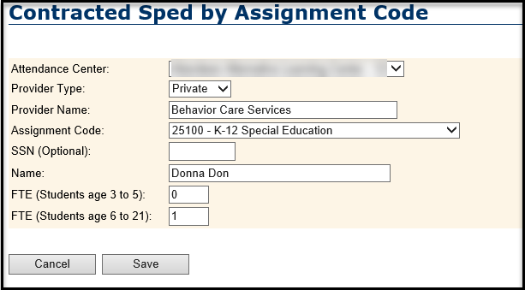

NOTE: If multiple staff are contracted for one assignment they must be encoded separately.

- By the Assignment, identify the % of FTE that works with Students (3 to 5) and (6 to 21).

If the individual works 25% with students age 3 to 5 and 50% with students age 6 to 21 you would code it as .25 and .50 respectively. It can be difficult to determine the exact percentage. Make your best guess and if you have a better idea after the PRF reopens, this field can be updated.

If you had selected the Assignment code Ages 3-5 Special Education, then you should enter the FTE only for Students age 3 to 5.

      - Click Save

- Continue adding all Assignments.

Adding Contracted SPED by Classified Code
NOTE: The process for adding Classified Staff works like adding Contracted SPED by Assignment. The differences include:

- List of Classified Staffing Codes
- Name not required

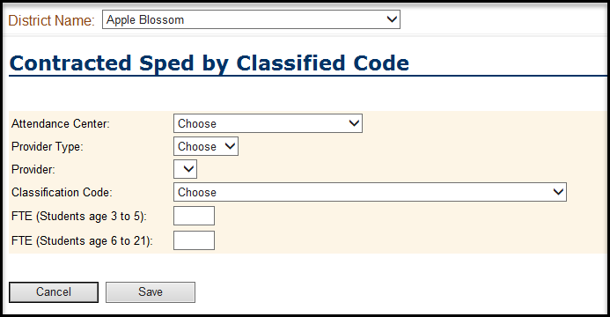

- Select the Attendance Center: we need to know which school the services are being carried out at.

- Select the Classified Staffing

105 `Other` Support Staff in Special Education
73 Audiologist (Certified or Licensed)
91 Audiologist (Non Certified or Licensed)
108 Braillist
76 Interpreter (Certified or Licensed)
100 Interpreter (Non Certified or Licensed)
79 Occupational Therapist (Certified or Licensed)
78 Occupational Therapist (Non Certified or Licensed)
122 Occupational Therapist Assistant
109 Orientation and Mobility Specialist
102 Other Occupational Technicians
80 Physical Therapist (Certified or Licensed)
90 Physical Therapist (Non Certified or Licensed)
123 Physical Therapist Assistant
103 Psychiatrist
87 Rehabilitation Counselor
115 Special Ed School Social Worker (Certified or Licensed)
117 Special Ed School Social Worker (Non Certified or Licensed)
106 Special Education Department Manager
86 Special Education Recreation and Therapeutic Recreation Specialist
104 Special Education School Nurse
67 Special Education Specialized Food Service Worker
88 Special Education Work Study Coordinator (Job Coach)
110 SPED Academic Assessor
107 SPED Bus Drivers (no CDL license)
111 Speech/Language Pathologist ages 3-5 (Certified or Licensed)
113 Speech/Language Pathologist ages 3-5 (Non Certified or Licensed)
112 Speech/Language Pathologist ages 6-21(Certified or Licensed)
114 Speech/Language Pathologist ages 6-21(Non Certified or Licensed)
119 Speech/Language Pathologist Birth – Age 2 (Certified or Licensed)
120 Speech/Language Pathologist Birth – Age 2 (Non Certified or Licensed)

Reviewing, Editing and Deleting Contracted SPED

- After you have added all relevant information, you will see it displayed on the main screen.

- If you need to Edit information, click the icon that looks like a piece of paper with a checkmark.

- If you need to Delete a provider, click the trash can.

