South Dakota

Teacher Effectiveness Handbook
Requirements, Support Systems and State Model Recommendations
FEATURING RECOMMENDATIONS OF THE SOUTH DAKOTA COMMISSION ON TEACHING AND LEARNING

APRIL 2015 – UPDATED JANUARY 2026



Table of Contents
Introduction to the Teacher Effectiveness Handbook 4
Acknowledgements 4
Implementation Timeline 4
2016-17: RESULTS USED TO INFORM PERSONNEL DECISIONS FOR 2017-18 4
The Design of the Teacher Effectiveness System 5
Requirements versus Recommendations 5
Definition of Teacher 5
Definition of Evaluator 5
State Effectiveness System Requirements 6
Broad Requirements for Teacher Evaluation 6
Comparison of State Effectiveness Requirements to Model 6
Minimum State Requirements 10
Evaluations of Professional Practice 10
EVALUATIONS OF STUDENT GROWTH 11
SUMMATIVE TEACHER EFFECTIVENESS RATINGS 12
EVALUATION OUTCOMES 12
SUMMATIVE EVALUATION CYCLE 12
The South Dakota Teacher Effectiveness Model 13
Evaluations of Professional Teaching Practice 15
South Dakota Framework for Teaching (2013 Charlotte Danielson Framework) 15
A Minimum of Eight Components, Including One from Each Domain 16
COMPONENT SELECTION 16
Recommended Method to Determine the Professional Practice Rating 16
USING STANDARDS-BASED RUBRICS TO EVALUATE TEACHING PERFORMANCE 17
EVALUATING PRACTICE USING EVIDENCE PROVIDED BY CLASSROOM OBSERVATION 17
EVALUATING PRACTICE USING EVIDENCE PROVIDED BY ARTIFACTS 17
PROFESSIONAL PRACTICE RATING DESCRIPTIONS 19
DETERMINING THE OVERALL PROFESSIONAL PRACTICES RATING 19
Evaluations of Student Growth 21
Four Key Benefits of Student Learning Objectives 21
ONE: REINFORCING RECOMMENDED PRACTICES 21
TWO: A TEACHER-LED, COLLABORATIVE GOAL-SETTING PROCESS 22
THREE: A FLEXIBLE FRAMEWORK BASED ON STUDENT NEEDS, GRADE LEVEL AND CONTENT AREA 22
FOUR: FOCUSED ON THE MOST IMPORTANT LEARNING THAT NEEDS TO OCCUR 22
The SLO Process 22
USE OF STATE ASSESSMENTS DURING THE SLO PROCESS 22
NUMBER OF SLOs USED FOR EVALUATION OF STUDENT GROWTH 22
SLO PROCESS RESOURCES 23
STEP 1: SLO DEVELOPMENT 23
STEP 2: SLO APPROVAL 24
STEP 3: ONGOING COMMUNICATION 24
STEP 4: PREPARING FOR THE SUMMATIVE CONFERENCE 24
Recommended Method to Determine the Student Growth Rating 25
Summative Teacher Effectiveness Ratings 26
Recommended Method to Determine Teacher Effectiveness Ratings 26
USING A MATRIX MODEL TO DETERMINE SUMMATIVE TEACHER EFFECTIVENESS RATINGS 26
Student Growth as One Significant Factor 27
EXERCISING PROFESSIONAL JUDGMENT TO ADJUST TEACHER EFFECTIVENESS RATINGS 27
South Dakota Evaluation and Professional Growth Process 28
One-Year Evaluation Cycle 28
PHASE 1: PREPARE 29
PHASE 2: PLAN 29
PHASE 3: PERFORM 30
PHASE 4: PROGRESS 30
State Implementation Support and Monitoring 32
Supporting System Development and Promoting Recommended Practices 32
Providing Technical Assistance and Implementation Planning 33
Assistance for Pilot Districts and Schools 33
Coaching For All Districts 33
Training and Support through Professional Development 33
Menu of State-Sponsored Professional Development Options 33
Orientation to South Dakota’s Teacher Effectiveness System 33
Training to Understand and Develop Student Learning Objectives 33
State Implementation Monitoring 34
Glossary of Terms 35
References 38
APPENDIX A: State Laws and Administrative Rules Related to Teacher Effectiveness 39
APPENDIX B: Implementation Planning Documents 45
APPENDIX C: Crosswalk and Assurance Forms 59
APPENDIX D: 2014 – 2016 State-Provided Professional Development Options 71
APPENDIX E: South Dakota Framework for Teaching – 2013 Charlotte Danielson’s Framework for Teaching 73
APPENDIX F: Framework for Teaching Component Selection Guidance 74
APPENDIX G: Student Learning Objectives Forms 76
APPENDIX H: Evaluation of Professional Growth Process Guides 81
APPENDIX I: Acknowledgements 105
THE 2013-14 SOUTH DAKOTA COMMISSION ON TEACHING AND LEARNING 106
The following information is provided to establish historical context. 106
2013-14 TEACHER EFFECTIVENESS PILOT AND SCALE-UP SCHOOLS 107
The following information is provided to establish historical context. 107
2012 Teacher Evaluation Work Group 108
The following information is provided to establish historical context. 108
2011 Teacher Standards Pilot Districts 109
The following information is provided to establish historical context. 109
2010 Teacher Standards Workgroup 109
APPENDIX J: Timeline 110

Foreword from the South Dakota Commission on Teaching and Learning

The following information is provided to establish historical context.
The South Dakota Commission on Teaching and Learning (CTL) embraces the important work of examining recommended practices, considering policy alternatives, and ensuring successful implementation of the South Dakota Teacher Effectiveness System.

The Commission – an ongoing partnership between the South Dakota Department of Education, South Dakota Education Association, and East Dakota Educational Cooperative – is a model of collaboration. At the state level, the Commission brings together teachers, administrators, school board members, university professors, education organizations and state education officials to achieve consensus.

South Dakota’s Teacher Effectiveness System is not a checklist. Successful implementation requires time, training, resources and support. The System is not designed to fade away in a few years. The work of improving instruction and student learning should be a central focus for all who provide public education. That is true today, and will remain true 50 years from now. The Commission encourages school districts across South Dakota to create a local Teacher Effectiveness design team – made up of teachers, administrators, and other stakeholders – to make key decisions and monitor implementation.

This work is important, which is why it was created for educators by educators. Approach this work with an open mind. Focus on the ultimate goal of improving instruction and student learning. Realize that there is additional support available, through the SD DOE, the South Dakota Education Association, and other professional organizations. Take ownership in the importance of the teaching profession. Understand that we are listening and adjusting to your needs.

Introduction to the Teacher Effectiveness Handbook
The following information is provided to establish historical context.
The South Dakota Teacher Effectiveness Handbook is a resource to support the implementation of high-quality educator evaluation systems in South Dakota’s public schools. This section of the Handbook outlines minimum state requirements for implementation of local evaluation systems. Information about South Dakota’s Teacher Effectiveness System, including a collection of recommended practices for implementation, is detailed on pages 13-31.

Acknowledgements
South Dakota’s work to develop meaningful Teacher Effectiveness systems is united by a common aspiration: To improve instruction and student learning. This Handbook has been influenced by the contributions of a diverse group of educators, professional organizations, state officials and other education stakeholders. Significant contributors are acknowledged below, and are also recognized in Appendix I.
- The 2010 Teacher Standards Workgroup
- The 2011-12 Teacher Standards Pilot districts
- The 2012 Teacher Evaluation Workgroup
- The South Dakota Commission on Teaching and Learning
- The 2013-14 Teacher Effectiveness Pilot participants
- The University of South Dakota

Implementation Timeline
South Dakota public school districts had two pathways toward implementation. In the 2014-15 school year, districts had the option of either fully implementing the system or treating the year as a learning year. By the 2015-16 school year, all districts must be implementing a system that meets the state minimum requirements and by the 2016-17 school year must be using the results of this system to inform personnel decisions.

2016-17: RESULTS USED TO INFORM PERSONNEL DECISIONS FOR 2017-18
No later than the start of the 2016-17 school year, all South Dakota public school districts must define a process by which Summative Teacher Effectiveness Ratings are used to inform personnel decisions. Considering the timeline as it applies to the school calendar, teacher evaluation results provided at the end of the 2016-17 school year must inform personnel decisions for the 2017-18 school year. South Dakota public school districts, through the adoption of local policies and procedures, should determine how best to use teacher evaluation results to inform personnel decisions. This is further defined in Appendix J.

The Design of the Teacher Effectiveness System
The Teacher Effectiveness System should result in the following outcomes if implemented with fidelity:

- Improved student success through the implementation of research-based educational practices.
- Improved student success through teachers’ professional growth and accountability.
- A record of facts and assessments for personnel decisions to ensure every public school in South Dakota has effective teachers.

Continuous improvement is at the core of the annual appraisal cycle with professional growth and accountability embedded in the use of rubrics. Student and school data as well as other sources of evidence will lead to a teacher’s professional growth plan. Data collected through the teacher evaluation process can help guide discussions about professional growth, especially as it relates to early career teachers. Assignment to performance levels will help teachers know what skills they need to develop to move to the next performance level.

Requirements versus Recommendations
The processes and procedures outlined in the South Dakota Teacher Effectiveness Handbook were developed to provide districts a teacher evaluation system that satisfies both state and federal requirements. South Dakota public school districts have the option to implement a teacher evaluation system that differs from recommendations contained in this document provided the district adheres to minimum state and federal requirements. To assist districts in determining where flexibility exists, requirements and recommendations are clearly identified throughout this Handbook.

Minimum state teacher evaluation system requirements are outlined briefly in the sections below:
- Applicable state laws and administrative rules are found in Appendix A.
- A summary of state teacher evaluation requirements is assembled into a State Minimum Requirements Checklist and is available in Appendix B.
- A comparison document which identifies the difference between South Dakota’s Teacher Effectiveness Model and the state minimum requirements is located on pages 7-9.

Definition of Teacher
South Dakota law and administrative rule require teachers to be evaluated according to minimum state effectiveness requirements. The definition of a teacher, as outlined in ARSD 24:57:01:01, as it applies to teacher evaluation requirements is an individual who:
- Provides instruction to any kindergarten through grade twelve student;
- Maintains daily student records;
- Has completed an approved teacher education program at an accredited institution or completed an alternative certification program;
- Has been issued a South Dakota certificate; and
- Is not serving as a principal, assistant principal, superintendent, or assistant superintendent.

Definition of Evaluator
An evaluator is any person charged with conducting formal teacher evaluations. In most cases the principal or assistant principal is the evaluator.

State Effectiveness System Requirements
By implementing a Teacher Effectiveness System with fidelity and providing teachers with evidence-based feedback on a regular basis, South Dakota public school districts can expect to improve a teacher’s effectiveness and to build a culture for student learning.

Implementation Timeline
SD DOE worked to establish a statewide implementation timeline that balanced ESEA Waiver requirements with the importance of implementing high-quality Teacher Effectiveness systems with fidelity. The Teacher Effectiveness Implementation Timeline is located in Appendix J.

Broad Requirements for Teacher Evaluation
The South Dakota Teacher Effectiveness System, or any teacher evaluation system developed and implemented by a local school district, must establish a foundation for implementing meaningful teacher evaluations focused on improving student learning. To provide a foundation for the minimum requirements, this section of the South Dakota Teacher Effectiveness Handbook briefly describes federal guidelines as a part of the ESEA Waiver Principle 3. The state process encompasses the following requirements:

- Will be used for continual improvement of instruction;
- Meaningfully differentiate teacher performance using at least three performance levels;
- Use multiple valid measures in determining performance levels, including, as a significant factor, data on student growth for all students (including English Learners and students with disabilities), and other measures of professional practice (which may be gathered through multiple formats and sources, such as classroom observations based on rigorous teacher performance standards, teacher portfolios, and student and parent surveys);
- Evaluate teachers on a regular basis;
- Provide clear, timely, and useful feedback, including feedback that identifies needs and guides teacher professional development; and
- Will be used to inform personnel decisions.

Comparison of State Effectiveness Requirements to Model
State administrative rule outlines the minimal requirements for implementation of Teacher Effectiveness (SDCL 13-42-33, SDCL 13-42-34, SDCL 13-42-70, ARSD 24:57). The Commission on Teaching and Learning (CTL) designed a recommended model that goes above and beyond these minimum requirements. The majority of this handbook will be devoted to describing the recommended model for implementation. A comparison of the minimum state requirements to the recommended South Dakota Teacher Effectiveness Model is found on the following page in Figure 1.

Figure 1: Comparison of Minimum Requirements to SD Teacher Effectiveness Model Recommendations
COMPARISON OF STATE TEACHER EFFECTIVENESS REQUIREMENTS TO MODEL
TEACHER EFFECTIVENESS | MINIMUM REQUIREMENTS | MODEL RECOMMENDATIONS
Professional Practice Standards | * South Dakota Framework for Teaching  (2013 Charlotte Danielson Framework for Teaching)  * Must use a minimum of one component from each of the four domains  *School districts wanting to use other teaching performance standards have the flexibility to crosswalk their standards to the South Dakota Framework for Teaching (2013 Charlotte Danielson Framework for Teaching) using forms provided by the SD DOE. | * South Dakota Framework for Teaching  (2013 Charlotte Danielson Framework for Teaching)  * Evaluating teachers based on all 22 components is the goal. However the recommendation is to begin with a minimum of eight components, including at least one from each domain.  Integrated Eight Components  * 1c: Setting Instructional Outcomes  * 1e: Designing Coherent Instruction  * 1f: Designing Student Assessments  * 2b: Establishing a Culture for Learning  * 3b: Using Questioning and Discussion Techniques  * 3c: Engaging Students in Learning  * 3d: Using Assessment in Instruction  * 4a: Reflecting on Teaching
Professional Practice Rating | * Assign a rating to a teacher using at least one component from each of the four domains of the South Dakota Framework for Teaching (2013 Charlotte Danielson Framework for Teaching) | * Use standards-based rubrics to evaluate performance  *Identify procedures to assess teacher performance relative to non-observable and observable teaching standards  * Assign point values to component-level performance to determine domain level performance  * Calculate an average score for all components evaluated  *Determine a method to assign a Professional Practice Rating (Unsatisfactory, Basic, Proficient, Distinguished)

TEACHER EFFECTIVENESS | MINIMUM REQUIREMENTS | MODEL RECOMMENDATIONS
Evaluation of Student Growth | * Student Growth is a change in student achievement between two or more points in time  SLOs are the chosen process for measuring student growth  * SLOs target goals of student growth which:  1) reflect a rigorous yet realistic expectation of student growth that can be achieved during the  instructional period  2) written by a teacher and approved by an evaluator  3) include district, school, or teacher developed assessments.  * Assign a Student Growth Rating based on attainment of SLOs  *School districts wanting to use an alternative measure of student growth other than SLOs have the flexibility to crosswalk their student growth measurement using forms provided by the SD DOE | * Student Growth is a change in student achievement between two or more points in time  SLOs are the chosen process for measuring student growth  * SLOs target goals of student growth which:  1) reflect a rigorous yet realistic expectation of  student growth that can be achieved during the  instructional period  2) are written by a teacher and approved by an evaluator  3) include district, school, or teacher developed assessments. Teachers assigned to tested grades and subjects should use data from state assessments as part of the SLO Process.  * Teachers assigned to tested grades and subjects should use data from state assessments as part of the SLO process to prioritize the learning content and analyze data to develop the baseline  * Utilize the SLO Process Guide to:  1) develop the SLO  2) obtain SLO approval from the evaluator  3) monitor the SLO  4) determine Student Growth Rating  * Assign a Student Growth Rating based on attainment of SLOs. The performance categories are:  - Low (<65% attained)  - Expected (65-85% attained) and  - High (86-100% attained)  * One SLO per teacher for the purpose of evaluation
Summative Teacher Effectiveness Rating | The Professional Practice Rating and the Student Growth Rating may be combined into a Summative Effectiveness Rating.  * Below Expectations  * Meets Expectations  * Exceeds Expectations | Use the Summative Rating Matrix to combine the Professional Practice Rating and Student Growth Rating into one Summative Teacher Effectiveness Rating.  The ratings include:  * Below Expectations  * Meets Expectations  * Exceeds Expectations

TEACHER EFFECTIVENESS | MINIMUM REQUIREMENTS | MODEL RECOMMENDATIONS
Evaluation Requirements | * Assigns a Professional Practice Rating  * Assigns a Student Growth Rating  * Will be used to guide professional growth  * Provides clear, timely, and useful feedback which identifies needs and guides professional development  The Professional Practice Rating and the Student Growth Rating may be combined into a Summative Effectiveness Rating. | * Assigns a Professional Practice Rating  * Assigns a Student Growth Rating  * Combines the Professional Practice Rating and Student Growth Rating into one Summative Teacher Effectiveness Rating  * Will be used to guide professional growth  * Provides clear, timely, and useful feedback which identifies needs and guides professional development
Evaluation Timeline | First three years of employment  * Once per school year  Four or more years of employment  * At least once every two school years | First three years of employment  * Two formal observations per school year  * Four informal observations per school year  Four or more years of employment  * One formal observation per school year  * Four informal observations per school year
Plan of Assistance | Public school districts shall adopt procedures to include a plan of assistance for any teacher, who is in the fourth or subsequent year of teaching, and whose performance does not meet the public school district's performance standards. | Public school districts shall adopt procedures to include a plan of assistance for any teacher, who is in the fourth or subsequent year of teaching, and whose performance does not meet the public school district's performance standards.  If a plan of assistance is necessary, the principal works with the teacher to prioritize areas of improvement. Professional Practice and Student Growth Ratings should be used to determine the areas of need.
Employment Decisions | Must be used to inform employment decisions | Must be used to inform employment decisions

Minimum State Requirements

All South Dakota public school districts must use multiple valid measures to evaluate Teacher Effectiveness. The teacher evaluation process must rely on qualitative and quantitative measures and be based on measures of both professional practice and student growth. See Figure 1, pages 7-9 for comparison of minimum state requirements to the recommended South Dakota Teacher Effectiveness Model.

Evaluations of Professional Practice
Local teacher evaluation systems must assess teaching performance relative to the South Dakota Framework for Teaching based on the Danielson Framework for Teaching.

Standards-based Evaluations of Professional Practice
All public school districts must evaluate teachers using domains and components aligned to the South Dakota Framework for Teaching. Public school districts wanting to use other teaching performance standards have the flexibility to crosswalk their standards to the South Dakota Framework for Teaching using forms provided by the SD DOE (SDCL 13-42-33, ARSD 24:57).

- Crosswalk forms are available online at the following URL:
https://doe.sd.gov/Effectiveness/Teacher.aspx
- For more information about the Framework for Teaching, visit: https://doe.sd.gov/Effectiveness/Teacher.aspx
- Additional planning tools are also available online at: https://doe.sd.gov/Effectiveness/Teacher.aspx

Minimum Number of Professional Performance Components
The South Dakota Framework for Teaching includes 22 individual teaching components clustered into four domains. All local effectiveness systems must include proSUfessional performance evaluations based on a minimum of four teaching components, including one from each domain (ARSD 24:57).

Evidence Collection for Non-Observable Teaching Components
Teaching performance components related to planning and preparation (Domain 1) and professional responsibilities (Domain 4) are generally considered “not observable” in a classroom setting. To demonstrate performance relative to “non-observable” components, evidence and artifacts must be provided by teachers and reviewed by evaluators (ARSD 24:57). Refer to

18 for a list of suggested artifacts.

Evidence Gathered Through Classroom Observation
Teaching performance components relating to the classroom environment (Domain 2) and instructional delivery (Domain 3) are generally considered to be observable in a classroom setting. Evidence related to observable performance components must be gathered through classroom observation (ARSD 24:57). Refer to page 18 for a list of suggested artifacts.

Assignment of a Professional Practice Rating
Local Teacher Effectiveness systems must assign an overall Professional Practice Rating that summarizes performance relative to the South Dakota Framework for Teaching. The Professional Practice Rating must serve as one measure to determine and differentiate teaching performance (ARSD 24:57).

EVALUATIONS OF STUDENT GROWTH

Student Learning Objectives as a Measure of Teacher Impact on Student Growth
Impact on student growth will be assessed through the Student Learning Objectives (SLOs) process. Public school districts may apply to use an alternate method of student growth, provided the measure meets minimum state requirements (ARSD 24:57).
- Crosswalk forms are available online at the following URL:
https://doe.sd.gov/Effectiveness/Teacher.aspx
- South Dakota Student Learning Objectives Handbook can be found at the following URL: https://doe.sd.gov/Effectiveness/Teacher.aspx

Use of State Assessment Data
A teacher assigned to a tested grade or subject should use data from state assessments as part of the SLO process (ARSD 24:57). Local public school districts may determine the most appropriate way to use state assessment data as part of the SLO process.
- There is no requirement for teachers to use state assessment data as an end-of-year assessment of student progress. In most cases, teachers will use prior-year state assessment data to identify core concepts and standards that will assist in identifying priority content on which to focus student growth goals.

Establishing Priorities for Student Learning
Public school districts using SLOs as a measure of teacher impact on student growth begin by identifying procedures to help teachers analyze student needs and establish learning priorities. Through the SLO process, teachers are asked to develop SLOs based on the unique and critical learning needs of students in a class or course (ARSD 24:57).

Selection or Development of Assessments to Measure Student Growth
Public school districts work with teachers to select and develop assessments that measure student growth between two or more points in time. Through the SLO process, teachers establish baseline student performance using appropriate assessment data. Teachers also identify an assessment appropriate to gauge student learning at the end of the instructional period (ARSD 24:57).

Development of Rigorous, Realistic Expectations for Student Growth
Public school districts using SLOs as a measure of student growth identify procedures to ensure that all teachers develop rigorous, realistic expectations for student growth that can be achieved during the instructional period (ARSD 24:57).

Assignment of a Student Growth Rating
All local teacher evaluation systems must assign an overall Student Growth Rating that summarizes performance relative to teacher-developed SLOs. The Student Growth Rating must serve as one measure to determine and differentiate overall teaching performance (ARSD 24:57).

SUMMATIVE TEACHER EFFECTIVENESS RATINGS
Local teacher evaluation systems may include a process to combine the Professional Practice Rating and Student Growth Rating into a Summative Teacher Effectiveness Rating (ARSD 24:57).

Performance Differentiated Into Three Categories
Summative teaching performance is assigned one of three overall performance ratings: Below Expectations, Meets Expectations, or Exceeds Expectations (ARSD 24:57). The Summative Teacher Effectiveness Rating includes an evaluation of student growth that serves as one significant factor and an evaluation of professional practices as the other significant factor used to determine teaching performance.

EVALUATION OUTCOMES
Local teacher evaluation systems must include practices and procedures that ensure evaluation results are focused on professional growth. State minimum requirements relating to professional growth for teachers are outlined below.

Clear, Timely and Useful Feedback
Public school districts adopt a local teacher evaluation process that provides teachers with relevant performance feedback in a structured and timely manner (SDCL 13-42-34; ARSD 24:57).

Used as a Basis to Guide Professional Growth for Teachers
Public school districts are required to adopt a local teacher evaluation process that ensures evaluation results will be used to guide professional growth for all teachers (SDCL 13-42-34; ARSD 24:57).

Provide a Plan of Assistance for Non-Probationary Teachers Not Meeting District Standards
State law requires public school districts to provide a plan of assistance to non-probationary teachers who do not meet the district’s established performance standards (SDCL 13-42-34).

SUMMATIVE EVALUATION CYCLE
All South Dakota public school districts must regularly provide teachers with a summative evaluation, but the frequency varies based on the amount of time a teacher has been employed with the district.

Probationary Teachers
Teachers in years one to three of employment, commonly referred to as probationary teachers, must be provided with a summative evaluation every school year (SDCL 13-42-34).

Non-Probationary Teachers
Teachers in or beyond their fourth year of employment, commonly referred to as continuing contract teachers, must be evaluated at least once every two school years (SDCL 13-42-34).

The South Dakota Teacher Effectiveness Model
The South Dakota Teacher Effectiveness Model is a collection of recommended practices that serves as guidance toward successful implementation of high quality teacher evaluation systems. Practices outlined in the model are not required. Public school districts have the freedom to implement evaluation systems that differ from the model, provided a locally developed system complies with all minimum state requirements. The alternative model must also be approved through the crosswalk process. South Dakota’s Teacher Effectiveness Model establishes clear performance expectations, identifies multiple performance measures, includes recommendations for evidence collection and provides guidance to meaningfully determine and differentiate teaching performance.

Figure 2: Overview of Recommended Model to Determine Teacher Effectiveness
*
(8 components is the Model Recommendation - a minimum of 4 components, one from each Domain, is the Minimum Requirement)
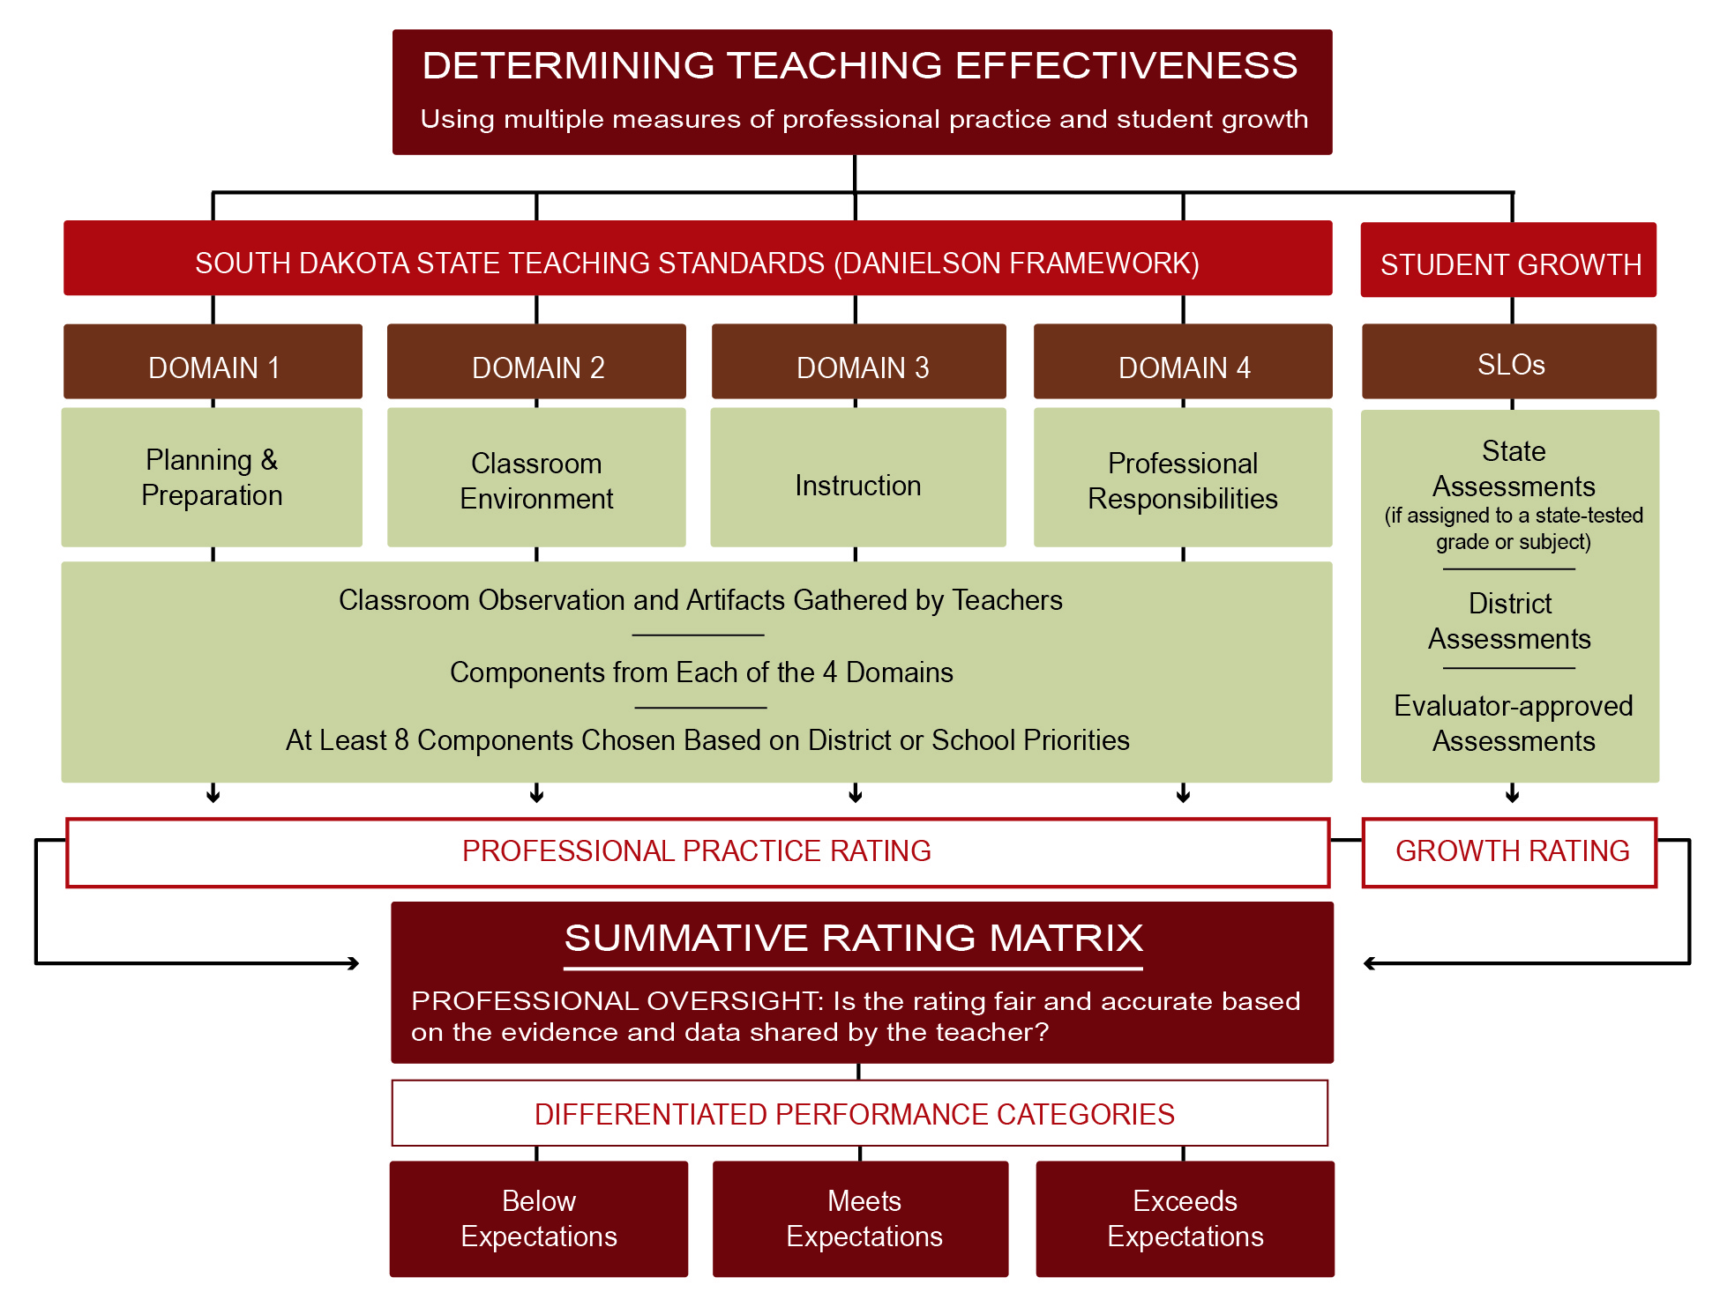
*The Professional Practice Rating and the Student Growth Rating may be combined into a Summative Effectiveness Rating. The Model Recommendation is to provide teachers with a Summative Rating.

Using the recommended model, public school districts will separately determine a Professional Practice Rating and a Student Growth Rating. The two separate ratings can be combined by using the Summative Rating Matrix, a tool that provides educators the opportunity to exercise professional judgment prior to classifying teacher performance into the three performance categories.

This model of combining the two ratings does not rely on a uniform formula to calculate a Summative Teacher Effectiveness Rating. Instead, the model prioritizes evaluations based on the South Dakota Framework for Teaching while incorporating the evaluation of student growth as one significant factor in the rating system.

Determining Teacher Effectiveness based on the recommended model is described in detail in the remaining portions of the South Dakota Teacher Effectiveness Handbook.

Evaluations of Professional Teaching Practice
Improving teaching performance begins with a clear definition of effective teaching. The South Dakota Framework for Teaching based on the 2013 Charlotte Danielson Framework offers a description of professional practices that, based on research and empirical evidence, have been shown to promote student learning. Evaluations of professional practice relative to the Framework contribute to the Teacher Effectiveness Rating and serve as a basis for developing individual professional growth plans focused on improving instruction.
- A portion of this Handbook is devoted to the South Dakota Evaluation and Professional Growth Process. For recommendations on the evaluation process, refer to pages 28-32.

South Dakota Framework for Teaching (2013 Charlotte Danielson Framework)
The South Dakota Framework for Teaching is divided into four domains of teaching practice. Nested underneath the four domains are 22 components and 76 elements that identify the skills and knowledge associated with that domain. The table below provides an overview of the full Framework down to the component level, and an outline including all 76 elements is provided in Appendix F.
- Additional resources, including a number of books that further explain standards-based evaluations and the South Dakota Framework for Teaching, are available for purchase from www.danielsongroup.org.

Figure 3: South Dakota Framework for Teaching – Domains and Components Overview, 2013
Domain 1  PLANNING AND PREPARATION |  | Domain 2  THE CLASSROOM ENVIRONMENT
- Demonstrating Knowledge of Content and Pedagogy  - Demonstrating Knowledge of Students  - Setting Instructional Outcomes  - Demonstrating Knowledge of Resources  - Designing Coherent Instruction  - Designing Student Assessments |  | - Creating an Environment of Respect and Rapport  - Establishing a Culture for Learning  - Managing Classroom Procedures  - Managing Student Behavior  - Organizing Physical Space
Domain 4  PROFESSIONAL RESPONSIBILITIES |  | Domain 3  INSTRUCTION
- Reflecting on Teaching  - Maintaining Accurate Records  - Communicating with Families  - Participating in a Professional Community  - Growing and Developing Professionally  - Showing Professionalism |  | - Communicating with Students  - Using Questioning and Discussion Techniques  - Engaging Students in Learning  - Using Assessment in Instruction  - Demonstrating Flexibility and Responsiveness

A Minimum of Eight Components, Including One from Each Domain
The CTL recognizes and appreciates the holistic view of teaching represented by the research-based South Dakota Framework for Teaching. Teacher evaluations based on the full Framework result in high levels of professional feedback and dialogue, setting the stage for all teachers to continually improve their instruction. For South Dakota public school districts in which consideration of the full Framework is not immediately achievable, the Commission recommends basing Professional Practice Ratings on a minimum of eight components, including at least one component from each of the four domains. This is the model recommendation. The minimum requirement is to evaluate teachers based on a minimum of one component from each of the four domains.

COMPONENT SELECTION
When considering less than the full South Dakota Framework for Teaching, school districts may select a common set of components across the public school district or select the components that are most important to a teacher’s individual professional growth.
- Public school districts seeking guidance on which eight components to select can refer to the Component Selection Guidance detailed in Appendix F.

Recommended Method to Determine the Professional Practice Rating
The Professional Practice Rating represents aggregate performance on all evaluated components. Evaluations of professional practice are guided by standards-based rubrics and supported by evidence gathered by the evaluator and teacher. Once component-level performance is determined, the evaluator assigns a numerical value to component-level performance and calculates an average score across the evaluated components. This average score translates into one of four levels of performance: Unsatisfactory, Basic, Proficient and Distinguished.
Figure 4: Determining the Professional Practice Rating
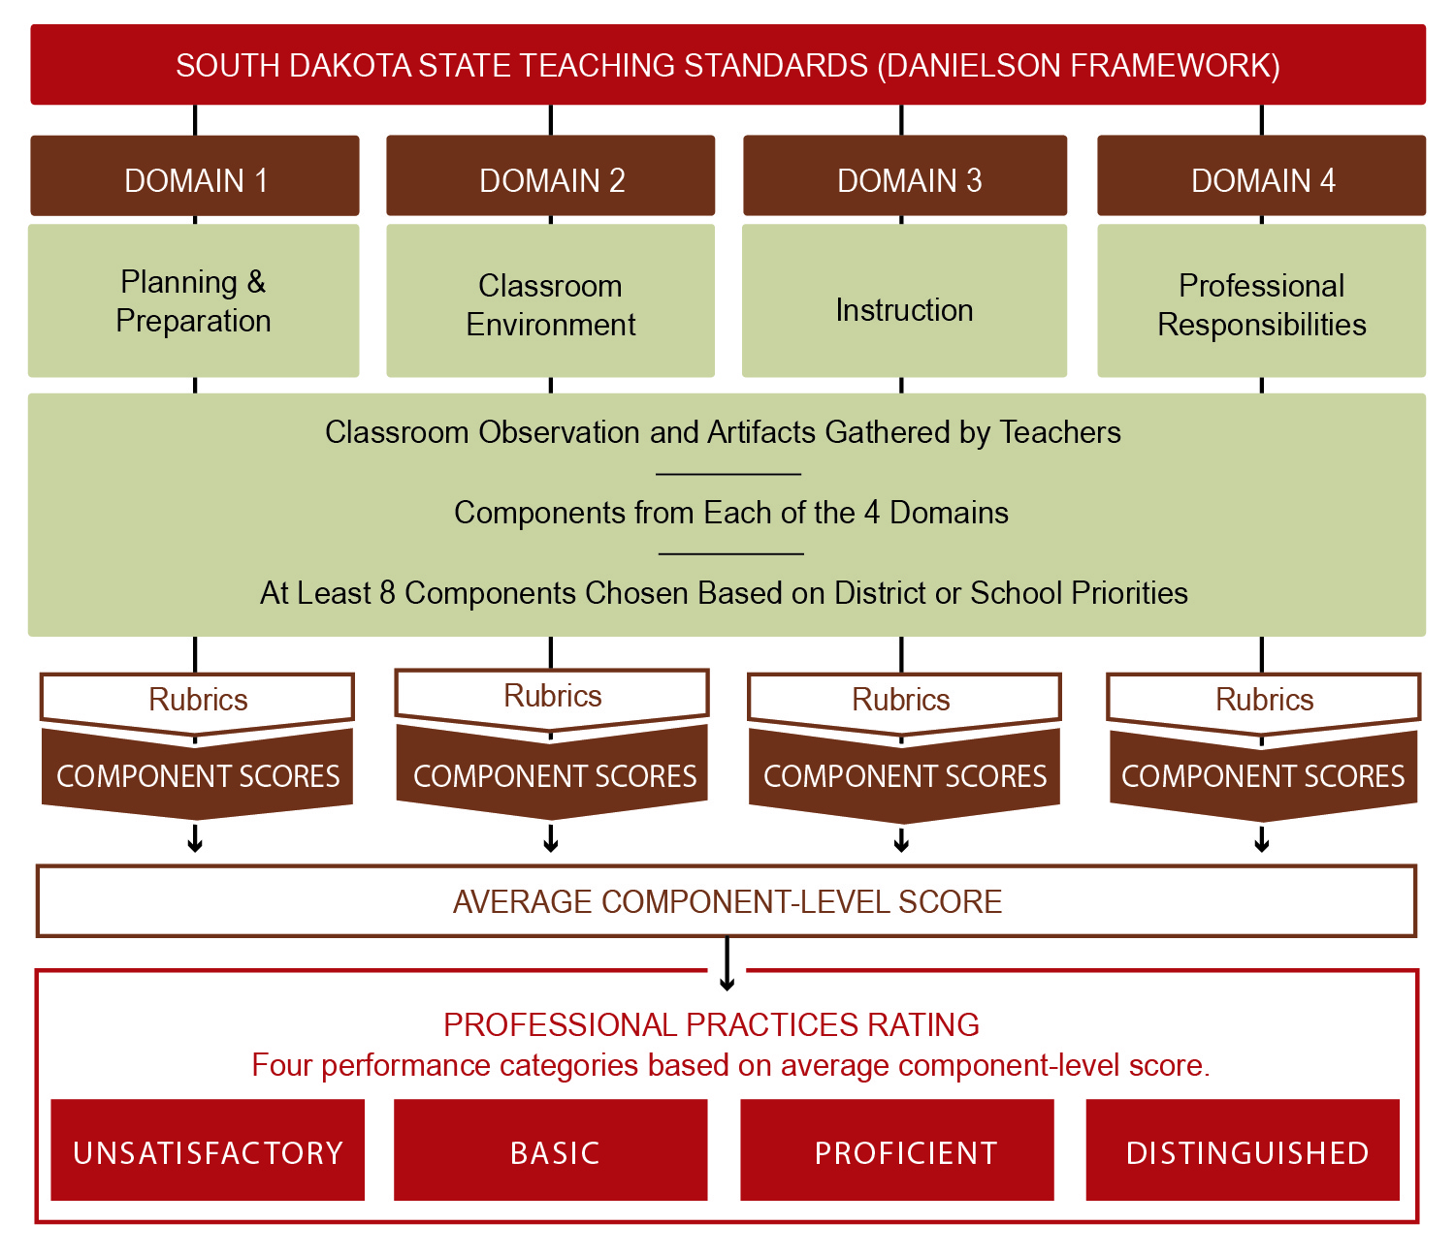

USING STANDARDS-BASED RUBRICS TO EVALUATE TEACHING PERFORMANCE
A collection of standards-based performance rubrics aligned to the South Dakota Framework for Teaching support transparent, accurate, and consistent assessments of teaching performance. Each rubric contains performance indicators and critical attributes that differentiate performance across a four-tiered continuum of performance: Unsatisfactory, Basic, Proficient and Distinguished.

EVALUATING PRACTICE USING EVIDENCE PROVIDED BY CLASSROOM OBSERVATION
Evaluations of professional practice relative to the Classroom Environment (Domain 2) and Instruction (Domain 3) domains of the South Dakota Framework for Teaching are supported primarily by evidence collected through classroom observation.

Formal Observations
A formal observation is at least 15 minutes in length, is conducted by the teacher’s evaluator, and includes structured conversations before and after the observation. A pre-observation conference provides the evaluator and teacher time to discuss the upcoming formal observation, including any lesson plans, assessments, or differentiation strategies. A post-observation conference is an opportunity for feedback, reflection, and analysis, giving the evaluator and teacher time to engage in a professional dialogue.

Informal Observations
An informal observation, commonly referred to as a drop-in, is an observation that is at least five minutes in length and results in feedback to the teacher. Informal observations may or may not be announced.

Observation Schedule for Probationary Teachers
For teachers in years one through three of continuous employment:
- Two (2) formal observations per school year, with sufficient time between the formal observations to allow for teacher reflection and professional growth.
- Four (4) informal observations per school year.

Observation Schedule for Non-Probationary Teachers
For teachers in the fourth contract and beyond:
- One (1) formal observation per school year.
- Four (4) informal observations per school year.

EVALUATING PRACTICE USING EVIDENCE PROVIDED BY ARTIFACTS
Professional practice evaluations also require the consideration of evidence that cannot be collected through classroom observation. Components that are not observable are supported by the collection of artifacts. Artifacts are documents, materials, processes, strategies, and other information that demonstrate performance relative to a component of professional teaching practice. It is up to the teacher and their evaluator to determine how artifacts are collected. To ensure expectations are established and artifact collection is focused, evaluators and teachers should discuss which artifacts support the evaluation. In many cases, artifacts stem from a teacher’s day-to-day work and teachers do not need to create documentation specifically to support the evaluation process.

Figure 5: Examples of Artifacts Aligned to Domains of Professional Practice
ARTIFACT | DOMAIN 1  Planning and Preparation | DOMAIN 2 Classroom Environment | DOMAIN 3 Instruction | DOMAIN 4  Professional Responsibilities
Stakeholder surveys | X | X | X | X
Teacher lesson plans | X
Discipline referrals |  | X
Parent newsletters |  |  |  | X
Class website |  |  | X | X
School improvement goals | X
Professional growth plan | X | X | X | X
Student enrollment (electives) |  | X
Community partnerships |  |  |  | X
Teacher journal | X | X | X | X
Safety report |  | X
Positive feedback portfolio | X | X | X | X
Parental contact log |  |  |  | X
Transcript | X |  |  | X
Demonstration of professional behavior (dress, punctuality, attendance) |  |  |  | X
Community involvement |  |  |  | X
Demonstration of high expectations |  | X
Discipline plans or contracts |  | X
Substitute teacher folder | X |  |  | X
Leadership opportunities |  |  |  | X
Curriculum maps | X |  | X
Committee assignments |  |  |  | X
Grade book |  |  |  | X
Video lesson | X | X | X | X
Professional organizations |  |  |  | X
Individual Education Plans (students) | X | X | X
Differentiated lesson plans | X |  | X
Mentoring | X | X | X | X
Action research | X | X | X | X
Professional development activities | X | X | X | X
Performance rubrics | X | X | X

PROFESSIONAL PRACTICE RATING DESCRIPTIONS
Each of the four final Professional Practice Ratings – Unsatisfactory, Basic, Proficient and Distinguished – are defined in general terms to illustrate the continuum of possible performance relative to the rigorous professional teaching components outlined in the South Dakota Framework for Teaching.

- Unsatisfactory: A teacher performing at the Unsatisfactory level does not appear to understand the underlying concepts represented by the Framework. Performance at this level requires significant intervention and coaching to improve the teacher’s performance.

- Basic: A teacher performing at the Basic level appears to understand the Framework conceptually but struggles to implement the standards into professional practice. Performance at this level is generally considered minimally competent for teachers early in their careers and improvement is expected to occur with experience.

- Proficient: A teacher performing at the Proficient level clearly understands the concepts represented by the Framework and implements them well. Teachers performing at this level are qualified in the craft of teaching and work to continually improve practice.

- Distinguished: A teacher performing at the Distinguished level is a master teacher and makes a contribution to the field, both inside and outside the classroom. While all teachers strive to attain Distinguished-level performance, this level is considered difficult to attain consistently.

DETERMINING THE OVERALL PROFESSIONAL PRACTICES RATING
After using standards-based rubrics to determine teaching performance for each component evaluated, the evaluator uses a three-step process to determine a Professional Practice Rating of Unsatisfactory, Basic, Proficient or Distinguished.

Step 1: Determine Component-Level Performance
Numerical values are assigned to teaching performance for each component evaluated: A Distinguished rating is assigned 4 points; a Proficient rating is assigned 3 points; a Basic rating is assigned 2 points; and an Unsatisfactory rating is assigned 1 point.

Step 2: Calculate an Average Score for All Components Evaluated
An average score across all components is calculated by dividing the total of all points earned by the number of components evaluated. The average will range from 1 to 4, and is rounded to the nearest hundredth of a point. All components are given equal weight.

Step 3: Determine the Overall Professional Practice Rating
The average component-level score is used to assign a Professional Practice Rating of Unsatisfactory, Basic, Proficient or Distinguished. The chart below presents the score ranges aligned to the four performance categories.

Figure 6: Overall Professional Practice Rating Score Ranges
Range | 1.00 to 1.49 | 1.50 to 2.49 | 2.50 to 3.49 | 3.50 to 4.00
Rating | Unsatisfactory | Basic | Proficient | Distinguished

Figure 7: Example of Determining the Professional Practice Rating for Eight Components
 |  |  | COMPONENT LEVEL PERFORMANCE
 |  |  | Unsatisfactory |  | Basic | Proficient | Distinguished |  | Points Earned
 |  |  | (1 point) |  | (2 points) | (3 points) | (4 points) |  | Points Earned
COMPONENTS SELECTED | 1c: Setting Instructional Outcomes |  |  |  |  | ✔ |  |  | 3
COMPONENTS SELECTED | 1e: Designing Coherent Instruction |  |  |  |  |  | ✔ |  | 4
COMPONENTS SELECTED | 2b: Establishing a Culture for Learning |  |  |  | ✔ |  |  |  | 2
COMPONENTS SELECTED | 2d: Managing Student Behavior |  |  |  | ✔ |  |  |  | 2
COMPONENTS SELECTED | 3b: Using Questioning & Discussion Techniques |  |  |  |  | ✔ |  |  | 3
COMPONENTS SELECTED | 3c: Engaging Students in Learning |  |  |  |  | ✔ |  |  | 3
COMPONENTS SELECTED | 4a: Reflecting on Teaching |  |  |  |  | ✔ |  |  | 3
COMPONENTS SELECTED | 4c: Communicating with Families |  |  |  |  |  | ✔ |  | 4
 | Total Points |  |  |  |  |  |  |  | 24
 | Average Component-Level Score |  |  |  |  |  |  |  | 3.00
 | OVERALL PROFESSIONAL PRACTICE SCORING RANGES |  |  |  |  | OVERALL PROFESSIONAL  PRACTICE RATING  PROFICIENT
 | 1.00 to 1.49 | 1.50 to 2.49 |  | 2.50 to 3.49 | 3.50 to 4.00
 | Unsatisfactory | Basic |  | Proficient | Distinguished

Evaluations of Student Growth
The complex task of connecting teaching performance to student academic outcomes is best handled closest to the student, which is why the SLO process asks teachers to identify and address the unique learning needs of all students. A Summative Teacher Effectiveness Rating is based in part on Student Growth, which is defined as a change in achievement between two or more points in time. SLOs contribute to the Summative Teacher Effectiveness Rating and provide another mechanism to generate feedback that guides professional growth.

- For comprehensive guidance on the implementation of SLOs, refer to the South Dakota Student Learning Objectives Handbook at the following URL: https://doe.sd.gov/Effectiveness/Teacher.aspx

Four Key Benefits of Student Learning Objectives
A Student Learning Objective is a process by which a teacher establishes expectations for student growth during a specified period of time. Specific, measurable student growth goals are based on student learning needs and aligned to applicable content standards. At the end of the instructional period, the teacher’s Student Growth Rating is determined by the progress toward documented goals.

ONE: REINFORCING RECOMMENDED PRACTICES
Setting goals for students, assessing student progress, and using data to inform adjustments to instructional strategies demonstrate good teaching practices (What Works Clearing House, 2009). Many South Dakota teachers regularly use assessment data to inform instructional decisions, and implementing the SLO process formalizes those recommended practices while working to focus conversations around student results, which ultimately benefits teaching and student learning (Lachlan-Hache, Cushing, & Bivona, 2012).

USING THE S.M.A.R.T. GOAL SETTING PROCESS TO DEVELOP SLOs
SLO implementation encourages teachers to make direct connections between planning and instruction by asking educators to use the S.M.A.R.T. goal-setting framework to structure classroom-level goal setting. Using the S.M.A.R.T. goal-setting framework, educators are guided toward establishing SLOs that are (S)pecific, (M)easurable, (A)ppropriate, (R)igorous and realistic, and (T)ime-bound.

CONNECTION TO THE FRAMEWORK FOR TEACHING
When integrated with evaluations of professional practice relative to the South Dakota Framework for Teaching, SLOs provide yet another way to reinforce recommended practices. Public school districts may consider focusing evaluations of professional practice on the components that are most closely connected to the knowledge and skills necessary to establish and attain SLOs (for more information, refer to the component selection guidance in Appendix F). In addition, SLO documentation can serve as an artifact to demonstrate performance relative to non-observable components of the Framework. When scheduling informal and formal observations, evaluators may opt to observe lessons related to the established SLO.

TWO: A TEACHER-LED, COLLABORATIVE GOAL-SETTING PROCESS
Districts that have effectively implemented SLOs found that the process provided teachers with the opportunity to take ownership in establishing authentic and relevant growths goals. Implementing SLOs has also been shown to build a culture of collaboration (Lachlan-Hache, Cushing, & Bivona, 2012).

THREE: A FLEXIBLE FRAMEWORK BASED ON STUDENT NEEDS, GRADE LEVEL AND CONTENT AREA
Implementing SLOs empowers districts to create a uniform goal-setting process that provides teachers with flexibility to match the assessment and student growth goal to course content and unique student population. SLOs are not entirely dependent upon the availability of statewide assessments; an important benefit considering nearly 70 percent of teachers teach in grades and subjects in which state assessments are not available (U.S. Department of Education, 2013).

FOUR: FOCUSED ON THE MOST IMPORTANT LEARNING THAT NEEDS TO OCCUR
SLOs promote educator expertise by emphasizing teacher knowledge of curriculum, assessment, learning context and student data. Through SLO development, teachers are asked to assess student needs and align instruction accordingly. While many teachers rely on similar goal-setting strategies to guide instruction for all content taught during the year, they are only asked to formalize the process for the most critical learning that needs to occur.

The SLO Process
South Dakota’s SLO process embeds recommended practices into a transparent and collaborative process. Through the SLO process teachers or teams of teachers identify important content, determine student baseline knowledge, write goals to set expectations for student growth, and measure student progress. The SLO process encourages teachers to monitor student learning and make data-informed adjustments to instructional strategies. Principals and evaluators support the SLO process by guiding and approving SLOs, providing structured and ongoing feedback, and scoring the final results.

USE OF STATE ASSESSMENTS DURING THE SLO PROCESS
Assessment of student learning is a critical component of the SLO process. Teachers assigned to tested grades and subjects should use data from state assessments as part of the SLO process. Local public school districts may determine the most appropriate way to use state assessment data as a part of the SLO process.
- There is no requirement for teachers to use state assessment data as an end-of-year assessment of student progress. In most cases, teachers will review prior-year assessment data as a means to assist in identifying priority content on which to focus student growth goals.

NUMBER OF SLOs USED FOR EVALUATION OF STUDENT GROWTH
Teachers may develop more than one SLO, however only one SLO may be used for the purpose of evaluation. The SLO used for evaluation purposes should be established early in the evaluation period and cover the period of instruction. Teachers assigned to tested grades and subjects must develop an SLO for the content or grade level in which the state assessment is administered.

SLO PROCESS RESOURCES
The most comprehensive guidance regarding SLOs is available in the Student Learning Objectives Handbook, which is available at the following URL: https://doe.sd.gov/Effectiveness/Teacher.aspx Several resources are also available in Appendix I, including:

- SLO Process Guide: A step-by-step approach to guide administrators and teachers through the entire four-step SLO process.

- SLO Quality Checklist: A resource used by teachers and administrators to determine whether a SLO meets the S.M.A.R.T. criteria.

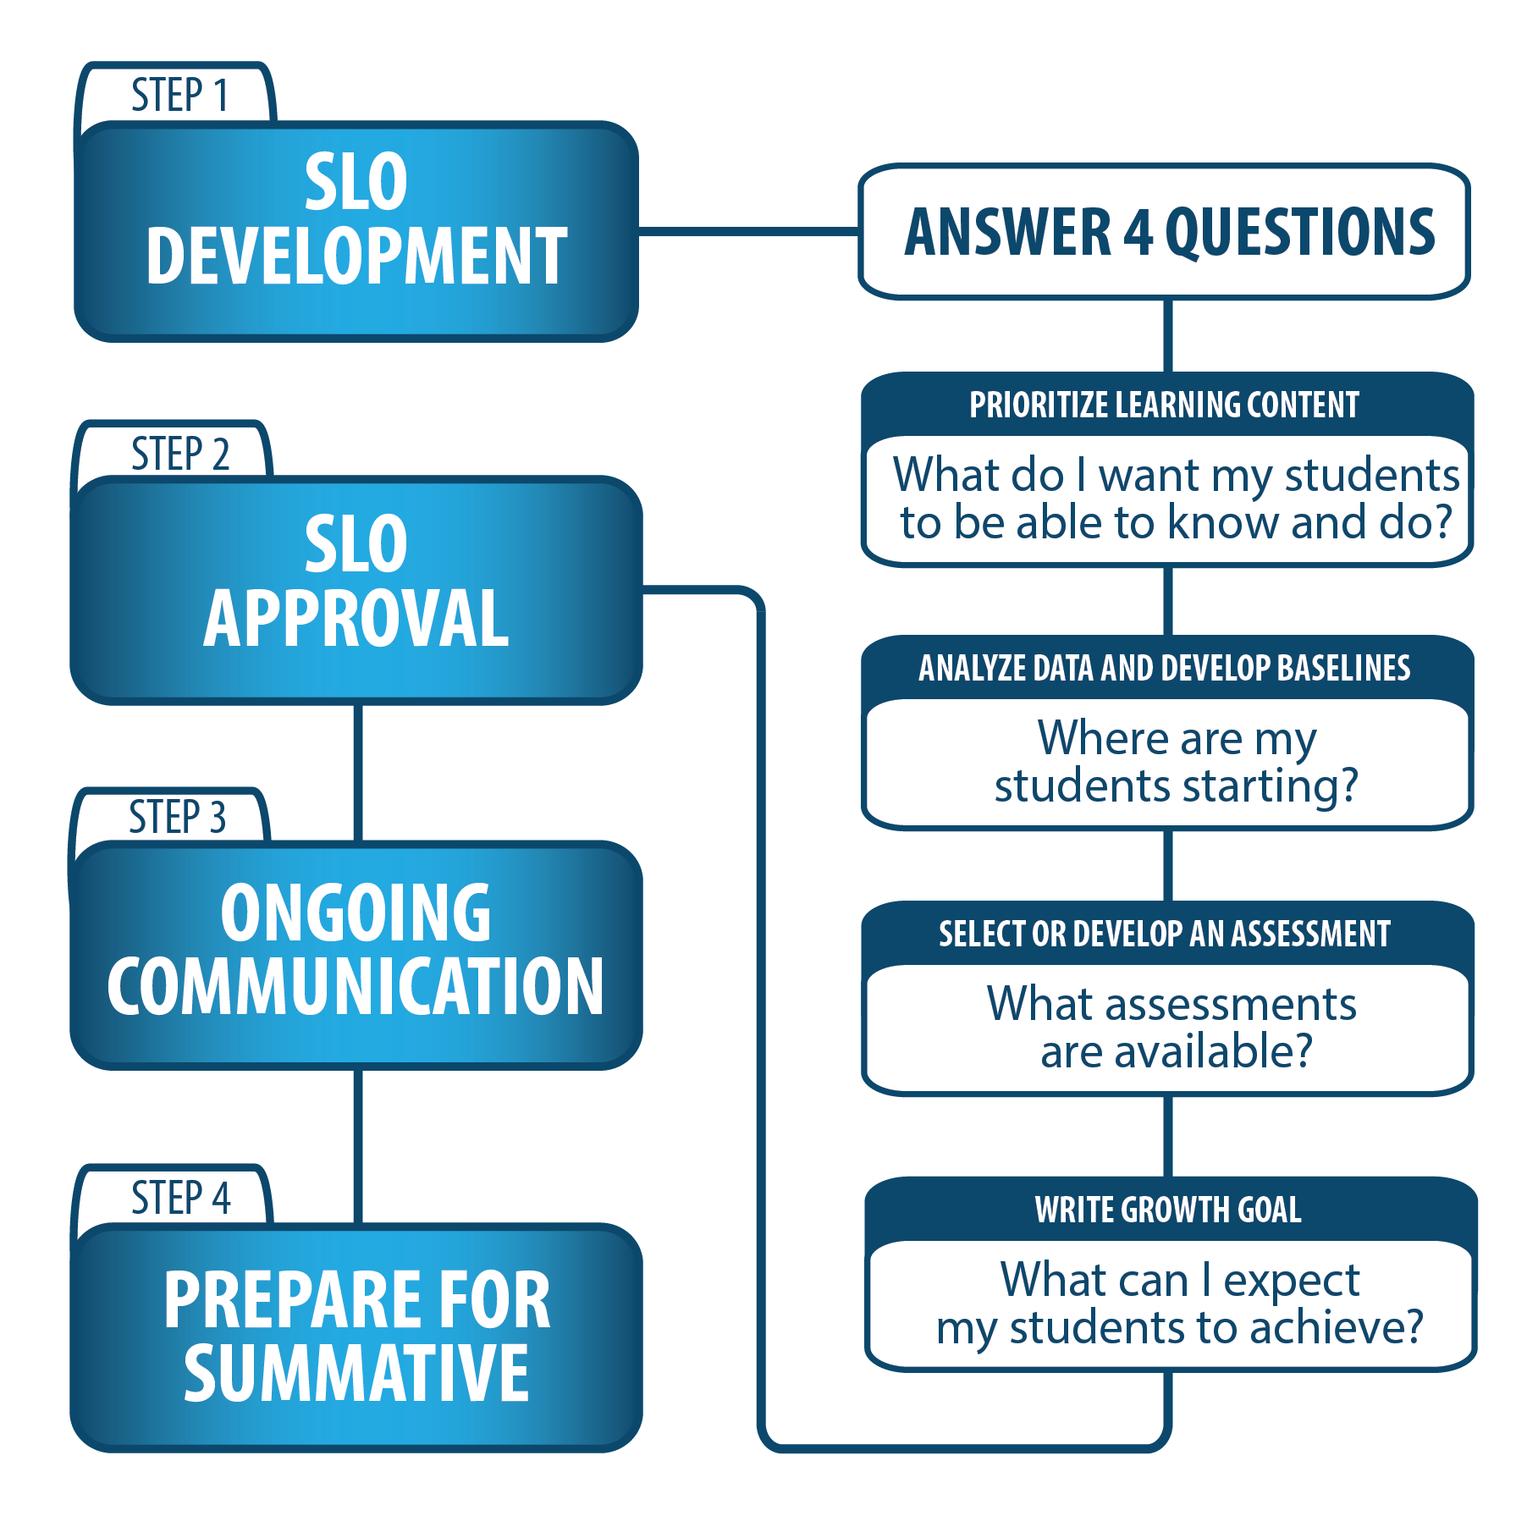
Figure 8: The SLO Process

STEP 1: SLO DEVELOPMENT
The SLO process begins with the important task of attaching structure to student learning expectations. Through SLO Development, teachers are asked to answer four key questions:
  - What do I most want my students to know and be able to do?
Answering this question helps the teacher identify the core concepts and standards that will be addressed by the SLO.

  - Where are my students starting?
Answering this question involves gathering and analyzing data to establish student baseline knowledge.

  - What assessments are available?
Answering this question leads to the selection or development of an appropriate assessment to measure student growth and goal attainment.

  - What can I expect my students to achieve?
Answering this question leads to the development of a student growth goal and a strong rationale statement supporting why the goal is appropriate for the instructional period.
Teachers, either individually or in teams, are encouraged to assume much of the responsibility for developing rigorous, achievable SLOs. A principal’s support and guidance will be important, particularly as teachers become familiar with any new expectations or processes. As the instructional leader, the principal holds the ultimate responsibility for leading teachers through the SLO process.

STEP 2: SLO APPROVAL
Once developed, the SLO must be approved as the official measure of student growth for the evaluation period. SLO approval is supported by at least one SLO conference between the teacher and evaluator. To ease time pressures, the SLO conference may be scheduled in conjunction with other face-to-face meetings that occur during the evaluation and professional growth process, such as goal-setting or post-observation conferences.

Teachers prepare for SLO approval by submitting the preliminary SLO document and providing evaluators with the necessary information to make informed judgments about goal quality and rigor. Teachers will identify the specific standard(s) being addressed, detail the assessment used to measure goal attainment, provide data supporting the need for the goal, and describe how the goal will benefit student learning. If the SLO is not approved, teachers should receive constructive feedback that explains how the SLO can be improved. Teachers will be given a window to make appropriate changes before resubmitting the SLO for approval.

STEP 3: ONGOING COMMUNICATION
Ongoing communication provides opportunities for evaluators and teachers to regularly correspond regarding progress toward goal attainment. The SLO process encourages, but does not require, teachers to monitor student progress through ongoing formative assessment. By using formative assessment, teachers have access to data that may either validate instructional strategies or determine whether mid-course modifications need to be made. Ongoing communication may be conducted electronically.

STEP 4: PREPARING FOR THE SUMMATIVE CONFERENCE
A discussion of the teacher’s Student Growth Rating will take place during a summative conference that occurs as part of the broader teacher evaluation and professional growth process. The final step of the SLO process prepares for that discussion to take place.

Evidence of SLO attainment, including any required assessment data, will be given to the evaluators. Preparing for the summative conference may include self-scoring the SLO, determining a preliminary Student Growth Rating and self-reflection.

In preparation for the summative conference, evaluators review teacher-submitted SLO evidence to establish a preliminary Student Growth Rating. To provide sufficient time to prepare the summative evaluation, principals establish timelines for evidence submission. A preliminary rating, with appropriate feedback, will be provided to the teacher in advance of the summative conference. The teacher will be given sufficient time to review the evaluator’s comments and gather any additional data necessary to reference during the summative conference.

Recommended Method to Determine the Student Growth Rating
A teacher’s Student Growth Rating quantifies the impact a teacher has on student learning during the instructional period. Once SLOs have been established and student growth has been measured between two points in time, the teacher’s Student Growth Rating is assigned based on SLO goal attainment. Performance relative to the student growth measure is classified into one of three performance categories: Low Growth, Expected Growth, or High Growth.

Figure 9: Student Growth Performance Categories
PERFORMANCE CATEGORY | DESCRIPTION
Low Growth | The teacher’s SLO is less than 65 percent attained.
Expected Growth | The teacher’s SLO is 65 to 85 percent attained.
High Growth | The teacher’s SLO is 86 to 100 percent attained.

Summative Teacher Effectiveness Ratings
The Summative Teacher Effectiveness Rating differentiates Teacher Effectiveness into one of three performance categories: Below Expectations, Meets Expectations and Exceeds Expectations. This is the Model Recommendation.

Recommended Method to Determine Teacher Effectiveness Ratings
The Professional Practice Rating and Student Growth Rating can be combined to form the Summative Teacher Effectiveness Rating using the Summative Rating Matrix.

Figure 10: The Summative Scoring Matrix
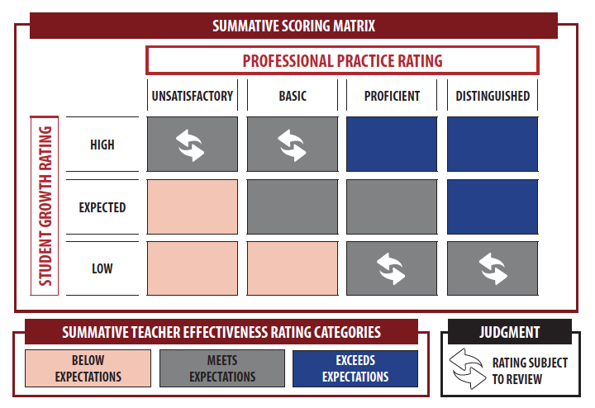

USING A MATRIX MODEL TO DETERMINE SUMMATIVE TEACHER EFFECTIVENESS RATINGS

The recommended matrix model does not rely on uniform, prescriptive formulas to calculate a Summative Teacher Effectiveness Rating. Instead, the matrix guides the assignment of the Summative Teacher Effectiveness Rating while providing opportunities for professional judgment to be exercised.

Professional Practice and Student Growth Ratings are represented in the columns and rows of the matrix. The Summative Teacher Effectiveness Rating, determined by the intersection of the two individual ratings, translates into one of three required performance categories.

The physical construction of the recommended Summative Rating Matrix reflects the emphasis placed on professional practice evaluations. A closer examination of all 12 areas of intersection reinforces the priority placed on professional practice evaluations. For example, a teacher earning a Professional Practice Rating of Proficient or Distinguished is, by default, assigned a Summative Teacher Effectiveness Rating of at least Meets Expectations.

Student Growth as One Significant Factor
The design of the recommended Summative Rating Matrix assigns significance to student growth measures while maintaining focus on evaluations relative to professional practices based on the South Dakota Framework for Teaching. Student growth remains a key piece of the system, as no educator receiving the lowest Student Growth Rating can receive the highest Summative Teacher Effectiveness Rating within the system.

EXERCISING PROFESSIONAL JUDGMENT TO ADJUST TEACHER EFFECTIVENESS RATINGS
The Summative Rating Matrix embeds opportunities for professional judgment to play a role in the assignment of a Summative Teacher Effectiveness Rating. In the four areas in which one rating is very high and another rating is very low, individual ratings are reviewed to ensure the rating is fair and accurate based on all evidence collected. The teacher and evaluator may agree that additional evidence may be required, and Summative Teacher Effectiveness Ratings can be adjusted if it is determined that the outcome misrepresents teaching performance.

Supporting Professional Judgment with Evidence and Documentation
High-quality implementation of the South Dakota Teacher Effectiveness System is intended to establish a firm connection between instructional practice and student academic outcomes. Exercising professional judgment should be rare; reserved only for situations in which the body of evidence clearly demonstrates that a Summative Teacher Effectiveness Rating is not truly reflective of teaching performance. When professional judgment is exercised, principals include evidence and rationale in narrative form along with the summative results. If a teacher ultimately disagrees with a principal’s use of professional judgment, teachers supply evidence and accompanying narrative to accompany the summative results.

Tracking the Use of Professional Judgment
High-quality implementation of the South Dakota Teacher Effectiveness System requires public school districts to track the number of times professional judgment is exercised. The data may be used to document any needed revisions or changes to the district’s policies, practice and procedures.

South Dakota Evaluation and Professional Growth Process
The South Dakota Evaluation and Professional Growth Process represents a collection of recommended practices to operationalize the South Dakota Teacher Effectiveness Model. The process engages teachers and principals in thoughtful, deliberate discussions designed to improve instruction and student learning.
- To reference a collection of forms to guide the South Dakota Evaluation and Professional Growth Process, refer to Appendix J.

One-Year Evaluation Cycle
An evaluation cycle ensures expectations are established and that professional communication occurs at regular intervals. The recommended evaluation cycle has four phases – Prepare, Plan, Perform and Progress – and eight individual steps.

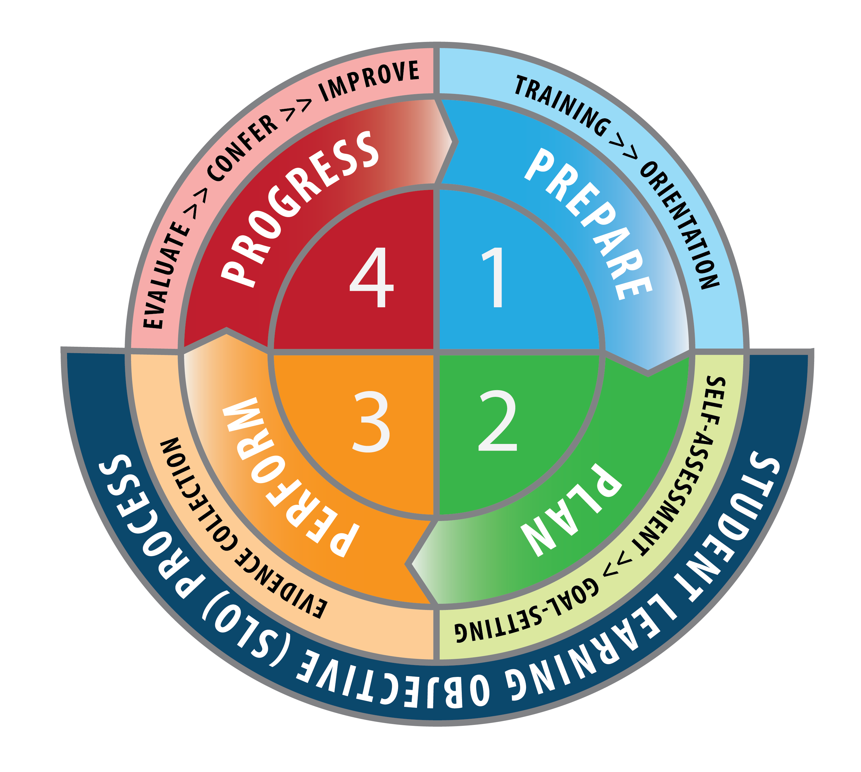
Figure 11: South Dakota’s Recommended Evaluation and Professional Growth Process

PHASE 1: PREPARE
During the Prepare phase, teachers and evaluators are trained and oriented to the evaluation system. The steps in the Prepare phase are crucial to ensure all teachers employed by a public school district understand the evaluation system. The training and orientation steps should be completed prior to full implementation of the Teacher Effectiveness System.

Figure 12: The Prepare Phase of the Evaluation Cycle
PREPARE | STEP ONE | - Teachers and evaluators are trained in South Dakota Framework for Teaching (2013 Charlotte Danielson Framework) and how teaching standards are used as the basis for evaluation of professional practice.  - Evaluators are trained and certified on how to conduct accurate, fair observations of professional practice.  - Teachers and evaluators are trained on how to develop SLOs and how student growth factors into the Teacher Effectiveness System.
PREPARE | TRAINING
PREPARE | STEP TWO | - All staff impacted by the Teacher Effectiveness System collectively review the Teacher Effectiveness System to ensure all staff have the knowledge to actively participate in the evaluation and professional growth process.
PREPARE | ORIENTATION

PHASE 2: PLAN
The Plan phase asks teachers to take the lead in establishing professional growth goals and establishing SLOs. The teacher and evaluator work collaboratively to establish a professional trajectory for the year and finalize SLOs. The Plan phase should be completed early in the school year or semester to allow sufficient time for evidence collection.

Figure 13: The Plan Phase of the Evaluation Cycle
PLAN | STEP THREE | - Each teacher assesses his or her professional practice and prepares professional practice goals for the school year.  - The teacher begins the SLO development process by examining student assessment data, including any available state assessment data, to prioritize learning content. The teacher may opt to give his or her students a baseline assessment to more accurately determine the starting point from which student growth will be measured.
PLAN | SELF-  ASSESSMENT
PLAN | STEP FOUR | - Teachers meet with evaluators to review the professional practice goals and jointly analyze student learning.  - Teachers and evaluators discuss the evidence necessary to support the evaluation of professional practice.  - Professional practice goals are approved.  - Progress toward SLO development is discussed, and, if appropriate, the SLO is approved.
PLAN | GOAL-SETTING

PHASE 3: PERFORM
The Perform phase involves the collection of evidence that supports both evaluations of professional practice and student growth. Formal and informal observations are conducted, teachers collect artifacts relative to non-observable components, and teachers gather ongoing assessment data to monitor progress toward SLOs. Evidence collection concludes when all evidence is submitted to the evaluator. The Perform phase should be completed early enough to provide evaluators with sufficient time to complete evaluations.

Figure 14: The Perform Phase of the Evaluation Cycle
PERFORM | STEP FIVE | - Formal and informal classroom observations occur to collect evidence of professional teaching practice.  - Evidence from multiple sources compiled to support non-observable elements of professional practice.  - Quantitative data demonstrating progress on SLOs is collected.  - Evidence is documented and teachers are provided structured feedback on performance throughout the evidence collection period.
PERFORM | EVIDENCE  COLLECTION

DISTRICT CONSIDERATIONS FOR COMPLETION OF THE PERFORM PHASE
As soon as the evidence period concludes for either the professional practice or student growth measure, the evaluator should determine the final rating for that measure. A Professional Practice Rating can be assigned once all informal and formal observations have occurred and the teacher has submitted sufficient evidence to demonstrate performance relative to non-observable teaching components. A Student Growth Rating can be assigned following the instructional period outlined in the SLO.
  - For example: A Professional Practice Rating may be determined in April, with a Student Growth Rating delayed until May. This scenario may occur if a final assessment of student learning needs to occur near the end of the second semester.
  - For example: A Student Growth Rating may be determined in January, with a Professional Practice Rating delayed until April. This scenario may occur if a teacher’s SLO is focused on content delivered in the first semester.

PHASE 4: PROGRESS
In the Progress phase, the evaluator reviews all evidence to determine and differentiate summative teaching performance. Results are provided to the teacher in advance of a summative conference, which provides an opportunity for in-depth discussion prior to finalizing a possible Summative Teacher Effectiveness Rating. The Progress phase concludes with teacher self-reflection and the adoption of plans to improve performance.

Figure 15: The Progress Phase of the Evaluation Cycle
PROGRESS | STEP SIX | - Using all documented evidence, the evaluator completes a summative evaluation including measures of both professional practice and student growth.  - The evaluator sends evaluation results to the teacher in advance of the summative conference.
PROGRESS | EVALUATION
PROGRESS | STEP SEVEN | - The evaluator and teacher meet to discuss summative evaluation results and engage in a comprehensive, evidence-based dialogue regarding teaching performance.  - The Summative Teacher Effectiveness Rating may be finalized and the conference concludes with a discussion about improvement planning.
PROGRESS | SUMMATIVE  CONFERENCE
PROGRESS | STEP EIGHT | - Following reflection, a teacher is empowered to develop an individual professional growth plan.  - If a plan of assistance is necessary, the evaluator works with the teacher to prioritize areas of improvement.  - After mutual review, the improvement plan is finalized and put into action.
PROGRESS | IMPROVEMENT  PLANNING

DISTRICT CONSIDERATIONS FOR COMPLETION OF THE PROGRESS PHASE
Many current local evaluation practices and procedures require evaluations to be completed by April 1. That deadline is primarily driven by a state law (SDCL 13-43-6.3) requiring public school districts to notify a teacher, prior to April 15, of the district’s recommendation to not renew a teacher’s contract. The presence of the notification deadline can create the misconception that the Evaluation and Professional Growth Process must be completed by April 1. To clarify, consider the following points:
  - Local public school districts are not required to justify the recommendation to non-renew a probationary teacher’s contract.
  - If a non-probationary teacher needs of a plan of assistance, non-renewal decisions are based on a plan of assistance, and do not need to be based entirely upon the results of the Evaluation and Professional Growth Process.
  - The South Dakota Teacher Effectiveness System and South Dakota Evaluation and Professional Growth Process both empower the public school district to determine the process by which non-probationary teachers are provided with a plan of assistance.
  - If the public school district has a policy dictating that evaluations must be completed by April 1, the district, prior to deadline established in the “implement or plan” timeline, should consider revising policy to clarify that procedures related to non-renewal are completed by April 1.

State Implementation Support and Monitoring
This section of the South Dakota Teacher Effectiveness Handbook outlines ways the SD DOE encourages and supports implementation of high quality Educator Effectiveness systems. Support systems were developed collaboratively with stakeholder groups and were created in response to the needs of South Dakota public schools.

The level of support provided to South Dakota public schools was made possible by grant funds, funds appropriated by the South Dakota Legislature, and resources provided by the passage of the South Dakota Investing in Teachers Initiative.
- The SD DOE’s website provides an archive of Teacher Effectiveness resources at the following URL: https://doe.sd.gov/Effectiveness/Teacher.aspx
- Public school districts can assess and track progress toward implementation by using the District Self-Assessment tool available in Appendix D.

Supporting System Development and Promoting Recommended Practices
The following information is provided to establish historical context.

SD DOE has worked collaboratively to facilitate the development of local Teacher Effectiveness systems that are rooted in recommended practices. SD DOE’s efforts are summarized below.

Supporting Research and Gathering Data to Inform Decision-Making
SD DOE has committed to using research and data to identify both challenges and recommended practices. Research and data from several sources is used to inform decision-making and develop solutions. Recommended practices are gathered and incorporated into state resources and trainings.

Raising Awareness
In October of 2013, SD DOE sponsored a series of four awareness webinars and a series of four regional face-to-face administrator trainings devoted in part to raising awareness about the South Dakota Teacher Effectiveness System. In addition, information about state requirements and recommendations has been communicated directly to public school officials through multiple communication channels.

Providing Technical Assistance and Implementation Planning
Providing teachers and administrators with high-quality training is a key component of the South Dakota Teacher Effectiveness System. SD DOE has supported and sponsored in-district technical assistance and implementation planning for all districts.

Assistance for Pilot Districts and Schools
Schools participating in the 2013-14 Teacher Effectiveness Pilot were eligible for technical assistance, including implementation planning, as part of the on-site assistance provided to pilot schools. Resources developed for pilot schools were used in the development of statewide resources.

Coaching For All Districts
During the 2013-14 school year SD DOE trained a cadre of facilitators to serve as in-district implementation coaches. Beginning in February of 2014, every public school district was eligible to receive a full-day, state-sponsored, in-district planning session using state-approved implementation tools. Public school districts were encouraged to assemble a team of school administrators and teachers to participate in the planning day.
- A summary of state requirements, recommendations and legal references is assembled into the Teacher Effectiveness District Self-Reflection available in Appendix D.

Training and Support through Professional Development
The following information is provided to establish historical context.

Menu of State-Sponsored Professional Development Options
During the pilot year, East Dakota Educational Cooperative provided more than 55 state-paid coaching and training days for pilot participants.

During the 2014-15 and 2015-16 school years, SD DOE provided access to a number of state-approved trainings relating to Teacher Effectiveness. Districts were free to select their preferred training provider and the training options that reflected the most pressing needs of the district. References to state-sponsored professional development are made throughout the remainder of the South Dakota Teacher Effectiveness Handbook.

Orientation to South Dakota’s Teacher Effectiveness System
All educators must understand the South Dakota Teacher Effectiveness System, including recommended practices surrounding the use of multiple measures of professional practice and student growth to determine and differentiate teaching performance. Public school districts may use state-provided resources, such as this South Dakota Teacher Effectiveness Handbook to design and offer an orientation program.

Training to Understand and Develop Student Learning Objectives
SD DOE supported the implementation of SLOs through a large-scale training effort in Spring and Summer 2014. The training frameworks were informed by pilot experiences and developed collaboratively with stakeholders, including members of the CTL. Prior to the summer teacher training effort, the design and content of the two-day summer training was validated, refined and influenced by a team of individuals who attended a four-day, intensive SLO training facilitated by the American Institutes for Research (AIR). Attendance at the training was made possible through a grant obtained by the South Dakota Education Association (SDEA).

Public school districts seeking training on SLOs had several options. SD DOE sponsored the development of a cadre of Education Service Agency (ESA) trainers capable of providing state-paid, in-district support. Alternatively, the South Dakota Education Association developed a cadre of teachers to provide SLO training.

Recommended: Peer Observation Programs
Public schools implementing the South Dakota Teacher Effectiveness System are encouraged to implement a peer observation program that asks teachers to observe each other. Peer-to-peer observation is not used for formal evaluation purposes, but the program does build understanding of the South Dakota Framework for Teaching while promoting reflective teaching practice.

State Implementation Monitoring
The SD DOE works to incorporate effectiveness system requirements into school accreditation
processes. Additional details about the state’s Teacher Effectiveness Accreditation Review Process can
be found at https://doe.sd.gov/oatq/districtaccreditation.aspx.

Glossary of Terms
Artifacts
Documents, materials, processes, strategies and other information that demonstrate performance relative to a standard of professional teaching practice.

Evaluator
Any person charged with conducting formal teacher evaluations. In most cases the principal or assistant principal is the evaluator.

Formal Observation
A scheduled observation of teaching practice conducted by an evaluator that is at least 15 minutes in length and includes structured conversations before and after the observation takes place.

Goal-setting Conference
A step in the annual evaluation cycle in which the teacher and evaluator agree upon professional practice goals, discuss appropriate sources of evidence to support professional practice evaluations, and agree upon SLOs that will serve as the basis for evaluations of student growth.

Informal Observation
An observation of teaching practice, which may or may not be announced, that is conducted by an evaluator, is at least five minutes in length, and results in feedback to the teacher.

Observer
Any person who conducts a classroom observation to provide feedback or support outside of the formal evaluation process.

Ongoing Communication
A step in the SLO process in which teachers and administrators engage in dialogue about student growth throughout the evaluation cycle.

Preparing for the Summative Conference
A step in the SLO Process in which teachers assemble and submit evidence of SLO goal attainment to the evaluator.

Pre-observation Conference
A face-to-face meeting held prior to a formal observation that enables the teacher and evaluator to discuss the formal observation, including any lesson standards, assessment tools and instructional strategies that will be used during the lesson.

Post-observation Conference
A face-to-face meeting held after a formal observation that enables the teacher and evaluator to reflect upon the observation and engage in dialogue about effective strategies that support teaching and learning.

Professional Practice Rating
A rating of Unsatisfactory, Basic, Proficient or Distinguished that is calculated and assigned following an evaluation of professional practice relative to the South Dakota Framework for Teaching.

Self-Assessment
A step in the annual evaluation cycle in which the teacher assesses his or her professional practice and analyzes student achievement data for the purpose of establishing professional practice and student growth goals for the evaluation period.

SLO Approval
The step in the SLO process in which the teacher and evaluator agree upon an SLO that will be used as the official measure of student growth for the evaluation period.

SLO Conference
A face-to-face meeting that provides an opportunity for teachers and evaluators to either approve SLOs or discuss progress toward SLO development. This conference may be scheduled in conjunction with other face-to-face meetings required as a part of the broader teacher evaluation and professional growth process.

SLO Development
The step in the SLO process that asks teachers and principals to collaboratively establish and document expectations for student growth.

SLO Process Guide
A state-approved, four-step process that guides teachers and administrators through the process of evaluating teacher impact on student growth.

SLO Quality Checklist
A state-approved guide for administrators and teachers to use in the process of evaluating the quality of a teacher-developed SLO.

South Dakota Framework for Teaching
A comprehensive, research-based definition of effective teaching practice that serves as the foundation of professional practice evaluations. The full Framework, also known as the 2013 Charlotte Danielson Framework for Teaching, is organized into four domains of practice. The four domains contain 22 components and 76 elements that collectively describe the complex teaching profession.

South Dakota Teacher Effectiveness Model
A collection of recommended practices that serves as guidance toward successful implementation of high-quality Teacher Effectiveness systems.

Student Growth
A change in student achievement between two or more points in time.

Student Growth Rating
A rating of Low Growth, Expected Growth, or High Growth that reflects the degree to which goals for student growth, as documented in a SLO, are attained.
Student Learning Objective (SLO)
A process by which a teacher establishes expectations for student growth over a specified period of time.

Summative Conference
A step in the evaluation cycle in which the teacher and evaluator meet face-to-face to reflect upon all evidence collected to support the evaluation and discuss the Summative Teacher Effectiveness Rating.

Summative Teacher Effectiveness Rating
A single rating that combines multiple measures of professional practice and student growth to differentiate teacher performance into one of three performance categories: Below Expectations, Meets Expectations or Exceeds Expectations.

References

Lachlan-Hache, L., Cushing, E., & Bivona, L. (2012). Student Learning Objectives - Benefits, Challenges and Solutions. Washington, D.C.: American Institutes for Research.

U.S. Department of Education. (2013, May 2). Elementary and Secondary Education: Technical Assistance Webinars. Retrieved August 5, 2013, from www.ed.gov: http://www2.ed.gov/admins/lead/account/growthmodel/webinar2ppt.pdf

What Works Clearing House. (2009). U.S. Department of Education, Institute of Educational Sciences, National Center for Education Evaluation and Regional Assistance. Retrieved 8 2013, from ies.ed.gov: http://ies.ed.gov/ncee/wwc/pdf/practice_guides/dddm_pg_092909.pdf

APPENDIX A: State Laws and Administrative Rules Related to Teacher Effectiveness
STATE LAWS

SDCL 13-42-33. Promulgation of rules on performance standards.
The Board of Education shall, no later than July 1, 2011, promulgate rules pursuant to chapter 1-26 to establish minimum professional performance standards for certified teachers in South Dakota public schools, and to establish best practices for the evaluation of the performance of certified teachers that may be used by individual school districts.

SDCL 13-42-34. Teacher evaluations.
Any public school district seeking state accreditation shall evaluate the performance of each certified teacher in years one through three not less than annually, and each certified teacher in the fourth contract year or beyond, not less than every other year.

Each school district shall adopt procedures for evaluating the performance of certified teachers employed by the school district that:

- Are based on the minimum professional performance standards established by the Board of Education pursuant to 13-42-33;
- Require multiple measures;
- Serve as the basis for programs to increase professional growth and development of certified teachers; and
- Include a plan of assistance for any certified teacher, who is in the fourth or subsequent year of teaching, and whose performance does not meet the school district’s performance standards.

SDCL 13-42-35. Work group to develop model evaluation instrument.
A work group appointed by the secretary of education shall provide input in developing the standards and shall develop a model evaluation instrument that may be used by school districts. The work group shall consist of the following:

- Six teachers: two from an elementary school, two from a middle school, and two from a high school;
- Three principals: one from an elementary school, one from a middle school, and one from high school;
- Two superintendents;
- Two school board members;
- Four parents who have students in various levels of the K-12 system:
- One representative of the South Dakota Education Association;
- One representative of the School Administrators of South Dakota; and
- One representative of the Associated School Boards of South Dakota.

SDCL 13-3-62. State accountability system established.
A single, statewide state accountability system is established. The system shall hold public schools accountable for the academic achievement of their students and shall ensure that all public schools make yearly progress in continuously and substantially improving the academic achievement of their students.
SDCL 13-3-69. Promulgation of rules to establish state accountability system.
The South Dakota Board of Education may promulgate administrative rules pursuant to chapter 1-26 to establish the state accountability system based on achievement and other indicators including:
- A definition of academic progress;
- The method of calculating yearly progress in mathematics and reading for all public schools, including methods for determining both the status and growth;
- A definition off our levels of student achievement, including a proficient level;
- Determination of cut scores in mathematics and reading for each level of student achievement;
- Establishment of the measurable objectives for academic progress;
- Establishment of a system of sanctions, rewards, and recognition;
- Establishment of the process for teacher and principal evaluation;
- Determination of the criteria to demonstrate student preparedness for college and career for each public high school;
- Determination of the method for calculating the attendance rate for each public elementary and middle school;
- Establishment of an appeal process for public schools; and
- Establishment of a process whereby the state accountability system will be periodically reviewed.

13-42-70. Evaluation records and documents not open to inspection or copying.
Any record or document, regardless of physical form, created by a public school, public school district, or any other school in connection with the evaluation of an individual teacher, principal, or other school employee constitutes personnel information and is not open to inspection or copying pursuant to subdivision 1-27-1.5(7).

ADMINISTRATIVE RULES
ARTICLE 24:57

TEACHER PERFORMANCE STANDARDS AND EVALUATION

Chapter
24:57:01 Definitions
24:57:02 Teacher Evaluation Process

CHAPTER 24:57:01
DEFINITIONS
Section

24:57:01:01 Definitions

24:57:01:01. Definitions. Terms used in this article mean:
(1) “Danielson framework,” the twenty-two components, clustered into domains one through four, inclusive, in The Framework for Teaching Evaluation Instrument (2013 edition) by Charlotte Danielson;

(2) “Department,” the South Dakota Department of Education;

(3) “Evaluation,” a process to assess objectively the performance of a teacher;

(4) “Professional practice rating,” the rating assigned to a teacher using at least one component from each of the four domains of the Danielson framework;

(5) “State assessments," the academic achievement tests referenced in SDCL 13-3-55 and the science achievement test provided by the Department pursuant to 20 U.S.C. § 6311(b)(1)(C), as amended through Dec 1, 2013.

(6) “State minimum evaluation requirements,” the model for evaluating teacher performance which, for each teacher:
(a) Assigns a professional practice rating;

(b) Assigns a student growth rating based on attainment of student learning objectives;

(c) Will be used to guide professional growth; and

(d) Provides clear, timely, and useful feedback, including feedback that identifies needs and guides professional development;

The ratings in (a) and (b) may be combined into a summative effectiveness rating.

(7) “Student growth,” a change in student achievement between two or more points in time;

(8) “Student growth rating,” the rating assigned to a teacher based on student growth;

(9) “Student learning objectives,” target goals of student growth which
(a) Reflect a rigorous, yet realistic expectation of student growth that can be achieved during the instructional period;

(b) Are written by a teacher and approved by an evaluator; and

(c) Include district, school, or teacher-developed assessments;
(10) “Summative effectiveness rating,” the combination of a teacher’s professional practice rating and student growth rating into one of the following categories: Below Expectations, Meets Expectations, or Above Expectations;

(11) “Teacher,” for purposes of this article, an individual who:

(a) Provides instruction to any kindergarten through grade twelve student;

(b) Maintains daily student records;

(c) Has completed an approved teacher education program at an accredited institution or completed an alternative certification program;

(d) Has been issued a South Dakota certificate; and

(e) Is not serving as a principal, assistant principal, superintendent, or assistant superintendent.
Source: 40 SDR 102, effective December 4, 2013; 41 SDR 109, effective January 12, 2015; 43 SDR 176, effective July 3, 2017.
General Authority: SDCL 13-3-69(7), 13-42-33.
Law Implemented: SDCL 13-3-69(7), 13-42-33 to 13-42-35, inclusive.

Reference: Charlotte Danielson, The Framework for Teaching Evaluation Instrument, published by the Danielson Group, 2013 edition. The materials are available for viewing at the South Dakota Department of Education, 800 Governors Drive, Pierre, South Dakota. Copies may be obtained from www.danielsongroup.org.

CHAPTER 24:57:02

TEACHER EVALUATION PROCESS

Section

24:57:02:01 Teacher performance standards

24:57:02:02 State minimum evaluation requirements.

24:57:02:03 Alternative evaluation model.

24:57:02:04 Alternative evaluation application.

24:57:02:05 Application timelines.

24:57:02:06 Effect of application denial.

24:57:02:01. Teacher performance standards. Beginning in the 2014-2015
school year, the minimum professional performance standards to be used as a basis for
evaluating teacher performance shall be aligned with the Danielson framework.

Source: 38 SDR 58, effective October 17, 2011; 39 SDR 32, effective September 3, 2012,
transferred from § 24:08:06:01.
General Authority: SDCL 13-3-69(7), 13-42-33, 13-42-34.
Law Implemented: SDCL 13-3-69(7), 13-42-33, 13-42-34.

24:57:02:02. State minimum evaluation requirements. Beginning in the 2014-2015 school year, each school district must, at a minimum, use all the state minimum evaluation requirements when evaluating teachers in the district. .
General Authority: SDCL 13-3-69(7), 13-42-33.
Law Implemented: SDCL 13-3-69(7), 13-42-33 to 13-42-35, inclusive.

24:57:02:03. Alternative evaluation model.
Notwithstanding § 24:57:02:02, a school district may use a model of professional practice other than the Danielson framework to evaluate its teachers if it proves to the department that this model is aligned with the Danielson framework. A school district may also choose not to use student learning objectives as a measure of student growth if it proves to the department that the district’s method of measuring student growth for all teachers in the district reflects a rigorous, yet realistic expectation of student growth that can be achieved during the instructional period and includes district, school, or teacher-developed assessments and, where applicable, state assessments.
Source:
General Authority: SDCL 13-3-69(7), 13-42-33.
Law Implemented: SDCL 13-3-69(7), 13-42-33 to 13-42-35, inclusive.

24:57:02:04. Alternative evaluation application.
If a district chooses to use the options provided in § 24:57:02:03, it must apply on forms provided by the department. The department may require additional documents and information necessary to enable the department to make the determinations referenced in § 24:57:02:03.
General Authority: SDCL 13-3-69(7), 13-42-33.
Law Implemented: SDCL 13-3-69(7), 13-42-33 to 13-42-35, inclusive

24:57:02:05. Application timelines.

All materials specified in § 24:57:02:04 must be received by the department by January thirty-first before the school year in which the district intends to implement the alternative evaluation model. By April 1 of that year, the department shall review the application and all documentation and issue a decision on the application. If a district’s model is approved by the department, the district must submit any subsequent revisions for review and approval pursuant to this chapter.

General Authority: SDCL 13-3-69(7), 13-42-33.
Law Implemented: SDCL 13-3-69(7), 13-42-33 to 13-42-35, inclusive.

24:57:02:06. Effect of application denial.

The department may deny the application if the district fails to submit all materials specified in § 24:57:02:04 by the deadline or if the department determines that the proposed model does not meet the requirements of § 24:57:02:03. If the application is denied, the district shall comply with all state minimum evaluation requirements for the upcoming school year. Nothing in this chapter requires the department to provide a hearing on the district’s application.
General Authority: SDCL 13-3-69(7), 13-42-33.
Law Implemented: SDCL 13-3-69(7), 13-42-33 to 13-42-35, inclusi

APPENDIX B: Implementation Planning Documents
TEACHER EFFECTIVENESS: DISTRICT SELF-ASSESSMENT TOOL
PLAN PHASE GOALS:  - District leaders and teachers understand new teacher effectiveness state requirements and engage in a collaborative process to identify and address gaps.  - School district staff impacted by the new teacher effectiveness system receives training and coaching. | Have Not Started | In Progress | Completed
STEPS FOR PLAN PHASE
- The district has formed a district-level steering committee, including district leaders and teachers, to guide decision-making and implementation planning.
- The district has completed the Teacher Effectiveness State Requirements Checklist and determined which teacher effectiveness system components must be addressed.
- The district has completed the Teacher Effectiveness Gap Analysis and Planning Tool, determined necessary implementation steps, and identified dates for professional development or coaching.
- The school district has shared the district’s implementation plan with district staff.
- Teachers have completed training on the district’s selected teacher performance standards and understand how the standards will be used for evaluation purposes.
- Evaluators have completed training on conducting fair, accurate classroom observations and teacher performance evaluations.
- Teachers and administrators have completed training on Student Learning Objectives (SLOs) and how SLOs they are used to evaluate a teacher’s impact on student growth.
- The school district has determined the number of teachers that will participate in a pilot of the district’s evaluation system.
- If the school district has a negotiated evaluation instrument or process, the district has identified changes to be negotiated or incorporated into a short-term memorandum of understanding.
- The school district has examined current school board policy and identified changes to district policy that must be made prior to implementation.
RESOURCES FOR PLAN PHASE
- South Dakota Educator Effectiveness Implementation Timeline
- Coaching Document: Teacher Effectiveness State Requirements Checklist
- Coaching Document: Teacher Effectiveness Gap Analysis and Planning Guide
- Coaching Document: State-Supported Professional Development Opportunities
- South Dakota Teacher Effectiveness Handbook: https://doe.sd.gov/Effectiveness/Teacher.aspx
- South Dakota Student Learning Objectives Guidebook: https://doe.sd.gov/Effectiveness/Teacher.aspx

IMPLEMENTATION PHASE GOALS:  - The school district has aligned the local teacher effectiveness system to address state minimum teacher evaluation requirements.  - The district is providing ongoing training and support to district staff and monitoring the progress of the district’s revised teacher effectiveness system. | Have Not Started | In Progress | Completed
STEPS FOR IMPLEMENTATION PHASE
- Using the Teacher Effectiveness Gap Analysis and Planning Tool, the district has identified a local evaluation system that addressees all minimum state teacher evaluation requirements.
- The district has adopted policy and approved evaluation procedures that reflect the district’s revised teacher evaluation system.
- If the district has a negotiated evaluation process, the negotiated agreement reflects the district’s revised teacher evaluation system.
- The district has developed procedures to make all teachers aware of the district’s revised teacher evaluation system.
- District staff are provided ongoing training and support on the district’s revised teacher evaluation system.
- The school district has determined how the district’s teacher evaluation system will be used to inform personnel decisions.

TEACHER EFFECTIVENESS: STATE REQUIREMENTS CHECKLIST
The Teacher Effectiveness State Requirements Checklist identifies components of evaluation systems that conform to state and federal requirements. Use the checklist to determine which requirements must still be addressed in your local school district.

Does your current evaluation system address the following teacher effectiveness system components? | Yes | No
1. EVALUATIONS OF PROFESSIONAL PRACTICE (SOUTH DAKOTA FRAMEWORK FOR TEACHING)
- The district has selected professional teaching standards aligned to the South Dakota Framework for Teaching (2013 Charlotte Danielson Model).
- The district has identified the number of teaching standards that will serve as the basis of professional practice evaluations.
- The district has identified procedures to assess teacher performance relative to non-observable teaching standards.
- The district has identified procedures to assess teacher performance relative to observable performance standards.
- The district has determined a method to assign a professional practice rating.
2. EVALUATIONS OF STUDENT GROWTH (STUDENT LEARNING OBJECTIVES)
- The district has adopted Student Learning Objectives as one measure of teacher performance, or has adopted a state approved, alternate measure to assess teacher impact on student growth.
- The district has identified procedures to guide teachers through analyzing student needs and establishing priorities for student learning.
- The district has identified procedures to guide teachers through the selection or development of assessments to measure student learning between two or more points in time.
- The district has identified procedures by which teachers develop and document rigorous, realistic student growth goals.
- The school district has determined a method to assign a student growth rating.
3. SUMMATIVE TEACHER EFFECTIVENESS RATINGS – MODEL RECOMMENDATION
- The district has determined a method to combine a professional practice rating and student growth rating into a summative teacher effectiveness rating. This is the Model Recommendation.
4. RESULTS AND OUTCOMES
- The school district has identified an evaluation process that provides teachers with clear, timely and useful performance feedback.
- The school district has identified procedures to use performance evaluation results as a basis to guide professional growth for all teachers.
- The school district has identified procedures to provide a plan of assistance to non-probationary teachers that do not meet the school district’s minimum performance standards.
5. EVALUATION CYCLE
- The school district has established an evaluation cycle in which probationary teachers receive an evaluation at least once per year and non-probationary teachers receive an evaluation at least once every two years.

2014-15 TEACHER EFFECTIVENESS: District Self-Reflection
The following information is provided to establish historical context.
- The Teacher Effectiveness District Self-Reflection was due June 30, 2015. The purpose of the District Self-Reflection was for districts to self-report their progress on planning and implementing Teacher Effectiveness.

- Each South Dakota public school district completed and submitted the Gap Analysis and Planning Guide to the SD DOE in the spring of 2014. It identified statutory and regulatory requirements for teacher evaluation in South Dakota and provided an opportunity for districts to plan for successful implementation.

- Submission of the Teacher Effectiveness Gap Analysis and Planning Guide allowed districts to participate in state-paid professional development opportunities.

 | TEACHER EFFECTIVENESS SYSTEM  Required elements of the teacher effectiveness system are listed below and include the related state model recommendation. Optional elements are also presented and may be considered part of the district’s implementation plan. |  | DISTRICT PLAN:  Below is the plan you developed. |  | REFLECTION:  How did your plan go? What lessons did you learn? What do you plan to change (if anything)?
 | 1. EVALUATIONS OF PROFESSIONAL PRACTICE
 | - The district will use professional performance standard.
State Requirement: Evaluate teachers using standards aligned to the South Dakota Framework for Teaching. Reference: SDCL 13-42-34; ARSD 24:57

Local Flexibility: School districts may crosswalk existing district performance standards to state teacher standards using forms provided by the South Dakota Department of Education.

Resource: Teacher Effectiveness Crosswalk (https://doe.sd.gov/Effectiveness/Teacher.aspx)

State Model Recommendation: Use the South Dakota Framework for Teaching, also known as the 2013 Charlotte Danielson Model.

 | TEACHER EFFECTIVENESS SYSTEM  Required elements of the teacher effectiveness system are listed below and include the related state model recommendation. Optional elements are also presented and may be considered part of the district’s implementation plan. |  | DISTRICT PLAN:  Below is the plan you developed. |  | REFLECTION:  How did your plan go? What lessons did you learn? What do you plan to change (if anything)?
 | 1. EVALUATIONS OF PROFESSIONAL PRACTICE (continued)
- The district has identified the number of teaching components that will serve as the basis of professional practice evaluations.

State Requirement: Use a minimum of 4 components, including at least 1 from each domain of performance. Reference: ARSD 24:57

Local Decision: Will the school district base evaluations upon 22 teacher performance components, or a sub-set of the components? If choosing less than 22, which components will be selected?

State Model Recommendation: Base evaluations upon a minimum of 8 components, including at least 1 from each domain.
- The district has identified procedures to assess teacher performance relative to non-observable teaching standards.

State Requirement: School districts are required to adopt local procedures to evaluate the performance of teachers. Reference: SDCL 13-42-34

Local Decision: How will your district gather evidence to assess performance relative to non-observable teaching standards?

State Model Recommendation: Teachers assemble artifacts for non-observable components (Domains 1 and 4) of the South Dakota Framework for Teaching.

 | TEACHER EFFECTIVENESS SYSTEM  Required elements of the teacher effectiveness system are listed below and include the related state model recommendation. Optional elements are also presented and may be considered part of the district’s implementation plan. |  | DISTRICT PLAN:  Below is the plan you developed. |  | REFLECTION:  How did your plan go? What lessons did you learn? What do you plan to change (if anything)?
 | 1. EVALUATIONS OF PROFESSIONAL PRACTICE (continued)
- The district has identified procedures to assess teacher performance relative to observable teaching standards.

State Requirement: School districts are required to adopt local procedures to evaluate the performance of teachers. Reference: SDCL 13-42-34

Local Decision: How will your district collect evidence through teacher observation?

State Model Recommendation: Probationary teachers: 2 formal and 4 informal observations per year. Non-probationary teachers: 1 formal and 4 informal observations per year.
- The district has determined a method to assign a professional practice rating.

State Requirement: Assign a professional practice rating based on observations of professional practice. Reference: ARSD 24:57

Local Decision: How will your district score all evidence of teaching performance to determine an overall professional practice rating?

State Model Recommendation: Use Framework for Teaching rubrics to determine a level of performance for each component evaluated, assign point values to component-level performance, calculate an average score for all components evaluated, and assign one of four overall professional practice ratings.

TEACHER EFFECTIVENESS SYSTEM  Required elements of the teacher effectiveness system are listed below and include the related state model recommendation. Optional elements are also presented and may be considered part of the district’s implementation plan. |  | DISTRICT PLAN:  Below is the plan you developed. |  | REFLECTION:  How did your plan go? What lessons did you learn? What do you plan to change (if anything)?
1. EVALUATIONS OF PROFESSIONAL PRACTICE (continued)
- Additional District-Level Decisions: State model recommendations.

  - Provide teachers training on the performance standards and how the performance standards are used for evaluation.
  - Evaluators are certified to conduct fair, accurate observations and performance assessments.

TEACHER EFFECTIVENESS SYSTEM  Required elements of the teacher effectiveness system are listed below and include the related state model recommendation. Optional elements are also presented and may be considered part of the district’s implementation plan. | DISTRICT PLAN:  Below is the plan you developed. | REFLECTION:  How did your plan go? What lessons did you learn? What do you plan to change (if anything)?
2. EVALUATIONS OF STUDENT GROWTH (STUDENT LEARNING OBJECTIVES)
- The district has adopted Student Learning Objectives as one measure of teacher performance, or has adopted an approved, alternate measure to assess teacher impact on student growth.
State and Federal Requirement: Incorporating quantitative measures of student growth is a federal requirement, and state administrative rule indicates Student Learning Objectives as the measure of teacher impact on student growth. Reference: ARSD 24:57
Local Flexibility: School districts may apply to use an alternative measure of student growth. A crosswalk form is available from the South Dakota Department of Education.
Resource: Teacher Effectiveness Crosswalk (https://doe.sd.gov/Effectiveness/Teacher.aspx)
State Model Recommendation. Use Student Learning Objectives as a measure of a teacher’s impact on student growth.
- The district has identified procedures to guide teachers through analyzing student needs and establishing priorities for student learning.
State Requirement: Student Learning Objectives are written by teachers and approved by evaluators. Reference: ARSD 24:57

SLO Guidance: SLOs ask teachers to develop SLOs based on the unique and critical learning needs of students in a particular class or course. Educators may choose to identify core content through a data-informed needs analysis, by demonstrating expert knowledge of the standards, or a combination of both.
TEACHER EFFECTIVENESS SYSTEM  Required elements of the teacher effectiveness system are listed below and include the related state model recommendation. Optional elements are also presented and may be considered part of the district’s implementation plan. | DISTRICT PLAN:  Below is the plan you developed. | REFLECTION:  How did your plan go? What lessons did you learn? What do you plan to change (if anything)?
2. EVALUATIONS OF STUDENT GROWTH (STUDENT LEARNING OBJECTIVES) (continued)
- The district has identified procedures to guide teachers through the selection or development of assessments to measure student learning between two or more points in time.

State and Federal Requirement: Evaluations of teacher performance must be based, in part, on student growth measured between two or more points in time. Student Learning Objectives must include district, school, or teacher developed assessments. Teachers assigned to tested grades and subjects should use data from state assessments as part of the SLO process.
Reference: ARSD 24:57

SLO Guidance: Teachers are encouraged to collaborate on assessment selection and development.
- The district has identified procedures by which teachers develop and document rigorous, realistic student growth goals.

State Requirement: Student Learning Objectives must reflect a rigorous, yet realistic expectation of student growth that can be achieved during the instructional period.
Reference: ARSD 24:57

SLO Guidance: Use the SLO Process Guide and SLO Quality Checklist to develop and approve Student Learning Objectives.

TEACHER EFFECTIVENESS SYSTEM  Required elements of the teacher effectiveness system are listed below and include the related state model recommendation. Optional elements are also presented and may be considered part of the district’s implementation plan. | DISTRICT PLAN:  Below is the plan you developed. | REFLECTION:  How did your plan go? What lessons did you learn? What do you plan to change (if anything)?
2. EVALUATIONS OF STUDENT GROWTH (STUDENT LEARNING OBJECTIVES) (continued)
- The district has determined a method to assign a student growth rating.

State Requirement: School districts must assign a student growth rating based on attainment of student learning objectives. Reference: ARSD 24:57

State Model Recommendation: Establish three student growth performance categories based on the percentage of SLO goal attainment.
- Additional District-Level Decisions: State model recommendations.
  - Provide administrators and teachers with training on developing Student Learning Objectives and how they are used to evaluate teacher performance.

TEACHER EFFECTIVENESS SYSTEM  Required elements of the teacher effectiveness system are listed below and include the related state model recommendation. Optional elements are also presented and may be considered part of the district’s implementation plan. |  | DISTRICT PLAN:  Below is the plan you developed. | REFLECTION:  How did your plan go? What lessons did you learn? What do you plan to change (if anything)?
 | 3. SUMMATIVE TEACHER EFFECTIVENESS RATINGS – MODEL RECOMMENDATION
- The district has determined a method to combine the professional practice rating and student growth rating into one summative teacher effectiveness rating.

State and Federal Requirement: School districts may differentiate teacher performance using at least three performance levels into one of three categories: Below Expectations, Meets Expectations or Exceeds Expectations. The summative effectiveness rating is the combination of a teacher’s professional practice rating and student growth rating. The minimum requirement is to assign
teachers a Professional Practice Rating. Reference: ARSD 24:57

State Model Recommendation: Use the summative rating scoring matrix to combine the professional practice rating and student growth rating into one summative effectiveness rating of Below Expectations, Meets Expectations or Exceeds Expectations.

TEACHER EFFECTIVENESS SYSTEM  Required elements of the teacher effectiveness system are listed below and include the related state model recommendation. Optional elements are also presented and may be considered part of the district’s implementation plan. | DISTRICT PLAN:  Below is the plan you developed. | REFLECTION:  How did your plan go? What lessons did you learn? What do you plan to change (if anything)?
4. RESULTS AND OUTCOMES
- The district has identified an evaluation process that provides teachers with clear, timely and useful performance feedback.

State Requirement: Provides clear, timely, and useful feedback, including feedback that identifies needs and guides professional development.
Reference: ARSD 24:57:01:01 (6e)

Local Decision: Do your local evaluation procedures need to change to accommodate new evaluation requirements? If so, how will they be changed?

State Model Recommendation: Adopt an annual process that allows teachers and principals to engage in thoughtful, deliberate discussions designed to improve instructional practice. The recommended process includes four phases and eight individual steps.
- The district has identified procedures to use performance evaluation results as a basis to guide professional growth for all teachers.

State and Federal Requirement: Evaluations must be used to guide professional growth and development.
Reference: SDCL 13-42-34, ARSD 24:57

Local Decision: How will your district use evaluation results to guide professional growth?

State Model Recommendation: Teachers reflect upon feedback provided through evaluations and develop an individual professional growth plan, which is reviewed and approved by the evaluator.
TEACHER EFFECTIVENESS SYSTEM  Required elements of the teacher effectiveness system are listed below and include the related state model recommendation. Optional elements are also presented and may be considered part of the district’s implementation plan. | DISTRICT PLAN:  Below is the plan you developed. | REFLECTION:  How did your plan go? What lessons did you learn? What do you plan to change (if anything)?
4. RESULTS AND OUTCOMES (continued)
- The district has identified procedures to provide a plan of assistance to non-probationary teachers who do not meet the district’s minimum performance standards.

State Requirement: School district shall adopt procedures to include a plan of assistance for any teacher, who is in the fourth subsequent year of teaching, and whose performance does not meet the school district’s performance standards.
Reference: SDCL 13-42-34

Local Decision: What minimum performance standards will be used to determine how teachers are placed on a plan of assistance?

State Model Recommendation: If a plan of assistance is necessary, the principal works with the teacher to prioritize areas of improvement.

TEACHER EFFECTIVENESS SYSTEM  Required elements of the teacher effectiveness system are listed below and include the related state model recommendation. Optional elements are also presented and may be considered part of the district’s implementation plan. | DISTRICT PLAN:  Below is the plan you developed. | REFLECTION:  How did your plan go? What lessons did you learn? What do you plan to change (if anything)?
5. SUMMATIVE EVALUATION CYCLE
- The school district has established an evaluation cycle in which probationary teachers receive a summative evaluation every year, and non-probationary teachers receive a summative evaluation at least once every two years.

State Requirement: Probationary teachers must be evaluated every year; non-probationary teacher must be evaluated at least every other year.
Reference: SDCL 13-42-34

Local Decision: How often will teachers receive a summative evaluation? Will your evaluation cycle be different for probationary teachers and non-probationary teachers?

State Model Recommendation: Probationary teachers are evaluated every year. It is recommended that probationary teachers have 2 formal observations and 4 informal observations in order to gather evidence to drive the summative evaluation. Non-probationary teachers are evaluated every year. It is recommended that non-probationary teachers have 1 formal observation and 4 informal observations.

APPENDIX C: Crosswalk and Assurance Forms
SOUTH DAKOTA TEACHER EVALUATION CROSSWALK

Each school district must, at a minimum, utilize the state minimum evaluation requirements when evaluating teachers in the district.

Minimum Requirements

- Assign a Professional Practice Rating

  - Professional Practice Rating is the rating assigned to a teacher using at least one component from each of the four domains of the South Dakota Framework for Teaching (2013 Charlotte Danielson Framework).

- Assign a Student Growth Rating based on attainment of student learning objectives

  - Student Growth Rating is the rating assigned to a teacher based on student growth.

  - Student growth is a change in student achievement between two or more points in time.

  - Student learning objectives are target goals of student growth which
  - Reflect a rigorous, yet realistic expectation of student growth that can be achieved during the instruction period;
  - Are written by a teacher and approved by an evaluator; and
  - Include district, school or teacher-developed assessment and, where applicable, state assessments.

  - State assessments are the academic achievement tests in English-language arts, math, and science administered statewide.
- Use results to guide professional growth

- Provide clear, timely and useful feedback, including feedback that identifies needs and guides professional development

Page 1

SOUTH DAKOTA TEACHER EVALUATION CROSSWALK

24:57:02:03 allows school districts to have the following flexibility:

- Use a model of professional practice other than the 2013 Danielson Framework to evaluate its teachers if it proves to the department that this model is aligned with the 2013 Danielson Framework.

- May choose not to use student learning objectives as a measure of student growth if it proves to the department that the district’s method of measuring student growth for all teachers in the district reflects a rigorous, yet realistic expectation of student growth that can be achieved during the instructional period and includes district, school or teacher-developed assessments and, where applicable, state assessments.

All other state minimum evaluation requirements must be met.

Page 2
SOUTH DAKOTA TEACHER EVALUATION CROSSWALK REQUEST FORM

District Name:

Superintendent Name:

Phone Number:

Email Address:

If you choose to request flexibility, please select the area(s) for which you would like flexibility:

______ 1) Request flexibility to use a model of professional practice other than the 2013 Charlotte Danielson Framework to evaluate our teachers. (Complete pages 3-8)

District-wide
School level (identify schools)

______ 2) Request flexibility to choose an alternative measure of student growth other than student learning objectives. (Complete pages 3 & 9-10)

District-wide
School level (identify schools)

Superintendent Date Submitted

Approved by School Board President Date Approved

These forms are due no later than January 31st prior to the school year they will be in effect. They should be sent to:
Hope Reichenbach
South Dakota Department of Education
800 Governors Drive
Pierre, SD 57501
Page 3
SOUTH DAKOTA TEACHER EVALUATION
CROSSWALK REQUEST FOR PROFESSIONAL PRACTICE RATING

What model of professional practice will be used to evaluate teachers?

Briefly describe the research base for this model:

Has the district provided training on this model to teachers and administrative staff? If yes, describe the type of training and when it has occurred. If no, will you provide training during the upcoming school year?

The minimum requirements for teacher evaluation state that at least one component from each of the four domains of the Danielson Framework are used to measure a teacher. How will you ensure each of the domains is included in the professional practice rating?

Please attach additional documentation including a rubric, evaluation tool, etc., reflecting the model for professional practice.

Using the form on the following 4 pages, identify how the professional practice model can be cross walked to the 2013 Charlotte Danielson Framework.
Page 4
South Dakota Framework for Teaching | Rubric Text or Descriptors Aligned to Components | Identify Gaps | Address Gaps
Domain 1 Planning and Preparation
1a Demonstrating Knowledge of Content and Pedagogy
* Knowledge of content and the structure of the discipline
* Knowledge of prerequisite relationships
* Knowledge of content-related pedagogy
1b Demonstrating Knowledge of Students
* Knowledge of child and adolescent development
* Knowledge of the learning process
* Knowledge of students' skills, knowledge, and language
proficiency
* Knowledge of students' interests and cultural heritage
* Knowledge of students' special needs
1c Setting Instructional Outcomes
* Value, sequence, and alignment
* Clarity
* Balance
* Suitability for diverse students
1d Demonstrating Knowledge of Resources
* Resources for classroom use
* Resources to extend content knowledge and pedagogy
* Resources for students
1e Designing Coherent Instruction
* Learning activities
* Instructional materials and resources
* Instructional groups
* Lesson and unit structure
1f Designing Student Assessments  * Congruence with instructional outcomes  * Criteria and standards  * Design of formative assessments  * Use for planning | Page 5
South Dakota Framework for Teaching | Rubric Text or Descriptors Aligned to Components | Identify Gaps | Address Gaps
Domain 2 the Classroom Environment
2a Creating an Environment of Respect and Rapport
* Teacher interactions with students, including both words
and actions
* Student interactions with other students, including both
words and actions
2b Establishing a Culture for Learning
* Importance of the content and of learning
* Expectations for learning and achievement
* Student pride in work
2c Managing Classroom Procedures
* Management of instructional groups
* Management of transitions
* Management of materials and supplies
* Performance of classroom routines
2d Managing Student Behavior
* Expectations
* Monitoring of student behavior
* Response to student misbehavior
2e Organizing Physical Space
* Safety and accessibility
* Arrangement of furniture and use of physical resources

Page 6
South Dakota Framework for Teaching | Rubric Text or Descriptors Aligned to Components | Identify Gaps | Address Gaps
Domain 3 Instruction
3a Communicating with Students
* Expectations for learning
* Directions for activities
* Explanations of content
* Use of oral and written language
3b Using Questioning and Discussion Techniques
* Quality of questions/prompts
* Discussion techniques
* Student participation
3c Engaging Students in Learning
* Activities and assignments
* Grouping of students
* Instructional materials and resources
* Structure and pacing
3d Using Assessment in Instruction
* Assessment criteria
* Monitoring of student learning
* Feedback to students
* Student self-assessment and monitoring of progress
3e Demonstrating Flexibility and Responsiveness
* Lesson adjustment
* Response to students
* Persistence

Page 7
South Dakota Framework for Teaching | Rubric Text or Descriptors Aligned to Components | Identify Gaps | Address Gaps
Domain 4 Professional Responsibilities
4a Reflecting on Teaching
* Accuracy
* Use in future teaching
4b Maintaining Accurate Records
* Student completion of assignments
* Student progress in learning
* Noninstructional records
4c Communicating with Families
* Information about the instructional program
* Information about individual students
* Engagement of families in the instructional program
4d Participating in a Professional Community
* Relationships with colleagues
* Involvement in a culture of professional inquiry
* Service to the school
* Participation in school and district projects
4e Growing and Developing Professionally
* Enhancement of content knowledge and pedagogical skill
* Receptivity to feedback from colleagues
* Service to the profession
4f Showing Professionalism
* Integrity and ethical conduct
* Service to students
* Advocacy
* Decision making
* Compliance with school and district regulations
Page 8
SOUTH DAKOTA TEACHER EVALUATION
CROSSWALK REQUEST FOR STUDENT LEARNING OBJECTIVES

Describe your process for measuring student growth.

Identify how your measurement reflects a rigorous yet realistic expectation of student growth.

The use of state assessments in all tested grades and subjects should be used as one measure to assess a teacher’s impact on student growth. How will these assessments be used in your district?
Page 9
For teachers in grades and subjects in which assessments are not required, how will you measure student growth?

How will your process for measuring student growth take into account all students?

How will your measurement of student growth transfer into a Student Growth Rating?

Please provide additional comments if needed:

Please attach additional document, forms, or other information you would like to share.

SOUTH DAKOTA TEACHER EVALUATION ASSURANCES
Page 10

Each school district must, at a minimum, utilize the state minimum evaluation requirements when evaluating teachers in the district.

Minimum Requirements

- Assign a Professional Practice Rating

  - Professional Practice Rating is the rating assigned to a teacher using at least one component from each of the four domains of the South Dakota Framework for Teaching (2013 Charlotte Danielson Framework).

- Assign a Student Growth Rating based on attainment of student learning objectives

  - Student Growth Rating is the rating assigned to a teacher based on student growth.

  - Student growth is a change in student achievement between two or more points in time.

  - Student learning objectives are target goals of student growth which
  - Reflect a rigorous, yet realistic expectation of student growth that can be achieved during the instruction period;
  - Are written by a teacher and approved by an evaluator; and
  - Include district, school or teacher-developed assessment and, where applicable, state assessments.

  - State assessments are the academic achievement tests in English-language arts, math, and science administered statewide.
- Use results to guide professional growth
- Provide clear, timely and useful feedback, including feedback that identifies needs and guides professional development
SOUTH DAKOTA PRINCIPAL EVALUATION ASSURANCES

Each school district must, at a minimum, utilize the state minimum evaluation requirements when evaluating principals in the district.

Minimum Requirements

- Base Principal/Assistant Principal evaluations on the South Dakota Framework for Effective Principals.
o The SD Framework for Effective Principals are the set of standards used to evaluate
the professional practices of South Dakota public principals and assistant principals.

- Use results to guide professional growth.

- Provide clear, timely and useful feedback, including feedback that identifies needs
and guides professional development.

- Evaluate the performance of each principal and assistant principal at least once per
year for the principal's or assistant principal's first four years of employment with the district and at least every other year thereafter.

- Principal and assistant principal evaluations shall be performed by the district superintendent or another supervisor of the principal or assistant principal assigned by the superintendent to perform the evaluation.

APPENDIX D: 2014 – 2016 State-Provided Professional Development Options
The following information is provided to establish historical context.

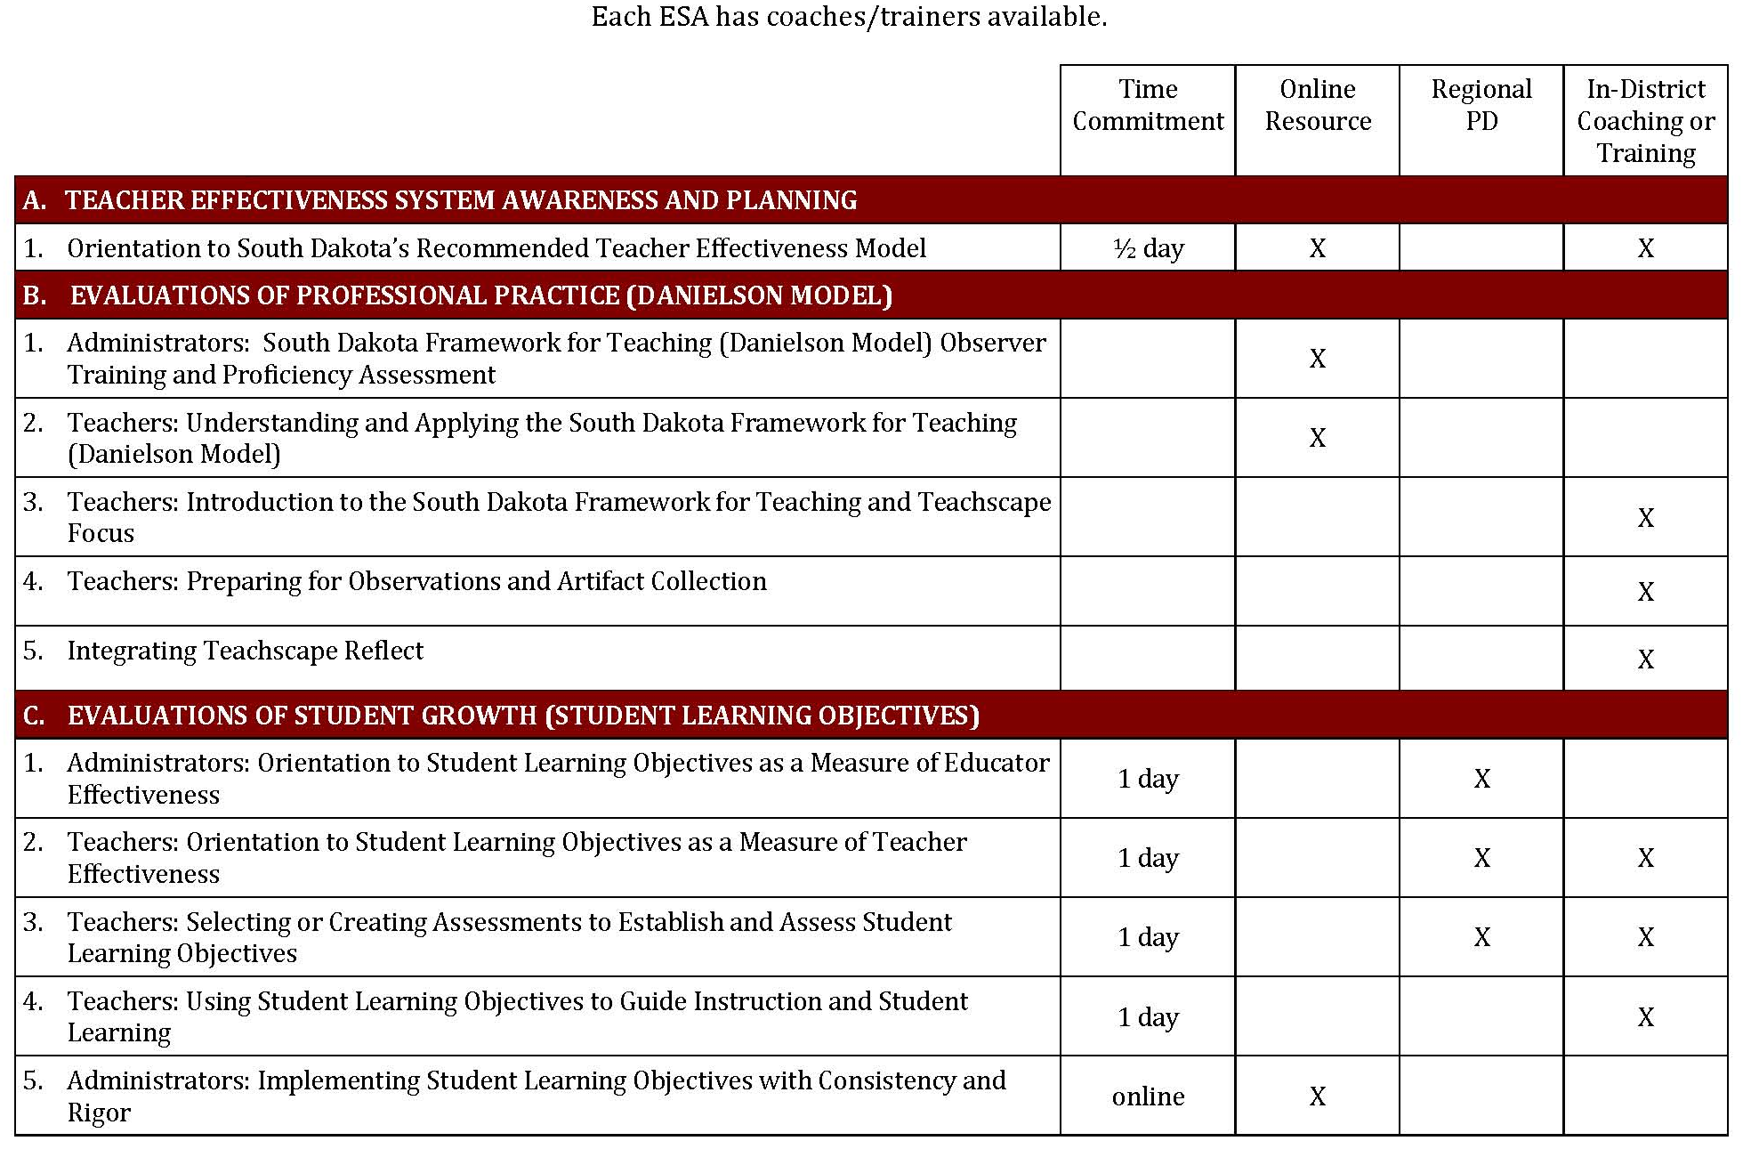
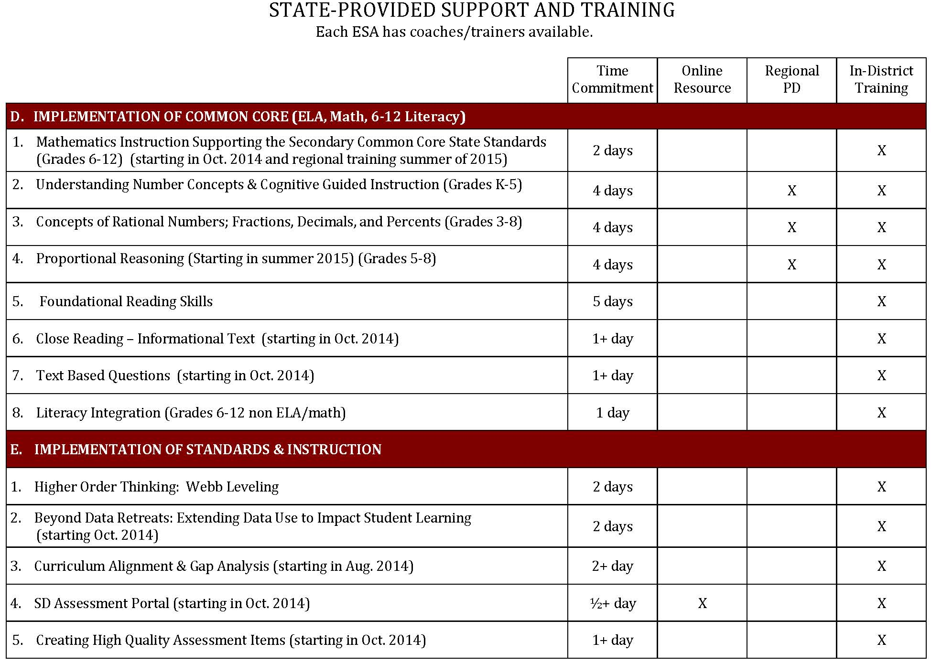

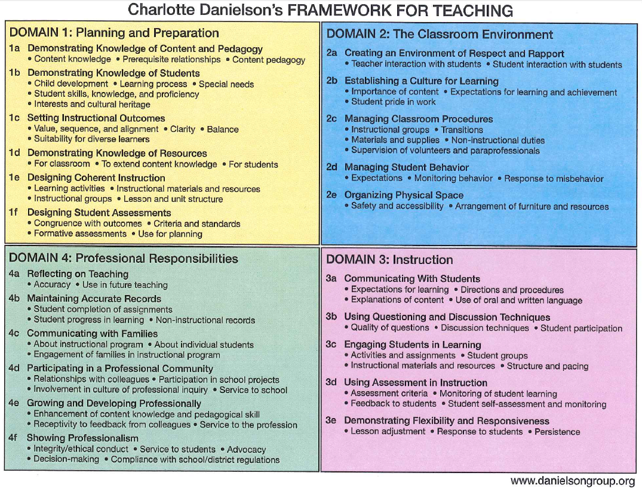
APPENDIX E: South Dakota Framework for Teaching – 2013 Charlotte Danielson’s Framework for Teaching

APPENDIX F: Framework for Teaching Component Selection Guidance
The following figures below represent alignment of Framework components to specific initiatives or outcomes. They are for discussion purposes only. School districts should consider their unique circumstances and initiatives before selecting components.

Figure 1: South Dakota Framework for Teaching - Domains and Components Overview, 2013
Domain 1  PLANNING AND PREPARATION |  | Domain 2  THE CLASSROOM ENVIRONMENT
- Demonstrating Knowledge of Content and Pedagogy  - Demonstrating Knowledge of Students  - Setting Instructional Outcomes  - Demonstrating Knowledge of Resources  - Designing Coherent Instruction  - Designing Student Assessments |  | - Creating an Environment of Respect and Rapport  - Establishing a Culture for Learning  - Managing Classroom Procedures  - Managing Student Behavior  - Organizing Physical Space
Domain 4  PROFESSIONAL RESPONSIBILITIES |  | Domain 3  INSTRUCTION
- Reflecting on Teaching  - Maintaining Accurate Records  - Communicating with Families  - Participating in a Professional Community  - Growing and Developing Professionally  - Showing Professionalism |  | - Communicating with Students  - Using Questioning and Discussion Techniques  - Engaging Students in Learning  - Using Assessment in Instruction  - Demonstrating Flexibility and Responsiveness

Figure 2: Guidance: The Balanced 8 (2013-14 Pilot School Guidance)
Domain 1  PLANNING AND PREPARATION |  | Domain 2  THE CLASSROOM ENVIRONMENT
- Demonstrating Knowledge of Content and Pedagogy  - Demonstrating Knowledge of Students  - Setting Instructional Outcomes  - Demonstrating Knowledge of Resources  - Designing Coherent Instruction  - Designing Student Assessments |  | - Creating an Environment of Respect and Rapport  - Establishing a Culture for Learning  - Managing Classroom Procedures  - Managing Student Behavior  - Organizing Physical Space
Domain 4  PROFESSIONAL RESPONSIBILITIES |  | Domain 3  INSTRUCTION
- Reflecting on Teaching  - Maintaining Accurate Records  - Communicating with Families  - Participating in a Professional Community  - Growing and Developing Professionally  - Showing Professionalism |  | - Communicating with Students  - Using Questioning and Discussion Techniques  - Engaging Students in Learning  - Using Assessment in Instruction  - Demonstrating Flexibility and Responsiveness

Figure 3: Components that Reflect the Instructional Implications of State Stsandards in Math and English Language Arts
Domain 1  PLANNING AND PREPARATION |  | Domain 2  THE CLASSROOM ENVIRONMENT
- Demonstrating Knowledge of Content and Pedagogy  - Demonstrating Knowledge of Students  - Setting Instructional Outcomes  - Demonstrating Knowledge of Resources  - Designing Coherent Instruction  - Designing Student Assessments |  | - Creating an Environment of Respect and Rapport  - Establishing a Culture for Learning  - Managing Classroom Procedures  - Managing Student Behavior  - Organizing Physical Space
Domain 4  PROFESSIONAL RESPONSIBILITIES |  | Domain 3  INSTRUCTION
- Reflecting on Teaching  - Maintaining Accurate Records  - Communicating with Families  - Participating in a Professional Community  - Growing and Developing Professionally  - Showing Professionalism |  | - Communicating with Students  - Using Questioning & Discussion Techniques  - Engaging Students in Learning  - Using Assessment in Instruction  - Demonstrating Flexibility and Responsiveness

Figure 4: South Dakota Framework for Teaching Components Linked to SLOs
Domain 1  PLANNING AND PREPARATION |  | Domain 2  THE CLASSROOM ENVIRONMENT
- Demonstrating Knowledge of Content and Pedagogy  - Demonstrating Knowledge of Students  - Setting Instructional Outcomes  - Demonstrating Knowledge of Resources  - Designing Coherent Instruction  - Designing Student Assessments |  | - Creating an Environment of Respect and Rapport  - Establishing a Culture for Learning  - Managing Classroom Procedures  - Managing Student Behavior  - Organizing Physical Space
Domain 4  PROFESSIONAL RESPONSIBILITIES |  | Domain 3  INSTRUCTION
- Reflecting on Teaching  - Maintaining Accurate Records  - Communicating with Families  - Participating in a Professional Community  - Growing and Developing Professionally  - Showing Professionalism |  | - Communicating with Students  - Using Questioning & Discussion Techniques  - Engaging Students in Learning  - Using Assessment in Instruction  - Demonstrating Flexibility and Responsiveness

APPENDIX G: Student Learning Objectives Forms
STUDENT LEARNING OBJECTIVE PROCESS GUIDE

Teacher:
School:
Evaluator:

STEP ONE: SLO DEVELOPMENT

Prioritize Learning Content:  Identify standards and content. | What is the most important learning that needs to occur during the instructional period? Specify which standard(s) the SLO addresses and Identify the specific data source or trend data used. (1a)

Identify the Student Population:  Describe the context of the class. | How many students are addressed by the SLO? Detail any characteristics or special learning circumstances of the class(es). (1b, 1c)

Interval of Instruction:  Specify the time frame in which growth with be measured. | What is the time period in which student growth is expected to occur? Identify the length of the course or provide rationale for a time period that is less than the full length of the course.
Analyze Data and Develop Baseline:  Detail student understanding of the content at the beginning of the instructional period. | Where are my students starting? Summarize student baseline performance and attach additional data if necessary. (1b, 1f)
Select or Develop an Assessment:  Describe how the goal attainment will be measured. | What specific assessment or instrument will be used to measure goal attainment? Describe the source of the assessment and the connection to identified content and standards. (1c, 1d, 1f, 3d)

Growth Goal:  Establish expectations for student growth. | What can I expect my students to achieve? Establish rigorous expectations for student performance. (1b, 1c)

Provide Rationale:  Describe how your SLO benefits student learning. | How do the content, baseline data, assessment and growth goal support student progress and growth? Describe why you chose to develop this SLO. (1a, 1f)

Learning Strategies:  Describe your plan to meet student needs. | How will you help students attain the goal? Provide any specific actions that will lead to goal attainment. (1b, 1e, 1f, 4a)
STEP TWO: SLO APPROVAL

The SLO has been reviewed jointly between the teacher and evaluator and will serve as the agreed-upon measure to determine the teacher’s student growth rating.

Teacher Signature: Date:

Evaluator Signature: Date:

STEP THREE: ONGOING COMMUNICATION

Progress Update:  Describe student progress toward the growth goal. | Are your students on track toward meeting the growth goal? Specify the assessment used to track progress. (1f, 3d, 4b)

Strategy Modification:  If necessary, document changes in strategy. | Does data suggest I need to adjust my instructional strategy? Describe how you plan to meet the goal. (1e, 4a)

SLO Adjustment:  If justified, describe changes to the SLO. | Are there circumstances beyond the teacher’s control that will impact growth goal? If needed, attach a revised SLO. (1b, 4a)

Teacher Signature: Date:

Evaluator Signature: Date:

STEP FOUR: PREPARE FOR THE SUMMATIVE CONFERENCE

This section documents the preliminary student growth rating, which will be discussed during the end-of-year Summative Conference.

SCORING

High Growth:  The growth goal was 86% to 100% attained. | What does high growth mean? Detail end-of-course achievement levels that equate to high growth. (4b)

Expected Growth:  The growth goal was 65% to 85% attained. | What does expected growth mean? Detail end-of-course achievement levels that equate to expected growth. (4b)

Low Growth:  The growth goal was less than 65% attained? | What does low growth mean? Detail end-of-course achievement levels that equate to low growth. (4b)

PRELIMINARY STUDENT GROWTH RATING

PRELIMINARY STUDENT GROWTH RATING
Based on final assessment data, the student growth rating is:
LOW | EXPECTED | HIGH

REFLECTION

Professional Growth:  Detail what you learned. | What worked? What should be refined? Describe the support you need to improve instruction and student learning. (1a, 4a)

SLO QUALITY CHECKLIST
 | Yes | No | ?
Is the SLO SPECIFIC?
- Does the SLO state exactly what learning content needs to be addressed and the specific standards to which the learning content relates?
- Is the learning content aligned to state content standards or credible national standards?
Is the SLO MEASURABLE?
- Will the SLO be measured using an assessment based on standards?
- Are expectations for student growth stated by rate, percentage, number, level of benchmark, rubric standards or juried level of standard (panel of experts)?
- Does the assessment method align to the kinds of learning in the SLO?
Is the SLO APPROPRIATE?
- Was the SLO developed using baseline data that is comparable between the beginning and end of the instructional period?
- Is the SLO directly related to a teacher’s subject, grade-level and students?
- For a Class Mastery Goal, does the goal include all students in the class or course?
- For a Differentiated Growth Goal, does the goal include a growth goal for all groups of students?
- For a Shared Performance Goal, does the goal include all students in the grade/subject level? Can each class set their growth under the same goal?
Is the SLO REALISTIC and RIGOROUS?
- Is the SLO attainable for the students in my class(es)?
- Does the SLO stretch/challenge my students?
Is the SLO TIME BOUND?
- Does the SLO contain a definitive timeline that allows for determining goal attainment?

APPENDIX H: Evaluation of Professional Growth Process Guides

PROFESSIONAL PRACTICE SELF-ASSESSMENT

Teacher:
School:
Evaluator:
Date:

The self-assessment asks teachers to identify strengths and areas of growth, providing a summary that reflects current level of performance relative to the South Dakota Framework for Teaching. Completing this self-reflection prepares teachers and evaluators to collaborate on developing professional practice goals for the year.

For each component, select the performance level that you believe best applies to your performance for each of the domain components.

DOMAIN 1: PLANNING AND PREPARATION

 | Unsatisfactory | Basic | Proficient | Distinguished
1a: Demonstrating Knowledge of Content and Pedagogy
1b: Demonstrating Knowledge of Students
1c: Setting Instructional Outcomes

1d: Demonstrating Knowledge of Resources
1e: Designing Coherent Instruction

1f: Designing Student Assessments

Identify an area of strength for Domain 1. Why do you believe this is an area of strength?

Identify an area of growth for Domain 1. How will improving benefit your instructional practice?

DOMAIN 2: THE CLASSROOM ENVIRONMENT

 | Unsatisfactory | Basic | Proficient | Distinguished
2a: Creating an Environment of Respect and Rapport
2b: Establishing a Culture for Learning
2c: Managing Classroom Procedures

2d: Managing Student Behavior

2e: Organizing Physical Space

Identify an area of strength for Domain 2. Why do you believe this is an area of strength?

Identify an area of growth for Domain 2. How will improving benefit your instructional practice?

DOMAIN 3: INSTRUCTION

 | Unsatisfactory | Basic | Proficient | Distinguished
3a: Communicating With Students

3b: Using Questioning and Discussion Techniques
3c: Engaging Students in Learning

3d: Using Assessment in Instruction

3e: Demonstrating Flexibility and Responsiveness

Identify an area of strength for Domain 3. Why do you believe this is an area of strength?

Identify an area of growth for Domain 3. How will improving benefit your instructional practice?

DOMAIN 4: PROFESSIONAL RESPONSIBILITIES

 | Unsatisfactory | Basic | Proficient | Distinguished
4a: Reflecting on Teaching

4b: Maintaining Accurate Records

4c: Communicating with Families

4d: Participating in the Professional Community
4e: Growing and Developing Professionally
4f: Showing Professionalism

Identify an area of strength for Domain 4. Why do you believe this is an area of strength?

Identify an area of growth for Domain 4. How will improving benefit your instructional practice?

PROFESSIONAL PRACTICE GOAL-SETTING FORM

Develop one professional practice goal that demonstrates how you will work to improve your instructional practice(s) during the school year.

Professional Practice Goal: | What do you do this year to improve your instructional practice? List the related Framework for Teaching components.

Identify Necessary Learning: | What personal learning has or needs to occur to accomplish your goal? Identify necessary supports or describe how your goal relates to an established professional growth plan.

Measures of Success: | How will you know you have accomplished your goal? Specify a timeline and any significant benchmarks during the year.

Teacher Signature: Date:

Evaluator Signature: Date:

Teacher:
School:
Evaluator:
Date of Formal Observation:
Date of Pre-Observation Conference:
Date of Post-Observation Conference:

Purpose: The formal observation process is structured to engage teachers and evaluators in thoughtful, in-depth dialogue focused on improving instruction and student learning. The Formal Observation Process Guide focuses conversations and encourages objective, evidence-based performance feedback. Portions of this guide may also act as an artifact that teachers may use to demonstrate performance relative to non-observable teaching standards.

Directions: Teachers and evaluators collaboratively complete and exchange the Formal Observation Process Guide during the observation process.

FORMAL PRE-OBSERVATION CONFERENCE FORM

Directions: The teacher completes the pre-observation conference form. The completed form is submitted to the evaluator in advance of the pre-observation conference. In addition, teachers may submit any relevant artifacts (lesson plans, individual professional growth plan, SLO Process Guide, etc.).

Date of Form Submission to Evaluator

To which part of your curriculum does this lesson relate? (1e)

How does this learning “fit” in the sequence of learning for this class? (1a, 1b, 1e)

What are your learning outcomes for this lesson? What do you want the students to understand? (1c, 1f)

How will you differentiate instruction for different individuals or groups of students in the class? (1c, 1d)

How and when will you know whether the students have learned what you intend? (1f)

Is there anything that you would like me to specifically observe during the lesson? (4a)

Does this lesson relate to your established Student Learning Objective (SLO)? If so, restate your student growth goal and describe the connection.

Does this lesson relate to your established professional practice goal(s)? If so, restate the goal and describe the connection.

EVALUATOR OBSERVATION EVIDENCE AND FEEDBACK FORM

Directions: The evaluator completes this portion of the Observation Process Guide to provide teachers with notes and evidence collected during a classroom observation. This form is completed and returned to the teacher as soon as possible following the formal observation.

Date of Form Submission to Teacher

CLASSROOM OBSERVATION NOTES AND EVIDENCE

TIME | EVIDENCE
EVALUATOR OBSERVATION SUMMARY

DOMAIN 2: THE CLASSROOM ENVIRONMENT
COMPONENT: 2a. Creating an Environment of Respect and Rapport………….

- Teacher interaction with students
- Student interaction with students
EVALUATOR SUMMARY

COMPONENT:
- Importance of content
- Expectations for learning and achievement
- Student pride in work
EVALUATOR SUMMARY

COMPONENT:
- Importance of content
- Expectations for learning and achievement
- Student pride in work
EVALUATOR SUMMARY

COMPONENT:
- Expectations
- Monitoring of student behavior
- Response to student misbehavior
EVALUATOR SUMMARY

COMPONENT: 2e. Organizing Physical Space………
- Safety and accessibility
- Arrangement of furniture and resources

EVALUATOR SUMMARY

= DOMAIN 3: INSTRUCTION DOMAIN 3: INSTRUCTION
COMPONENT:
- Expectations for learning
- Directions and procedures
- Explanations of content
- Use of oral and written language
EVALUATOR SUMMARY

COMPONENT:
- Quality of questions
- Discussion techniques
- Student participation
EVALUATOR SUMMARY

COMPONENT:
- Activities and assignments
- Grouping of students
- Instructional materials and resources
- Structure and pacing
EVALUATOR SUMMARY

COMPONENT:

- Assessment criteria
- Monitoring of student learning
- Feedback to students
- Student self-assessment and monitoring
EVALUATOR SUMMARY

COMPONENT: 3e. Demonstrating Flexibility and Responsiveness…

- Lesson adjustment
- Response to students
- Persistence
EVALUATOR SUMMARY

FORMAL POST-OBSERVATION CONFERENCE FORM

Directions: The teacher completes this post-observation conference form after the evaluator has provided observation feedback to the teacher. The completed form is submitted to the evaluator in advance of the post-observation conference. In addition, teachers may submit any relevant post-observation artifacts.

Date of Form Submission to Evaluator

In general, how successful was the lesson? Did the students learn what you intended for them to learn? How do you know? (3d, 4a)

If you were able to bring samples of student work, what do those samples reveal about those students’ levels of engagement and understanding? (3c, 3d, 4a)

Comment on your classroom procedures, student conduct, and your use of physical space. To what extent did these contribute to student learning? (2c, 2d, 2e, 4a)

Did you depart from your plan? If so, how, and why? (3e, 4a)

Comment on different aspects of your instructional delivery (e.g. activities, grouping of students, materials, and resources). To what extent were they effective? (1c, 1d, 2a, 2b, 3c, 3e, 4a)

If you had a chance to teach this lesson again to the same group of students, what would you do differently? (4a)

After considering the feedback from your evaluator, detail any specific areas related to the observation that you would like to discuss at the post-observation conference.

If appropriate, provide and update on your students’ progress toward the student growth goal documented in your Student Learning Objective.

If appropriate, provide an update on your progress toward the attainment of your individual professional growth plan.

FORMAL POST-OBSERVATION EVALUATOR FEEDBACK AND NARRATIVE
Directions: The evaluator completes this form following the post-observation conference. This form serves as the official documentation of the observation and provides clear performance feedback related to the observable components of the Framework for Teaching. In addition, this document may also summarize progress on the teacher’s Student Learning Objective and Individual Professional Growth Plan.

Date of Form Submission to Teacher

FORMAL OBSERVATION SUMMARY

DOMAIN 2: THE CLASSROOM ENVIRONMENT
EVALUATOR SUMMARY:

DOMAIN 3: INSTRUCTION
EVALUATOR SUMMARY:

OBSERVATION SUMMARY COMMENTS
EVALUATOR NARRATIVE

STUDENT LEARNING OBJECTIVE GOAL ATTAINMENT PROGRESS (OPTIONAL)
EVALUATOR NARRATIVE

INDIVIDUAL PROFESSIONAL GROWTH PLAN PROGRESS (OPTIONAL)
EVALUATOR NARRATIVE

SIGNATURES
The signature of the employee shall not imply that the employee agrees with evaluation, but merely indicates that the observation as been discussed.

We have discussed the evaluation.

Evaluator: ________________________________________________ Date: _____________________

Employee: ________________________________________________ Date: _____________________

Teacher:
School:
Evaluator:
Date of Form Submission to Teacher:

Purpose: The professional practice rating form summarizes performance relative to the Framework for Teaching and serves to document a teacher’s final professional practice rating for the evaluation cycle.

Directions: Evaluators complete this form after all evidence of professional practice performance is gathered and assessed. The completed form is provided to the teacher in advance of the summative conference.

PROFESSIONAL PRACTICE RATING SUMMARY

Directions: Evaluators complete this portion of the form to summarize the professional practice rating and provide a summative narrative of performance relative to the Framework for Teaching.

PROFESSIONAL PRACTICE RATING CALCULATION
 | DOMAIN 1 | DOMAIN 2 | DOMAIN 3 | DOMAIN 4
Points Earned
Total Points Earned
Number of Components Evaluated
Average Component Level Score

PROFESSIONAL PRACTICE SCORING RANGES
UNSATISFACTORY | BASIC | PROFICIENT | DISTINGUISHED
1.00 – 1.49 | 1.50 to 2.49 | 2.50 to 3.49 | 3.50 – 4.00

PROFESSIONAL PRACTICE RATING

EVALUATOR NARRATIVE

‘
COMPONENT-LEVEL PERFORMANCE SUMMARY

Directions: Evaluators complete this form to provide detailed information about performance relative to both observable and non-observable components.

OBSERVABLE COMPONENTS
The level of performance associated with an observable component is a composite of all evidence gathered through classroom observation during the evaluation cycle. The level of performance may reflect a summative score for multiple formal and informal observations.

DOMAIN 2: THE CLASSROOM ENVIRONMENT
EVALUATOR SUMMARY:

DOMAIN 3: INSTRUCTION
EVALUATOR SUMMARY:

NON-OBSERVABLE COMPONENTS
The level of performance associated with a non-observable component is a composite of all artifacts and evidence supplied by the teacher to the evaluator.

DOMAIN 1: PLANNING AND PREPARATION
EVALUATOR SUMMARY:

DOMAIN 4: PROFESSIONAL RESPONSIBILITIES
EVALUATOR SUMMARY:

Teacher:
School:
Evaluator:
Date for Form Submission to Teacher:

Purpose: This summative evaluation form combines multiple measures of teacher performance to determine and document a teacher’s overall performance rating for the evaluation cycle. The summative rating is used to guide professional growth and improvement recommendations. The summative document is based upon information previously documented through the Professional Practice Rating Form and the Student Learning Objectives Process Guide.

SUMMATIVE TEACHER PERFORMANCE AND NARRATIVE

Directions: Using the scoring matrix below, classify overall teacher performance by combining the professional practice rating and student growth rating into an overall performance rating of Exceeds Expectations, Meets Expectations or Below Expectations.

 |  | PROFESSIONAL PRACTICE
 |  | UNSATISFACTORY | BASIC | PROFICIENT | DISTINGUISHED
STUDENT GROWTH | HIGH
STUDENT GROWTH | EXPECTED
STUDENT GROWTH | LOW
 |  |  | EXCEEDS EXPECTATIONS
 |  |  | MEETS EXPECTATIONS
 |  |  | BELOW EXPECTATIONS

EVALUATOR NARRATIVE

RECOMMENDATIONS AND ACKNOWLEDGEMENT

EVALUATOR RECOMMENDATION
Based on the evidence gathered throughout the evaluation cycle, the teacher’s performance will result in the development of a:

PROFESSIONAL GROWTH PLAN | PLAN OF ASSISTANCE

SIGNATURES
The signature of the employee shall not imply that the employee agrees with evaluation, but merely indicates that the evaluation has been discussed.

We have discussed the evaluation.

Evaluator: ________________________________________________ Date: _____________________

Employee: ________________________________________________ Date: _____________________

PROFESSIONAL JUDGEMENT (ONLY IF APPLICABLE)

 |  | PROFESSIONAL PRACTICE RATING
 |  | UNSATISFACTORY | BASIC | PROFICIENT | DISTINGUISHED
STUDENT GROWTH RATING | HIGH
STUDENT GROWTH RATING | EXPECTED
STUDENT GROWTH RATING | LOW
 |  | SUMMATIVE EFFECTIVENESS RATING CATEGORIES
 |  |  | EXCEEDS EXPECTATIONS
 |  |  | MEETS EXPECTATIONS
 |  |  | BELOW EXPECTATIONS
 |  |  | PROFESSIONAL JUDGMENT MAY BE EXERCISED

PROFESSIONAL JUDGEMENT - EVALUATOR NARRATIVE REQUIRED
If applicable, provide a narrative explaining justification for adjustments made to the teacher’s final summative effectiveness rating.

Teacher:
School:
Evaluator:
Date:

Purpose: To promote reflective teaching and professional growth, teachers are encouraged to develop an individual professional growth plan. Goals may be based upon a professional practice self-assessment, feedback received through the evaluation process, or other school or district initiatives.

Directions: Teachers may complete this form to document areas of individual professional growth and improvement. The form may be completed during the first quarter of the annual evaluation cycle and will serve to initiate professional dialogue during evaluation conferences. The document may also serve as an artifact to demonstrate performance relative to non-observable teaching standards (4a).

Select Area(s) for Professional Growth: | What goal(s) have you identified for this year? List any related Framework for Teaching components and describe the connection between this goal and your teaching assignment.

Growth Strategies Action Steps and Timelines: | How do you plan accomplish the goals you have outlined? List specific tasks and targeted completion dates.

Identify Necessary Supports: | What support do you need to implement your plan? List necessary professional development, support or resources.

EVALUATOR NARRATIVE

Teacher Signature: _____________________________________ Date: ____________

Evaluator Signature: ____________________________________ Date: ____________

APPENDIX I: Acknowledgements

THE 2014-2015 SOUTH DAKOTA COMMISSION ON TEACHING AND LEARNING
The following information is provided to establish historical context.

2014-15 COMMISSION MEMBERS |  |  |  | COMMISSION ADVISORS
SOUTH DAKOTA TEACHERS |  |  |  | Carla Leingang
Sandy Arseneault | Custer | High School |  | Abby Javurek-Humig
Jared Baumann | Sioux Falls Public | Middle School |  | Dr. Melody Schopp
Robin Curtis | Winner | Elementary |  | SD DOE
Donna DeKraai | Brookings | Elementary |  | Laura Haug
Lou Ann Jensen | Estelline | High School English |  | Rich Mittelstedt
Kathy Meyer | Huron | Kindergarten |  | SDEA
Pat Moller | Mitchell | Middle School Math |  | Dr. Janeen Outka
Pam Oberembt | Sioux Falls | SFEA President |  | Joan Frevik
Steve O’Brien | Watertown | High School English |  | Brian Aust
Sami Peil | Deubrook | High School English |  | EDEC
Sue Podoll | Rapid City Area | Special Education
SOUTH DAKOTA SCHOOL ADMINISTRATORS
Kyley Cumbow | Pierre | Principal
Ethan Dschaak | Meade | Principal
Jeremy Hurd | Custer | Principal
Roxanne Lamphere | Lake Preston | Principal
Tammy Meyer | Sisseton | Principal
SOUTH DAKOTA SCHOOL BOARD MEMBERS
Pam Haukaas | Colome Consolidated | School Board
SOUTH DAKOTA K-12 EDUCATION STAKEHOLDERS
Mary McCorkle | South Dakota Education Association | President
Linda Mallory | East Dakota Educational Coop. | Instructional Coach
Sharla Steever | Black Hills Special Services (TIE) | Learning Specialist
SOUTH DAKOTA HIGHER EDUCATION STAKEHOLDERS
Alan Neville | Council of Higher Education | Higher Ed
Scott DesLauriers | South Dakota State University | Student Member
Taylor Reinke | Augustana | Student Member
Cheryl Medearis | Sinte Gleska University | Faculty
Pat Simpson | Black Hills State University | Faculty
Jill Thorngren | South Dakota State University | Faculty

THE 2013-14 SOUTH DAKOTA COMMISSION ON TEACHING AND LEARNING

The following information is provided to establish historical context.

The South Dakota Commission on Teaching and Learning began a partnership between the South Dakota Education Association, Associated School Boards of South Dakota, the School Administrators of South Dakota and the South Dakota Department of Education. To arrive at a Teacher Effectiveness model to guide the 2013-13 pilot schools, The Commission on Teaching and Learning relied on input from teachers, school administrators, school board members, education stakeholders and officials from the South Dakota Department of Education.

COMMISSION MEMBERS
TEACHERS | Sue Podoll  Rapid City | ADMINISTRATORS | EDUCATION  STAKEHOLDERS
Donna DeKraai  Brookings | Pam Oberembt  Sioux Falls | Melinda Jensen  Principal, Brookings | Wade Pogany  ASBSD
Sami Peil  Deubrook | Jared Baumann  Sioux Falls | Jeremy Hurd  Principal, Custer | Alan Neville  Northern State University
Lou Ann Jensen  Estelline | Tammy Meyer  Sisseton | Kyley Cumbow  Principal, Pierre | Sandy Arseneault  SDEA
Kathy Meyer  Huron | Linda Mallory  Spearfish | Don Kirkegaard  Superintendent, Meade | Sharla Steever  TIE
Pat Moller  Mitchell | Amy Engel  Todd County | SCHOOL BOARD  MEMBERS | DEPARTMENT OF EDUCATION
Mary McCorkle  Mobridge | Steve O’Brien  Watertown | Pam Haukaas  Colome | Abby Javurek-Humig  SD DOE
Katie Anderson  Rapid City | Darlene Dulitz  Webster |  | Carla Leingang  SD DOE
Nicole Keegan  Rapid City | Robin Curtis  Winner |  | Lanette Johnston  SD DOE
Lead Teacher Effectiveness Facilitator: Brian Aust, East Dakota Educational Cooperative

2013-14 TEACHER EFFECTIVENESS PILOT AND SCALE-UP SCHOOLS

The following information is provided to establish historical context.

SCHOOL DISTRICT | PILOT SCHOOL | SCALE-UP SCHOOLS
Alcester-Hudson | Junior High | Elementary School and High School
Bon Homme | Tyndall Elementary | Tabor, Springfield and Colony elementary schools; Middle School and High School
Brandon Valley | Fred Assam Elementary | Brandon, Robert Bennis and Valley Springs elementary schools; Middle School and High School
Bridgewater-Emery | High School
Brookings | Medary Elementary | Hillcrest Elementary
Castlewood |  | Elementary School and High School
Clark | Middle School | Hillcrest, Silverlake and Fordham colony schools; Clark Elementary and High School
Dell Rapids | High School | Elementary School and Middle School
Elk Point-Jefferson |  | Middle School and High School
Florence |  | Elementary, Junior High and High School
Groton | Middle School | Elementary School and High School
Harrisburg | High School
Ipswich |  | Middle School
Irene-Wakonda | Junior High | Elementary School and High School
Lake Preston |  | Elementary, Middle School and High School
Lead-Deadwood | Elementary School
McLaughlin | Elementary, Middle School and High Schools
Mobridge-Pollock | Middle School | Fred Davis and Upper Elementary schools; High School
Rapid City | Southwest Middle School | Horace Mann and Grandview Elementary Schools; Stevens and Central High Schools
Redfield | High School | Elementary School and Middle School
South Central | High School | Elementary School and Middle School
Wagner | Elementary School | Early Learning Center, Middle School and High School
Wessington Springs | High School | Spring Valley Colony; Wessington Springs Elementary and Middle School

2012 Teacher Evaluation Work Group

The following information is provided to establish historical context.

The South Dakota Teacher Effectiveness Handbook builds on previous work of the Teacher Evaluation Workgroup, which was established in 2012. In recognition of their work to advance the structure of the state’s model evaluation and professional support system, the members of the Teacher Evaluation Workgroup are listed below.

TEACHERS
- Sharla Steever, Hill City
- Kristin Skogstad, Sioux Falls
- Pat Moller, Mitchell
- Nicole Keegan, Rapid City
- Paul Kuhlman, Avon
- Candy Ballard, Lead-Deadwood

PRINCIPALS
- Kym Johnston, Lennox
- Kyley Cumbow, Pierre
- Kevin Lein, Harrisburg

SUPERINTENDENTS
- Don Kirkegaard , Meade
- Shayne McIntosh, Parkston

SCHOOL BOARD MEMBERS
- Pam Haukaas, Colome
- Rebecca Reimer, Chamberlain

PARENTS
- Amy Blum, Chamberlain
- Stacy Bauer-Jones, Brandon Valley
- Shauna Hoglund, Dell Rapids

EDUCATION ASSOCIATIONS
- Steve O’Brien, SDEA
- Wade Pogany, ASBSD
- Rob Monson, SASD

Special thanks should be given to Dr. Rick Melmer, Dean of Education at the University of
South Dakota and Dr. Fred Aderhold, Lecturer in the Division of Educational Administration at the University of South Dakota for leading this workgroup. Their support and guidance during this process has been instrumental to the success of the Teacher Evaluation Workgroup.

2011 Teacher Standards Pilot Districts

The following information is provided to establish historical context.

Aberdeen, Brookings, Custer, Deuel(middle school only), Harrisburg, Kimball, McCook Central, Stanley County, Todd County, Wagner, White River.

2010 Teacher Standards Workgroup

TEACHERS
- Lisa Handcock, Agar/Blunt/Onida
- Tom Mead, Spearfish
- Kira Christensen, Sioux Falls
- Darlene Dulitz, Webster
- Alayna Siemonsma, Rapid City
- Amelia Rose, Rapid City
- Sue Podoll, Rapid City
- Lynn Lagner, Watertown
PRINCIPALS
- Kevin Lein, Harrisburg
- Susan Patrick, Watertown
- Anne Williams, Sioux Falls
- Mike Taplett, Huron
SUPERINTENDENTS
- Margo Heinert, Todd County
- Dave Pappone, Brandon
SCHOOL BOARD MEMBERS
- Duane Alm, Aberdeen
- Bev Banks, Belle Fourche
PARENTS
- Jill Kruger, Pierre
- Jill Dean, Pierre
- Stacy Kolbeck, Pierre
- Melissa Whipple, Todd County
- Mary Stadick Smith, Pierre
EDUCATIONAL ORGANIZATIONS
- Wayne Lueders, Associated School Boards of South Dakota
- Sandy Arsenault, South Dakota Education Association
- John Pedersen, School Administrators of South Dakota

APPENDIX J: Timeline
SUPPORTING STUDENTS WITH EFFECTIVE TEACHERS
The following information is provided to establish historical context.

South Dakota continues to advance a multi-year, collaborative effort to develop, support and implement high quality Educator Effectiveness systems. The most significant benchmarks in the ongoing process are outlined briefly below.

2010: Evaluations and Teaching Standards Required
The South Dakota Legislature passed Senate Bill 24, now codified as SDCL 13-42-34, requiring school districts to adopt professional teaching standards and conduct regular teacher evaluations. The same legislation required the South Dakota Board of Education to establish rules requiring districts to evaluate teaching performance based on multiple measures, to increase professional growth for all teachers, and to include a plan of assistance, if needed, for non-probationary teachers.

2010-2011: State Teaching Standards Adopted
A workgroup comprised of education stakeholders recommended state adoption of the Charlotte Danielson Framework for Teaching as South Dakota’s performance standards for the teaching profession. In 2011 the South Dakota Board of Education officially adopted the Framework and established administrative rule requiring school districts to implement standards-based professional practice evaluations beginning in the 2014-15 school year.

2011-2012: Teaching Standards Pilot
The state’s teaching standards were piloted in 11 school districts during the 2011-12 school year. Teaching Standards Pilot participants were provided state-sponsored support and resources to deepen educator understanding of the state’s new teaching standards.

2012: South Dakota Applies for ESEA Flexibility
As a part of the state’s application for flexibility from certain provisions of the federal Elementary and Secondary Education Act (ESEA), commonly referred to as No Child Left Behind, South Dakota agreed to incorporate quantitative measures of student growth as one factor in determining and differentiating teaching performance.

2013: South Dakota Commission on Teaching and Learning Established
The South Dakota Commission on Teaching and Learning was formed to finalize a model of effective teaching that satisfies state and federal requirements and promotes research-based recommended practices. The Commission was an ongoing partnership between the South Dakota Education Association (SDEA), the South Dakota Department of Education (SD DOE), and East Dakota Educational Cooperative (EDEC). During the course of the Commission’s work, the membership included teachers, school administrators, school board members, university professors, and state education officials.

2013-14: Teacher Effectiveness Pilot (Year One)
A total of 72 schools representing school districts of various sizes, school administration structures, and geographic locations participated in the 2013-14 Teacher Effectiveness Pilot Project. Twenty schools were chosen to participate at the “pilot” level and were asked to implement the state’s recommended Teacher Effectiveness Model. Another 52 schools were invited to participate at the “scale-up” level. SD DOE, though a partnership with EDEC, offered pilot participants state-sponsored training and on-site support.

The 20 schools participating at the “pilot” level were asked to participate in a formal research effort to assess the model, identify recommended practices, and provide feedback to guide future implementation decisions.

December 2013: Statewide Implementation Planning and Capacity Building Announced
In response to requests from South Dakota school districts, the South Dakota Department of Education announced an “implement or plan” option for the 2014-15 school year. Districts choosing the “implement” option were required to evaluate all teachers in accordance with minimum state requirements beginning in the 2014-15 school year. Districts choosing the “plan” option were required to participate in a state-sponsored, in-district implementation planning session and submit a plan to build capacity for implementation in the 2015-16 school year.

At the same time the implementation timeline was announced, the South Dakota Department of Education initiated a state-sponsored, two-year, capacity-building and training effort. During the 2014-15 and 2015-16 school years, all school districts had access to professional development and coaching, including a number of options that focus on supporting the implementation of high-quality Educator Effectiveness systems.

March 2014: SDEA Receives Grant to Support Student Learning Objectives Implementation
The South Dakota Education Association announced that South Dakota was part of a nine-state consortium that received a grant from the National Education Association’s Great Public Schools initiative. A primary focus of the grant was to create a network of teacher leaders with the capacity to support and shape the implementation of Student Learning Objectives as one measure of teaching performance.

April – October 2014: State-Sponsored Student Learning Objectives Training
Beginning in April of 2014, the South Dakota Department of Education sponsored a series of six free regional trainings to help school administrators better understand the role Student Learning Objectives (SLOs) play in determining and differentiating educator performance.

The administrator training was a precursor to an expansive teacher training initiative aimed at preparing teachers to understand and develop SLOs. More than 5,800 teachers registered for the two-day training. State-trained facilitators, including a large cadre of classroom teachers, delivered grade-level and content-specific trainings. Attendees were provided an orientation to SLOs and training on how to select or create assessments appropriate for the SLO process. Nearly 4,500 teachers completed an SLO.

2015-16 School Year
The South Dakota Teacher Effectiveness System was fully implemented in all public schools.

Support and resources will be available in 2015 and beyond.

SOUTH DAKOTA TEACHER EFFECTIVENESS IMPLEMENTATION TIMELINE
The following information is provided to establish historical context.

Updated: Oct. 30, 2014
This document is an updated version of the timelines for Teacher Effectiveness systems in South Dakota.
The chart below summarizes milestones during the implementation of high quality Educator Effectiveness systems.

TEACHER EFFECTIVENESS SYSTEM TIMELINE
SY 2014-15  Teacher Effectiveness Learning Year | SY 2015-16  Teacher Effectiveness Implementation | SY 2016-17 | SY 2017-18
AUGUST-MAY  Plan or Implement Teacher Effectiveness System | AUGUST-MAY  Implement Teacher Effectiveness System | AUGUST-MAY  Continue Implementing Teacher Effectiveness System | AUGUST-MAY  Continue Implementing Teacher Effectiveness System
 |  | OCTOBER  Report school- and district-level aggregate Teacher Effectiveness data from SY 2015-16 via PRF | OCTOBER  Report school- and district-level aggregate Teacher Effectiveness data from SY 2016-17 via PRF
DECEMBER
Cross-walk due Jan. 31 for districts not using state Teacher Effectiveness System for SY 2015-16 & beyond
 |  | APRIL  Use 2015-16 Teacher Effectiveness data and data available for current year to inform personnel decisions re: teachers for SY 2017-18* | APRIL  Use 2016-17 Teacher Effectiveness data and data available for current year to inform personnel decisions re: teachers for SY 2018-19*
District Self-Reflection for Teacher Effectiveness due June 30
OPTIONAL: Take advantage of PD offered through DOE’s Menu of Options | OPTIONAL: Take advantage of PD offered through DOE’s Menu of Options
*Evidence and data from effectiveness systems intended to inform personnel decisions. Evidence from these systems may be used in determining if/when a teacher might be put on a plan of assistance.
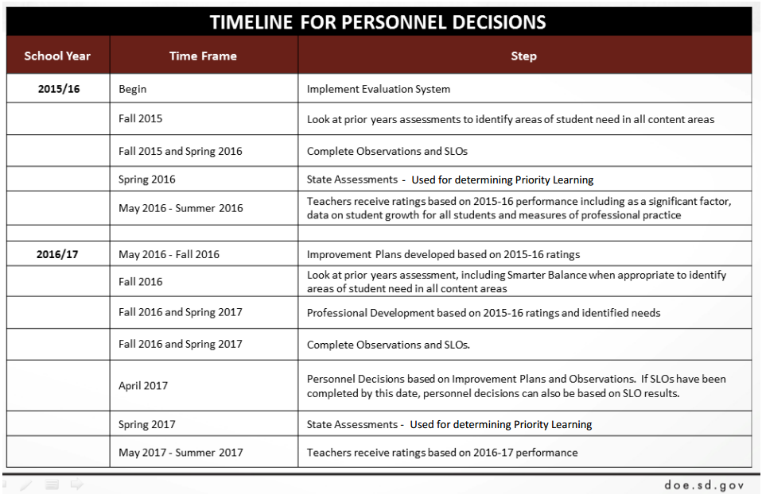
The following information is provided to establish historical context.

