Instructions to Access Training Module
Child & Adult Advocacy Studies Training

- Navigate to the following link: https://sdcpcm.com/courses/caast/
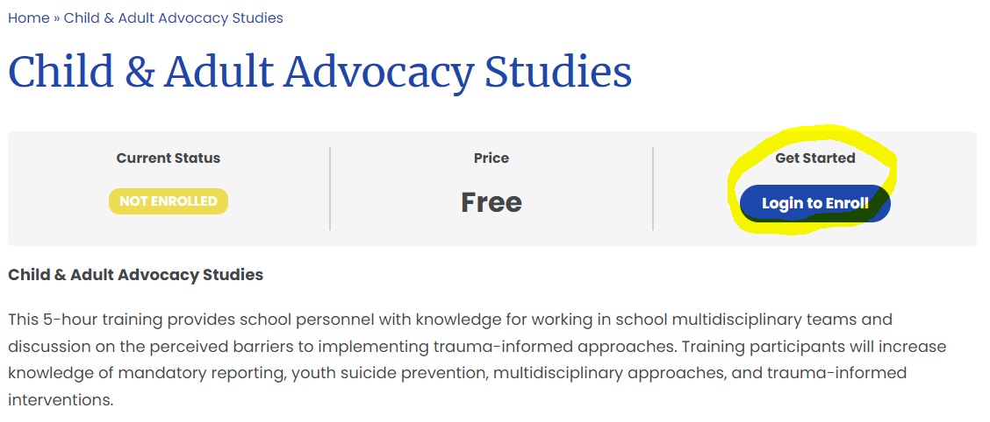
- On the subsequent page, navigate to the “Get Started” box on the right-hand side of the screen and click on “Login to Enroll”.
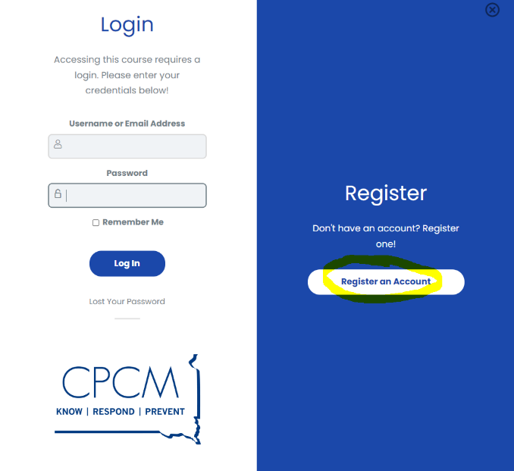
- A pop-up will appear which will allow you to register if you are a new user to online courses on SDCPCM.com or log-in if you have existing log-in information. If you are a new user, navigate to the “Register an Account” button on the right-hand side of the screen. If you try to register an account (email address) that already exists, you can follow the steps for “Lost Your Password” under the login button.
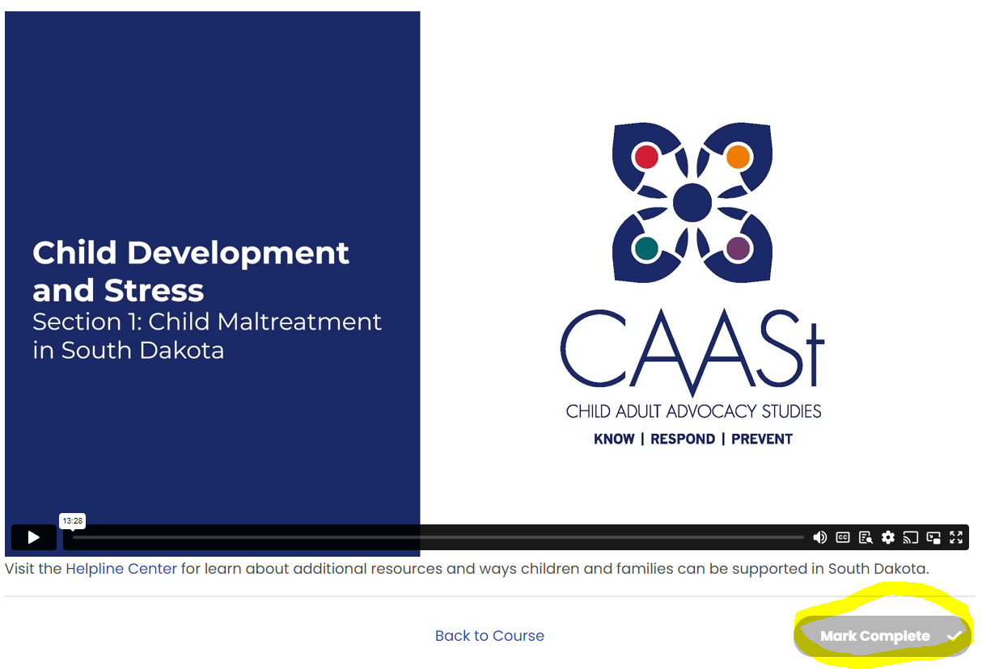
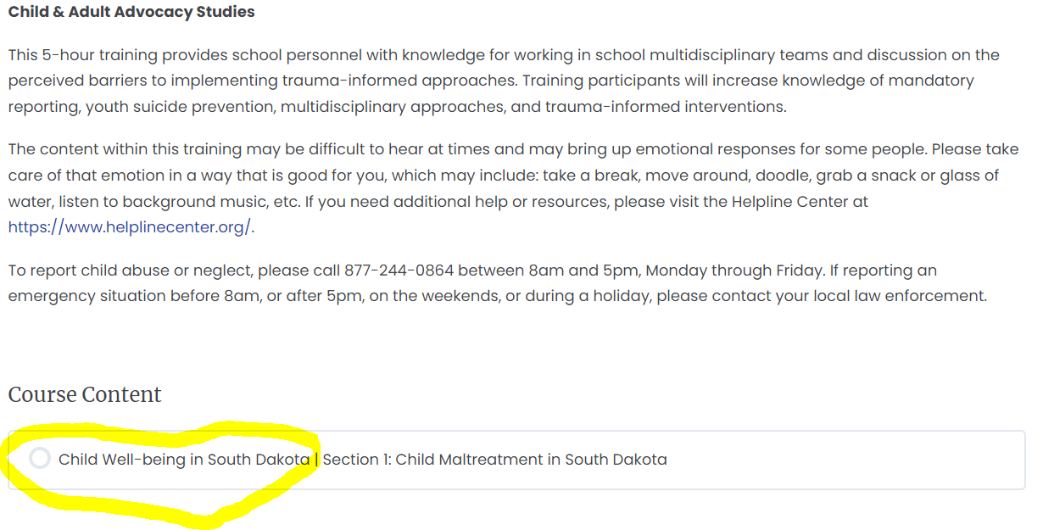
- Once you are logged-in, select the first lesson in the course, “Child Well-being in South Dakota: Child Maltreatment in South Dakota.” After watching the entire lesson, the “Mark Complete” button on the lower right-hand corner will turn green, click the button to proceed to the next section.
- The course will maintain your progress, so you are able to exit (after clicking the “mark complete” button on your most recently watched video) and access the course on another date/time with the same login information to begin where you left off.

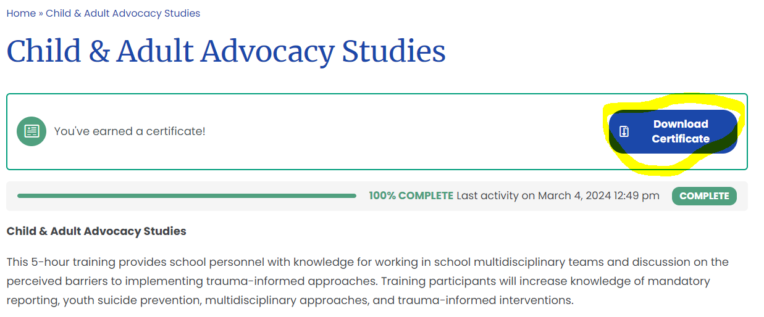
- In total, you will watch 15 videos. Upon completing the final section, you will receive a certificate of completion for the training. You can download and save that certificate for reporting purposes.
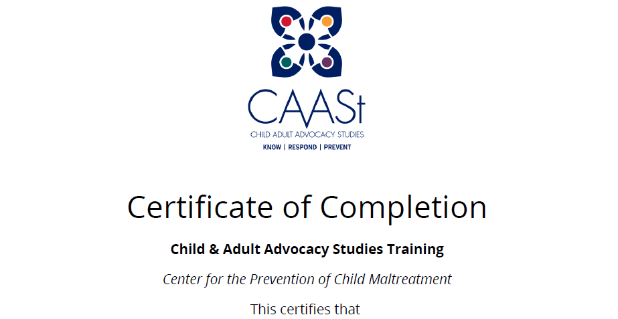
- A certificate like the one below with your name will appear on the screen. Download or save to your files.

