CTE Student Summary Report- Column by Column Explanation
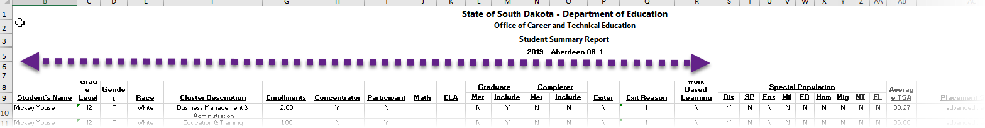
Header | Description
Student Name | Student name.
Grade Level | The grade the student was in, in the reporting year. For example, if ‘2019’ was selected as the report year, this would be the grade the student was in during the 2018-2019 school year.
Gender | The student’s gender.
Race | The student’s race or ethnicity.
Enrollments | The number of different cluster, pathway, and/or CTE dual credit courses the student has taken and earned credit in. Essentially how many different course codes at those levels has the student earned credit in.
Concentrator | Y= Yes, the student is a concentrator. (has 2+ Cluster, Pathway, and/or CTE dual credit course enrollments in that cluster)  N= No, the student is not a concentrator for that Career Cluster.
Participant | Y= Yes, the student is a Participant. (took a Cluster, Pathway, and/or CTE dual credit course during the reporting year)  N= No, the student did not participate in approved CTE during the reporting year.  *Note, a student can be a concentrator but not a participant. Example- the student became a concentrator their 11th grade year but did not take a Business course her 12th grade year.
Math | IF, the student took the SD Math Assessment in the reporting year, his/her score will be listed.  Blanks under Math mean the student did not take the SD Math Assessment during the reporting year.
ELA | IF, the student took the SD ELA Assessment in the reporting year, his/her score will be listed.  Blanks under ELA mean the student did not take the SD ELA Assessment during the reporting year.
Graduate Met | This student met the on-time graduation requirement during the reporting year and therefore is marked as a graduate.
Graduate Include | This student is in the on-time graduation cohort of students.
Completion Met | Disregard. At this time, this data will not be used for calculation CTE Performance Indicators.
Completion Include | Disregard. At this time, this data will not be used for calculating CTE Performance Indicators.
Exiter | Students that exited or left secondary education in the reporting year. For example- many students exit secondary education because they graduate. Others may drop out, age-out of receiving education services or earn their GED.  Y= The student exited secondary education during the reporting year.  N= The student did not exit secondary education during the reporting year.
Exit Reason | This reflects the exit code or reason for leaving secondary education that the district entered within Infinite Campus.
Work Based Learning | Y= The student has taken and earned credit in any one of the Capstone/WBL Learning courses during the (student’s high school career, or during the reporting year?) including- Entrepreneurship Experience 80026, Senior Experience 80019, Youth Apprenticeship 80020, Youth Internships 80018.
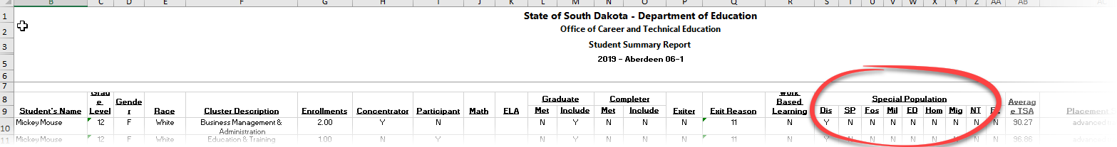

Special Population Data
Y= Student is within the Special Population group.
N= Student is not within the Special Population group.
Abbreviation | Full Title | Description
DS | Students with Disabilities | Students with disabilities.
SP | Single parents including single pregnant women. | Students who are parents, including students who are pregnant.  Note- students whose parents are single parents should NOT be flagged as single parent students. This subgroup is only for if the student him/herself is parenting or is pregnant.
FS | Foster Care | Youth who are in or have aged out of the foster care system.
M | Military Connected Students | Students with a parent in US Armed Services who is on active duty.
ED | Economically Disadvantaged | Students that qualify for free and reduced lunch or who attend a CEP/Provisional school or district.
Hom | Homeless Students | Students who lack a fixed, regular, and adequate nighttime residence.
Mig | Migrant Students | Students of migrant workers whom move frequently.  See complete and legal definition here.
NT | Nontraditional Students | Students enrolled in a Career Cluster program of study in which either gender comprises less than 25% of the workforce. For example, in manufacturing, less than 25% of the workforce is female. Therefore, females in Manufacturing Career Cluster programs of study are identified as ‘Nontraditional Students’.
EL | English Learners | Students with a home language background other than English, whose English language skills are not yet well enough developed for them to be able to participate successfully in the classrooms where all academic instruction is provided in English.
Placement Indicator Data
 | Average TSA | The average of the student’s final grades for Cluster, Pathway, and/or CTE dual credit courses within that cluster. This information is no longer used for Perkins accountability.
 | Placement Status | The placement data as entered by the district into the Perkins Data Collection system.

