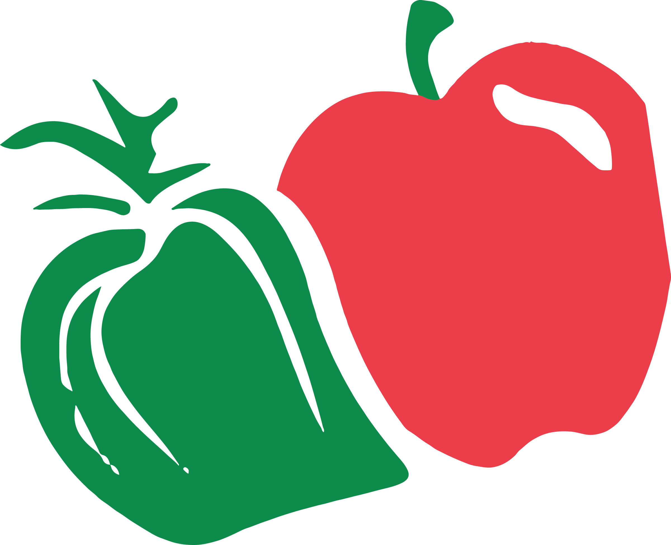

**I Crunched!**

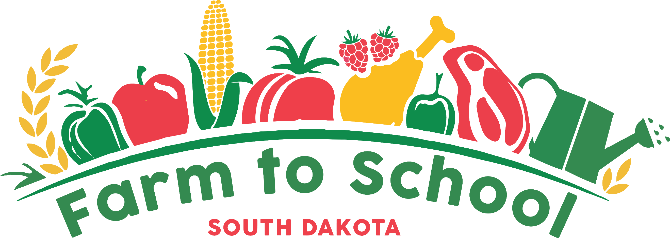

**SD Crunch Off**

