Project AWARE - SEA

Implementation Guide

June 2021

South Dakota Department of Education
and South Dakota Department of Social Services –
Division of Behavioral Health
This Photo by Unknown Author is licensed under CC BY-NC

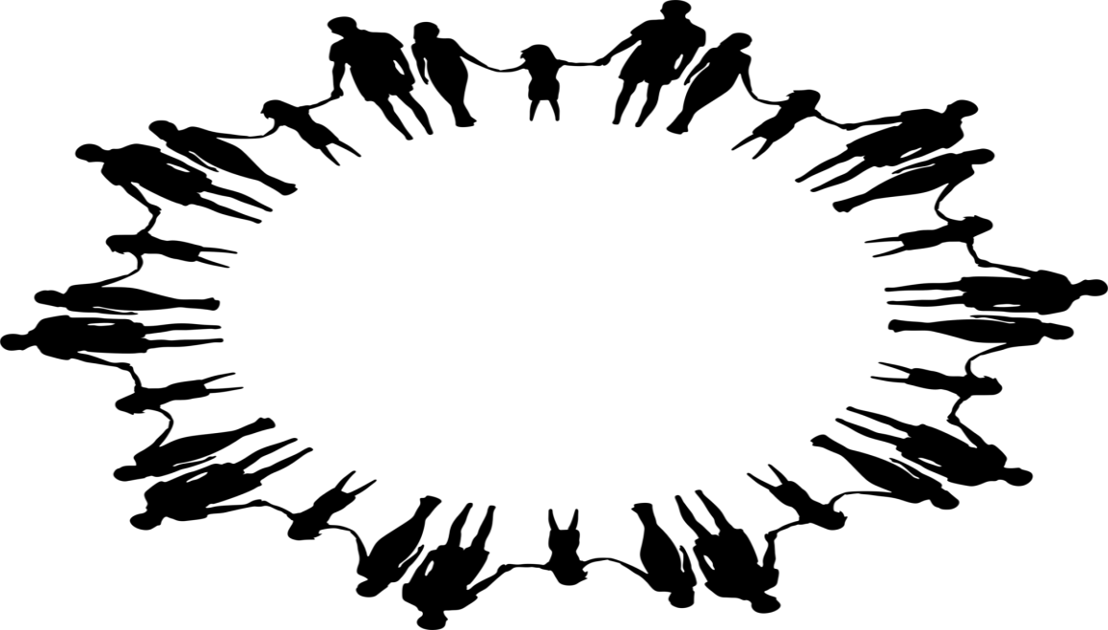
Advancing Wellness and Resiliency in Education
South Dakota Project AWARE

South Dakota Project AWARE is a grant program provided by the Substance Abuse and Mental Health Services Administration. A main purpose of this program is to build the partnership between state education agencies and state mental health agencies to increase awareness of mental health issues among school-aged youth. This program also provides training for adults to detect and respond to mental health issues among youth and connect youth and their families who may have behavioral health or mental illness to needed services.

Educational and mental health agencies interconnect in this program. Therefore, an Interconnected Systems Framework provides the foundation of the system. The framework is made up of four tiers which include:
- Home and Community Awareness
- Universal Prevention
- Targeted Interventions
- Wrap-Around Services

The diagram below shows examples of partnerships, activities, interventions, and services in each tier.
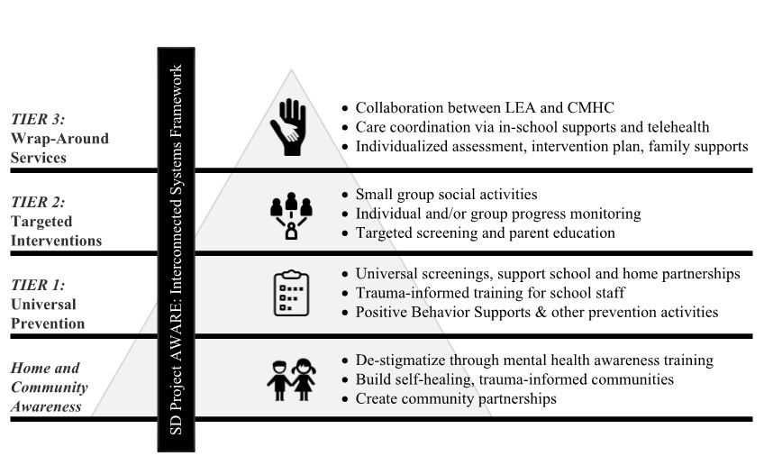

Project AWARE Goals

- Increase and improve access to mental health services for school-aged youth across South Dakota through partnerships with local education agencies, schools, educational cooperatives, and community mental health centers.

- Equip education professionals with the tools necessary to recognize and respond to behavioral health issues among their students through multi-tiered systems of support.

- Conduct outreach and engagement with school-aged youth and their families to promote positive mental health and increase awareness of mental health issues.

- Help school-aged youth develop skills that promote resilience, de-stigmatize mental health, and increase self- and peer awareness of mental health issues.

Objectives to reach Project AWARE goals
Goal 1
- Secure universal screening materials and provide training to educators.

- Establish consent process and begin screening students.

- Refine and implement strategy for Tier 2: Targeted Interventions to include referral processes/shared services between the school and CMHC in support of EBP delivery among at-risk youth identified in Tier 1.

- Establish consent processes and launch Tier 2 services

- Implement strategy, based on DSS System of Care, for Tier 3: Wraparound Services to include referral processes and consent, initial assessment, information release for identified resources, creation of an action plan for student success, and care coordination

- Provide technical assistance to Phase 1 (cohort I) LEAs and CMHC to assess viability, establish MOU, and develop procedures with telehealth services as a possible option

Objectives to reach Project AWARE goals
Goal 2

- Train school-based personnel in systematic universal screening and parental consent procedures

- Create decision rules to identify students who are at-risk for social, emotional, and behavioral concerns

- Screen students up to three times per year upon full implementation

- Train school-based personnel in Youth Mental Health First Aid

- Deliver NAMI Ending the Silence for School Staff presentations for 6-8th grade staff

- Provide training in Understanding Adverse Childhood Experiences (ACEs)

- Provide training via Enough Abuse: Strategies for Your Family and Community to school personnel through in-service training

- Implement Positive Behavioral Intervention and Supports after attending in-state and conference-based PBIS training

- Support data collection efforts via SWIS suite and incentives for community awareness building

- Implement Second Step as the choice EBP in social-emotional learning modules that teachers can use within their classrooms

• Attend State PBIS training

- Promote the development and delivery of trauma-informed communities in partnership with Center for the Prevention of Child Maltreatment

Objectives to reach Project AWARE goals
Goal 3
- Conduct Youth Mental Health First Aid trainings in the community

- Deliver NAMI Ending the Silence for Families presentations for 6-8th grade students’ parents and guardians

- Provide training in ACEs and via Enough Abuse: Strategies for Your Family and Community

Objectives to reach Project AWARE goals
Goal 4
- Implement the Sources of Strength program in alignment with fidelity components over a three-year process

- The Community Project AWARE Manager may attend SOS training following year one of implementation

- Integrate Second Step curriculum and reinforce the strategies

Evidence-Based Services/Programming

A series of Evidence-Based Practices have been identified to address each step of the multi-tiered systems of support for South Dakota Project AWARE some of which include:

Positive Behavior Intervention and Supports
Second Step Curriculum
Sources of Strength
Youth Mental Health First Aid
Social, Academic, and Emotional Behavior Risk Screener

Refer to Project AWARE Data Impact chart for a listing of programming recommended for the project. If an LEA wishes to supplement programs or practices, the LEA may complete a form describing the need and research base for the supplemental programs. (See Appendix A.)
Project AWARE – SEA Data Impact July 2020

¹Programming under consideration
Programming | SPARS or Annual  reporting | Audience/Participant Demographic reported | Tier
Ending the Silence NAMI | SPARS TR1 | Parents/community | 1
Ending the Silence NAMI | SPARS TR1 | Students | 1
Ending the Silence NAMI | SPARS WD2 | Workforce | 1
Youth Mental Health First Aid - Train the Trainer | SPARS WD2 | Workforce | 1
Youth Mental Health First Aid – course training | SPARS WD2 | Workforce | 1
SAEBRS Screener Training | SPARS WD2 | Workforce | 1
PBS National Conference | SPARS WD2 | Workforce | 1
PBS National Conference | SPARS WD2 | Workforce | 1
Second Step Curriculum  - training | SPARS WD2 | Workforce | 1
Second Step Curriculum used | SPARS TR1 | Students | 1
Positive Behavior Intervention and Support (PBIS) - Training | SPARS WD2 | Workforce | 1 - 3
SWIS Suite (PBIS) Software - Training | SPARS WD2 | Workforce | 1 - 2
Ruby Payne – Emotional Poverty Training | SPARS WD2 | Workforce | 1 - 2
Trauma-Informed Conference/training | SPARS WD2 | Workforce | 1
Community Mental Health Centers – Varied Services Scope  i. Basic Needs;  ii. Social Supports;  iii. Emotional Needs;  iv. Educational Needs;  v. Community Supports;  vi. Housing Supports;  vii. Health; and/or  viii. Safety | Annual | Students and family | 2 - 3
SAEBRS Screener used | Annual School | Students | 1
SWIS Suite (PBIS) results | Annual School | Students | 1 - 2
Center for the Prevention of Child Maltreatment (CPCM) and Children’s Home Society - ACEs | SPARS WD2 | Workforce | 1
CPCM and Children’s Home Society – Enough Abuse | SPARS WD2 | Workforce | 1
CPCM and USD CASSt Training | SPARS WD2 | Workforce | 1
Telehealth – training | SPARS WD2 | Workforce | 3
Telehealth – Services | Annual | Students | 3
Explicit Instruction-Effective and Efficient Teaching | SPARS WD2 | Workforce | 1
^{Mind Up Curriculum} | SPARS TR1 | Students | 1-2
^{Zones of Regulation Curriculum} | SPARS TR1 | Students | 1-2
¹Sources of Strength - training | SPARS WD2 | Workforce | 1-2
¹Sources of Strength results | Annual School | Students | 1 - 2
¹ PREPaRE Crisis - Training | SPARS WD2 | Workforce | 1
¹ PREPaRE Crisis results | Annual School | Students | 1

Data Collection and Measurement
A third-party evaluation firm will collect data related to project outcomes and oversee the timely transfer of data into the SAMHSA Performance and Accountability Reporting System (SPARS) in alignment with SAMHSA’s requirements.

The federal fiscal year is the accounting period of the federal government. A Federal Fiscal Year (FFY) begins on October 1st and ends on September 30th of the next calendar year.
Reporting is divided into four quarters:
- 1st Quarter: October 1st – December 31st
- 2nd Quarter: January 1st - March 31st
- 3rd Quarter: April 1st – June 30th
- 4th Quarter: July 1st – September 30th

Data will be reported quarterly on the following collection points:
- The number of organizations that entered into a formal written inter/intra organizational agreements (e.g. MOUs/MOAs) to improve mental health-related practices/activities that are consistent with the goals of the grant.

- The number of individuals who have received training in prevention or mental health promotion.

- The number of people in mental health and related workforce trained in mental health-related practices/activities that are consistent with the goals of the grant.

- The number of state and local policy changes completed as a result of the grant.

- As a result of the grant, the number of students receiving an informal or formal assessment to determine if they are at risk for a mental health-related concern and may need of specific mental health-related intervention (s), e.g. universal, Tier 1, or Tier 2 intervention.

- As a result of the grant, the number of students referred to mental health or related services.

- As a result of the grant, the number and percentage of students receiving mental health or related services after a referral.

Services
Coordinated referral, services, and follow-up to school-aged youth and their families will be provided through the multi-tiered framework; students in need of intensive, specialized assessment and services will be served through a referral process managed by the LEA/Community Project AWARE Manager. The SOC Coordinator will work as an outreach extension of the CMHC to ensure care transitions are made and family supports are provided.

Roles

Community Project AWARE Manager
The Community Project AWARE Manager (CPAM) will oversee and implement the Project AWARE Program at the local level. This role is considered key to be a conduit for appropriate mental health services within community mental health centers. Funded through the grant, the CPAM will provide 1.0 FTE (100% - 40 hours per week) effort each year towards the project over 12 months.

Examples of basic responsibilities include:

- Direct Student Support
- Using a tiered approach for intervention programs and counseling standards, the CPAM is to create a comprehensive school program that can implement the multi-tiered systems of support proposed through Project AWARE.
- Acting as a liaison, with the Community Mental Health Center (CMHC) personnel, the CPAM establishes the process with the CMHC where the school’s youth can receive Tier 2 and 3 responsive services and interventions.

- Foundational and Tier One Support – includes leadership, advocacy and collaboration as implementer of behavioral and mental health awareness with staff and community:
- Project AWARE partners like National Alliance on Mental Illness (NAMI)
- Professional training for stakeholders like schools’ staff, families and communities at large
- The grant’s DOE and DSS grant coordinators

- Point of contact for all school, community events, and trainings with Project AWARE partners

- Submit monthly grant reports to DOE by CPAM by hours spent by:
- Type of work provided in connection to the four grant goals
- Type of stakeholders and numbers served.

- Submit reports as requested for data collection required for Substance Abuse and Mental Health Services Administration (SAMHSA)

- Provide monthly documentation to the school, educational cooperative, or appropriate administration or business office for invoicing of expenses incurred for the grant to be sent to DOE for reimbursement to the school or educational cooperative

- Local Advisory Group – The school is to develop a local Project AWARE behavioral and mental health advisory group. (Suggested representation would include the CPAM, school staff, community leadership, parents, youth, and representative personnel from the CMHC and other mental health professionals.)
- This group is to be kept informed of the grant’s progress.
- This group is also to help plan the process moving forward for the behavioral and mental health supports needed for youth in the community beyond the grant years.

30% Area of CPAM’s Responsibility
The CPAM collaboratively leads grant activities that provide access for youth to mental health services and provide school -community trainings, following the grant’s tiered system. For this purpose, the CPAM collaborates with the:

Specific tasks within this area of responsibility of the CPAM:
- Follows the evaluation system to make sure the project meets yearly grant renewal through the life of the project
- Establishes local leadership duties by:
-providing expertise regarding behavior and mental health practices for youth, which leads to community support through local advisory group and school programming
- Establishes local leadership duties by:
-understanding community mental health center requirements for mental health services in connection to the youth access with the schools
-attending and helping local staff and other relevant people attend yearly state and national conferences and quarterly grant state advisory group meetings
-following the project action plans to meet grant goal deliverables in a timely manner
-producing a yearly report of the grant progress to meet all SAMHSA grant management requirements at the local level

70% Area of CPAM’s Responsibility
Oversee daily on-time completion of project trainings and mental health services using the collaborative approach of the grant, while monitoring local goal evaluation, financial targets and data collection. This directly relates to the required grant component that local personnel provide technical assistance through the CPAM who works in the school districts daily.

Specific tasks within this area of responsibility for the CPAM:
-Coordinates youth access to quality care for mental health services
-Coordinates access and, if qualified, provides for the families, youth, school personnel and community members prevention and mental health awareness training.
-Uses the grant management software, Project Accomplishment Database (PAD) and other local school software required by districts
-Uses DOE financial services processes like contracts and payment requests system for all local grant funds
-Uses data collection process and collaborates with other required data collection software or SAMHSA grant third-parties
-Collaborates as needed with other local CPAMS, training providers, CMHCs, school personnel, families, and community leaders
-Coaches school personnel to use highly effective practices in the tiered system

Systems of Care Coordinator

The Systems of Care (SOC) program is a wraparound approach to delivering services to at-risk youth and families, as identified by school systems through the Project Aware-SEA screening process. Detailed points of consideration for this approach include services, admission information, discharge information, reimbursable services, and income eligibility.

- Services - Conditions of services to be provided to school districts through the funding of the Project AWARE-SEA grant:

- All treatment services provided, as required by Department of Education (DOE), shall utilize evidence-based practices focusing on adolescent risk factors to improve mental health, and to reduce the likelihood of youth violence and prolonged educational disruption.

- Agency agrees to use the SOC model, as outlined below:

- The model should employ the SOC values of being strengths-based and family-driven as well as culturally competent.

- Families are provided information about and methods of accessing resources and can determine what services will best meet their needs.

- The model should provide for the use of natural resources as well as Family Support Program funds to assist with resources that are otherwise unavailable in the community.

Systems of Care Coordinator Services (continued)

- The model should employ a System of Care Coordinator position to work in collaboration with many agencies including school systems and other community resources, to provide the following services:

~Consultation with schools and community agencies;
~ Accepting referrals and ensuring completion of intake paperwork;
~ Assess and assist families with needs across life domains;
~ Ensuring families are informed of service options;
~ Facilitating team meetings as needed to develop and monitor service plans
and ensure that service plans are driven by the family;
~ Case management to refer and facilitate access to an array of community
services and supports
~ Collaboration and coordination to facilitate implementation of service plans
across all involved child and family serving agencies
~ Continually updating knowledge of and relationship with community
resources available to children and families; and
~ Conducting training, outreach and marketing in support of SOC
programming

- Care coordinator must have a minimum of a high school diploma or equivalent with preference for experience working with people, such as in a school setting or a case manager role. Agency will follow all additional recruitment, orientation, and supervision expectations as set forth in ARSD 67:62:06 when employing care coordinators.

- Care coordinator position will work with students at the school or other neutral location.

- Care coordinator should maintain a caseload of, on average, no more than
20 active families.

- Caseload includes all active clients, clients that started services in the last month, and clients that completed the program in the last month.

Systems of Care Coordinator Caseload

- For the first two months of services, families are defined as active if they have received a minimum of one face-to-face, 30-minute contact within the last month. Any exceptions to this must be approved by the Project Aware-SEA DOE coordinator and Division of Behavioral Health (DBH) co-coordinator. Expectations regarding face-to-face contacts should be established with the family at intake.

After the initial two months of services, families are considered active if they have received at least one face-to-face, 15-minute contact within the last month and at least one other contact (phone call, text conversation, email correspondence, etc.).

Previous SOC clients returning to SOC services require only one face-to-face 15-minute
contact per month and at least one other contact per month to be defined as active.

If a family starts services after the 15th of the month, they may be considered active with only
one face-to-face contact within that month.

SOC services provided via telehealth technology meet the criteria to be considered face-to-
face contacts.

f. Families should be discharged from SOC services as soon as all goals have been met as set forth in the family’s service plan and/or 30 days after the youth or other family member has entered other services such as Children Youth and Family (CYF) or targeted services for justice involved youth, unless otherwise approved by the Project Aware-SEA coordinator.

g. The SOC coordinator and CYF case manager or targeted services for justice involved youth service provider will hold a team meeting, including the family, within 30 days of the start of CYF or targeted services for justice involved youth to facilitate the transfer to CYF or targeted services for justice involved youth , unless otherwise approved by the Project Aware-SEA DOE coordinator and DBH co-coordinator.

h. Agency agrees to attend trainings for SOC as well as trainings regarding cultural competency and trauma informed care.

i. Agency agrees to work jointly with the DOE, DBH, LEA coordinator, local school administrators, and other community stakeholders to design and implement SOC programming at a local level including regularly scheduled meetings to review services and outcomes, ensure collaborative communication, and conduct problem solving.

j. Agency agrees to develop cooperative agreements and a multi-agency, HIPAA compliant release of information to help facilitate open communication and collaboration.

k. Agency agrees to provide community partners with SOC training to ensure that SOC values are clearly understood by all involved.

l. Agency agrees to work jointly with the DOE, DBH, and any contracted entities to provide outcome measures.

2. Admission Information
a. Client eligibility will be determined by the SOC agency based on the following minimum requirements:
- Client may be up to the age of 21.
- Client must have identified needs in at least one of the following domains
Basic Needs, Social Supports, Emotional Needs, Educational Needs, Community
Supports, Housing Supports, Health, and/or Safety
b. If the SOC agency determines it cannot meet the needs of the client through SOC, the agency will work with the referral source to identify other appropriate recommendations. Agency agrees to facilitate referrals to appropriate services based on any recommendations made.

3. Discharge Information
a. Agency shall discharge a client after a 60-day period without face-to-face contact, after completion of a case plan, or referral to another level of care.
- If a client prematurely discontinues services, reasonable attempts shall be made and documented by the agency to re-engage the client into services if appropriate.
- Upon discharge or termination from SOC services, the SOC agency will provide discharge information to DBH as outlined in the monthly invoice during the billing period, immediately following termination. Information can be sent to: DSSBH@state.sd.us
- If a client returns to SOC services after discharge, new intake paperwork must be completed.

4. Reimbursable Services
a. Co-pays/sliding fee scales are not to be assessed to clients for services unless authorized by DBH.
b. For clients who require additional services, the appropriate referral must be made using the established method of referral.
c. If a client is eligible for CYF or targeted services for justice involved youth, the client should be transitioned into CYF or targeted services for justice involved youth as per requirements set forth in Services.
d. Services will be billed monthly through the invoice format created by DBH, but the invoice format may be subject to change if requested by the needs of the Project AWARE-SEA grant entity, Substance Abuse and Mental Health Services Administration (SAMHSA).
e. Services invoices are not to exceed the submitted grant funded amount.
5. Income Eligibility
a. The Means 101 form must be completed for all SOC participants. If participants do not meet income eligibility guidelines, please notify DBH.

Project AWARE Advisory Group
The System of Care Coordinator will participate in the local Project AWARE behavioral and mental health advisory group. Suggested representation would include the CPAM, school staff, community leadership, parents, youth and representative personnel from the CMHC and other mental health professional partners. This group is to be kept informed about the grant’s progress, provide recommendations, and insight. This group is also to help plan the process moving forward for the behavioral and mental health supports needed for youth in the community beyond the grant years.

Project AWARE Tier 2: Individual Students
Referrals indicate intervention
a. School-based intervention lead by school personnel (including Project AWARE CPAM)
Examples:
Faculty and staff trained in interventions and strategies.
School counselor interventions guide school supports
School psychologist interventions guide individual youth support
PBIS check in/check out – school adult support
Peer coaches (Possible Sources of Strength programming)
Targeted screening (SAEBRS ongoing for individuals)
Parent support with individual youth
Social-Emotional small groups

Tier Two Decision Structure in Relationship with Tier Three
Student

Target: Services responsive to student’s need based on school site strategic options.

Telemental Health Access Phase 1

Merging of Services and Children’s Access

Telehealth has become prevalent in the United States. Under the phrases of telebehavior health, telemedicine, virtual visits and more, Health services “explore ways to reduce gaps and increase access to essential behavioral health services. This option falls under the telehealth umbrella—a tool that capitalizes on technology to provide health services remotely.”

As schools work on telehealth partnerships with behavior and mental health services, one major area of concern is the possible lack of internet and technology access commonly called a digital divide.

Great strides have been made in lessening the digital divide (Pew Research, April 30, 2020) for students and will be an ongoing process. The use of remote or telehealth services is a life reality. National practice models show progress in digital access, especially during the COVID-19 pandemic response, and is part of the considerations section of the pilot programs.

Appendix A

Project AWARE Change of Practices or Programs Application
Name of the LEA _____________________________ Date of Request __________________
Check one: Tier One ☐ Tier Two ☐
(See Appendix B for Cohort 1 programming connected to tiers.)

- Evidence-based Program ____________________________________________________
Grade(s) to be used?
Check Any Grant Goal: Goal One ☐ Goal Two ☐ Goal Three ☐ Goal 4 ☐
(See Appendix C for approved SAMHSA Project AWARE four goals.)
- Documented Research Evidence (Requirement of SAMHSA): What research has been done to support the effectiveness of the program? Materials? Presenter’s organization? Links to the research or evaluation of the program, materials or organization may be submitted.
For example, Second Step is evidence based through https://casel.org/guidprogramssecond-step/

(Please attach a separate Document Research Evidence document if more description space is needed but not more than 200 words.)

- Funding: Describe per student or person funding that is existing in current budget line item. For example, the amount cannot replace existing travel, PBIS training costs, SAEBRS or SWIS Suite. Also, there are currently no additional funds for the project in 2020.

(Please attach a separate Funding Description document if more description space is needed.)

Signature of Superintendent/Principal/Executive Director authorizing request

Refer to Department of Health and Human Services Substance Abuse and Mental Health Services Administration FY 2018 Project AWARE (Advancing Wellness and Resilience in Education) State Education Agency Grants: AWARE SEA Funding Opportunity Announcement (FOA) No. SM-18-006

SAMHSA’s grants are intended to fund services or practices that have a demonstrated evidence base and that are appropriate to the population(s) of focus. An evidence-based practice (EBP) refers to approaches to prevention or treatment that are validated by some form of documented research evidence. Both researchers and practitioners recognize that EBPs are essential in improving the effectiveness of treatment and prevention services in the behavioral health field. While SAMHSA realizes that EPBs have not been developed for all populations and/or service settings, application reviewers will closely examine proposed interventions for evidence base and appropriateness for the population to be served. If an EBP exists for the types of problems or disorders being addressed, the expectation is that the EBP will be utilized.

The submitted practice or program has been approved by the undersigned as a full and satisfactory completion of evidence-based program requirements for 2018 Project AWARE – SEA.

Approval:

Project AWARE Director: _____________________________________________________________

Appendix B
Practice/Programming Cohort 1 | Tier | Description
Adverse Childhood Experiences  and Resiliency Training (ACES) | 1 | Training which offers a trauma-informed, science- based theory that many of the behavioral symptoms seen in individuals are a direct result of the brains development and ACEs.
Boys Town Curriculum | 1 or 2 | Focuses on managing behavior, building relationships, and teaching social skills. It emphasizes preventive and proactive practices rather than reactive responses to deal with student behavior.
Enough Abuse | 1 | Framework for looking at child sexual abuse as the public health problem that it is and addressing the prevention of abuse in a manner similar to the way other behavior-based public health issues have been.
Explicit Instruction – Dr. Anita Archer | 1 | Effective direct instruction includes explicitly teaching behavioral expectations and routines as well as intentionally increasing student opportunity to respond – cornerstones of classroom implementation.
PREPaRE Crisis | 1 or 2 | Provides evidence-based resources and consultation related to school crisis intervention and response
National Alliance on Mental Illness: Ending the Silence (NAMI) | 1 | Evidence in de-stigmatizing mental health conditions across students and families through an interactive presentation which includes a young adult who shares the journey of recovery
Ruby Payne-Emotional Poverty | 1 | Utilizes a brain-based approach to look at underlying causes of anger, anxiety, and violence; how they develop; and the tools that can be used to change those responses
Second Step | 1 | Provides an evidence-based approach for schools to create and sustain safe, supportive learning environments through a social-emotional learning program for grades K-8. (Bullying Prevention Unit and Child Protection Unit available to grades K-5)
Sources of Strength | 1 or 2 | Strength-based comprehensive wellness program that focuses on suicide prevention but also impacts other issues such as substance abuse and violence
Youth Mental Health First Aid | 1 | Peer reviewed evidence in improving mental health literacy and de-stigmatizing attitudes and has broad applicability to families, teachers, school staff, peers, neighbors, employers, and other citizens that interact with adolescents who may experience a mental health or addictions challenge or crisis
Check and Connect | 2 | Mentors systematically monitor student performance variables (e.g., absences, tardies, behavioral referrals, grades), and provide interventions to helps students solve problems, build skills, and enhance competence.
Check-In Check-out | 2 | Applicability to situations where a student is struggling with various behavior problems and/or emotional issues (e.g. anxiety, frustration), and has been shown to provide a structure by which the student can improve
Mind Up | 1 or 2 | Practices are designed to enhance students’ self- awareness, focus attention, promote self-regulation, and reduce stress. Throughout, the program works to promote generalization and support connections to academic instruction, and there are suggested lesson extensions to support social and emotional development, mathematics, physical education, health, science, literature, and journal writing.
Zones of Regulation | 1 or 2 | The Zones of Regulation framework provides strategies to teach students to become more aware of and independent in controlling their emotions and impulses, manage their sensory needs, and improve their ability to problem solve conflicts.

Appendix C
Goal 1 | Increase and improve access to mental health services for school-aged youth across South Dakota through partnerships with LEAs, schools, educational cooperatives, and Community Mental Health Centers (CMHCs).
Goal 2 | Equip education professionals with the tools necessary to recognize and respond to behavioral health issues among their students through multi-tiered systems of support.
Goal 3 | Conduct outreach and engagement with school-aged youth and their families to promote positive mental health and increase awareness of mental health issues.
Goal 4 | Help school-aged youth develop skills that promote resilience, de-stigmatize mental health, and increase self- and peer-awareness of mental health issues.

