
August 2026
Private Schools
Student Data Collections
Desk Guide
Office of Data Management

Table of Contents

Purpose 4
Definitions 5
South Dakota Codified Laws 7
South Dakota Administrative Rules 17
Data Collection Calendar for 2026/2027 20
Fall Enrollment 26
Timeline 26
Criteria for Fall Enrollment – Census Count (Used for statistical reporting purposes) 26
Section I - Calendars 27
Deleting a Calendar 32
Section II - Student Enrollments 34
Enrolling a Student 34
Race/Ethnicity 36
Enrollment Tab 38
Grade Level - Definitions: 38
Service Type - Definitions: 38
End Status – Definitions: 39
Resident District 41
County 41
Serving (Attending) District 41
Citizenship box 41
Enrollment Status – Definitions 42
Percent Enrolled 44
Enrollment % Changes during the School Year 44
FERPA Program Screen 44
Enrollments in Infinite Campus 46
Enrollment Record of a student who is a resident within your school district and participating in Online/Virtual Courses 46
Section III – High School Requirements 47
High School Grade Progression 47
Updating the Graduation Tab 47
Graduation Endorsements/State Seals 48
1. Advanced Endorsement 49
2. Advanced Career Endorsement 50
3. Advanced Honors Endorsement 51
4. State Seal of Biliteracy 52
Section IV – SD Infinite Campus Listserv 53

Purpose
The purpose of this desk guide is to assist private accredited school districts with the data entry required in South Dakota for accreditation purposes.
The Department of Education currently contracts with Infinite Campus for our Student Information Management System. Districts MUST strive to keep their student data accurate at all times as student data is extracted throughout the school year purposes such as:
- To create Assessment Pre-ID files
- To populate student data and properly assign students to the correct schools in the online Assessment systems
- Legislative requests – Dec/Jan/Feb/March
- General data requests throughout the year
- To compute Attendance rates, Graduation rates, Completer rates and Dropout rates
YOUR DATA
IS IMPORTANT!

Definitions
Admission Date – The month, day and year that a student is admitted to a school or an educational institution.
Advanced Endorsements - In graduation requirements, specific coursework outlined within the high school diploma requirements to denote particular emphases. Advanced endorsements include:
(a) Advanced Endorsement," indicates a student has pursued coursework consistent with entrance requirements for postsecondary education at an university;
(b) "Advanced Career Endorsement," indicates a student has career experience in a concentrated area, based on academic and workplace experience and a related credential; and
(c) "Advanced Honors Endorsement," indicates a student has pursued advanced rigorous, academic coursework consistent with SDCL 13-55-31.1.
After School Program – Programs that provide academic enrichment opportunities during non-school hours that serve children and youth of all ages. After-School programs help students meet state and local content standards in core academic subjects, such as reading and math; offer students a board array of services such as social emotional supports or family programs.
December Child Count – The unduplicated count of all children with disabilities ages 3-21 receiving special education and related services according to an individualized education program (IEP) or service plan on December 1st of each year.
Dropout – per 24:55:01:01 – A student who was enrolled in school at some time during the school year and was expected to be enrolled the following year but was not enrolled; has not graduated from high school or completed a state or district approved educational program; has not met any of the following exclusionary conditions:
- The student transferred to another public school district, private school, or state or district-approved educational program;
- The student has been granted a school recognized temporary absence due to suspension or illness;
- Death.
Dual Enrollment - The enrollment of a pupil in elementary or secondary educational programs in two or more school systems at the same time.
EC – Early Childhood - Students not yet enrolled in Kindergarten but who are receiving ONLY Special Education services from the school district should be entered into the Student Information System using the “EC” as the grade level in the grade level field. Attendance is not required for the “EC” students.
Economically Disadvantaged - Students who qualify for free and reduced lunch status.
Elementary School - A school consisting of any combination of grades from kindergarten through eighth grade.
Exit/Withdrawal Date - The month, day and year of an individual’s last attendance in school; for a graduating student it is the last day of the school year (even if the seniors are dismissed a few days early) unless the student is graduating early and then it would be the last day the student is required to attend.
Fall Enrollment Census Count – This is a head count of students enrolled in pre-school through twelfth grade in all schools operated by the school district on the last Friday of September of the current school year. The Fall Enrollment Census Count is used for statistical comparisons, federal reports and grant allocations.
Fall Enrollment State Aid– per § 13-13-10.1 - The number of kindergarten through twelfth grade students enrolled in all schools operated by the school district on the last Friday of September of the current school year minus the number of students for whom the district receives tuition, except nonresident students who are in the care and custody of a state agency and are attending a public school and students for whom tuition is being paid pursuant to § 13-28-42.1, plus the number of students for whom the district pays tuition. See 13-13-10.1 for specifics.
Full Academic Year – per 24:55:01:03 – The term full academic year means a student is continuously enrolled in a public school from October first to May first with an enrollment gap of no more than fifteen consecutive school days.
Jr. Kindergarten Student – A student enrolled in a Jr. Kindergarten program would be considered the same as a Kindergarten student for data collection purposes. The student must be at least 5 years old by September 1st to be counted for State Aid funding purposes.
Junior High School - A school consisting of a combination of two or more consecutive grades that must include grades seven and eight and may include grade nine.
Middle School - A school consisting of any combination of two or more consecutive grades, five through eight.
Pre-School Student – per 24:17:01:07 – For the purpose of data collection, a preschool student is defined as a child who is at least three years of age on or before September 1st, is not enrolled in Kindergarten, and is receiving educational services from a public school district for a minimum of 128 hours. A full-time preschool student is a student who is enrolled in a program that operates at least 448 hours per year. For purposes of data collection, students enrolled in programs operated for a lesser time shall be reported on a prorated basis as a percentage of 448 hours. All public school districts operating a preschool program shall report student data for preschool students including attendance data. This definition is intended exclusively for data collection and should not be used for any other purpose.
Secondary School - A school consisting of any combination of three or more consecutive grades, including ninth grade through twelfth grade.
Student data submission - A report containing detailed information on each student in a format prescribed by the secretary.
Tutoring - Tutoring is a short additional block of time, both within and outside of the regular school day, intended to complement specific classroom instruction to support gaps in student mastery of previously instructed learning objectives. Tutoring programs can be operated as teacher-to-teacher or peer-to-peer tutoring. Material covered is based on the individual student’s needs focusing on helping the student succeed in areas where the student is struggling.

South Dakota Codified Laws
SDCL 13-3-51: Data reporting and record systems. The secretary of the Department of Education shall establish a uniform system for the gathering and reporting of educational data for the keeping of adequate educational and financial records and for the evaluation of educational progress. Any school district or school seeking state accreditation shall submit enrollment data, personnel data, and shall verify all state and federal standards for accreditation and approval of schools, including those related to safety and educational equity of the school district or school by October fifteenth of each year. If the due date falls on a weekend or state holiday, the due date is the next business day following the scheduled due date. An annual written evaluation of the educational progress in the state and in each school district shall be submitted to the Legislature and shall be made available in each school district to the general public. The South Dakota Board of Education Standards may promulgate rules pursuant to chapter 1-26 to further define the data required pursuant to this section. However, nothing in this section authorizes the collection of information not necessary for the calculation of funding for public education, the determination of student academic progress, state and federal reporting requirements, or other duties prescribed to a school district, the department, or the South Dakota Board of Education Standards by law.
SDCL 13-3-55: Academic achievement tests. Every public school district shall annually administer the same assessment to all students in grades three to eight, inclusive, and in grade eleven. The assessment shall measure the academic progress of each student. Every public school district shall annually administer to all students in at least two grade levels an achievement test to assess writing skills. The assessment instruments shall be provided by the Department of Education, and the department shall determine the two grade levels to be tested. The tests shall be administered within timelines established by the Department of Education by rules promulgated pursuant to chapter 1-26 starting in the spring of the 2002-2003 school year. Each state-designed test shall be correlated with the state's content standards. The South Dakota Board of Education Standards may promulgate rules pursuant to chapter 1-26 to provide for administration of all assessments.
SDCL 13-3-62: State accountability system established. A single, statewide state accountability system is established. The system shall hold public schools accountable for the academic achievement of their students and shall ensure that all public schools make yearly progress in continuously and substantially improving the academic achievement of their students.
SDCL 13-3-84: Partially enrolled student required to take academic achievement test. If a student is partially enrolled in a school district pursuant to § 13-28-41 or 13-28-51, and the student's enrollment is equal to or greater than fifty percent, that student is required to take any academic achievement test administered by the school district pursuant to § 13-3-55. If a student's partial enrollment in a school district is less than fifty percent, the student is not required to take any academic achievement test administered by the school district pursuant to § 13-3-55.
SDCL 13-13-1.2: Fall enrollment records subject to examination by department. Any records related to the reporting of fall enrollment of a public school district shall be subject to examination by the Department of Education at all times.
SDCL 13-13-10.4: Enrolled student defined. For the purposes of § 13-13-10.1, a student is enrolled if:
- The student is less than twenty-one years of age on the first day of July or meets the requirements of § 13-28-5 and 13-28-6;
- The student has not completed an approved program or graduated from high school;
- The student's parent or guardian resides within the school district, or in the case of an emancipated minor the student resides within the district or the student has been properly assigned to the district or has been approved to attend school in the district under the terms of the enrollment options program established in § 13-28-40; and
- The student is not simultaneously enrolled in any other school district and has not been excused from school attendance under the terms of § 13-27-1.1 or 13-27-2.
SDCL 13-13-10.5: Student enrolled on partial basis. Effect on fall enrollment. For purposes of state aid to education, a student enrolled pursuant to § 13-28-41 or 13-28-51 shall be counted in a school's fall enrollment as defined in § 13-13-10.1 in a proportion equal to the share of the student's enrollment in the school.
SDCL 13-15-30: Agreements for whole-grade sharing of students—Conditions: Notwithstanding the provisions of § 13-5-1, the school board of any school district may enter into an agreement or contract with one or more school boards of other school districts to provide for the whole-grade sharing of students among the participating school districts if:
- The school district offers an instructional program within the boundaries of the school district; and
- The school district meets the minimum fall enrollment requirements pursuant to § 13-6-97.
For purposes of §§ 13-15-30 to 13-15-32, inclusive, whole-grade sharing is a sharing arrangement for students among participating school districts that allows the resident students at any one or more grade levels within one school district to attend school in one or more of the other participating school districts. The whole-grade sharing may be one-way whereby a participating school district sends all of its students at one or more grade levels to attend school in one or more of the other participating school districts without receiving any students in return. The whole-grade sharing may also be two-way whereby a school district sends all of its students at one or more grade levels to attend school in one or more of the other participating school districts, and in return receives students at one or more grade levels from one or more of the other participating school districts.
SDCL 13-15-31: Approval and adoption of agreements for whole-grade sharing of students--Term--Termination—Requirements: Any agreement or contract entered into pursuant to § 13-15-30 shall be approved by the secretary of education and shall remain in effect for a period of at least three years. It shall provide for the sharing of governance among the participating school districts. The school board of each participating school district shall adopt the contract or agreement no later than February first of the school year proceeding the school year for which the agreement will take effect. The contract or agreement may be terminated by any participating school district if that school district provides written notice to the other participating school districts at least eighteen months prior to the termination. The contract or agreement shall adhere to the following provisions:
- Students at one grade level within a school district are only eligible to attend school in another participating school district if all the students at that particular grade level within the school district are sent to another participating school district. The school boards of the participating school districts shall determine which students and which facilities will be shared under the terms of the agreement;
- The participating school districts may negotiate the rate of tuition that will be charged for any student sent to attend school in another participating school district. However, the rate of tuition per year may not be less than the per student allocation as defined in § 13-13-10.1 for that school fiscal year;
- The fall enrollment as defined in § 13-13-10.1 for each participating school district shall include any students that the school district sends to another participating school district to attend school, and may not include any students that are sent to the school district to attend school from other participating school districts;
- For the purposes of determining adequate yearly progress under the state's accountability system established in § 13-3-62, and calculating the graduation rates, any student sent to another participating school district to attend school shall be counted in the receiving school district; and
- For the purposes of state aid for special education, the school residence of any student in need of special education or special education and related services who is sent to a participating school district to attend school remains with the sending school district. However, both the sending and the receiving school districts shall agree upon the student's individualized education program.
SDCL 13-23-1: School board's power to establish and discontinue--Time for action closing school. The school board shall have the power to establish and discontinue attendance centers by resolution of the board. An action to close an operating school shall be taken by December first prior to the closure. However, if an emergency exists, the board may close the school after notice to the patrons.
SDCL 13-23-10. Establishment of attendance center outside boundaries of school district--Joint powers agreement: A school board may establish an attendance center outside the boundaries of its school district that is within the boundaries of another school district only when both school districts have entered into a joint powers agreement pursuant to chapter 1-24 to provide instruction to the students enrolled in the attendance center.
If each school board adopts a resolution to approve the joint powers agreement, the school board for the school district that will operate the attendance center shall submit the joint powers agreement and each school board's resolution of approval to the secretary of education.
SDCL 13-26-1: School fiscal year--Local board to set length of school term, day and week--Number of hours in school term: The school fiscal year shall begin July first and end June thirtieth. Each local school board shall set the number of days in a school term, the length of a school day, and the number of school days in a school week. The local school board or governing body shall establish the number of hours in the school term for kindergarten programs, which may not be less than four hundred thirty-seven and one-half hours. The number of hours in the school term for grades one through five may not be less than eight hundred seventy-five hours, exclusive of intermissions. The number of hours in the school term for grades six through twelve may not be less than nine hundred sixty-two and one-half hours, exclusive of intermissions. An intermission is the time when students are at recess or lunch and for grades six through twelve, the passing time between classes. The minimum number of hours required in this section may be waived by the secretary if the Governor or the President of the United States declares a state of emergency and the affected school is located within the area to which the state of emergency is applicable. The Department of Education shall monitor emergency-related school closures and provide updates to the schools.
During a declared state of emergency, the school district shall forward to the Department of Education, at the time and in the manner requested by the department, a record of the continuous instruction provided to the students. The department shall consider the nature and scope of the instruction provided to determine whether it will count towards the minimum number of hours required in a school term.
SDCL 13-26-2: Time required in school term--Make up time--Summer term: The school board or governing body shall operate kindergarten through grade twelve in its schools. The school board shall operate grades one through twelve for at least a nine-month regular term in any one school year, and the number of hours in a school term for kindergarten shall be set pursuant to § 13-26-1. The regular school term may be conducted on a year-round basis and shall begin on a date established by the school board. The Board of Education Standards shall promulgate rules pursuant to chapter 1-26 governing the operation and scheduling of year-round schools. Any school board or governing body may release graduating high school seniors from school before the end of the regular term. A school is not required to make up time for school closing because of weather, disease, or emergency once it has reached the minimum number of hours in the school term as required by state law. Graduating seniors are excused from makeup time if the makeup time occurs after the students have graduated or after graduation exercises have been held. If classes have been convened and then are dismissed, or if classes convene at a time later in the day than normal, because of inclement weather, that day constitutes a school day in session equal to the number of hours planned for that day as established in the local school district calendar for the year. School boards are encouraged to provide time within the regular school term for curriculum and staff development which shall be in addition to the time required in this section. Each school board shall determine the appropriate amount of time for this activity and how best to use the time based on local needs for program development, increased parent participation, student contact, teachers' preparation, or other needs of the schools in the district. School is in session only when classes are held and as provided in §§ 13-26-4 and 13-26-4.1. A school board may operate a special term during the summer months.
SDCL 13-26-4: Teacher-parent conferences counted as hours in session: A school may have teacher-parent conferences during the school year and not more than 16.5 hours may be counted as hours in session.
SDCL 13-26-4.1: In-service training: The school board may designate a maximum of 5.5 hours of the 16.5 session hours provided for in § 13-26-4 as in-service teacher training.
SDCL 13-27-1: Responsibility of person controlling child for school attendance--High school equivalency test preparation program--Kindergarten--Transfer from another state: Any person having control of a child, who is not younger than five or older than six years old by the first day of September, or any child who, by the first day of September, is at least six years old, but who has not exceeded the age of eighteen, shall cause the child to regularly attend school, either public, nonpublic, or alternative instruction as set forth in § 13-27-3, until the child reaches the age of eighteen years, unless the child has graduated or is excused as provided in this chapter. However, the requirements of this section are met if a child who is at least sixteen years of age enrolls in a high school equivalency test preparation program and the child successfully completes the test or reaches the age of eighteen years. A child is eligible to enroll in a school-based or school-contracted high school equivalency test preparation program or take the high school equivalency test if the child is sixteen or seventeen years of age, and the child presents written permission from the child's parent or guardian and one of the following:
- Verification from a school administrator that the child will not graduate with the child's cohort class because of credit deficiency;
- Authorization from a court services officer;
- A court order requiring the child to enter the program;
- Verification that the child is under the direction of the Department of Corrections; or
- Verification that the child is enrolled in Job Corps as authorized by Title I-C of the Workforce Investment Act of 1998, as amended to January 1, 2009.
Any child who is sixteen or seventeen years of age and who completes the high school equivalency test preparation program may take a high school equivalency test immediately following release from the school program or when ordered to take the test by a court. Any such child who fails to successfully complete the test shall re-enroll in the school district and may continue the high school equivalency preparation program or other suitable program as determined by the school district. All children shall attend kindergarten prior to age seven. Any child who transfers from another state may proceed in a continuous educational program without interruption if the child has not previously attended kindergarten.
SDCL 13-27-1.1: Religious exemption after eighth grade: A child of compulsory school age who has successfully completed the first eight grades is excused from compulsory school attendance under § 13-27-1 if:
- The child or the parents of the child are members of a recognized church or religious denomination that objects to the regular public high school education; and
- The recognized church or religious denomination either individually or in cooperation with another recognized church or religious denomination provides a regularly supervised program of instruction in which each child participates in learning activities appropriate to the adult occupation that the child is likely to assume in later years.
SDCL 13-27-3: Alternative instruction--Notification--Requirements. Upon a filing of a notification with either the Department of Education or the local district from the parent, or guardian, or other person having control of a child, the Department of Education or the local district has been notified that the child is being provided with alternative instruction in the basic skills of language arts and mathematics. The person providing instruction is not required to be certified. No person may instruct more than twenty-two children. All instructions shall be given so as to lead to a mastery of the English language.
SDCL 13-27-3.1: Birth certificate or affidavit to be submitted--Violation as misdemeanor. Any person who is required pursuant to § 13-27-1 to cause any child to attend any public or nonpublic school in this state shall, either at the time of enrollment in any school in this state or within thirty days of initial enrollment, provide the public or nonpublic school with a certified copy of the child's birth certificate or affidavit in lieu of birth certificate as issued by the Department of Health in such cases where the original birth certificate is deemed unattainable. A violation of this section is a Class 2 misdemeanor.
SDCL 13-27-3.2. Maintenance of birth certificate by school as permanent record. Any copy of any certified birth certificate provided pursuant to § 13-27-3.1 shall be maintained by the public or nonpublic school and shall be a part of the child's permanent cumulative school record.
SDCL 13-27-7: Notification of alternative instruction. Each notification of alternative instruction pursuant to § 13-27-3 shall be on a standard form that declares that the child will be provided with alternative instruction per § 13-27-3. The completed form must contain the child's name, birthdate, resident district, and open enrolled district if applicable, signature of the parent, guardian, or other person having control of the child and information for the return of the form. The Department of Education or the local district shall provide the parent, guardian, or other person having control of the child with a signed or stamped copy of the notification as proof of notification. The notification shall be kept confidential. The form shall be provided by the secretary of the Department of Education but may not require more details than set forth by this section. The notification shall be filed within thirty days from the first time the child begins an alternative instruction program while the child is of school age as defined in § 13-27-1 and is not required thereafter unless one or more of the following transitions occur:
- A child enrolls in a public or nonpublic school; or
- A child moves to a different school district.
The parent, guardian, or other person having control of the child shall provide notification of any transitions by submitting the standard notification form to the Department of Education or the local district within thirty days of the transition.
SDCL 13-27-9. Record of certificates of excuse--Copies to secretary and place of instruction. A permanent record of all certificates of excuse, pursuant to §§ 13-27-6 and 13-27-6.1, shall be kept in some safe place as determined by the school board. Copies of any certificate of excuse shall be forwarded to the secretary of the Department of Education. Copies of any certificates of excuse shall also be forwarded to the place where the child is instructed. The copies shall be forwarded within thirty days of issuance.
SDCL 13-27-11. Failure to send child to school as misdemeanor. Any person having control of a child of compulsory school age who fails to have the child attend school, as required by the provisions of this title, or provide alternative instruction pursuant to § 13-27-3, is guilty of a Class 2 misdemeanor for the first offense. For each subsequent offense, a violator of this section is guilty of a Class 1 misdemeanor.
SDCL 13-27-14. Truancy officer employed by district--Duties--President of board acting where no officer employed. The school board of each school district shall annually appoint and provide for the remuneration of one or more truancy officers, to enforce, under the school board's direction, the compulsory attendance laws within the district. In a school district failing to provide a truancy officer, the president of the school board is the truancy officer and is responsible for the enforcement of the compulsory attendance laws within the school district.
SDCL 13-27-15. Attendance records maintained by superintendent or president of board--Reports required. Each superintendent, or the president of the school board in districts without a superintendent, is responsible for maintaining an accurate record of the attendance of all persons of compulsory school age who are enrolled in an accredited school under his or her supervision. The superintendent or president shall, at regular intervals, report the names of all enrolled persons who are of compulsory school age, not excused from school, who do not or who irregularly attend an accredited school to the truancy officer. The superintendent or president shall include reasons for the absences in the report.
SDCL 13-27-29. Placement of child who has attended unaccredited school or alternative program--Appeal. If a child of compulsory school age has been attending an unaccredited school in another state or country or has been receiving alternative instruction pursuant to § 13-27-3 enrolls in a public school in this state, the child shall be placed at the child's demonstrated level of proficiency as established by one or more standardized tests. However, a child's placement may be in one grade level higher than warranted by the child's chronological age assuming entry into the first grade at age six and annual grade advancement thereafter. After initial placement, the child may be advanced according to the child's demonstrated performance. If a child of secondary school age has been attending an unaccredited school in another state or country or has been receiving alternative instruction pursuant to § 13-27-3 enrolls in a public school in this state, the child shall be placed in English and math at the level of achievement demonstrated by one or two standardized tests, and in all other subjects on a review of transcripts according to the policy formally adopted by the school board. The child's placement may be in one grade level higher than warranted by the child's chronological age assuming entry into the first grade at age six and annual grade advancement thereafter. After initial placement the child may be advanced according to his demonstrated performance. Any parent or guardian who is dissatisfied with the placement of his child may appeal it to the secretary of the Department of Education.
SDCL 13-28-1.1. Enrolled student defined. As used in this title, a student is enrolled if:
- The student is less than twenty-one years of age on the first day of July or the student is twenty-one years of age or older and is admitted to the school district pursuant to § 13-28-8; and
- The student has not completed an approved program or graduated from high school; and
- The student's parent or guardian resides within the school district, or in the case of an emancipated minor or an adult admitted to the district pursuant to § 13-28-8, the student resides within the district or the student has been properly assigned to the district or has been approved to attend school in the district under the terms of the enrollment options program established in § 13-28-40; and
- The student is not simultaneously enrolled in any other school district and has not been excused from school attendance under the terms of § 13-27-1.1 or 13-27-2.
SDCL 13-28-2: Kindergarten enrollment eligibility--Transfer from another state. Any child who is five years old on the first day of September is eligible for enrollment in kindergarten during that school year. Any child who transfers from another state may proceed in a continuous educational program without interruption.
SDCL 13-28-5. Public school privileges free to children until age twenty-one--Fee for early childhood services. The privileges of the public schools of any district shall be free to all persons with school residence within the district until they complete the secondary school program or until they reach the age of twenty-one. However, except as otherwise prohibited by law, schools may charge a fee for early childhood services for any child who is under the age of compulsory attendance pursuant to § 13-27-1 and is not enrolled in kindergarten or a more advanced grade.
SDCL 13-28-6. Continuation of privileges to pupil becoming twenty-one during school year. A pupil who is enrolled in school and becomes twenty-one years of age during the fiscal school year shall have free school privileges during that school year.
SDCL 13-28-9. School residence for free school privileges--Change of residence--Children of transferred active duty military personnel. School residence for the purpose of claiming free school privileges means the legal residence of the student's parents or guardian except as provided in § 13-28-10. If a parent or guardian has more than one residence, the school residence is the residence where the parent or guardian actually lives and makes a home or domicile. In case of dispute, if the student's parent or guardian has claimed a credit pursuant to § 10-13-39, it is presumed that the dwelling so claimed is the residence of the parent or guardian. The student or the student's parents or guardian may not establish school residence and be exempt from the payment of tuition if the residence of the parents or guardian of the student is acquired solely or principally for obtaining free school privileges. At the time a child is enrolled in a school district, the school residence of the child as determined by that school district within thirty days after the enrollment may not change during the school fiscal year, unless the child ceases to be an enrolled member of a school within the district. If a student's parents or guardians are separated or divorced, the school residence is the school district in which the custodial parent or guardian has residence. If the parents or guardian have joint custody of a student, school residence is that of the parent or guardian with whom the child resides the greater portion of the school year. Notwithstanding the provisions of any other law, if the parent or guardian of a child is transferred to or is pending transfer to a military installation within the state while on active military duty pursuant to an official military order, the child meets the residency requirement for free school privileges in the school district in which the parent or guardian resides or will reside. For the purposes of this section, a military installation is a base, camp, post, station, yard, center, or other installation under the jurisdiction of the United States Department of Defense.
SDCL 13-28-9.1. Residence of child assigned to special education program. A child in need of special education or special education and related services assigned to and enrolled in an approved out of district special education residential or tuition day program by an individualized education program team has school residence in the school district making the assignment. The fiscal responsibility of the school district making the assignment continues until the end of the school fiscal year or until the child's parent or guardian enrolls the child in another school district, the child participates in the new school district's special education program, the new school district conducts a placement committee meeting, a new individualized educational program for the child is adopted, and the child's placement is changed.
SDCL 13-28-10: School residency of child residing in home other than residence of parents, guardian, or noncustodial parents--Petition to local school board. Except as otherwise provided in this section, if a school age child resides in a home other than the residence of the child's parents, guardian, or noncustodial parents, on a temporary or permanent basis, the school residency of the child is where the parents, noncustodial parents, or guardian reside unless, upon request of the person with whom the child is living, the board of the school district accepts the child as a resident of that school district. If the board rejects the request, the person who made the request may, within fifteen days after receipt of the rejection, petition the board for a hearing. The decision of the board, after the hearing, may be appealed to the circuit court. A school age child is a resident of the school district in which the child is placed by the Department of Corrections, the Department of Human Services, or the Department of Social Services.
SDCL 13-28-11. Child residing in residential treatment center or intensive residential treatment center--Responsibility for tuition. If a child is residing in a residential treatment center or an intensive residential treatment center that provides an educational program through a school district, the school district in which the residential treatment center or intensive residential treatment center is located is responsible for providing an educational program for the child. Tuition for a child who is not placed by an individualized education program team but is, at the time of placement , enrolled in a school district or state operated school must be paid as provided in § 13-13-87. The provisions of this section and § 13-13-87 do not apply to any placement by the Department of Corrections or the Department of Social Services. For purposes of this section, the term, school district, means a political subdivision of this state created in accordance with chapter 13-5. For purposes of this section, the term, state operated school, means the South Dakota Human Services Center academic program, the South Dakota School for the Blind and Visually Impaired, or any school so designated by the South Dakota Board of Education Standards.
SDCL 13-28-30. Period of pupil's membership in school--Date of permanent withdrawal. A pupil is a member of the school from the date the pupil arrives at the school and is placed on the current roll until the pupil permanently leaves the school. The date of permanent withdrawal is the day the pupil last attended the school.
SDCL 13-28-43: Enrollment of student in other than resident district or transfer within district--Approval and notification. A student's parent or legal guardian who wishes to enroll the student, or an emancipated student who wishes to enroll, under the provisions of §§ 13-28-40 to 13-28-47, inclusive, in a South Dakota school district other than the resident district or in a school within the resident district other than the school to which the student has been assigned shall apply on forms provided by the Department of Education. The school board or the board's designee of the district in which the student desires to enroll shall approve or disapprove the application and shall notify the applicant and the resident board, if applicable, of its decision within five days of the decision. The district in which the student desires to enroll shall review the applications in the order received. However, if the applicant is a sibling of a student accepted into and currently enrolled in the district pursuant to §§ 13-28-40 to 13-28-47, inclusive, that student's application shall take priority over all other applications the district has received consistent with § 13-28-44. Transfers to a school district other than the resident school district under the provisions of §§ 13-28-40 to 13-28-47, inclusive, may only take place prior to the last Friday in September during the first semester of any school year, and prior to the last Friday in January during the second semester of any school year. If a school district approves an application for such a transfer after the deadline in the first semester, the transfer will occur at the start of the second semester. If a school district approves an application for such a transfer after the deadline in the second semester, the transfer will occur at the start of the following school year. However, the deadlines for transfer do not apply if:
- A student is seeking to transfer to an alternative school or a specialized nonpublic educational program;
- A student enrolls in a school district after the deadline in either semester; or
- The receiving school district school board or the board's designee determines that special circumstances exist and allows a student to transfer after the deadline.
Intra-district transfer applications may be accepted and acted upon at any time at the board's discretion if the policies on which the transfer decisions are based are consistent with the other requirements of §§ 13-28-40 to 13-28-47, inclusive. An application may be withdrawn by the applicant prior to the approval of the request and upon notification of the district to which the student applied. Once approved by the district in which the student wishes to enroll, the approved application serves as the applicant's notice of intent to enroll in the nonresident district or desired school during the school year and obligates the student to attend school in the nonresident district or desired school during the school year, unless the affected school board or boards agree in writing to allow the student to transfer back to the resident district or assigned school, or unless the parents, guardians, or emancipated student change residence to another district. Once enrolled in a nonresident district or non-assigned school, the student may remain enrolled and is not required to resubmit annual applications.
SDCL 13-28-50: School districts to provide student mailing lists to Board of Regents and postsecondary technical institutes. Use in providing post-secondary school information--Exception. By November first each year, each school district shall provide a list of students by name in grades seven to twelve, inclusive, together with their mailing addresses, to the executive director of the Board of Regents and to each postsecondary technical institute located in the state. The board and each postsecondary technical institute shall use the information to inform the parents and guardians of any such student in any public middle school and high school about the courses needed to prepare for postsecondary-level work and about the benefits of such preparation. However, no school district may forward the name of any student whose parent has directed that the school district does not release directory information about the student. The board shall provide a format through which the information may be submitted.
SDCL 13-28-51. Enrollment of child on partial basis upon request of parent or guardian--Alternative instruction. The resident school district of a child being provided alternative instruction pursuant to § 13-27-3 shall admit that child to a public school in the district upon request from the child's parent or legal guardian. A child enrolled in a school district pursuant to this section may be enrolled in a school of the school district on only a partial basis and shall continue to also be provided with alternative instruction pursuant to § 13-27-3.
SDCL 13-33-20: Distance learning defined. For purposes of §§ 13-33-20 to 13-33-23, inclusive, distance learning is the technology and educational process used to provide instruction when the student and primary instructor are not physically present at the same time or place.
SDCL 13-33-23.1: Distance learning--Children of transferred military personnel--Eligibility. If the parent or guardian of a child is ordered to transfer to a military installation in this state pursuant to a military order, the child is eligible, upon issuance of the order, to be registered and enrolled with a state-approved distance learning provider by the school district in which the parent or guardian will reside.
SDCL 13-33-29: Granting of credit for distance learning courses not offered by South Dakota Virtual School prohibited—Exceptions. No school district may grant credit for any course successfully completed through distance learning as defined in § 13-33-20 unless the course is offered through the South Dakota Virtual School. However, a school district may grant credit for a distance learning course offered through an entity other than the South Dakota Virtual School if any of the following conditions apply:
- The course is provided through an agreement among accredited school districts;
- The course is a university or technical college course taken by a student who is dually enrolled pursuant to the provisions of § 13-28-37;
- The course was previously taken through an accredited high school or other accredited provider by a student who subsequently transferred into the school district; or
- The course is not available through the South Dakota Virtual School and is pre-approved by the secretary of education.
SDCL 34-20G-19: Schools and Landlords – Prohibited conduct (Medical Cannabis). A cardholder may not be refused enrollment by a school or a lease by a landlord, or otherwise be penalized by a school or landlord solely for the person's status as a cardholder, unless failing to do so would violate federal law or regulations or cause the school or landlord to lose a monetary or licensing-related benefit under federal law or regulation. This section does not prevent a landlord from imposing reasonable restrictions on the medical use of cannabis by a cardholder who resides at the landlord's property.

South Dakota Administrative Rules
24:05:17:09: Return of information. Local education agencies shall return information on counting eligible children to the Office of Data Collection. Each local school superintendent shall certify in writing that the information provided is an accurate and unduplicated count of children with disabilities receiving special education or special education and related services on December 1 of each school year. If December 1 falls on Saturday or Sunday, the count shall be taken on the first working day following the weekend.
24:17:01:05. Short-term group care education program. A short-term group care education program includes an educational program at a county juvenile detention center, a group care center for minors licensed by the Department of Social Services, or an alcohol and drug treatment center accredited by the Department of Human Services. The education program must be operated by a public school district and be located within the boundaries of the public school district providing the program to qualify as a short-term group care education program. The school district may not receive reimbursement from the Department of Social Services under the auxiliary placement program for the students attending this education program. The facility must be reported to and approved by the department in a format prescribed by the secretary before the fiscal year for which state aid will be provided. The secretary may waive the timelines for application as a short-term group care education program if the school district can show unforeseeable extenuating circumstances.
24:17:01:06: Reporting Percent of Day Enrollment. For the purposes of reporting day enrollment, a full-time student or 100 percent enrolled student is any student who is carrying a full course load. The term, full course load, means any student who is enrolled in at least five courses or is scheduled for a full school day. The term, full school day, means the amount of time in the day between the start and end of classes during an average school day. If any student is enrolled in less than five classes or does not attend school for the full school day, the student shall be reported based on the percentage of classes taken or the portion of the full school day that the student is in school.
24:17:01:07: Definition of preschool for data collection purposes. For the purpose of data collection, a preschool student is defined as a child who is at least three years of age on or before September 1st, is not enrolled in kindergarten, and is receiving educational services from a public school district for a minimum of 128 hours. A full-time preschool student is a student who is enrolled in a program that operates at least 448 hours per year. For purposes of this data collection, students enrolled in programs operated for a lesser time shall be reported on a prorated basis as a percentage of 448 hours. All public-school districts operating a preschool program shall report student data for preschool students. This definition is intended exclusively for data collection and should not be used for any other purpose.
24:17:03:01: Requirement to submit student record form. Each accredited school district shall report, for each student attending school within the school district, detailed information on the student as requested by the secretary on the student record form.

24:17:03:02: Student data submission. The due date for submission of the fall student data through the student information system is 15 days following the last Friday of September of each school year. State aid fall enrollment count is final on the last business day of October and no additional students may be added after this date but may be removed if found to be reported in error. The December child count data is due 10 days following December 1 of each school year. If a due date falls on a weekend or state holiday, the due date is the next business day following the scheduled due date. The final student record forms for each school year must be submitted no later than the second Friday in June of each school year.
24:17:03:03: Extension of deadlines. The secretary may extend any of the deadlines contained in this chapter. The extension may be on a case-by-case basis or a blanket extension for all school districts required to submit the forms. Blanket extensions shall be granted if the state's reporting format fails for a significant amount of time. Individual extensions may be granted upon written request signed by both the chief executive officer and board president of the school district if the district experiences unforeseeable extenuating circumstances.
24:17:03:04: Department review of student records. Department staff shall review all student record forms to verify the accuracy of the data reported. Except as provided in this chapter, no student may be reported as attending more than one attendance center for the same period of time.
24:17:03:05: Exception to nonduplicative dates requirement. Any residentially placed student reported as attending a short-term group care education program may be reported as attending another attendance center for the same period of time, not to exceed 90 consecutive school days. After attending for more than 90 consecutive school days, the student must be dropped on the ninety-first day from the count of the attendance center at which the student was enrolled prior to being enrolled in the short-term group care education program.
24:17:03:06: Student count for state aid purposes. No student who has an unexcused absence of 15 consecutive school days may be included in the count of the attendance center for state aid purposes, retroactive to the last day the student attended school or had an excused absence. An excused absence, for purposes of this section, includes medical illness and enrollment in a short-term group care education program for up to 90 consecutive school days. Nothing in this section supersedes the student due process requirements referenced in SDCL chapter 13-32, article 24:07, or other applicable law.
24:17:03:08: Requirement to submit calendar data. All school calendars are due by the last Friday in August. The minimum data reporting requirements for a school calendar are as follows:
- Start date of school year;
- End date of school year;
- Grade levels;
- School terms in quarters, semesters, or trimesters; and
- Periods
24:17:03:09: Student enrollment dates. Enrollment start date of a student is determined on the day, month, and year on which a student is admitted to a school or educational institution to include preschool. An enrollment end date is the day, month, and year of a student’s last attendance in the school. The end date for graduating students shall be the last calendar day of the school year unless the student graduates early, in which case the student is counted on the last required day of attendance.
24:17:03:10: Requirement to submit educational structure data. The finalized educational structure data for each school district is due by April first for the next school year. The school district shall report the following information:
- New schools;
- Closed schools; and
- Grade span changes.
24:43:09:02. Student records. A permanent record of each student's scholarship and attendance shall be kept and stored in a safe place where it cannot be destroyed. If safe storage is not available at the school, a duplicate set of records shall be maintained and stored in a safe place other than the school building. A cumulative record shall be kept for each student through the elementary and secondary schools.
24:43:11:01: Number of required credits for graduation from high school -- Personal learning plan required. Required units of credit for high school graduation must be earned in grades 9 through 12, and students must earn a minimum of 22 units of credit. Local school boards or governing bodies may set requirements of credit beyond the minimum. Transfer students unable to meet graduation requirements set by a local school board or governing body because of time and scheduling constraints, but not due to course failure, may graduate on the basis of meeting state minimum requirements for graduation. The local school board or governing body may waive one or more graduation requirements for senior students who transfer from another state, who have met the standards in that state, and who are unable to meet the graduation requirements set by the state board because of time and scheduling constraints but not due to course failure. A student must earn a high school diploma as outlined in § 24:43:11:02 in which coursework aligns with the student's personal learning plan. All students in grades 9 through 12 must have a personal learning plan. The personal learning plan must document a minimum of 22 units of credit. Effective July 1, 2020, any advanced endorsement earned must be listed on the high school transcript. After January 1, 2026, the department shall review the required credits for high school graduation.

Data Collection Calendar for 2026/2027
The following calendars contain important data related events that occur during the school year.
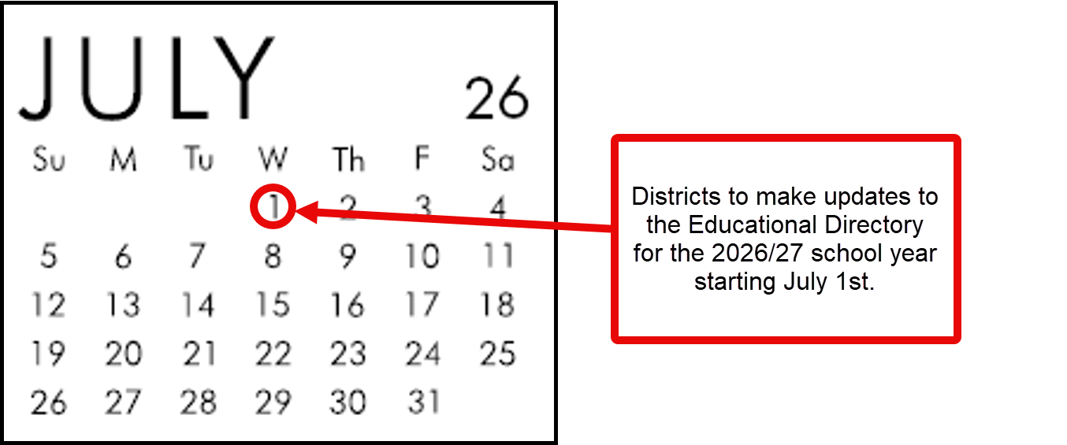
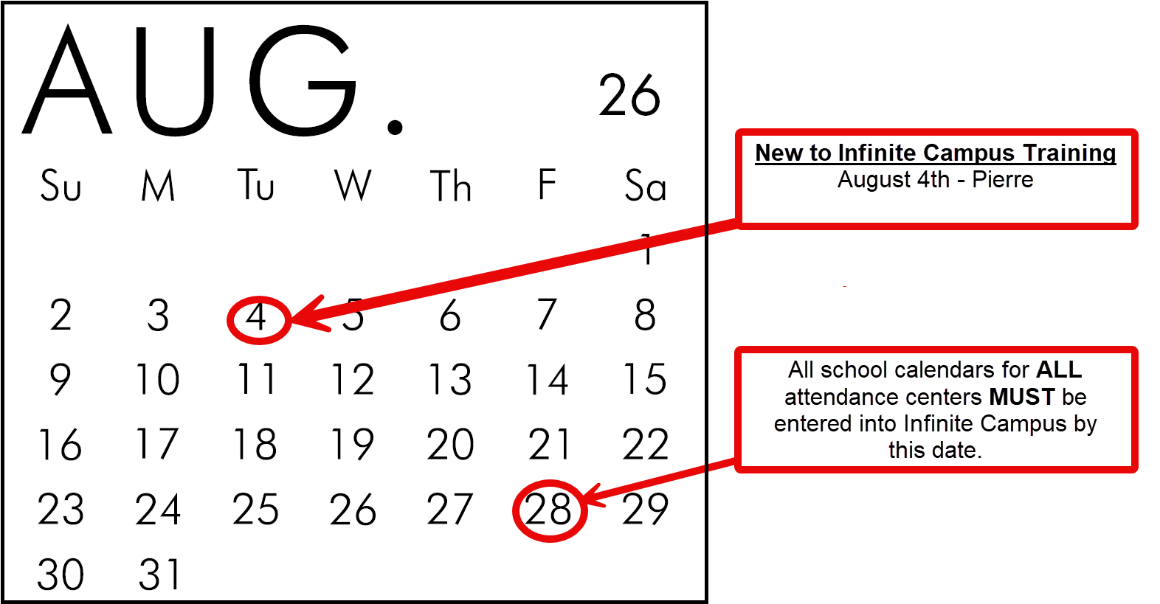
**Calendar Data: All school calendars for all attendance centers must be entered or uploaded into Infinite Campus by the last Friday in August. This includes any calendars that you have for your Preschools and After School Programs. Calendars for Summer Schools are due in the Infinite Campus system by the last Friday in April.
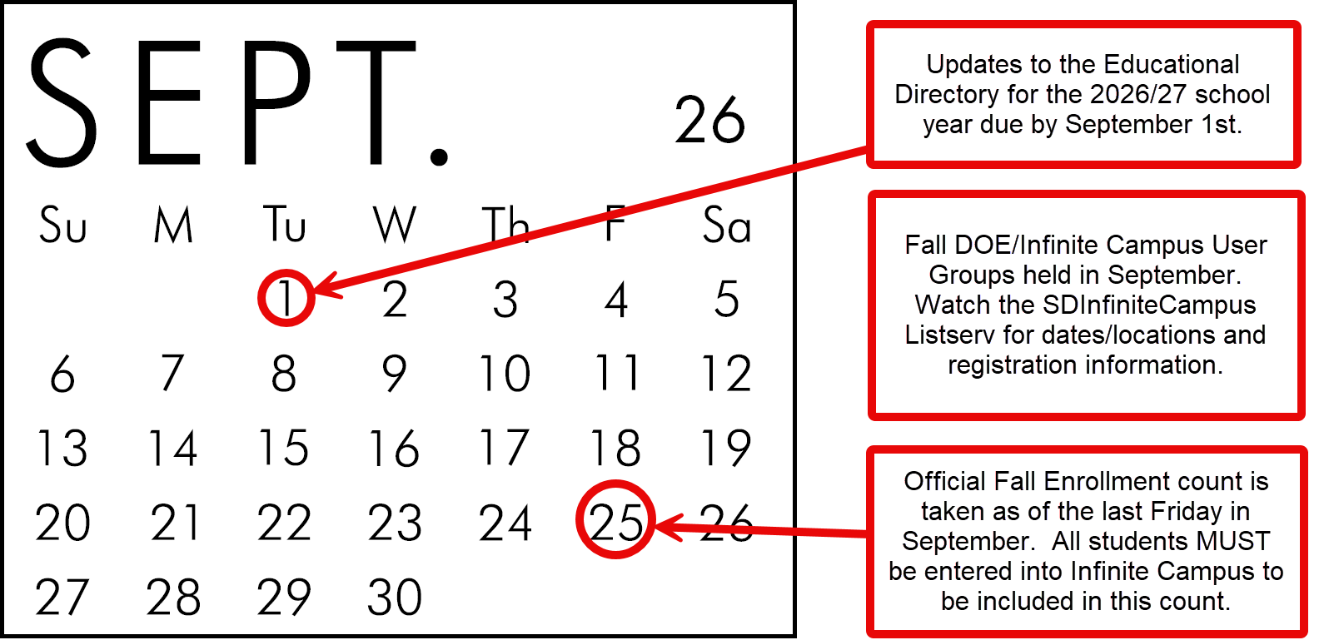

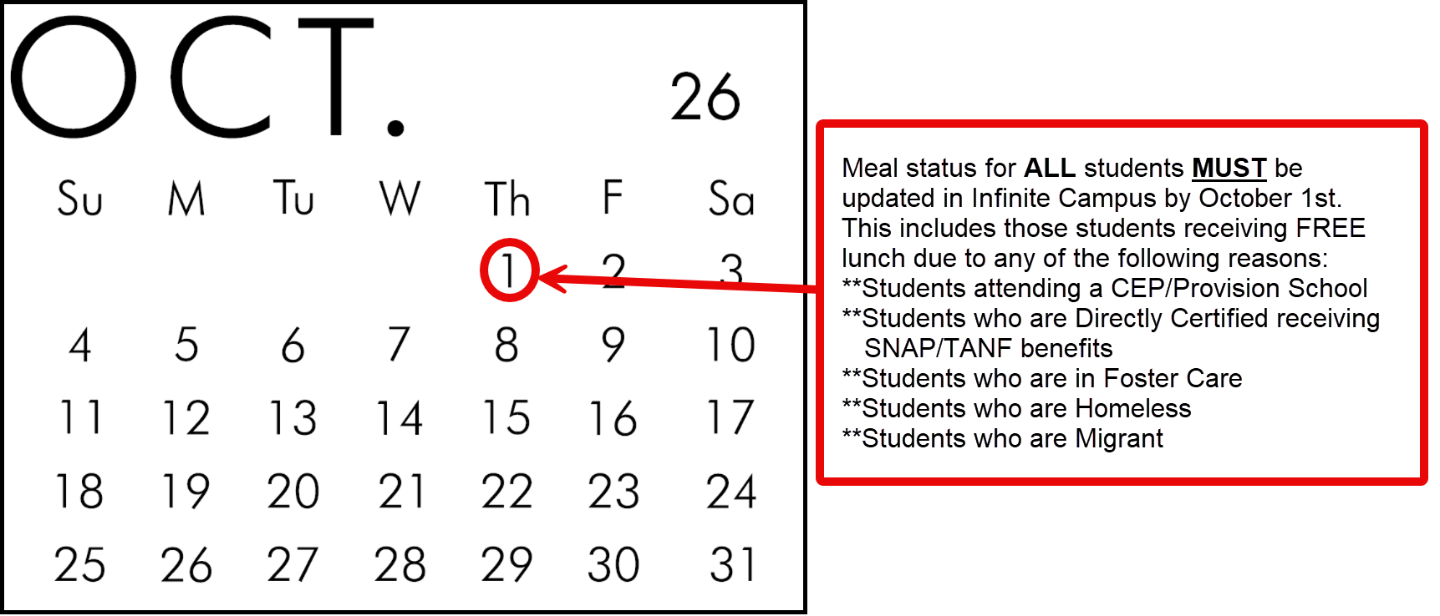

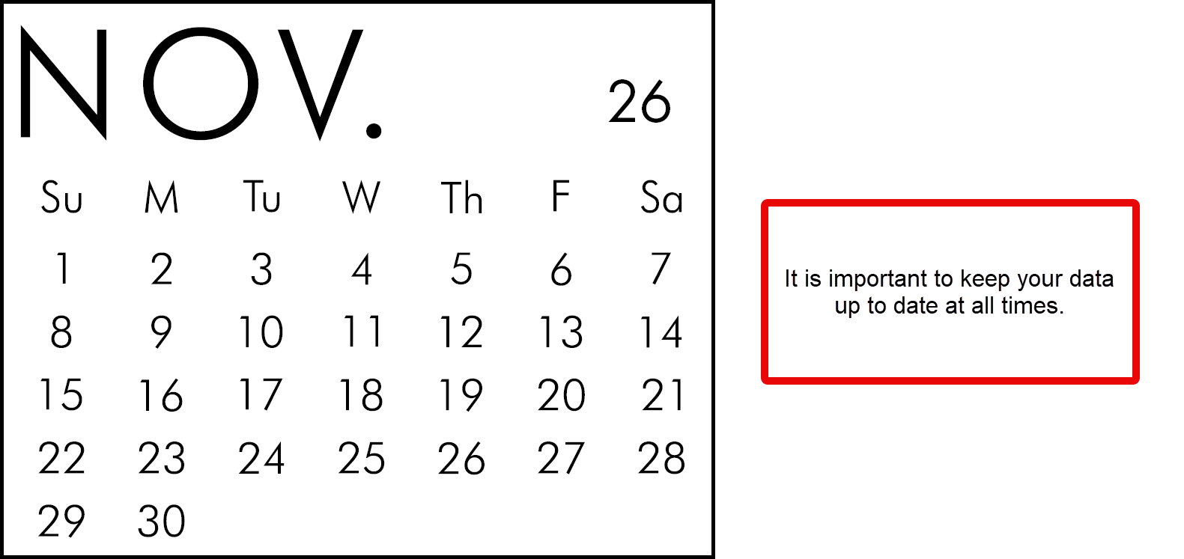
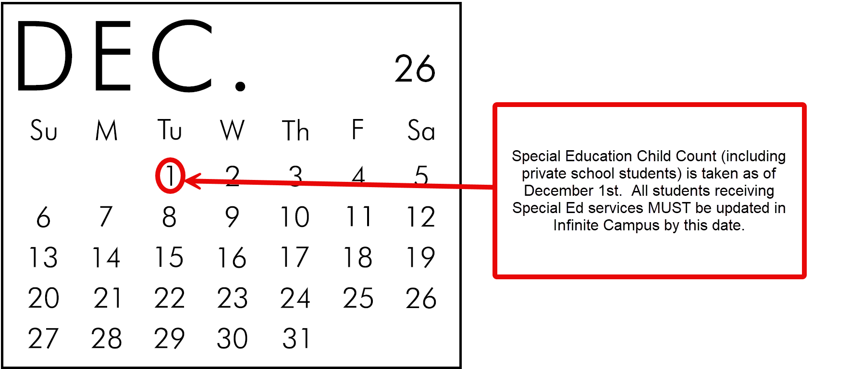

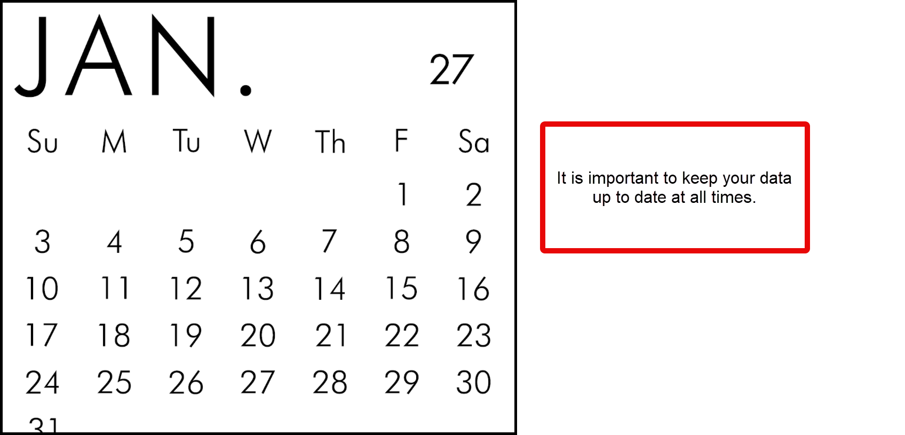

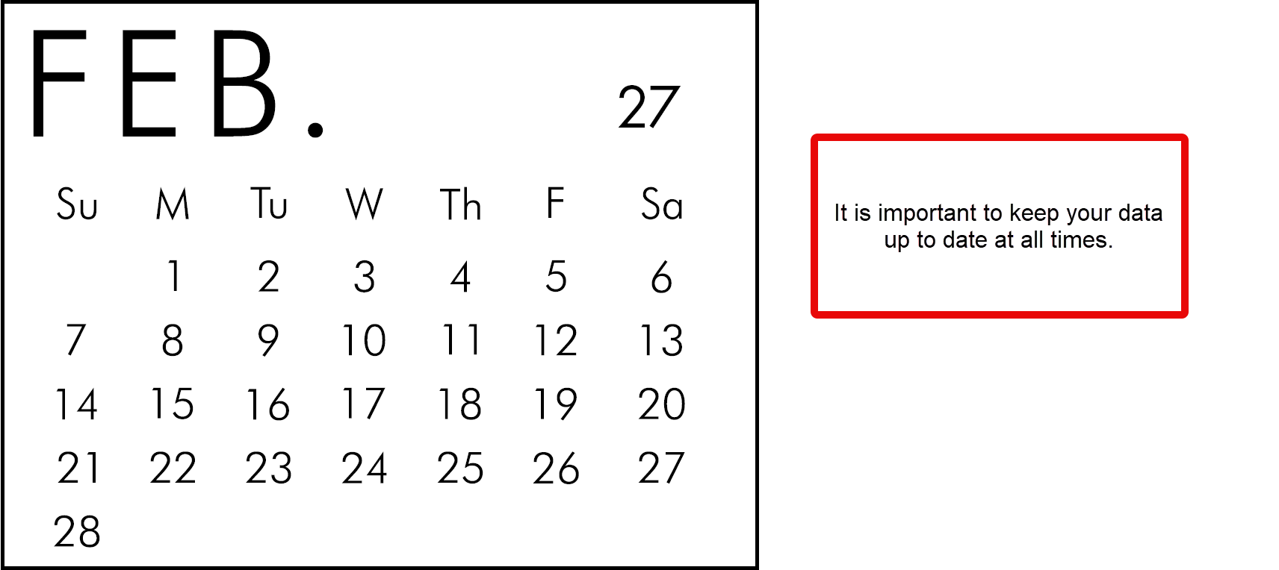
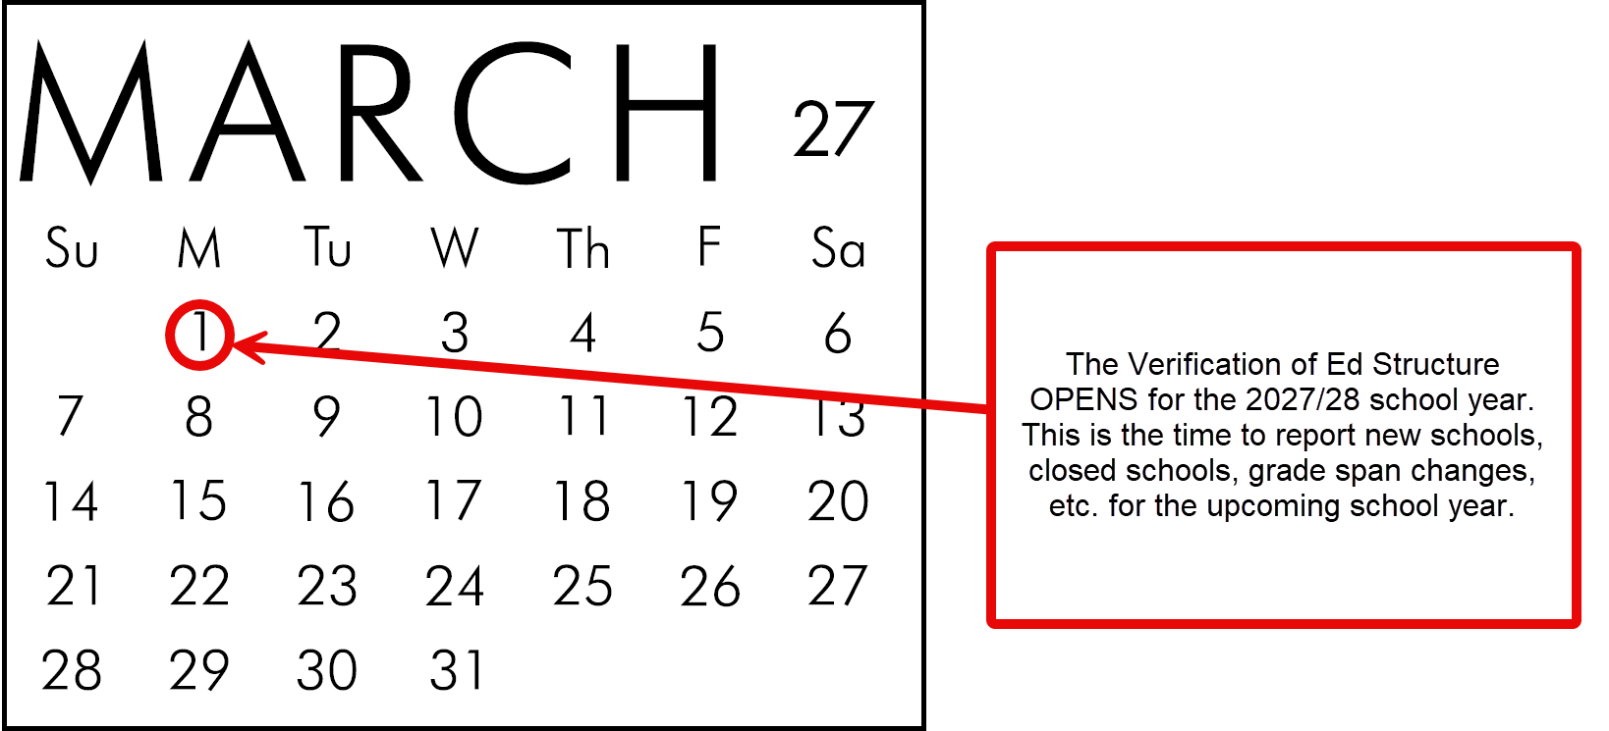

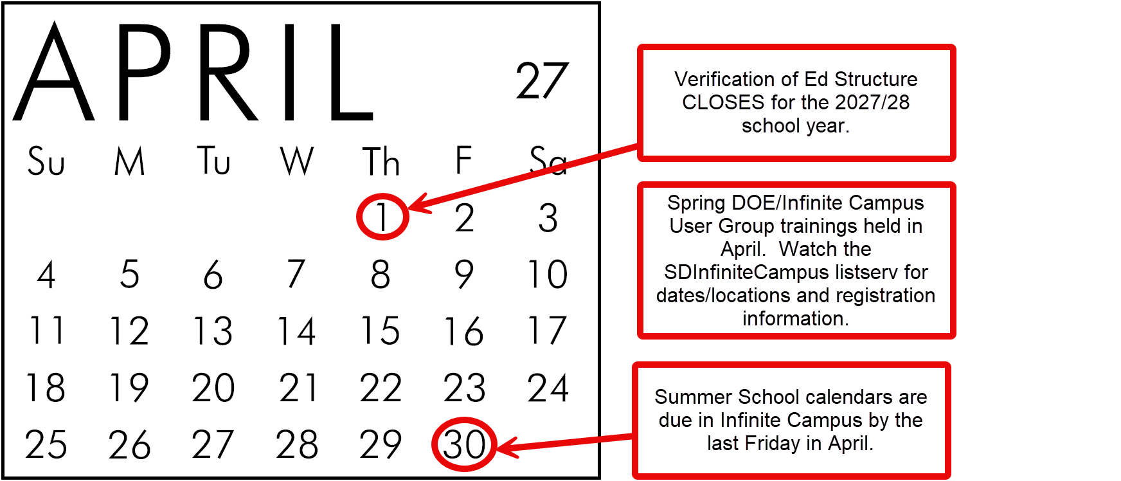

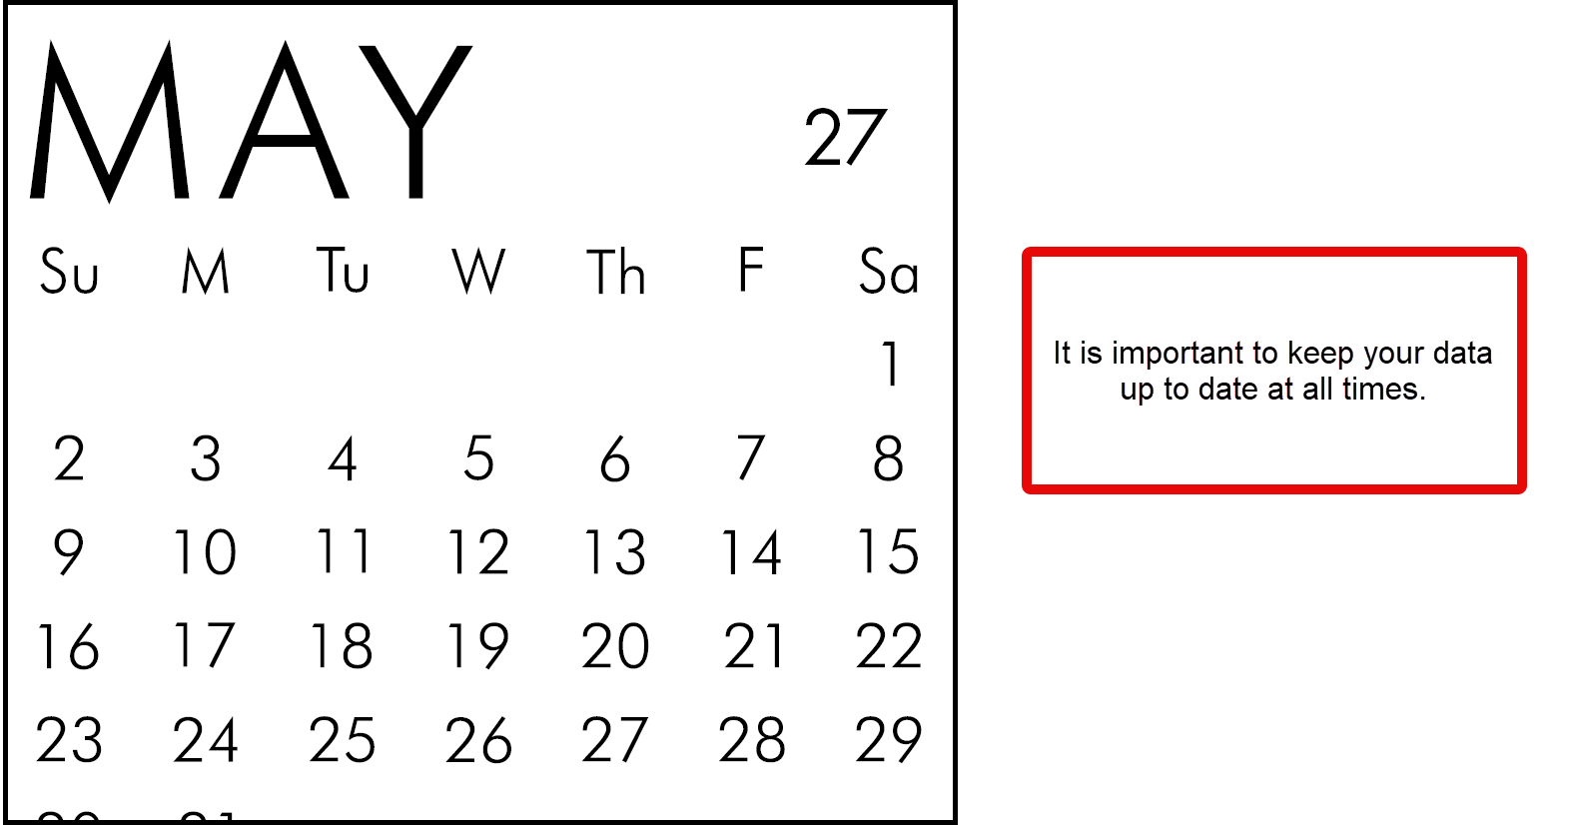

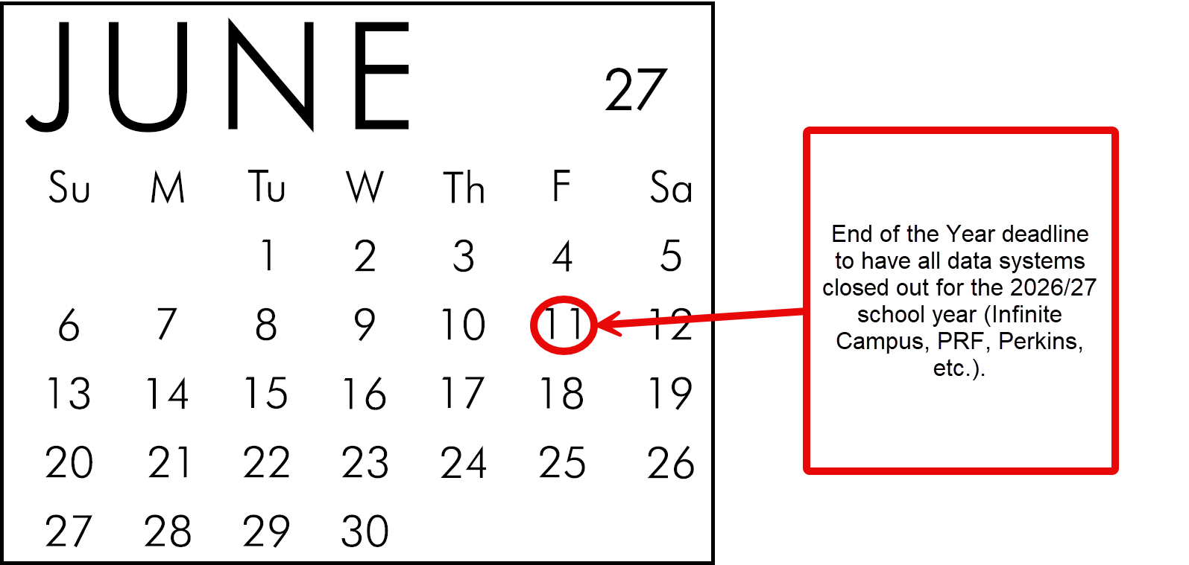

Fall Enrollment

Timeline
In accordance with 24:17:03:02 and 24:17:03:08 – Fall Enrollment student data must be reported in the Statewide Information Management System (Infinite Campus) according to the below timelines:
- Calendar Data: All school calendars for all attendance centers must be entered or uploaded into Infinite Campus by the last Friday in August. This includes any calendars that you have for your Preschool programs. Calendars for Summer School are due in the Infinite Campus system by the last Friday in April.
- Fall Data: All student enrollments must be entered or uploaded into Infinite Campus no later than 15 business days following the last Friday of September.

Criteria for Fall Enrollment – Census Count (Used for statistical reporting purposes)
- Students must be enrolled on the last Friday in September. Students who exit or fail to return to school by this date and students enrolling after this date WILL NOT be included.
- Students must be enrolled greater than 49% to be included in the Fall Enrollment – Census Count.
- Out of state students enrolled in South Dakota schools are included in this count.
- Enrollment in Pre-School is included in the Fall Enrollment Census Count.

Section I - Calendars
The first step in making sure your Fall Enrollment data is entered accurately is by creating a calendar for EVERY attendance center in your district. All school calendars are due by the last Friday in August according to 24:17:03:08. **This includes any calendars that you have for your Pre-School programs. Calendars for Summer School are due in the Infinite Campus system by the last Friday in April.
- Additional information regarding how to create a new calendar or modify an existing calendar in Infinite Campus can be found on the Campus Community at the following link: Infinite Campus Knowledge Base | Infinite Campus. Please contact your district’s Infinite Campus Tech Coordinator if you have any trouble accessing the information at the above link.
Please note: Both District Edition and State Edition users MUST roll forward their calendar information from school year to school year. State Edition users do not have the functionality to roll forward their students; therefore, Infinite Campus will roll forward your students after you have completed the calendar roll forward function.
Important Calendar elements that MUST be entered include:
- A calendar must be entered for EVERY attendance center including Pre-Schools, Sped Out of District Placements, Virtual Schools, Private Schools and Summer Schools.
- Check your school calendar dates and your student day minutes under Calendar Information.
- At a bare minimum, your calendar must include the following:
- Start date of the school year
- End date of the school year
- Student Day (instructional minutes)
- Whole Day Absence (minutes)
- Half Day Absence (minutes)
- Type
- Summer School – Only check if this is a Summer School calendar.
- 4 Day School Week – Only check this area of the calendar if the entire district is operating a 4-day school week.
- Virtual – Only check if this calendar is specifically for your students who are attending your school virtually.
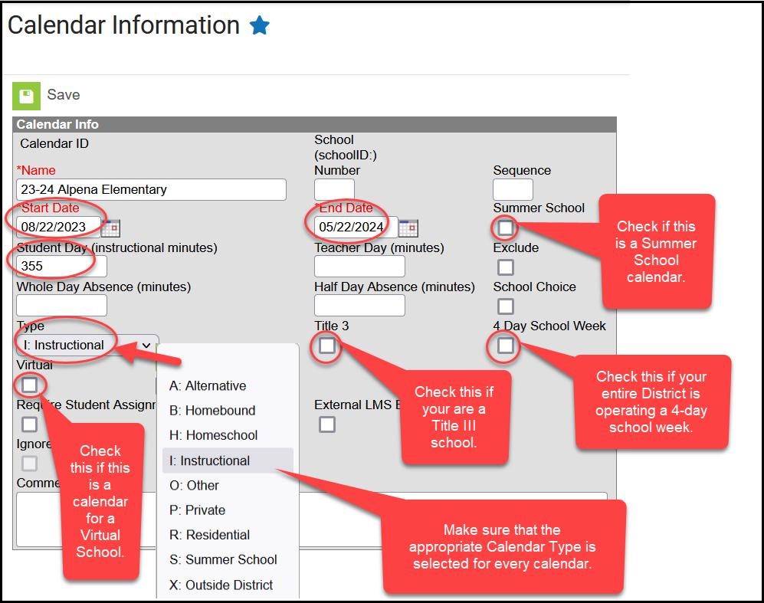
Virtual Calendars - Districts are allowed to create a separate calendar within an already existing school to house their students who are choosing to receive their educational services virtually.
To provide consistency throughout the state, the DOE is asking districts to name these virtual calendars as follows: Calendar Name = Name of School Virtual (Example = Alpena Elem Virtual).
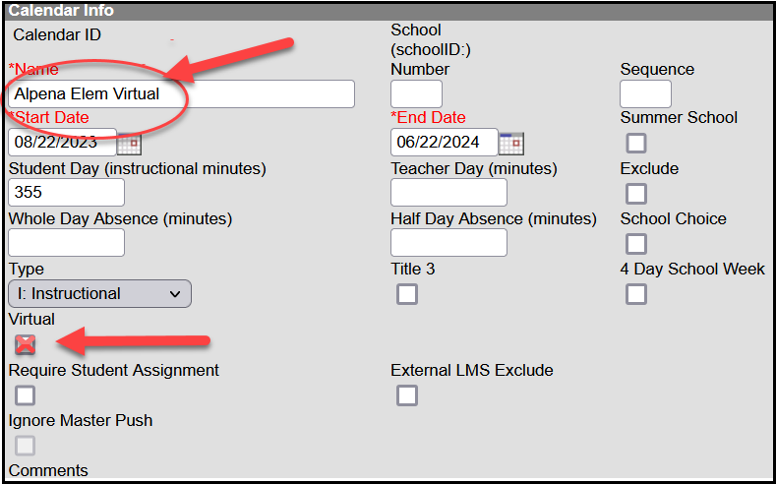
Districts must utilize their existing school structure and create separate virtual calendars for each attendance center. (Example: Alpena Elem Virtual calendar, Alpena Middle School Virtual calendar, Alpena Virtual High School calendar). Districts CANNOT create one virtual calendar for all their K-12 virtual students.
Grade Levels - Make sure that all grade levels that are being served within your school(s) are entered under the Grade Levels Setup. The district MUST then map all their local grade levels to the state grade levels. It is the district’s responsibility to make sure that the grade levels are mapped accurately.
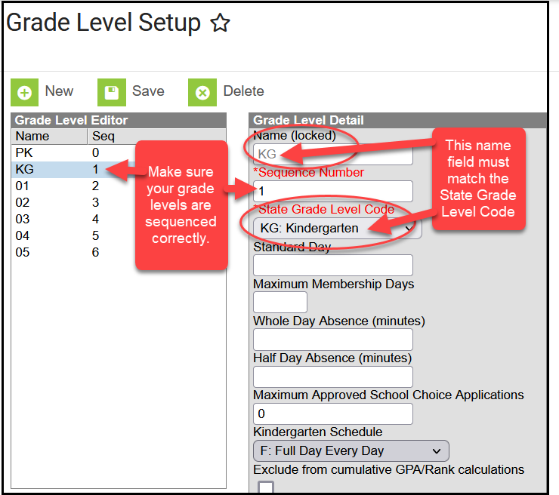
Terms - Do you operate on quarters, semesters, trimesters, etc.? Make sure that the start and end dates of your terms are correctly entered under the Term Setup.
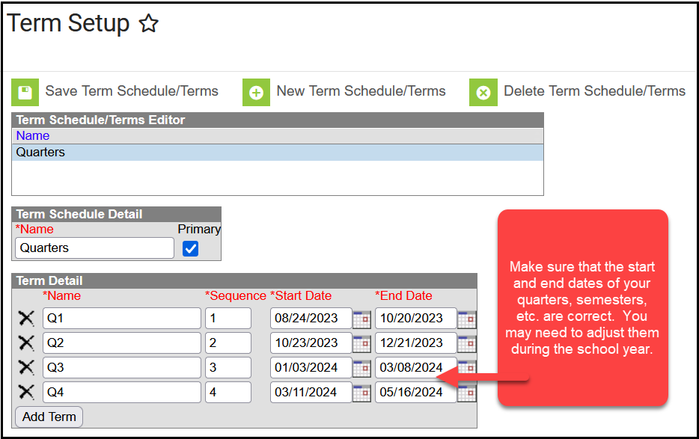

Periods - On the Period Setup screen enter your period schedule for a day. When entering the period minutes, you cannot overlap minutes. You are not allowed to count a class that is being held prior to the start of the school, home room minutes, lunch minutes, recess minutes, passing minutes or after school tutoring sessions as instructional minutes. Once you have entered your period schedule, it will automatically calculate the total instructional minutes for you.
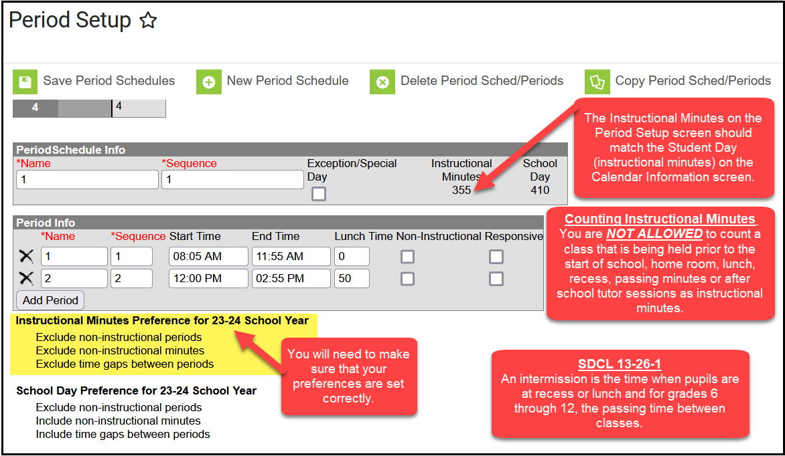
Days - If the Instructional Minutes are not calculating correctly you will need to check your preferences on Day Setup. The instructional minutes should read the same on the Calendar tab as they do on the Periods tab.
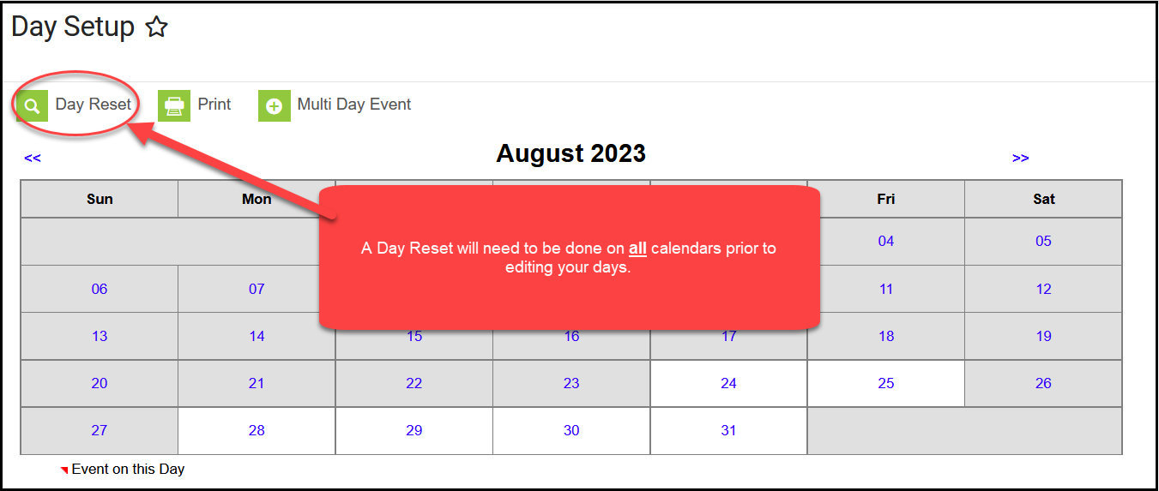
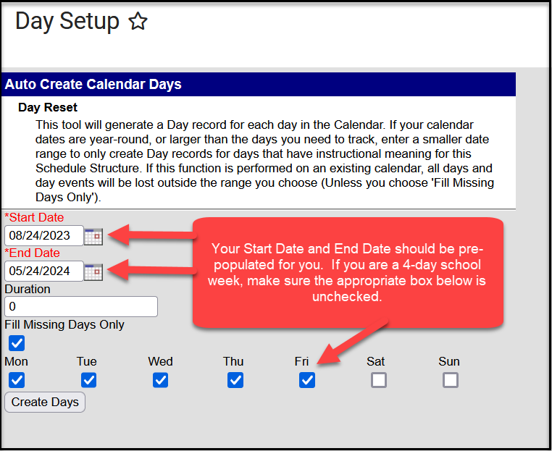
Enter the start and end dates and select the days that should be included in the reset (Monday, Tuesday, etc.). Select “Create Days”.
You will need to edit the start/end dates of the terms and any vacation days, etc. You can also set up day events such as Parent Teacher Conferences, In-Service Days, Holidays, etc. A “Day Reset” will need to be done for every calendar that you have in your District. If a “Day Reset” is not done, your numbered calendars days will not start over for the new school year.
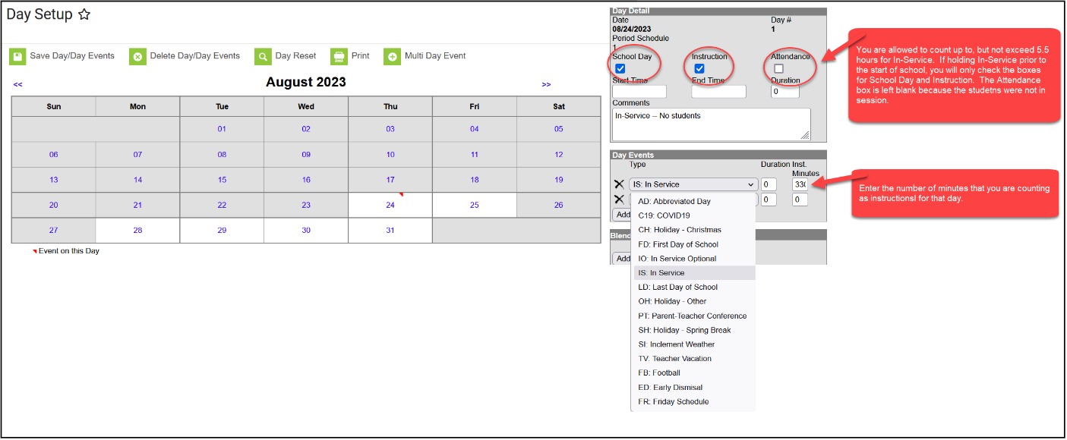

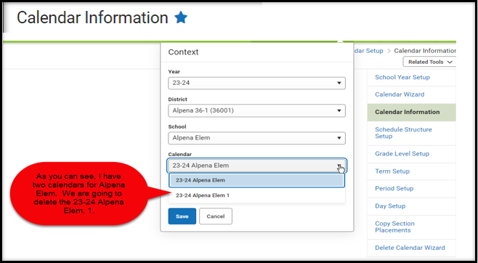
Deleting a Calendar
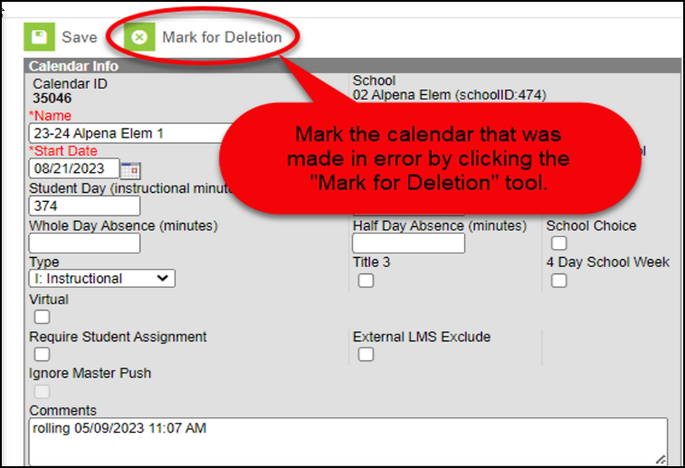
There are times when you may need to delete a calendar that was created in error. Select the calendar that you want deleted.
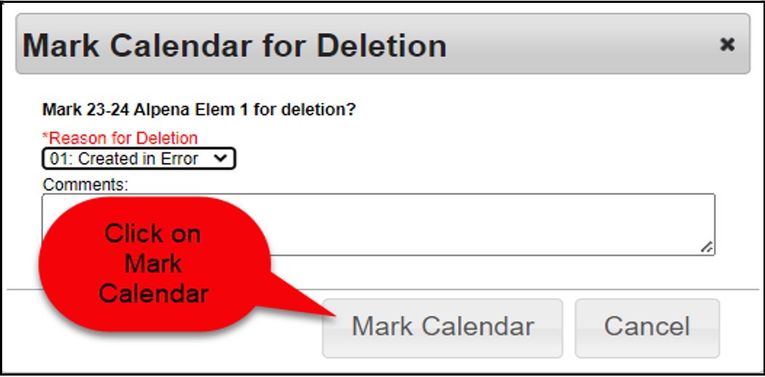

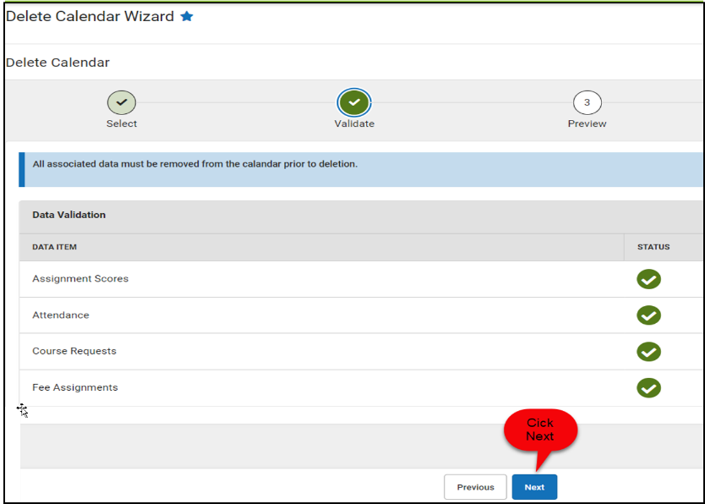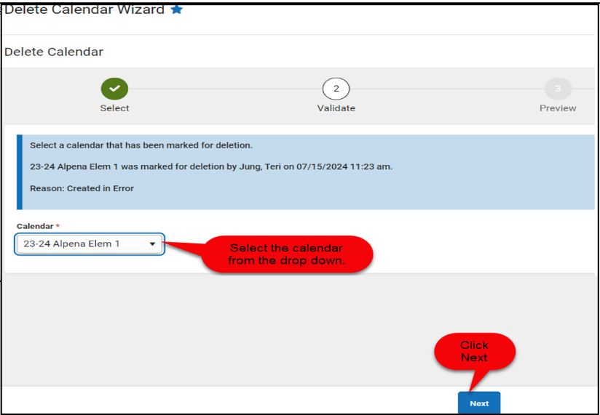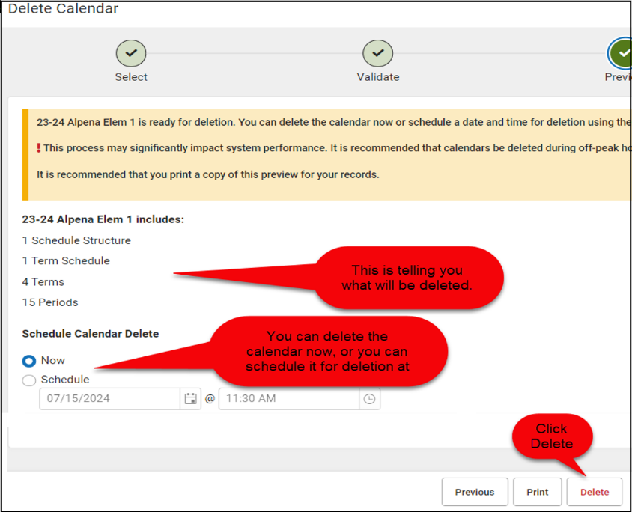

Section II - Student Enrollments
To get accurate Fall Enrollment counts, it is absolutely necessary that districts enter ALL student enrollments including Pre-School (PK) students into Infinite Campus in a timely manner. All students who attended your school district (even for a short time) must have an enrollment record in Infinite Campus.
Students not yet enrolled in Kindergarten but who are enrolled in a Pre-School program and are receiving a pre-school curriculum must be entered into Infinite Campus using PK as the grade level in the grade level field. Students must be at least 3 years of age prior to September 1st to be considered a pre-school student.

Enrolling a Student
The first step in enrolling any student is to search the Infinite Campus system to see if the student was ever previously enrolled in South Dakota. This includes doing a search for those entering Kindergarten as they may have previously been enrolled in Pre-school (PK) or may have previously received Early Childhood Special Education services (EC). These students will have already been assigned a State Student ID. To search for a student, you will use the Student Locator Wizard. Remember, if a student is transferring to your district from another SD district, the student should appear when you do a student locator search. If the student does not appear after the first search, try again using the “All People” search criteria. If you are still not able to locate the student, check and see if the student goes by a nickname or a different last name. If you still are unable to find the student in Infinite Campus and you know for certain that the child previously attended school in South Dakota, call Data Management at 605-773-3134 for assistance.
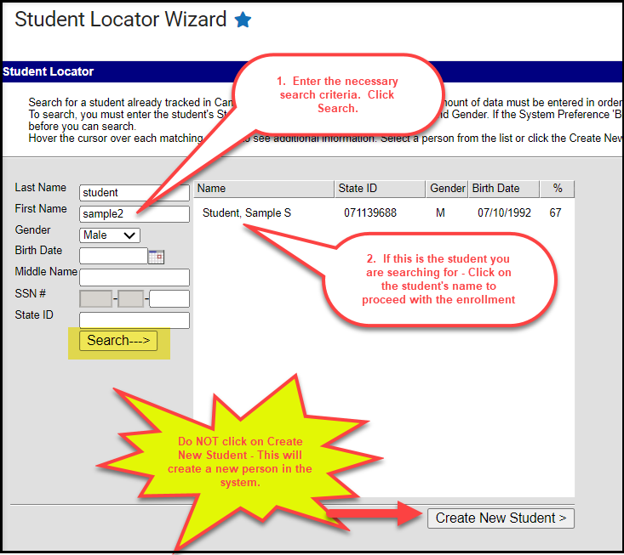
When enrolling a student, the student’s name should ALWAYS be entered as it appears on the student’s birth certificate or other legal documents. When entering student names, do not use commas. If the student goes by a nickname (ex: Chris instead of Christopher), you still need to enter “Christopher” in the First Name field and you can add “Chris” to the Nickname Field. If there is a hyphenated last name, you can use a hyphen (Merriman-Koch) or you can just use a space (Merriman Koch). Jr and Sr should be entered in the Suffix box. Do not “space” after the first or last name as the space is a character in Infinite Campus.
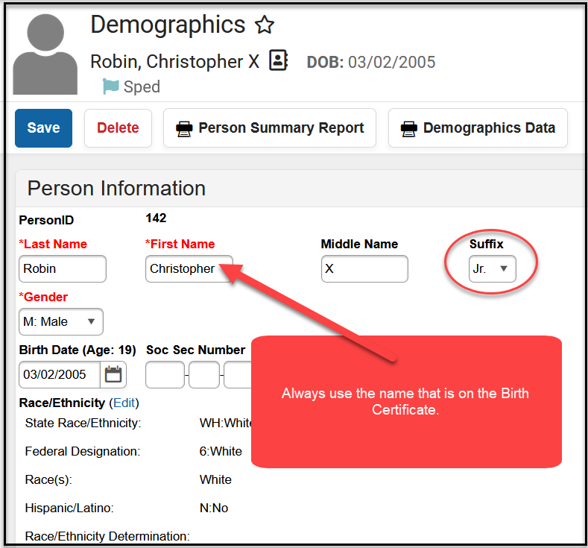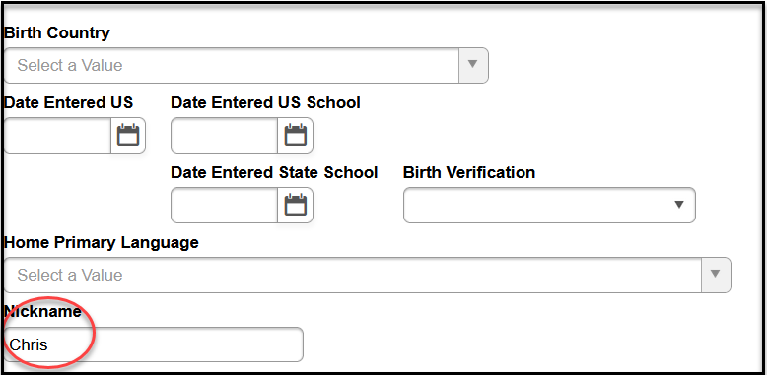

Please note that for transgender students, there is the option for you to enter the student’s legal name and legal gender as identified on the student’s birth certificate in the Protected Identity Information fields. For data entry of the name and gender for transgender students and tool rights to the Protected Identity Information, please follow your school district’s policy.
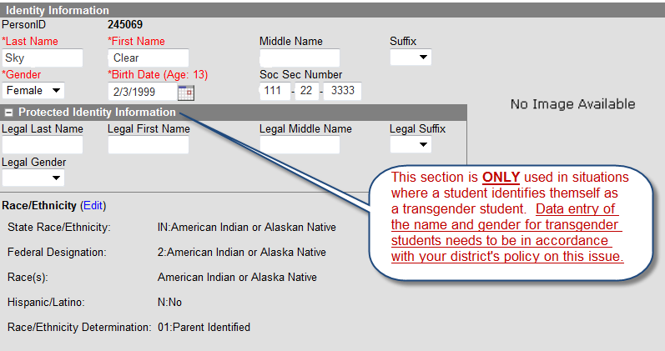

Race/Ethnicity
Within Infinite Campus, Race/Ethnicity data is located on the student’s Demographics and Identities screens. To enter or make a change in the Race/Ethnicity, click on the Edit button.
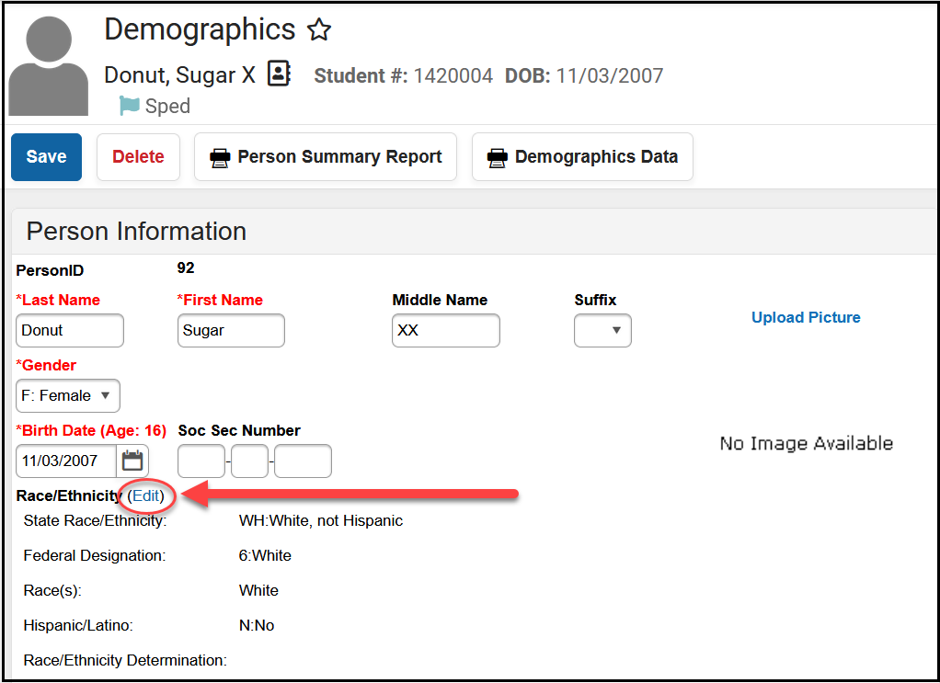

The below fields need to be populated for all students.
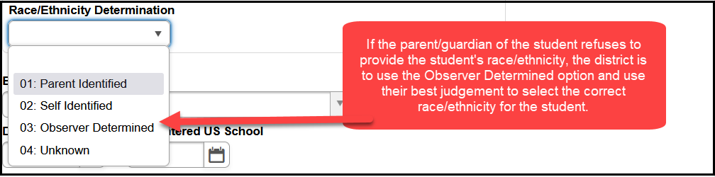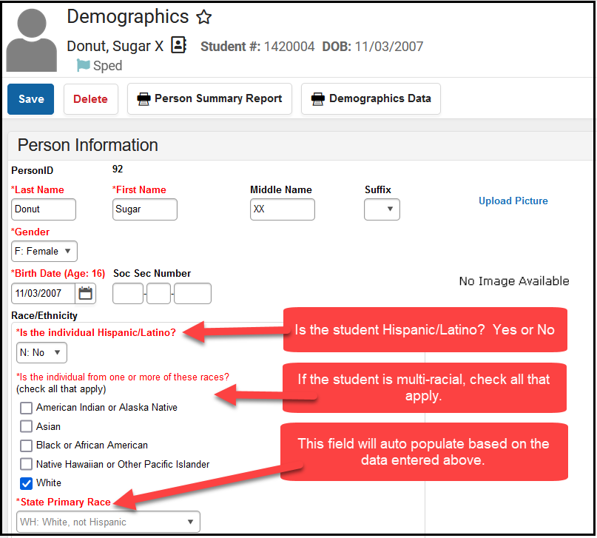
If a parent/guardian of a student refuses to self-identify the race/ethnicity of the student, it is the district’s responsibility to use the Observer Determined Identification method to determine the race/ethnicity of the student. The Observer Determined Identification method means the district staff are using their best judgement as to what the correct race/ethnicity of the student is. This is then what is recorded in Infinite Campus.

Enrollment Tab
Below you will find screen shots of the Enrollment Tab along with the required data fields and possible entries highlighted.
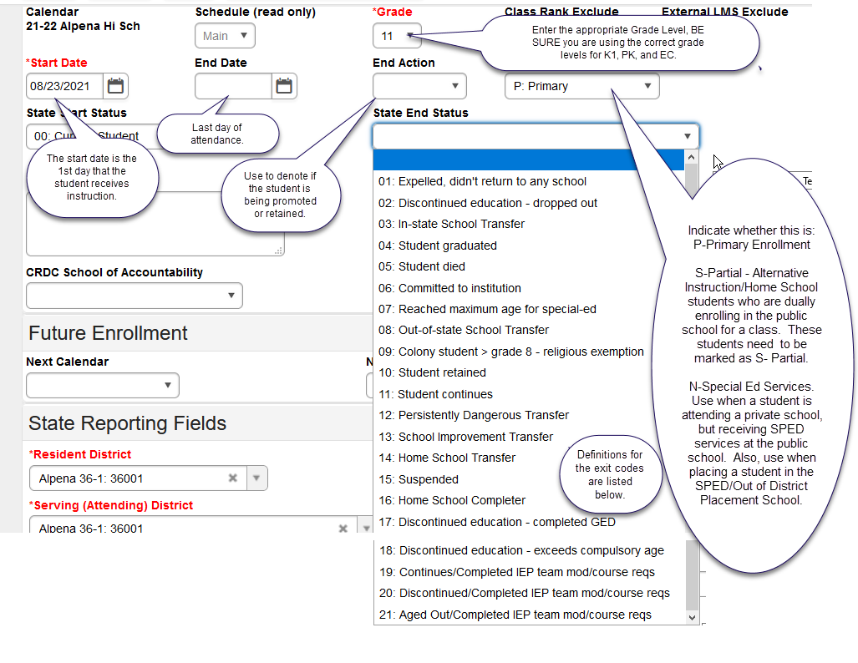

Grade Level - Definitions:
PK is used when a student is attending Pre-school. Students must be 3 or older prior to September 1st of the school year. These students are those participating in a pre-school curriculum.
K1 is used Junior Kindergarten. If your district offers a Junior Kindergarten program, a student enrolled in Junior Kindergarten would be considered the same as a Kindergarten student for data collection purposes. The student must be at least 5 years old by September 1st to be counted for State Aid funding purposes. Attendance IS required for K1 students.

Service Type - Definitions:
Service Type describes if the enrollment is Primary (P), Partial (S), or Special Ed Services (N).
Primary (P) In most cases, students cannot have multiple primary enrollments. If a student has dual enrollments, the school districts must agree to identify one enrollment as the primary enrollment and the second enrollment as partial. Dual enrollments CANNOT be split 50/50. Instead, the split should be 51/49 with the 51% enrollment marked as primary and the 49% enrollment marks as partial.
Partial (S) A student’s enrollment should be marked as Partial (S) if the student is enrolled 49% or less in the school district.

End Status – Definitions:
01: Expelled, didn’t return to any school - The action of the school board that terminates a pupil’s membership in school for not more than 12 consecutive months.
02: Discontinued education – dropped out (any student that is under the compulsory age of 18). This is used if a student is under age 18 and (1) the student/parent indicate that they are dropping out or (2) if the student does not show for the school for 15 consecutive school days. Dropouts count for the year they fail to show up for. For example, a student may have completed the 2025/26 school year but fails to show up for the 2026/27 school year. In this case, the school would create a 2026/27 enrollment record. Both the start AND end dates would be the first day of the 2026/27 school year and the End Status would be updated to 02-Discontinued education- dropped out.
03: In-state School Transfer - Transferring from your district to another SD district.
04: Student graduated - A student who has attained sufficient credits to receive a regular high school diploma. This end status code can only be used for students who are enrolled in the 12th grade.
**DO NOT mark your Kindergarten or 8th grade graduates as graduates.
**DO NOT mark your special education students who plan to continue receiving services until the age of 21 as graduates. You should use the End Status Code of 11: Student Continues for these students. Once a student is marked as a graduate, that student is not eligible to receive services until age 21 nor is the district eligible to receive State Aid for these students.
**DO NOT mark your foreign exchange students as graduates as chances are they did not meet the criteria to obtain a regular high school diploma in SD. If they are returning to their home country, you should use the End Status Code of 08: Out of State School Transfer.
**DO NOT mark Alternative Instruction/Home School students as graduates if they are completing Alternative Instruction/Home School course work. If the Alternative Instruction/Home School student is dually enrolled in your district, you should use the End Status Code of 16: Home School Completer on the S-Partial Enrollment record. If the Alternative Instruction/Home School student is more than 50% enrolled in your district, you can mark the student as a graduate on the student’s P-Primary enrollment record.
05: Student Died
06: Committed to institution - Student is being served at: SD Human Services Center or the State Penitentiary.
07: Reached maximum age for special ed - 21 years of age.
08: Out of state School Transfer - Student moving out of state.
09: Colony student > Grade 8 - Religious exemption
10: Student retained
11: Student continues
12: Persistently Dangerous Transfer – Only to be used if your public school has been designated as a Persistently Dangerous School and the student is choosing to transfer to a different school due to this designation.
13: School Improvement Transfer
14: Home School Transfer - Student leaving public school and transferring to Alternative Instruction/Home School.
15: Suspended - The exclusion of a pupil from a class or classes for not more than 90 days.
16: Home School Completer - Student completes their Alternative Instruction/Home School course work. This is used if a student is receiving Alternative Instruction/Home School through the 12th grade. Since they do not receive a regular high school diploma, this code indicates they are completing their Alternative Instruction/Home School program.
17: Discontinued education – completed GED - When a student has completed their GED credential through an approved high school equivalency test preparation program, the enrollment record can be ended with the end status code of “17: Discontinued education – completed GED”. This end status code should not be used prior to the student completing the GED credential.
18: Discontinued education - Exceeds compulsory age (18 years of age).
19: Continues – Completed IEP team modified Course requirements – Students with disabilities whose requirements differed to those required for all students. These students may participate in graduation ceremonies, but the students are not considered graduates for reporting purposes and are still eligible to receive SPED services until age 21.
20: Discontinued education – Completed IEP team modified course requirements – These students would be coded 03- Continues – Completed IEP team modified course requirements (in the Special Education fields in Infinite Campus) at the end of a school year but then dropped out and didn’t continue education during the next year without completing the regular graduation requirements. This code should be used to end the record that rolled forward.
21: Aged Out – Completed IEP team modified course requirements - These students will have been previously coded as 03- Continues – Completed IEP team modified course requirements (in the Special Education fields in Infinite Campus) until the end of the fiscal year in which they turned 21 when this code is used to end their record.
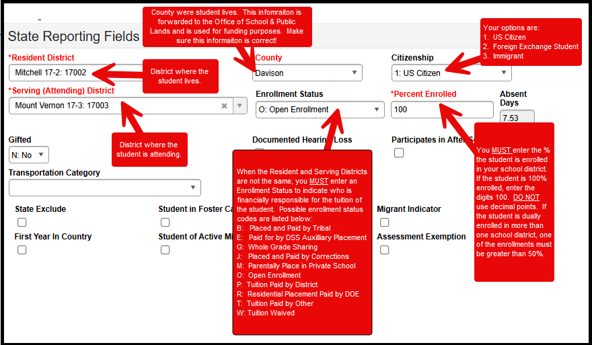

Resident District
This is the school district where the student lives.

County
This is the county where the student lives NOT the county where the school district they are attending is located.

Serving (Attending) District
This is the school district where the student is attending school at.

Citizenship box
Be sure all your students have the correct citizenship status reflected for their situation.
1: US Citizen – the student is a citizen of the United States.
2: Foreign Exchange Student – the student is not a citizen of the United States but is participating in a foreign exchange program and is attending your school.
3: Immigrant – The term immigrant children and youth mean individuals who:
- Are aged 3 through 21;
- Were not born in any State; and
- Have not been attending one or more schools in any one or more States for more than 3 full academic years. “Three full academic years: = cumulative”. A student can only be considered an immigrant for three full academic years for the Title III funding purposes.
- Please note the term “immigrant “as used in Title III is not related to an individual’s legal status in the United States.

Enrollment Status – Definitions
The Enrollment Status field is used to identify how the student came to your school and who is financially responsible for the student. If the Resident and Attending districts are the same, typically there is no need to complete this field. However, D: Persistently Dangerous refers to the rare case when a student switches schools as described at https://doe.sd.gov/ofm/sdgf.aspx. A: School Choice is no longer a valid option.
B: Placed and Paid by Tribal
- Used primarily by BIE schools.
- In few cases, public schools could use the code if the student is attending a residential treatment program operated by public school districts but paid for by the tribe.
E: Paid for by DSS Auxiliary Placement
- Use when the student is placed by the Department of Social Services. Resident district for students with E code must be either Custody of the State (90090) or DSS Aux Placement (68302).
- If the student is a Foster Child placed with a family in your school district, this Enrollment Status code SHOULD NOT be used. A Foster Child should be coded as any other resident student in your school district.
G: Whole Grade Sharing
- Refer to SDCL 13-15-31. All school districts shall adopt the contract or agreement no later than February 1st of the school year proceeding the school year for which the agreement will take effect. The Department of Education must approve the agreement for whole grade sharing. The only districts currently approved to use this Enrollment Status are:
  - Burke and South Central
  - Bowdle and Edmunds Central
J: Placed and Paid by Corrections
- Use when the student is placed by the Department of Corrections. Resident district for students with J code must be either Custody of State (90090) or Department of Corrections (49321).
M: Parentally Placed in Private School
- Use when the student is attending a private school paid for by the parent.

O: Open Enrollment
- Use when a student lives in one South Dakota school district but chooses to attend another South Dakota school district.
- Use for “cross-border” enrollments with North Dakota and Minnesota.
- If the student changes address during the school year that results in a change in their resident district, then the previous enrollment must be ended and a new enrollment entered with the updated resident district and the correct county of residency. In addition, Open Enrollment does not apply to students who are homeless and remain in the school of origin after moving to a different district.
- PK students CANNOT be coded as Open Enrolled.
P: Tuition Paid by District
- Use when the resident district is paying for the student’s placement in another school district/facility.
- Use for an Iowa student enrolling in South Dakota.
R: Residential Placement Paid by DOE
- Use for students placed in one of the below facilities associated with a SD public school district, for whom DOE is paying the tuition for their placement. Psychiatric Residential Treatment Facility (PRTF)
  - Plankinton – Aurora Plains Academy (Intensive PRTF)
  - Huron – Our Home ASAP (PRTF)
  - Mitchell – Abbott House (PRTF)
  - Parkston – Our Home (PRTF)
  - Spearfish – Spearfish Academy at Canyon Hills (Elementary and High School) (PRTF)
  - Sioux Falls – Summit Oaks Residential (PRTF)
  - Rapid City – Abbott House West (PRTF)
T: Tuition Paid by Other
- Use for students attending the School for the Deaf in Harrisburg & Brandon Valley
- Use for a South Dakota student enrolling in Iowa. (This pertains to Alcester-Hudson & Elk Point-Jefferson only).
- If the student’s tuition is being paid by an outside entity, such as a foundation or a program.
- PK non-resident students attending a public school and tuition is charged. “T: Tuition Paid by Other” is needed as PK students cannot have the enrollment status of “O: Open Enrollment”.
W: Tuition Waived
- This code is used for students attending the School for the Blind.
- PK non-resident students attending a public school and no tuition is charged. “W: Tuition Waived” is needed as PK students cannot have the enrollment status of “O: Open Enrollment”.

Percent Enrolled
According to 24:17:01:06, you must report the percentage of the day that the student is enrolled. A full-time student or 100 percent enrolled student is any student who is carrying a full course load. The term, full course load, means any student who is enrolled in at least five courses or is scheduled for a full school day. The term, full school day, means the amount of time in the day between the start and end of classes during an average school day. If any student is enrolled in less than five classes or does not attend school for the full school day, the student shall be reported based on the percentage of classes taken OR the portion of the full school day that the student is in school.
ENROLLMENT PERCENTAGE BASED ON AT LEAST 5 COURSES
Standard or Block Schedule  # OF CLASSES (8 Periods) | Trimester Schedule  # OF CLASSES (5 Periods) | % ENROLLED
1 CLASS | 1 CLASS | 20%
2 CLASSES | 2 CLASSES | 40%
3 CLASSES | 3 CLASSES | 60%
4 CLASSES | 4 CLASSES | 80%
5-8 CLASSES | 5 CLASSES | 100%

Enrollment % Changes during the School Year
During the school year a student’s enrollment percentage may change. A student may add a class, drop a class, or their resident district may have changed, etc. It is important to maintain a history of all enrollment records with the different enrollment percentages.
When a change occurs, the original enrollment record must be ended (using Exit Code 11: Student continues) as the end status and a new enrollment record created with the new enrollment percentage. In order to maintain the schedule and attendance information, it is important to create the new enrollment first before ending the old enrollment. The creation of the new enrollment record is required to maintain the history of the student’s enrollment records through the school year.

FERPA Program Screen
Information regarding whether the district can share student directory information, that is protected by FERPA, is collected via the FERPA program screen in Infinite Campus. Districts are required to obtain parental consent on student directory information on an annual basis. This information is normally collected during the start of year enrollment process. The FERPA program screen collects the following information:
Question 1: Do you grant permission for your student’s contact information to be provided to the US Military for the sole purpose of informing students of potential career opportunities? Required for grades 9 – 12 in compliance with ESSA/Title 10 (10 U.S.C. 503).
Question 2: Do you grant permission to share information with SD BOR/SD Tech Colleges? Required for grades 7 – 12 in compliance with SDCL 13-28-50.
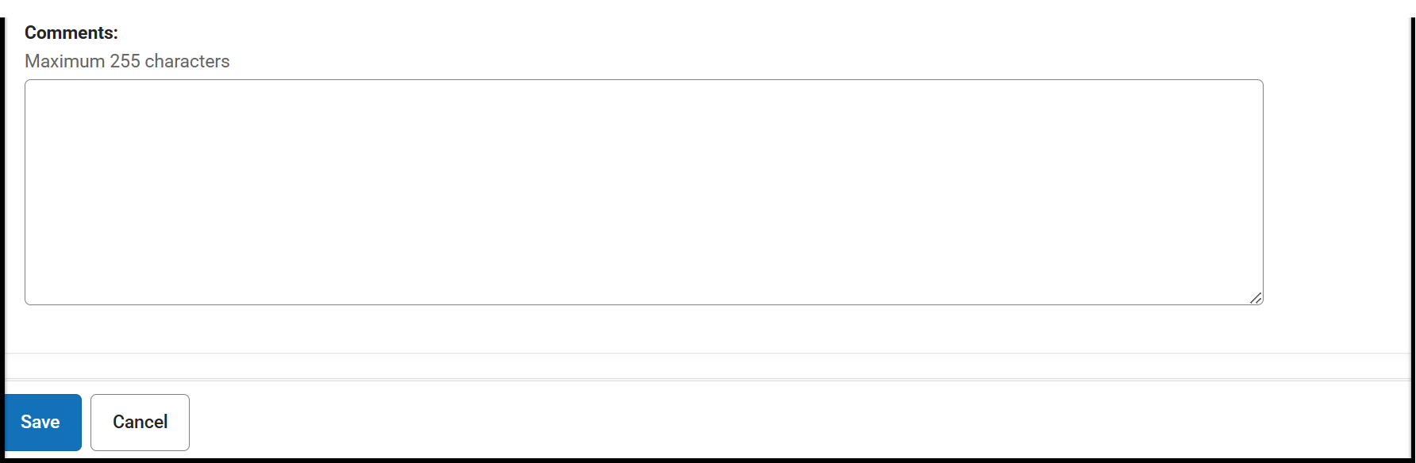
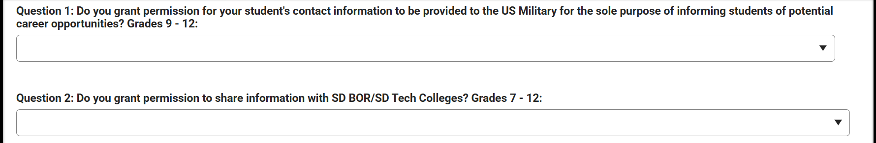
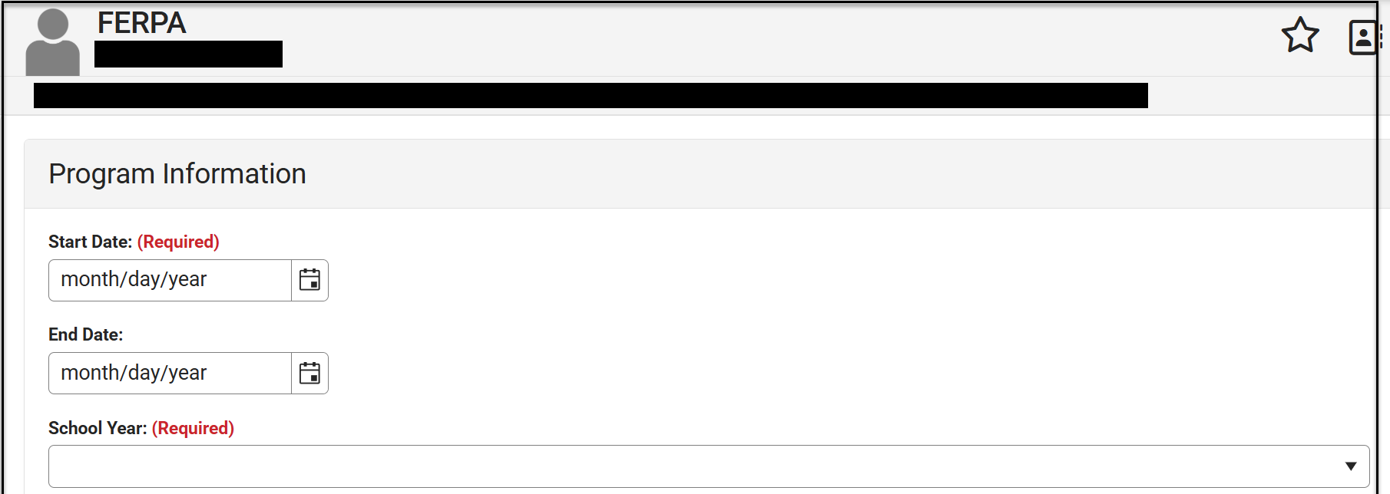
Example of Completed FERPA Program Screen
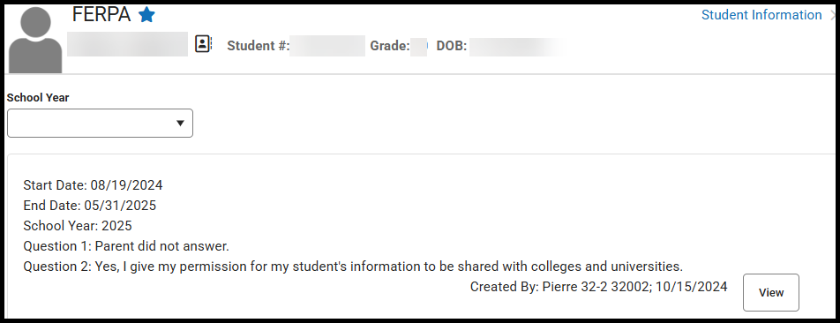
Enrollments for Students who are 100% Enrolled in Online/Virtual Courses
For enrollment, students who are 100% enrolled in online/virtual courses are treated like every other student in the district. For school districts agreeing to provide these alternatives to “traditional education”, the district is agreeing to be accountable for these students in all capacities just like every other student in their district. To be counted as a student enrolled at 100%, the student needs to be enrolled in five online/virtual classes and have logged into at least one of the five courses prior to the end of the day on the last Friday in September. Recording the attendance in Infinite Campus is REQUIRED for all students enrolled in online/virtual courses. The Attendance policy is a local decision.

Enrollments in Infinite Campus
- Students participating in online/virtual programs must have an enrollment record in Infinite Campus in the calendar (elementary, middle school, & high school) in the school that the student will be attached to. As noted previously, you can create a separate calendar to house these online/virtual students, if you wish.
- The student will be coded as 100% enrolled.
- This will be considered the student’s Primary enrollment.
- These students MUST be tested.
- Recording the attendance in Infinite Campus is required.

Enrollment Record of a student who is a resident within your school district and participating in Online/Virtual Courses
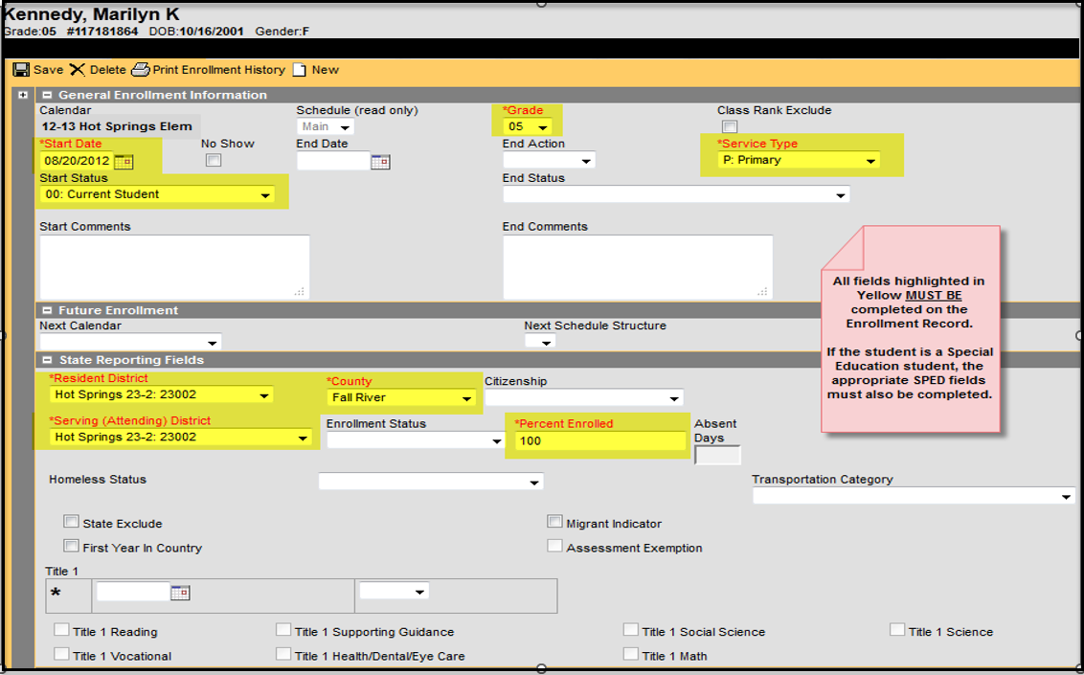

Section III – High School Requirements

High School Grade Progression
Districts are to progress students through all high school grade levels (9, 10, 11 and 12). The progression from one grade level to the next doesn’t always need to coincide with the start/end of the academic school year but rather should occur as the high school credits are earned. The enrollment records of all students graduating from high school with the 04: Student Graduated code, should be in the 12th grade, even if the student is graduating in less than 4 years. Remember, students need to be progressed through all grade levels.

Updating the Graduation Tab
To provide consistency and to aid with the numerous data requests received for graduation information, we ask all school districts to complete the below circled fields for all students who are graduating.
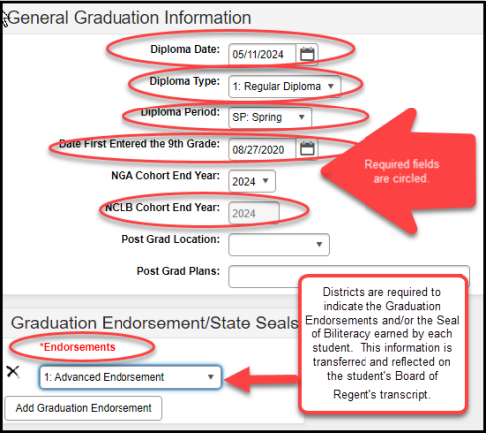

Graduation Endorsements/State Seals
South Dakota’s current requirements for graduation were passed by the Board of Education Standards on July 16, 2018. Those requirements are outlined in South Dakota Administrative Rule 24:43:11. The requirements include a base of required coursework and the ability for students to earn advanced endorsements on top of that base. The requirements are designed to provide flexibility for students to meet their postsecondary and career aspirations within a framework of general requirements.
Districts are REQUIRED to indicate on the student’s GRAD Tab in Infinite Campus if a student has earned one or more of the three Graduation Endorsements.
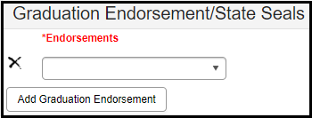
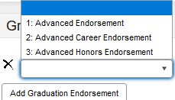
There is a canned report under SD State Reporting named “Graduation Data Extract” that will list the Graduation Endorsement that a student has earned. You must have rights to this report to run it.

Advanced Endorsement
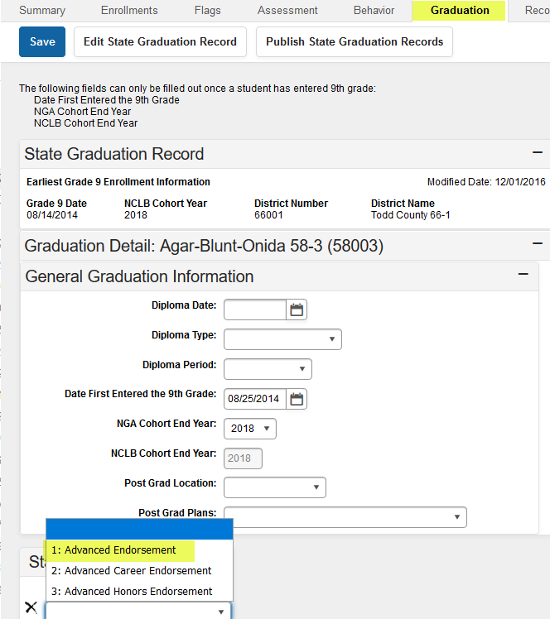
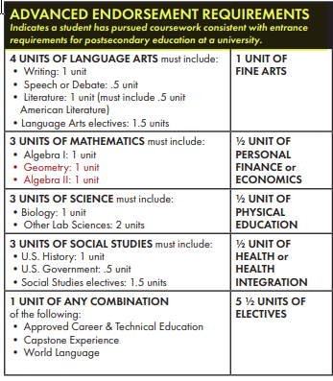

Advanced Career Endorsement
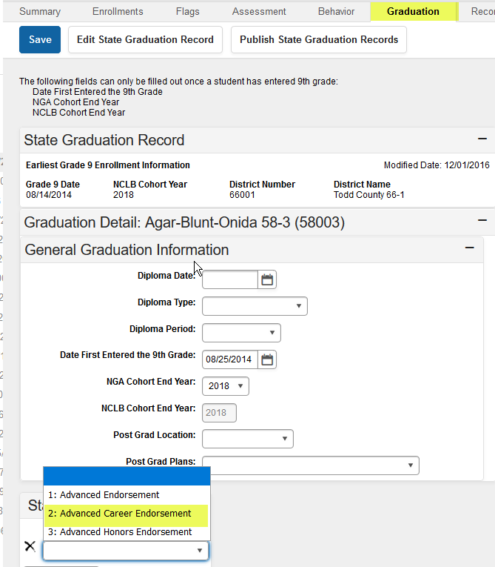
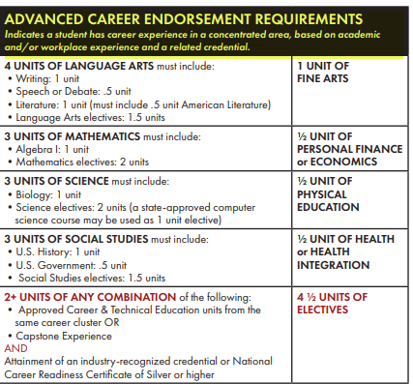

Advanced Honors Endorsement
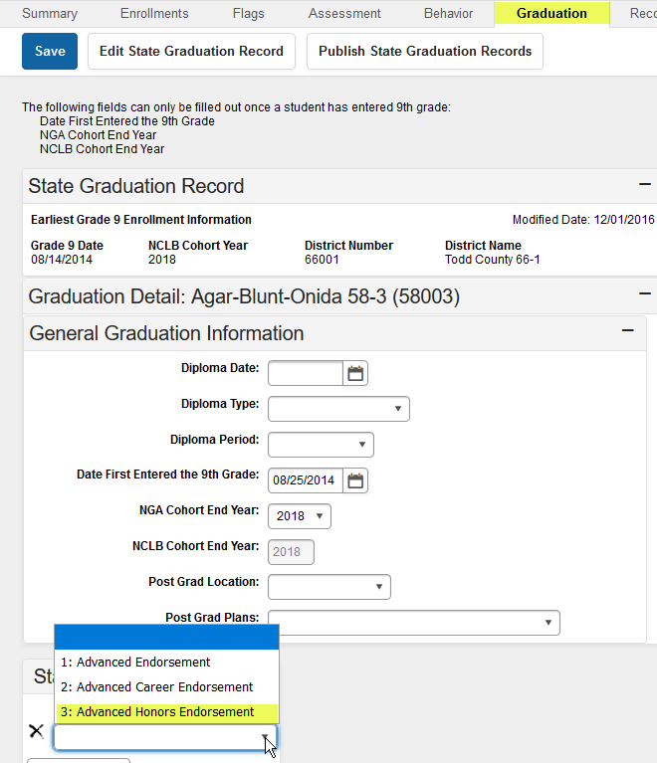
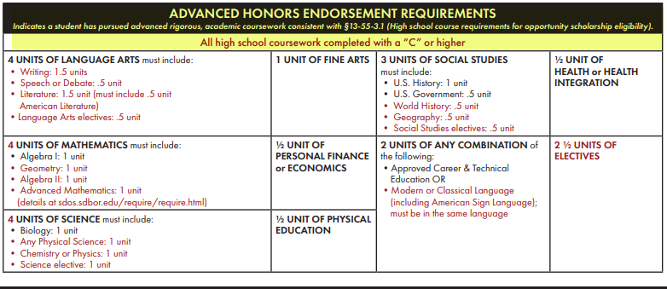

State Seal of Biliteracy
To recognize South Dakota’s growing diverse population of students and highlight the importance of mastering multiple languages, the SD DOE has developed the SD State Seal of Biliteracy. While participation in this program is completely VOLUNTARY, DOE will provide a specific seal to schools that request them for their students’ diplomas. Additional information regarding eligibility requirements is available at: https://doe.sd.gov/biliteracy/.
Districts who are participating are required to update the Graduation Endorsements/State Seal field for each student who qualifies to received it.
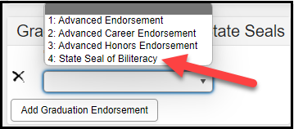

Section IV – SD Infinite Campus Listserv
If you are not a member of the SD Infinite Campus Listserv, you can subscribe at: http://k12.sd.us/MailingList/ Scroll down and click on SD Infinite Campus from the Mailing List menu. Follow the directions given on how to subscribe to the SD Infinite Campus listserv.
This Listserv is a great resource in putting you in touch with your co-workers across the state who are also responsible for the student data within Infinite Campus. This is also the listserv that the DOE uses to communicate upcoming training opportunities, updates to the Infinite Campus system, etc.

