
August 2026
Student Data Collections
Desk Guide
Office of Data Management

FREE Infinite Campus Training
The South Dakota Department of Education provides access to Infinite Campus trainings FREE of charge to all South Dakota public school district employees. ALL STAFF in South Dakota public school districts can join live training sessions, watch recorded webinars, and access a series of on-demand trainings, to ensure they have the foundational knowledge of how to use the Infinite Campus system. To access these courses, staff will need to create an account within the Infinite Campus Community and log into Campus Passport.
Training Events – Check Campus Passport for specific dates/times.
August 2026: “Let’s Get it Started”. Get the year started off right. Learn about the skills needed to complete day-to-day tasks in Infinite Campus.
November 2026: Infinite Campus Discovery Week. Join thousands of other school and district staff for the largest training offerings of the year.
May 2027: “Putting a Bow on It”. Wrap up the school year right with tips and tricks for completing end-of-year tasks with ease and expertise.
On-Demand Courses – All employees in South Dakota public school districts have access to the below course catalog of on-demand Campus Passport courses.
Academic Planner | Census (Staff Employment) | Lockers
Ad Hoc Reporting | Contact Log | Messenger (End User)
Assessments | Counseling | Messenger Setup
Attendance (End User) | Course Setup | Online Registration Prime
Attendance Setup | Cross-Site Enrollment | Online Registration Stnd
Basic Navigation | Custom Forms | Portal Display Options
Behavior (End User) | Custom Tools | Records Transfer
Behavior Setup | Elem. Scheduling | Responsive Scheduling
Calendar Administration | English Learners | Resync State Data
Campus Data Suite | Fees | Resp. to Intervention
Campus Inst. Standards Based Grading | Flags | Spec. Education (End User)
Campus Inst. Traditional Grading | Food Service | Spec. Education Setup
Campus Learning Setup | Free/Reduced App. Mng. | Student Information
Campus Learning Teacher | Grading Setup Stnd-Based | Transcripts
Campus Payments | Grading Setup Traditional | Transportation
Campus Workflow | Health (End User) | User Security
Census (End User) | Health Setup | Virtual Scheduling

Table of Contents

Purpose 8
Definitions 9
South Dakota Codified Laws 11
South Dakota Administrative Rules 21
Data Collection Calendar for 2026/2027 24
Section I - Fall Enrollment 30
Timeline 30
Criteria for Fall Enrollment – State Aid (Used for funding purposes) 30
Criteria for Fall Enrollment – Census Count (Used for statistical reporting purposes) 30
Required Data Elements for Infinite Campus District Edition and State Edition Schools 32
Calendars 32
Deleting a Calendar 37
District and School History 39
Records Transfer Process 40
Requesting Records Through the Student Locator 40
Requesting Records Through the Records Transfer Tab 41
Completing the Process 42
Completing the Process (cont.) 42
Student Enrollments 43
Enrolling a Student 43
Race/Ethnicity 46
Race/Ethnicity Designation for Alternative Instruction/Home School Students 47
Immunizations 48
Enrollment Tab 48
Grade Level - Definitions: 48
Service Type - Definitions: 49
End Status – Definitions: 49
Resident District 51
County 51
Serving (Attending) District 51
Citizenship box 52
Enrollment Status – Definitions 52
Percent Enrolled 54
Enrollment % Changes during the School Year 54
Alternative Instruction/Home School Students 54
Open Enrollment 55
Open Enrollment for Alternative Instruction/Home school Students 55
Cross Border Enrollment Agreements 55
Overlapping enrollments 56
504 Students 57
Documented Hearing Loss 57
Students Participating in After School Program 57
Students in Foster Care 58
students with parent serving in the armed forces 59
FERPA Program Screen 60
Example of Completed FERPA Program Screen 61
Enrollments for Students who are 100% Enrolled in Online/Virtual Courses 62
Enrollments in Infinite Campus 62
Enrollment Record of a student who is a resident within your school district and participating in Online/Virtual Courses 62
Enrollment Record of a student who is open enrolling into your school district to participate in Online/Virtual Coursework 63
Entering Online/Virtual Courses into Infinite Campus 63
Course Schedules for Students taking Online/Virtual Courses 64
Title I 64
Homeless (McKinney-Vento Eligible) 65
Migrant Students 67
First Year in Country 67
EL (English Learner) 68
Creating an EL Record 68
Exited EL 69
EL Re-Entry 70
EL Services Record 71
Transfer of State Reporting Fields 73
Creating an Enrollment History 75
How to Enter an 8th Grader Taking 9th Grade Course 77
If a High School teacher is teaching the course at the middle school/jr. high 78
If a Middle School/Jr. High teacher is teaching the course at the middle school/jr. high 78
Entering the Grade Level to the High School Calendar 79
State Course Codes 80
Dual Credit 80
Dual Credit Courses for Alternative Instruction/Home School Students 81
How to transcribe Dual Credit Courses to the Board of Regent’s (BOR) Transcript 82
Industry-Recognized Credentials 85
Absolute Minimum Fields Required to SAVE an Industry-Recognized Credential 86
BOR Transcript 86
High School Grade Progression 87
Enrollments for the Board of Regents’ Jump Start Scholarship 87
Releasing the Board of Regents Transcript 87
Graduation Endorsements/State Seals 88
1. Advanced Endorsement 89
2. Advanced Career Endorsement 90
3. Advanced Honors Endorsement 91
4. State Seal of Biliteracy 92
FRAM (Free and Reduced Priced Lunch) 92
Community Eligibility Provision in Infinite Campus 93
Screen Print #1 - Free/Non-Direct/Income = Community Eligibility Provision or Provision II or Provision III 94
Screen Print #3 - Free/Non-Direct/Income = Normal application process 95
Screen Print #4 - Reduced/Non-Direct/Income = Normal application process 96
Required Data Elements for Upload School Districts 97
Calendars 97
Student Enrollments 97
Section II – Accountability – Year End Data 98
Timeline 98
Student Enrollments 98
Students who are Graduating 101
Accountability related data elements to check include: 101
Required Data Elements for Upload School Districts 103
Student Enrollments 103
Section III – Students with Disabilities State Reporting Data and December Child Count 104
Requirements for Special Education State Reporting Data and Child Count 104
Entering the Special Ed Fields 104
Data Elements for Students with Disabilities 105
Effective Date 106
Special Ed. Program/Instructional Program Type 106
Special Education Category (Least Restrictive Environment –LRE) 107
Disability 110
State Special Ed Aid funding 110
Special Education Services: Therapy Hours 111
Students Participating in the State Alternate Assessment 112
How to make a change in the Special Ed Fields within the Special Education Summary 112
Making a change 112
IEP Program Exit Reason 113
Ending enrollment for seniors who are in Special Education 114
Reporting sped out of district 117
Creating a Sped out of district calendar 117
Key Data Reporting Fields for Students in School #97 118
Parentally placed private School Enrollment 120
Required Data Elements for Upload School Districts 121
Student Enrollments 121
Section IV – Certified Staff 122
Staff Members within Infinite Campus 122
Searching for a Staff Member 122
Former Students Who Are Now Staff Members or Parents 123
Section V – SD Infinite Campus Listserv 124

Purpose
The purpose of this desk guide is to assist school districts with the data entry required for timely and accurate State and Federal reporting. This document will touch on the main data collection periods throughout the year which include:
- Fall Enrollment State Aid/Fall Enrollment Census Count
- Accountability – Year End Close Out
- Students with Disabilities December Child Count
The Department of Education currently contracts with Infinite Campus for our Student Information Management System. Districts MUST strive to keep their student data accurate at all times. In addition to the above listed data collection periods, student data is also extracted throughout the school year for additional purposes such as:
- To create Assessment Pre-ID files
- To populate student data and properly assign students to the correct schools in the online Assessment systems
- To pre-populate student data in other systems such as SDMyLife-Xello, SD-STARS and Perkins
- Student lists for NAEP testing
- EL (English Learner) and Immigrant data used for calculating Title III funding
- Federal reporting through EdFacts
- Consolidated State Performance Report (CSPR)
- Legislative requests – Dec/Jan/Feb/March
- General data requests throughout the year
- To compute Attendance/Graduation rates/Completer rates and Dropout identification for Accountability purposes
- To compute ADA/ADM calculations
- To compute State and County Apportionment calculations
- To comply with requirements for the Federal Perkins Loan Teacher Cancellation program to assist teachers in obtaining loan cancellation services.

YOUR DATA
IS IMPORTANT!

Definitions
Admission Date – The month, day and year that a student is admitted to a school or an educational institution.
Advanced Endorsements - In graduation requirements, specific coursework outlined within the high school diploma requirements to denote particular emphases. Advanced endorsements include:
(a) “Advanced Endorsement," indicates a student has pursued coursework consistent with entrance requirements for postsecondary education at an university;
(b) “Advanced Career Endorsement," indicates a student has career experience in a concentrated area, based on academic and workplace experience and a related credential; and
(c) "Advanced Honors Endorsement," indicates a student has pursued advanced rigorous, academic coursework consistent with SDCL 13-55-31.1.
After School Program – Programs that provide academic enrichment opportunities during non-school hours that serve children and youth of all ages. After-School programs help students meet state and local content standards in core academic subjects, such as reading and math; offer students a board array of services such as social emotional supports or family programs.
December Child Count – The unduplicated count of all children with disabilities ages 3-21 receiving special education and related services according to an individualized education program (IEP) or service plan on December 1st of each year.
Dropout – per 24:55:01:01 – A student who was enrolled in school at some time during the school year and was expected to be enrolled the following year but was not enrolled; has not graduated from high school or completed a state or district approved educational program; has not met any of the following exclusionary conditions:
- The student transferred to another public school district, private school, or state or district-approved educational program;
- The student has been granted a school recognized temporary absence due to suspension or illness;
- Death.
Dual Enrollment - The enrollment of a pupil in elementary or secondary educational programs in two or more school systems at the same time.
EC – Early Childhood - Students not yet enrolled in Kindergarten but who are receiving ONLY Special Education services from the school district should be entered into the Student Information System using the “EC” as the grade level in the grade level field. Attendance is not required for the “EC” students.
Economically Disadvantaged - Students who qualify for free and reduced lunch status.
Elementary School - A school consisting of any combination of grades from kindergarten through eighth grade.
Exit/Withdrawal Date - The month, day and year of an individual’s last attendance in school; for a graduating student it is the last day of the school year (even if the seniors are dismissed a few days early) unless the student is graduating early and then it would be the last day the student is required to attend.
Fall Enrollment Census Count – This is a head count of students enrolled in pre-school through twelfth grade in all schools operated by the school district on the last Friday of September of the current school year. The Fall Enrollment Census Count is used for statistical comparisons, federal reports and grant allocations.
Fall Enrollment State Aid– per § 13-13-10.1 - The number of kindergarten through twelfth grade students enrolled in all schools operated by the school district on the last Friday of September of the current school year minus the number of students for whom the district receives tuition, except nonresident students who are in the care and custody of a state agency and are attending a public school and students for whom tuition is being paid pursuant to § 13-28-42.1, plus the number of students for whom the district pays tuition. See 13-13-10.1 for specifics.
Full Academic Year – per 24:55:01:03 – The term full academic year means a student is continuously enrolled in a public school from October first to May first with an enrollment gap of no more than fifteen consecutive school days.
Jr. Kindergarten Student – A student enrolled in a Jr. Kindergarten program would be considered the same as a Kindergarten student for data collection purposes. The student must be at least 5 years old by September 1st to be counted for State Aid funding purposes.
Junior High School - A school consisting of a combination of two or more consecutive grades that must include grades seven and eight and may include grade nine.
Middle School - A school consisting of any combination of two or more consecutive grades, five through eight.
Pre-School Student – per 24:17:01:07 – For the purpose of data collection, a preschool student is defined as a child who is at least three years of age on or before September 1st, is not enrolled in Kindergarten, and is receiving educational services from a public school district for a minimum of 128 hours. A full-time preschool student is a student who is enrolled in a program that operates at least 448 hours per year. For purposes of data collection, students enrolled in programs operated for a lesser time shall be reported on a prorated basis as a percentage of 448 hours. All public school districts operating a preschool program shall report student data for preschool students including attendance data. This definition is intended exclusively for data collection and should not be used for any other purpose.
Secondary School - A school consisting of any combination of three or more consecutive grades, including ninth grade through twelfth grade.
Student data submission - A report containing detailed information on each student in a format prescribed by the secretary.
Tutoring - Tutoring is a short additional block of time, both within and outside of the regular school day, intended to complement specific classroom instruction to support gaps in student mastery of previously instructed learning objectives. Tutoring programs can be operated as teacher-to-teacher or peer-to-peer tutoring. Material covered is based on the individual student’s needs focusing on helping the student succeed in areas where the student is struggling.

South Dakota Codified Laws
SDCL 13-3-51: Data reporting and record systems. The secretary of the Department of Education shall establish a uniform system for the gathering and reporting of educational data for the keeping of adequate educational and financial records and for the evaluation of educational progress. Any school district or school seeking state accreditation shall submit enrollment data, personnel data, and shall verify all state and federal standards for accreditation and approval of schools, including those related to safety and educational equity of the school district or school by October fifteenth of each year. If the due date falls on a weekend or state holiday, the due date is the next business day following the scheduled due date. An annual written evaluation of the educational progress in the state and in each school district shall be submitted to the Legislature and shall be made available in each school district to the general public. The South Dakota Board of Education Standards may promulgate rules pursuant to chapter 1-26 to further define the data required pursuant to this section. However, nothing in this section authorizes the collection of information not necessary for the calculation of funding for public education, the determination of student academic progress, state and federal reporting requirements, or other duties prescribed to a school district, the department, or the South Dakota Board of Education Standards by law.
SDCL 13-3-55: Academic achievement tests. Every public school district shall annually administer the same assessment to all students in grades three to eight, inclusive, and in grade eleven. The assessment shall measure the academic progress of each student. Every public school district shall annually administer to all students in at least two grade levels an achievement test to assess writing skills. The assessment instruments shall be provided by the Department of Education, and the department shall determine the two grade levels to be tested. The tests shall be administered within timelines established by the Department of Education by rules promulgated pursuant to chapter 1-26 starting in the spring of the 2002-2003 school year. Each state-designed test shall be correlated with the state's content standards. The South Dakota Board of Education Standards may promulgate rules pursuant to chapter 1-26 to provide for administration of all assessments.
SDCL 13-3-62: State accountability system established. A single, statewide state accountability system is established. The system shall hold public schools accountable for the academic achievement of their students and shall ensure that all public schools make yearly progress in continuously and substantially improving the academic achievement of their students.
SDCL 13-3-84: Partially enrolled student required to take academic achievement test. If a student is partially enrolled in a school district pursuant to § 13-28-41 or 13-28-51, and the student's enrollment is equal to or greater than fifty percent, that student is required to take any academic achievement test administered by the school district pursuant to § 13-3-55. If a student's partial enrollment in a school district is less than fifty percent, the student is not required to take any academic achievement test administered by the school district pursuant to § 13-3-55.
SDCL 13-13-1.2: Fall enrollment records subject to examination by department. Any records related to the reporting of fall enrollment of a public school district shall be subject to examination by the Department of Education at all times.
SDCL 13-13-10.4: Enrolled student defined. For the purposes of § 13-13-10.1, a student is enrolled if:
- The student is less than twenty-one years of age on the first day of July or meets the requirements of § 13-28-5 and 13-28-6;
- The student has not completed an approved program or graduated from high school;
- The student's parent or guardian resides within the school district, or in the case of an emancipated minor the student resides within the district or the student has been properly assigned to the district or has been approved to attend school in the district under the terms of the enrollment options program established in § 13-28-40; and
- The student is not simultaneously enrolled in any other school district and has not been excused from school attendance under the terms of § 13-27-1.1 or 13-27-2.
SDCL 13-13-10.5: Student enrolled on partial basis. Effect on fall enrollment. For purposes of state aid to education, a student enrolled pursuant to § 13-28-41 or 13-28-51 shall be counted in a school's fall enrollment as defined in § 13-13-10.1 in a proportion equal to the share of the student's enrollment in the school.
SDCL 13-15-30: Agreements for whole-grade sharing of students—Conditions: Notwithstanding the provisions of § 13-5-1, the school board of any school district may enter into an agreement or contract with one or more school boards of other school districts to provide for the whole-grade sharing of students among the participating school districts if:
- The school district offers an instructional program within the boundaries of the school district; and
- The school district meets the minimum fall enrollment requirements pursuant to § 13-6-97.
For purposes of §§ 13-15-30 to 13-15-32, inclusive, whole-grade sharing is a sharing arrangement for students among participating school districts that allows the resident students at any one or more grade levels within one school district to attend school in one or more of the other participating school districts. The whole-grade sharing may be one-way whereby a participating school district sends all of its students at one or more grade levels to attend school in one or more of the other participating school districts without receiving any students in return. The whole-grade sharing may also be two-way whereby a school district sends all of its students at one or more grade levels to attend school in one or more of the other participating school districts, and in return receives students at one or more grade levels from one or more of the other participating school districts.
SDCL 13-15-31: Approval and adoption of agreements for whole-grade sharing of students--Term--Termination—Requirements. Any agreement or contract entered into pursuant to § 13-15-30 shall be approved by the secretary of education and shall remain in effect for a period of at least three years. It shall provide for the sharing of governance among the participating school districts. The school board of each participating school district shall adopt the contract or agreement no later than February first of the school year proceeding the school year for which the agreement will take effect. The contract or agreement may be terminated by any participating school district if that school district provides written notice to the other participating school districts at least eighteen months prior to the termination. The contract or agreement shall adhere to the following provisions:
- Students at one grade level within a school district are only eligible to attend school in another participating school district if all the students at that particular grade level within the school district are sent to another participating school district. The school boards of the participating school districts shall determine which students and which facilities will be shared under the terms of the agreement;
- The participating school districts may negotiate the rate of tuition that will be charged for any student sent to attend school in another participating school district. However, the rate of tuition per year may not be less than the per student allocation as defined in § 13-13-10.1 for that school fiscal year;
- The fall enrollment as defined in § 13-13-10.1 for each participating school district shall include any students that the school district sends to another participating school district to attend school, and may not include any students that are sent to the school district to attend school from other participating school districts;
- For the purposes of determining adequate yearly progress under the state's accountability system established in § 13-3-62, and calculating the graduation rates, any student sent to another participating school district to attend school shall be counted in the receiving school district; and
- For the purposes of state aid for special education, the school residence of any student in need of special education or special education and related services who is sent to a participating school district to attend school remains with the sending school district. However, both the sending and the receiving school districts shall agree upon the student's individualized education program.
SDCL 13-23-1: School board's power to establish and discontinue--Time for action closing school. The school board shall have the power to establish and discontinue attendance centers by resolution of the board. An action to close an operating school shall be taken by December first prior to the closure. However, if an emergency exists, the board may close the school after notice to the patrons.
SDCL 13-23-10. Establishment of attendance center outside boundaries of school district--Joint powers agreement: A school board may establish an attendance center outside the boundaries of its school district that is within the boundaries of another school district only when both school districts have entered into a joint powers agreement pursuant to chapter 1-24 to provide instruction to the students enrolled in the attendance center.
If each school board adopts a resolution to approve the joint powers agreement, the school board for the school district that will operate the attendance center shall submit the joint powers agreement and each school board's resolution of approval to the secretary of education.
SDCL 13-26-1: School fiscal year--Local board to set length of school term, day and week--Number of hours in school term: The school fiscal year shall begin July first and end June thirtieth. Each local school board shall set the number of days in a school term, the length of a school day, and the number of school days in a school week. The local school board or governing body shall establish the number of hours in the school term for kindergarten programs, which may not be less than four hundred thirty-seven and one-half hours. The number of hours in the school term for grades one through five may not be less than eight hundred seventy-five hours, exclusive of intermissions. The number of hours in the school term for grades six through twelve may not be less than nine hundred sixty-two and one-half hours, exclusive of intermissions. An intermission is the time when students are at recess or lunch and for grades six through twelve, the passing time between classes. The minimum number of hours required in this section may be waived by the secretary if the Governor or the President of the United States declares a state of emergency and the affected school is located within the area to which the state of emergency is applicable. The Department of Education shall monitor emergency-related school closures and provide updates to the schools.
During a declared state of emergency, the school district shall forward to the Department of Education, at the time and in the manner requested by the department, a record of the continuous instruction provided to the students. The department shall consider the nature and scope of the instruction provided to determine whether it will count towards the minimum number of hours required in a school term.
SDCL 13-26-2: Time required in school term--Make up time--Summer term: The school board or governing body shall operate kindergarten through grade twelve in its schools. The school board shall operate grades one through twelve for at least a nine-month regular term in any one school year, and the number of hours in a school term for kindergarten shall be set pursuant to § 13-26-1. The regular school term may be conducted on a year-round basis and shall begin on a date established by the school board. The Board of Education Standards shall promulgate rules pursuant to chapter 1-26 governing the operation and scheduling of year-round schools. Any school board or governing body may release graduating high school seniors from school before the end of the regular term. A school is not required to make up time for school closing because of weather, disease, or emergency once it has reached the minimum number of hours in the school term as required by state law. Graduating seniors are excused from makeup time if the makeup time occurs after the students have graduated or after graduation exercises have been held. If classes have been convened and then are dismissed, or if classes convene at a time later in the day than normal, because of inclement weather, that day constitutes a school day in session equal to the number of hours planned for that day as established in the local school district calendar for the year. School boards are encouraged to provide time within the regular school term for curriculum and staff development which shall be in addition to the time required in this section. Each school board shall determine the appropriate amount of time for this activity and how best to use the time based on local needs for program development, increased parent participation, student contact, teachers' preparation, or other needs of the schools in the district. School is in session only when classes are held and as provided in §§ 13-26-4 and 13-26-4.1. A school board may operate a special term during the summer months.
SDCL 13-26-4: Teacher-parent conferences counted as hours in session: A school may have teacher-parent conferences during the school year and not more than 16.5 hours may be counted as hours in session.
SDCL 13-26-4.1: In-service training: The school board may designate a maximum of 5.5 hours of the 16.5 session hours provided for in § 13-26-4 as in-service teacher training.
SDCL 13-27-1: Duty of person controlling child – Kindergarten-Transfer from another state: A parent, guardian, or other custodian of a child, who is not younger than five or older than six by the first day of September, or any child who, by the first day of September is at least six years old, shall cause the child to regularly attend a public or nonpublic school or receive alternative instruction, as set forth in 13-27-3, until the child is eighteen years old, has graduated, or is excused or withdraws as provided in this chapter. Each child shall attend kindergarten prior to age seven. Any child who transfers from another state may proceed in a continuous educational program without interruption if the child has not previously attended kindergarten.
SDCL 13-27-1.1: Religious exemption after eighth grade: A child of compulsory school age who has successfully completed the first eight grades is excused from compulsory school attendance under § 13-27-1 if:
- The child or the parents of the child are members of a recognized church or religious denomination that objects to the regular public high school education; and
- The recognized church or religious denomination either individually or in cooperation with another recognized church or religious denomination provides a regularly supervised program of instruction in which each child participates in learning activities appropriate to the adult occupation that the child is likely to assume in later years.
SDCL 13-27-1.3: Withdrawal from school--Record of withdrawal documentation--Copies to secretary. A child may withdraw from attending a school at the age of seventeen if the child has the written consent of a parent, guardian, or other custodian. The school district shall keep the documentation presented pursuant to this section. The school district shall forward a copy of the documentation to the Department of Education within thirty days of receipt.
SDCL 13-27-1.4: High school equivalency test--Requirements--Process. A child who is at least sixteen years old may enroll in a school-based or school-contracted high school equivalency test preparation program or take the high school equivalency test if the child presents any one of the following:
(1) The written consent of a parent, guardian, or other custodian;
(2) Verification that the child will not graduate with the child's cohort class because of a credit deficiency;
(3) Authorization from a court services officer;
(4) A court order requiring the child to enter the program;
(5) Verification that the child is under the direction of the Department of Corrections; or
(6) Verification that the child is enrolled in Job Corps as authorized by 29 U.S.C. §§ 3191 to 3212,
inclusive, (January 1, 2009).

Any child who is at least sixteen years old and who completes the high school equivalency test preparation program may take a high school equivalency test immediately following release from the school program or when ordered to take the test by a court.
Any child who fails to successfully complete the test shall re-enroll in the school district, unless the child has withdrawn from school pursuant to § 13-27-1.3. Any child who fails to successfully complete the test may continue the high school equivalency preparation program or other suitable program as determined by the school district.
SDCL 13-27-3: Alternative instruction--Notification--Requirements. Upon a filing of a notification with either the Department of Education or the local district from the parent, or guardian, or other person having control of a child, the Department of Education or the local district has been notified that the child is being provided with alternative instruction in the basic skills of language arts and mathematics. The person providing instruction is not required to be certified. No person may instruct more than twenty-two children. All instructions shall be given so as to lead to a mastery of the English language.
SDCL 13-27-3.1: Birth certificate or affidavit to be submitted--Violation as misdemeanor. Any person who is required pursuant to § 13-27-1 to cause any child to attend any public or nonpublic school in this state shall, either at the time of enrollment in any school in this state or within thirty days of initial enrollment, provide the public or nonpublic school with a certified copy of the child's birth certificate or affidavit in lieu of birth certificate as issued by the Department of Health in such cases where the original birth certificate is deemed unattainable. A violation of this section is a Class 2 misdemeanor.
SDCL 13-27-3.2. Maintenance of birth certificate by school as permanent record. Any copy of any certified birth certificate provided pursuant to § 13-27-3.1 shall be maintained by the public or nonpublic school and shall be a part of the child's permanent cumulative school record.
SDCL 13-27-7: Notification of alternative instruction. Each notification of alternative instruction pursuant to § 13-27-3 shall be on a standard form that declares that the child will be provided with alternative instruction per § 13-27-3. The completed form must contain the child's name, birthdate, resident district, and open enrolled district if applicable, signature of the parent, guardian, or other person having control of the child and information for the return of the form. The Department of Education or the local district shall provide the parent, guardian, or other person having control of the child with a signed or stamped copy of the notification as proof of notification. The notification shall be kept confidential. The form shall be provided by the secretary of the Department of Education but may not require more details than set forth by this section. The notification shall be filed within thirty days from the first time the child begins an alternative instruction program while the child is of school age as defined in § 13-27-1 and is not required thereafter unless one or more of the following transitions occur:
- A child enrolls in a public or nonpublic school; or
- A child moves to a different school district.
The parent, guardian, or other person having control of the child shall provide notification of any transitions by submitting the standard notification form to the Department of Education or the local district within thirty days of the transition.
SDCL 13-27-9. Record of certificates of excuse--Copies to secretary and place of instruction. A permanent record of all certificates of excuse, pursuant to §§ 13-27-6 and 13-27-6.1, shall be kept in some safe place as determined by the school board. Copies of any certificate of excuse shall be forwarded to the secretary of the Department of Education. Copies of any certificates of excuse shall also be forwarded to the place where the child is instructed. The copies shall be forwarded within thirty days of issuance.
SDCL 13-27-11. Failure to send child to school as misdemeanor. Any person having control of a child of compulsory school age who fails to have the child attend school, as required by the provisions of this title, or provide alternative instruction pursuant to § 13-27-3, is guilty of a Class 2 misdemeanor for the first offense. For each subsequent offense, a violator of this section is guilty of a Class 1 misdemeanor.
SDCL 13-27-14. Truancy officer employed by district--Duties--President of board acting where no officer employed. The school board of each school district shall annually appoint and provide for the remuneration of one or more truancy officers, to enforce, under the school board's direction, the compulsory attendance laws within the district. In a school district failing to provide a truancy officer, the president of the school board is the truancy officer and is responsible for the enforcement of the compulsory attendance laws within the school district.
SDCL 13-27-15. Attendance records maintained by superintendent or president of board--Reports required. Each superintendent, or the president of the school board in districts without a superintendent, is responsible for maintaining an accurate record of the attendance of all persons of compulsory school age who are enrolled in an accredited school under his or her supervision. The superintendent or president shall, at regular intervals, report the names of all enrolled persons who are of compulsory school age, not excused from school, who do not or who irregularly attend an accredited school to the truancy officer. The superintendent or president shall include reasons for the absences in the report.
SDCL 13-27-29. Placement of child who has attended unaccredited school or alternative program--Appeal. If a child of compulsory school age has been attending an unaccredited school in another state or country or has been receiving alternative instruction pursuant to § 13-27-3 enrolls in a public school in this state, the child shall be placed at the child's demonstrated level of proficiency as established by one or more standardized tests. However, a child's placement may be in one grade level higher than warranted by the child's chronological age assuming entry into the first grade at age six and annual grade advancement thereafter. After initial placement, the child may be advanced according to the child's demonstrated performance. If a child of secondary school age has been attending an unaccredited school in another state or country or has been receiving alternative instruction pursuant to § 13-27-3 enrolls in a public school in this state, the child shall be placed in English and math at the level of achievement demonstrated by one or two standardized tests, and in all other subjects on a review of transcripts according to the policy formally adopted by the school board. The child's placement may be in one grade level higher than warranted by the child's chronological age assuming entry into the first grade at age six and annual grade advancement thereafter. After initial placement the child may be advanced according to his demonstrated performance. Any parent or guardian who is dissatisfied with the placement of his child may appeal it to the secretary of the Department of Education.
SDCL 13-28-1.1. Enrolled student defined. As used in this title, a student is enrolled if:
- The student is less than twenty-one years of age on the first day of July or the student is twenty-one years of age or older and is admitted to the school district pursuant to § 13-28-8; and
- The student has not completed an approved program or graduated from high school; and
- The student's parent or guardian resides within the school district, or in the case of an emancipated minor or an adult admitted to the district pursuant to § 13-28-8, the student resides within the district or the student has been properly assigned to the district or has been approved to attend school in the district under the terms of the enrollment options program established in § 13-28-40; and
- The student is not simultaneously enrolled in any other school district and has not been excused from school attendance under the terms of § 13-27-1.1 or 13-27-2.
SDCL 13-28-2: Kindergarten enrollment eligibility--Transfer from another state. Any child who is five years old on the first day of September is eligible for enrollment in kindergarten during that school year. Any child who transfers from another state may proceed in a continuous educational program without interruption.
SDCL 13-28-5. Public school privileges free to children until age twenty-one--Fee for early childhood services. The privileges of the public schools of any district shall be free to all persons with school residence within the district until they complete the secondary school program or until they reach the age of twenty-one. However, except as otherwise prohibited by law, schools may charge a fee for early childhood services for any child who is under the age of compulsory attendance pursuant to § 13-27-1 and is not enrolled in kindergarten or a more advanced grade.
SDCL 13-28-6. Continuation of privileges to pupil becoming twenty-one during school year. A pupil who is enrolled in school and becomes twenty-one years of age during the fiscal school year shall have free school privileges during that school year.
SDCL 13-28-9. School residence for free school privileges--Change of residence--Children of transferred active duty military personnel. School residence for the purpose of claiming free school privileges means the legal residence of the student's parents or guardian except as provided in § 13-28-10. If a parent or guardian has more than one residence, the school residence is the residence where the parent or guardian actually lives and makes a home or domicile. In case of dispute, if the student's parent or guardian has claimed a credit pursuant to § 10-13-39, it is presumed that the dwelling so claimed is the residence of the parent or guardian. The student or the student's parents or guardian may not establish school residence and be exempt from the payment of tuition if the residence of the parents or guardian of the student is acquired solely or principally for obtaining free school privileges. At the time a child is enrolled in a school district, the school residence of the child as determined by that school district within thirty days after the enrollment may not change during the school fiscal year, unless the child ceases to be an enrolled member of a school within the district. If a student's parents or guardians are separated or divorced, the school residence is the school district in which the custodial parent or guardian has residence. If the parents or guardian have joint custody of a student, school residence is that of the parent or guardian with whom the child resides the greater portion of the school year. Notwithstanding the provisions of any other law, if the parent or guardian of a child is transferred to or is pending transfer to a military installation within the state while on active military duty pursuant to an official military order, the child meets the residency requirement for free school privileges in the school district in which the parent or guardian resides or will reside. For the purposes of this section, a military installation is a base, camp, post, station, yard, center, or other installation under the jurisdiction of the United States Department of Defense.
SDCL 13-28-9.1. Residence of child assigned to special education program. A child in need of special education or special education and related services assigned to and enrolled in an approved out of district special education residential or tuition day program by an individualized education program team has school residence in the school district making the assignment. The fiscal responsibility of the school district making the assignment continues until the end of the school fiscal year or until the child's parent or guardian enrolls the child in another school district, the child participates in the new school district's special education program, the new school district conducts a placement committee meeting, a new individualized educational program for the child is adopted, and the child's placement is changed.
SDCL 13-28-10: School residency of child residing in home other than residence of parents, guardian, or noncustodial parents--Petition to local school board. Except as otherwise provided in this section, if a school age child resides in a home other than the residence of the child's parents, guardian, or noncustodial parents, on a temporary or permanent basis, the school residency of the child is where the parents, noncustodial parents, or guardian reside unless, upon request of the person with whom the child is living, the board of the school district accepts the child as a resident of that school district. If the board rejects the request, the person who made the request may, within fifteen days after receipt of the rejection, petition the board for a hearing. The decision of the board, after the hearing, may be appealed to the circuit court. A school age child is a resident of the school district in which the child is placed by the Department of Corrections, the Department of Human Services, or the Department of Social Services.
SDCL 13-28-11. Child residing in residential treatment center or intensive residential treatment center--Responsibility for tuition. If a child is residing in a residential treatment center or an intensive residential treatment center that provides an educational program through a school district, the school district in which the residential treatment center or intensive residential treatment center is located is responsible for providing an educational program for the child. Tuition for a child who is not placed by an individualized education program team but is, at the time of placement , enrolled in a school district or state operated school must be paid as provided in § 13-13-87. The provisions of this section and § 13-13-87 do not apply to any placement by the Department of Corrections or the Department of Social Services. For purposes of this section, the term, school district, means a political subdivision of this state created in accordance with chapter 13-5. For purposes of this section, the term, state operated school, means the South Dakota Human Services Center academic program, the South Dakota School for the Blind and Visually Impaired, or any school so designated by the South Dakota Board of Education Standards.
SDCL 13-28-30. Period of pupil's membership in school--Date of permanent withdrawal. A pupil is a member of the school from the date the pupil arrives at the school and is placed on the current roll until the pupil permanently leaves the school. The date of permanent withdrawal is the day the pupil last attended the school.
SDCL 13-28-43: Enrollment of student in other than resident district or transfer within district--Approval and notification. A student's parent or legal guardian who wishes to enroll the student, or an emancipated student who wishes to enroll, under the provisions of §§ 13-28-40 to 13-28-47, inclusive, in a South Dakota school district other than the resident district or in a school within the resident district other than the school to which the student has been assigned shall apply on forms provided by the Department of Education. The school board or the board's designee of the district in which the student desires to enroll shall approve or disapprove the application and shall notify the applicant and the resident board, if applicable, of its decision within five days of the decision. The district in which the student desires to enroll shall review the applications in the order received. However, if the applicant is a sibling of a student accepted into and currently enrolled in the district pursuant to §§ 13-28-40 to 13-28-47, inclusive, that student's application shall take priority over all other applications the district has received consistent with § 13-28-44. Transfers to a school district other than the resident school district under the provisions of §§ 13-28-40 to 13-28-47, inclusive, may only take place prior to the last Friday in September during the first semester of any school year, and prior to the last Friday in January during the second semester of any school year. If a school district approves an application for such a transfer after the deadline in the first semester, the transfer will occur at the start of the second semester. If a school district approves an application for such a transfer after the deadline in the second semester, the transfer will occur at the start of the following school year. However, the deadlines for transfer do not apply if:
- A student is seeking to transfer to an alternative school or a specialized nonpublic educational program;
- A student enrolls in a school district after the deadline in either semester; or
- The receiving school district school board or the board's designee determines that special circumstances exist and allows a student to transfer after the deadline.
Intra-district transfer applications may be accepted and acted upon at any time at the board's discretion if the policies on which the transfer decisions are based are consistent with the other requirements of §§ 13-28-40 to 13-28-47, inclusive. An application may be withdrawn by the applicant prior to the approval of the request and upon notification of the district to which the student applied. Once approved by the district in which the student wishes to enroll, the approved application serves as the applicant's notice of intent to enroll in the nonresident district or desired school during the school year and obligates the student to attend school in the nonresident district or desired school during the school year, unless the affected school board or boards agree in writing to allow the student to transfer back to the resident district or assigned school, or unless the parents, guardians, or emancipated student change residence to another district. Once enrolled in a nonresident district or non-assigned school, the student may remain enrolled and is not required to resubmit annual applications.
SDCL 13-28-50: School districts to provide student mailing lists to Board of Regents and postsecondary technical institutes. Use in providing post-secondary school information--Exception. By November first each year, each school district shall provide a list of students by name in grades seven to twelve, inclusive, together with their mailing addresses, to the executive director of the Board of Regents and to each postsecondary technical institute located in the state. The board and each postsecondary technical institute shall use the information to inform the parents and guardians of any such student in any public middle school and high school about the courses needed to prepare for postsecondary-level work and about the benefits of such preparation. However, no school district may forward the name of any student whose parent has directed that the school district does not release directory information about the student. The board shall provide a format through which the information may be submitted.
SDCL 13-28-51. Enrollment of child on partial basis upon request of parent or guardian--Alternative instruction. The resident school district of a child being provided alternative instruction pursuant to § 13-27-3 shall admit that child to a public school in the district upon request from the child's parent or legal guardian. A child enrolled in a school district pursuant to this section may be enrolled in a school of the school district on only a partial basis and shall continue to also be provided with alternative instruction pursuant to § 13-27-3.
SDCL 13-33-20: Distance learning defined. For purposes of §§ 13-33-20 to 13-33-23, inclusive, distance learning is the technology and educational process used to provide instruction when the student and primary instructor are not physically present at the same time or place.
SDCL 13-33-23.1: Distance learning--Children of transferred military personnel--Eligibility. If the parent or guardian of a child is ordered to transfer to a military installation in this state pursuant to a military order, the child is eligible, upon issuance of the order, to be registered and enrolled with a state-approved distance learning provider by the school district in which the parent or guardian will reside.
SDCL 13-33-29: Granting of credit for distance learning courses not offered by South Dakota Virtual School prohibited—Exceptions. No school district may grant credit for any course successfully completed through distance learning as defined in § 13-33-20 unless the course is offered through the South Dakota Virtual School. However, a school district may grant credit for a distance learning course offered through an entity other than the South Dakota Virtual School if any of the following conditions apply:
- The course is provided through an agreement among accredited school districts;
- The course is a university or technical college course taken by a student who is dually enrolled pursuant to the provisions of § 13-28-37;
- The course was previously taken through an accredited high school or other accredited provider by a student who subsequently transferred into the school district; or
- The course is not available through the South Dakota Virtual School and is pre-approved by the secretary of education.
SDCL 34-20G-19: Schools and Landlords – Prohibited conduct (Medical Cannabis). A cardholder may not be refused enrollment by a school or a lease by a landlord, or otherwise be penalized by a school or landlord solely for the person's status as a cardholder, unless failing to do so would violate federal law or regulations or cause the school or landlord to lose a monetary or licensing-related benefit under federal law or regulation. This section does not prevent a landlord from imposing reasonable restrictions on the medical use of cannabis by a cardholder who resides at the landlord's property.

South Dakota Administrative Rules
24:05:17:09: Return of information. Local education agencies shall return information on counting eligible children to the Office of Data Collection. Each local school superintendent shall certify in writing that the information provided is an accurate and unduplicated count of children with disabilities receiving special education or special education and related services on December 1 of each school year. If December 1 falls on Saturday or Sunday, the count shall be taken on the first working day following the weekend.
24:17:01:05. Short-term group care education program. A short-term group care education program includes an educational program at a county juvenile detention center, a group care center for minors licensed by the Department of Social Services, or an alcohol and drug treatment center accredited by the Department of Human Services. The education program must be operated by a public school district and be located within the boundaries of the public school district providing the program to qualify as a short-term group care education program. The school district may not receive reimbursement from the Department of Social Services under the auxiliary placement program for the students attending this education program. The facility must be reported to and approved by the department in a format prescribed by the secretary before the fiscal year for which state aid will be provided. The secretary may waive the timelines for application as a short-term group care education program if the school district can show unforeseeable extenuating circumstances.
24:17:01:06: Reporting Percent of Day Enrollment. For the purposes of reporting day enrollment, a full-time student or 100 percent enrolled student is any student who is carrying a full course load. The term, full course load, means any student who is enrolled in at least five courses or is scheduled for a full school day. The term, full school day, means the amount of time in the day between the start and end of classes during an average school day. If any student is enrolled in less than five classes or does not attend school for the full school day, the student shall be reported based on the percentage of classes taken or the portion of the full school day that the student is in school.
24:17:01:07: Definition of preschool for data collection purposes. For the purpose of data collection, a preschool student is defined as a child who is at least three years of age on or before September 1st, is not enrolled in kindergarten, and is receiving educational services from a public school district for a minimum of 128 hours. A full-time preschool student is a student who is enrolled in a program that operates at least 448 hours per year. For purposes of this data collection, students enrolled in programs operated for a lesser time shall be reported on a prorated basis as a percentage of 448 hours. All public-school districts operating a preschool program shall report student data for preschool students. This definition is intended exclusively for data collection and should not be used for any other purpose.
24:17:03:01: Requirement to submit student record form. Each accredited school district shall report, for each student attending school within the school district, detailed information on the student as requested by the secretary on the student record form.

24:17:03:02: Student data submission. The due date for submission of the fall student data through the student information system is 15 days following the last Friday of September of each school year. State aid fall enrollment count is final on the last business day of October and no additional students may be added after this date but may be removed if found to be reported in error. The December child count data is due 10 days following December 1 of each school year. If a due date falls on a weekend or state holiday, the due date is the next business day following the scheduled due date. The final student record forms for each school year must be submitted no later than the second Friday in June of each school year.
24:17:03:03: Extension of deadlines. The secretary may extend any of the deadlines contained in this chapter. The extension may be on a case-by-case basis or a blanket extension for all school districts required to submit the forms. Blanket extensions shall be granted if the state's reporting format fails for a significant amount of time. Individual extensions may be granted upon written request signed by both the chief executive officer and board president of the school district if the district experiences unforeseeable extenuating circumstances.
24:17:03:04: Department review of student records. Department staff shall review all student record forms to verify the accuracy of the data reported. Except as provided in this chapter, no student may be reported as attending more than one attendance center for the same period of time.
24:17:03:05: Exception to nonduplicative dates requirement. Any residentially placed student reported as attending a short-term group care education program may be reported as attending another attendance center for the same period of time, not to exceed 90 consecutive school days. After attending for more than 90 consecutive school days, the student must be dropped on the ninety-first day from the count of the attendance center at which the student was enrolled prior to being enrolled in the short-term group care education program.
24:17:03:06: Student count for state aid purposes. No student who has an unexcused absence of 15 consecutive school days may be included in the count of the attendance center for state aid purposes, retroactive to the last day the student attended school or had an excused absence. An excused absence, for purposes of this section, includes medical illness and enrollment in a short-term group care education program for up to 90 consecutive school days. Nothing in this section supersedes the student due process requirements referenced in SDCL chapter 13-32, article 24:07, or other applicable law.
24:17:03:08: Requirement to submit calendar data. All school calendars are due by the last Friday in August. The minimum data reporting requirements for a school calendar are as follows:
- Start date of school year;
- End date of school year;
- Grade levels;
- School terms in quarters, semesters, or trimesters; and
- Periods
24:17:03:09: Student enrollment dates. Enrollment start date of a student is determined on the day, month, and year on which a student is admitted to a school or educational institution to include preschool. An enrollment end date is the day, month, and year of a student’s last attendance in the school. The end date for graduating students shall be the last calendar day of the school year unless the student graduates early, in which case the student is counted on the last required day of attendance.
24:17:03:10: Requirement to submit educational structure data. The finalized educational structure data for each school district is due by April first for the next school year. The school district shall report the following information:
- New schools;
- Closed schools; and
- Grade span changes.
24:43:09:02. Student records. A permanent record of each student's scholarship and attendance shall be kept and stored in a safe place where it cannot be destroyed. If safe storage is not available at the school, a duplicate set of records shall be maintained and stored in a safe place other than the school building. A cumulative record shall be kept for each student through the elementary and secondary schools.
24:43:11:01: Number of required credits for graduation from high school -- Personal learning plan required. Required units of credit for high school graduation must be earned in grades 9 through 12, and students must earn a minimum of 22 units of credit. Local school boards or governing bodies may set requirements of credit beyond the minimum. Transfer students unable to meet graduation requirements set by a local school board or governing body because of time and scheduling constraints, but not due to course failure, may graduate on the basis of meeting state minimum requirements for graduation. The local school board or governing body may waive one or more graduation requirements for senior students who transfer from another state, who have met the standards in that state, and who are unable to meet the graduation requirements set by the state board because of time and scheduling constraints but not due to course failure. A student must earn a high school diploma as outlined in § 24:43:11:02 in which coursework aligns with the student's personal learning plan. All students in grades 9 through 12 must have a personal learning plan. The personal learning plan must document a minimum of 22 units of credit. Effective July 1, 2020, any advanced endorsement earned must be listed on the high school transcript. After January 1, 2026, the department shall review the required credits for high school graduation.

Data Collection Calendar for 2026/2027
The following calendars contain important data related events that occur during the school year.
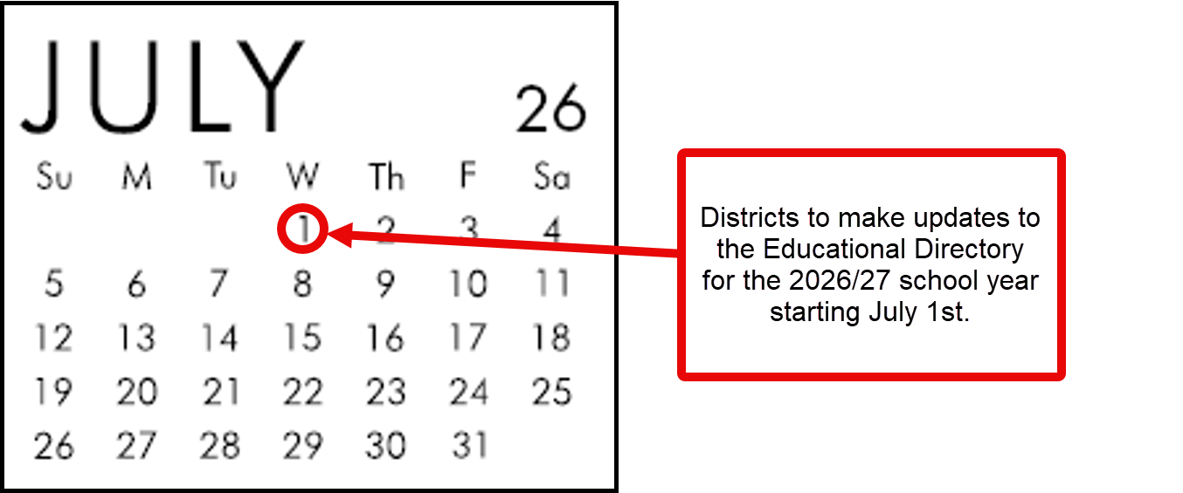
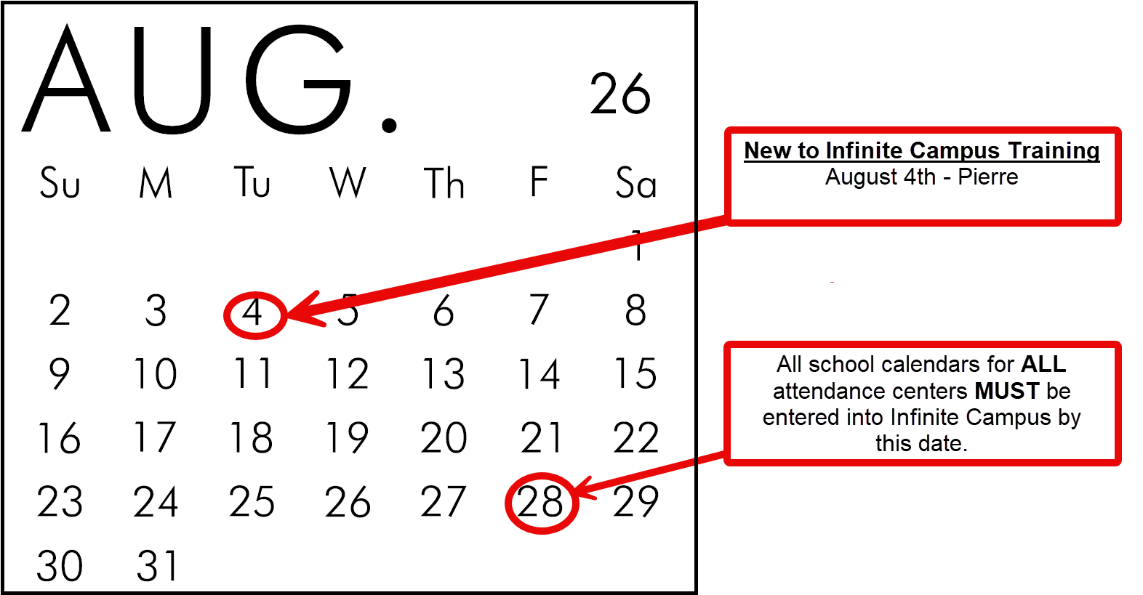
**Calendar Data: All school calendars for all attendance centers must be entered or uploaded into Infinite Campus by the last Friday in August. This includes any calendars that you have for your Preschools and After School Programs. Calendars for Summer Schools are due in the Infinite Campus system by the last Friday in April.
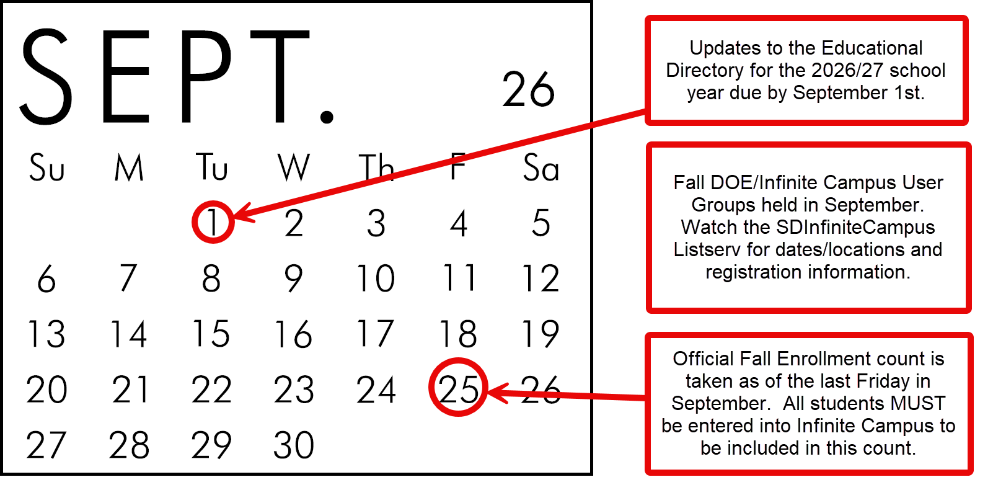

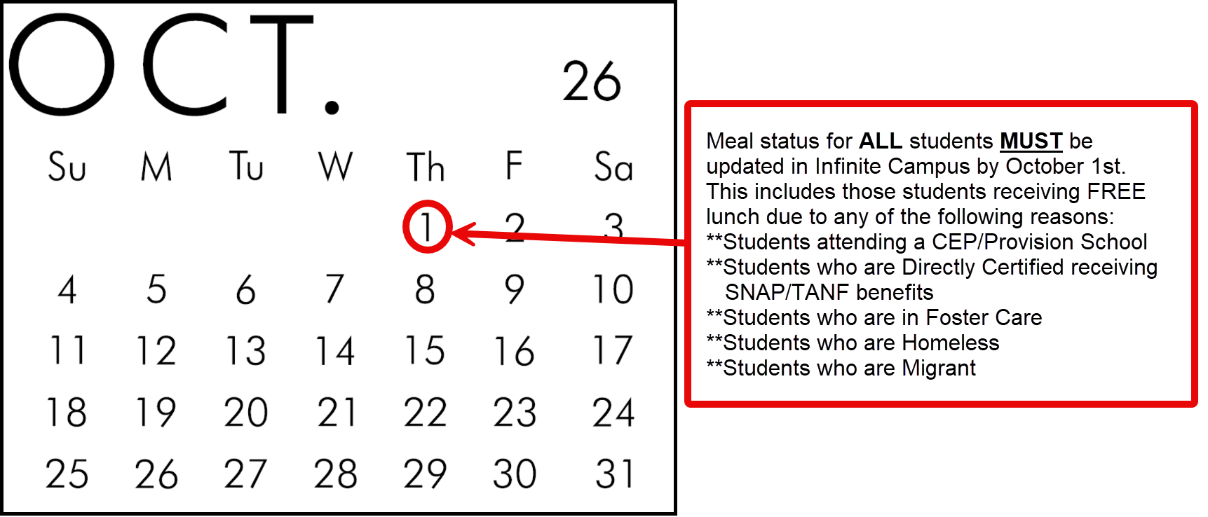

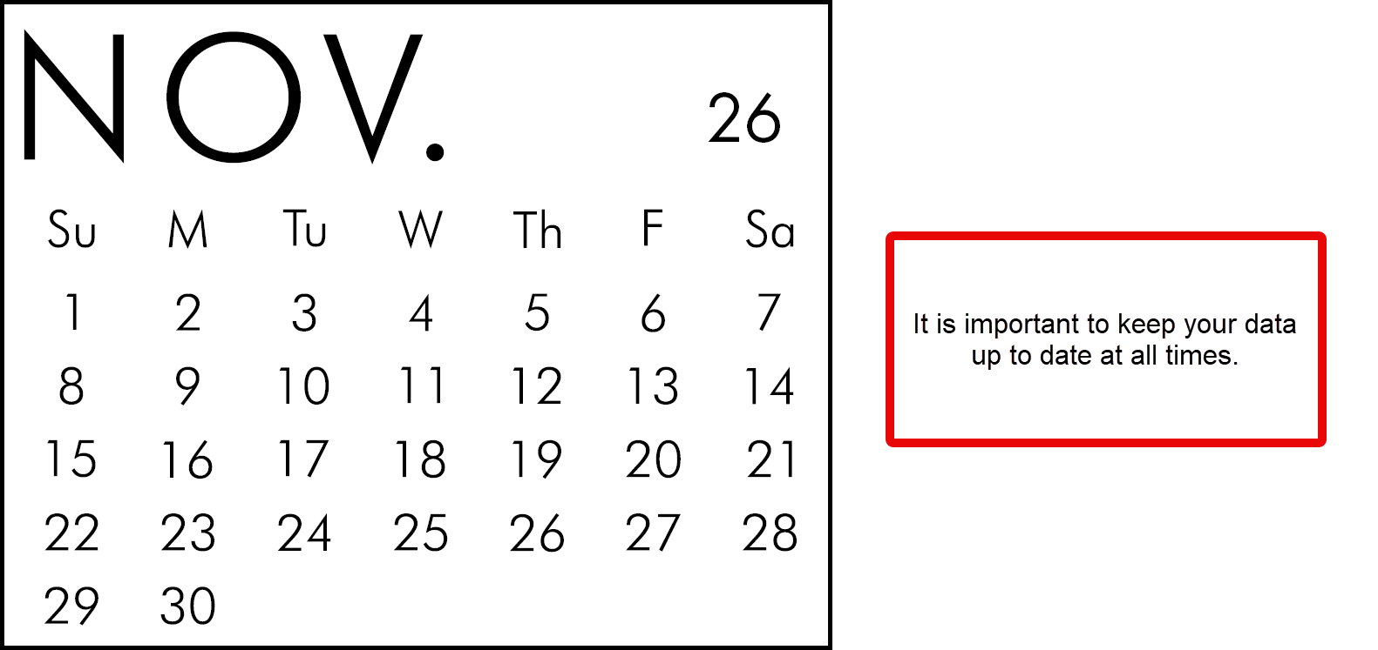
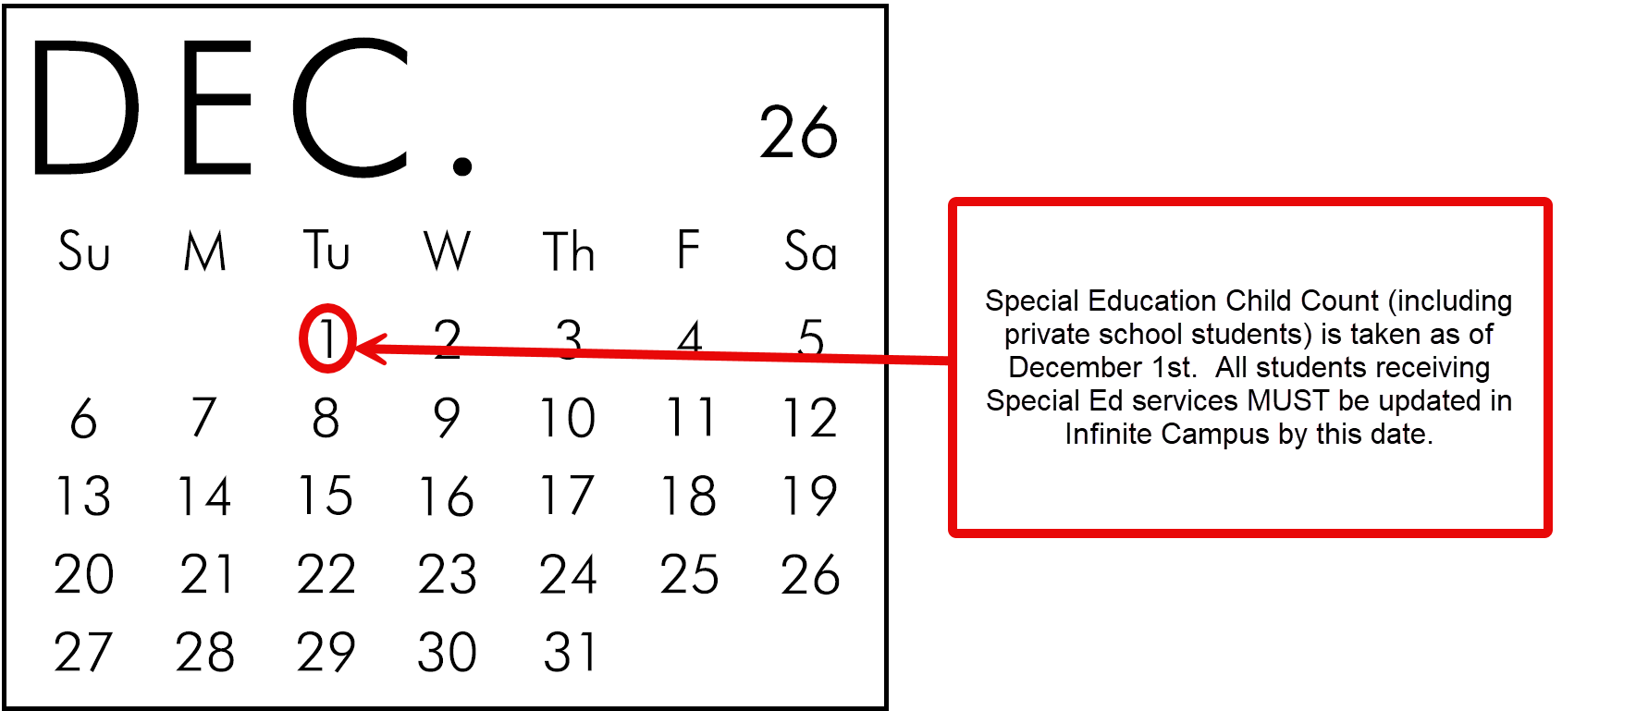

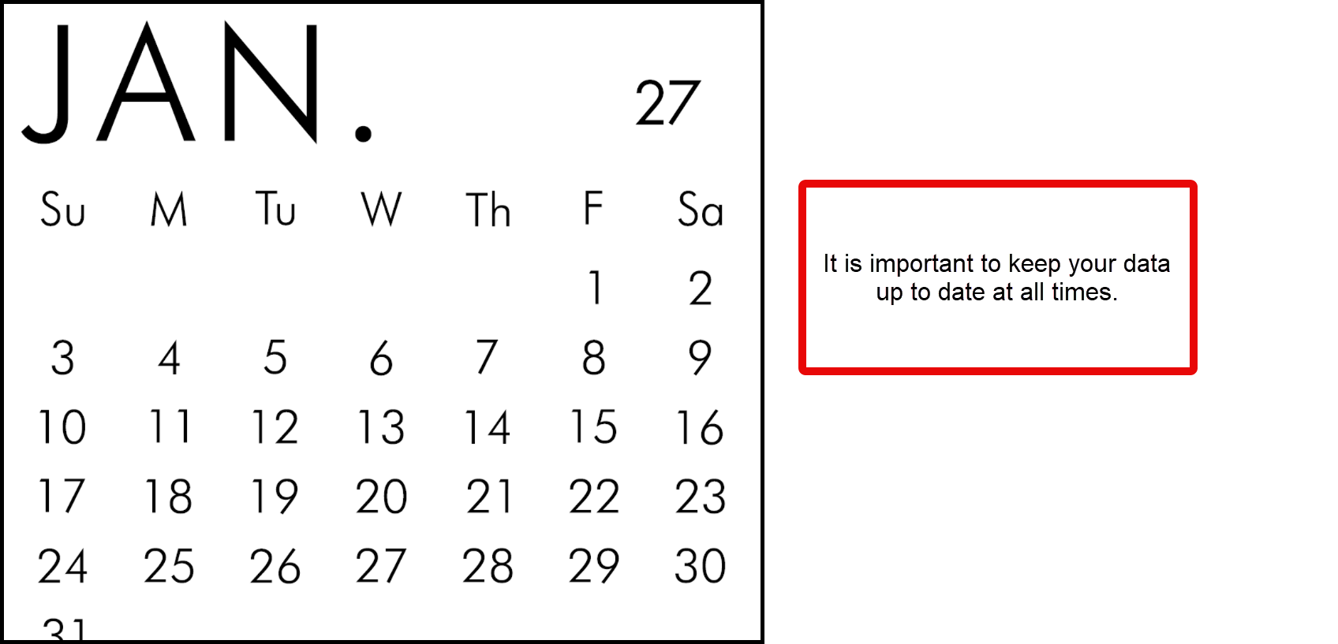

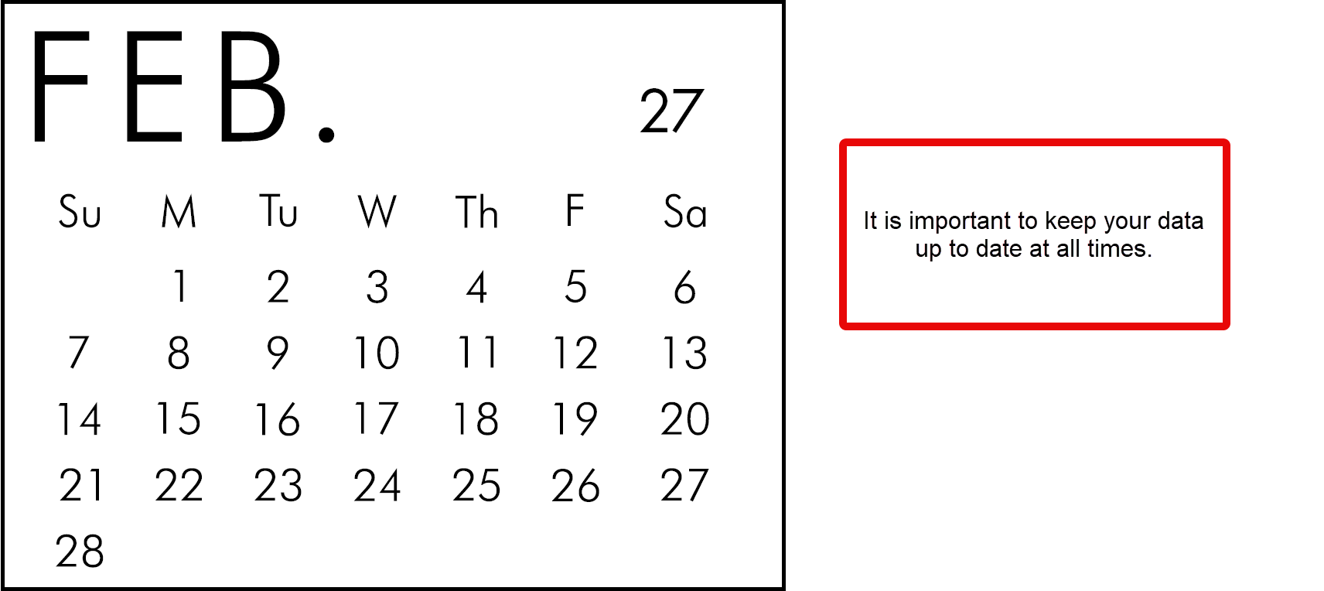
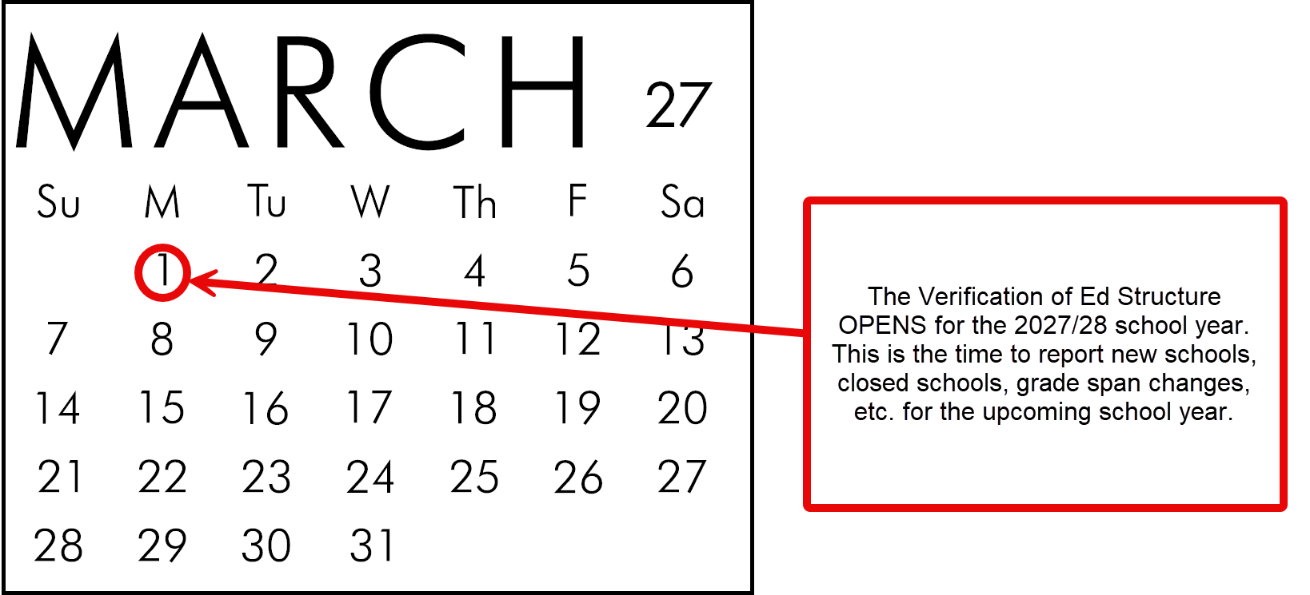

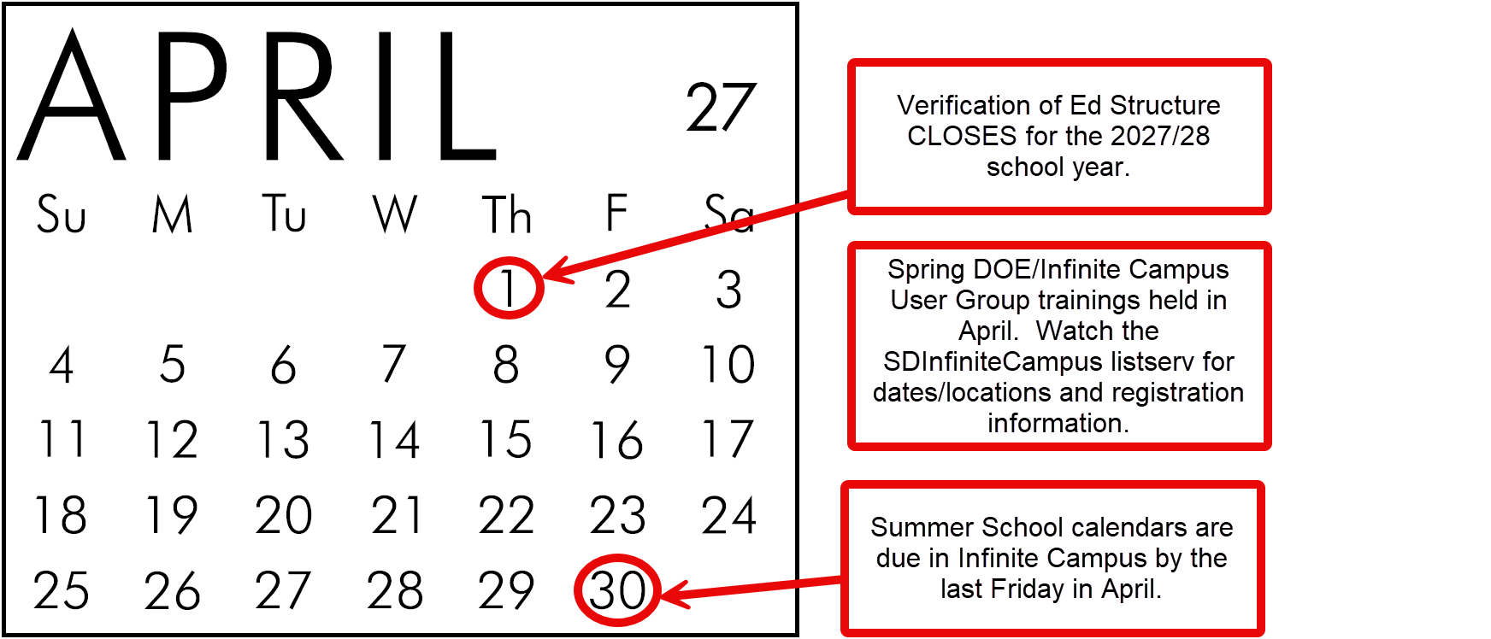

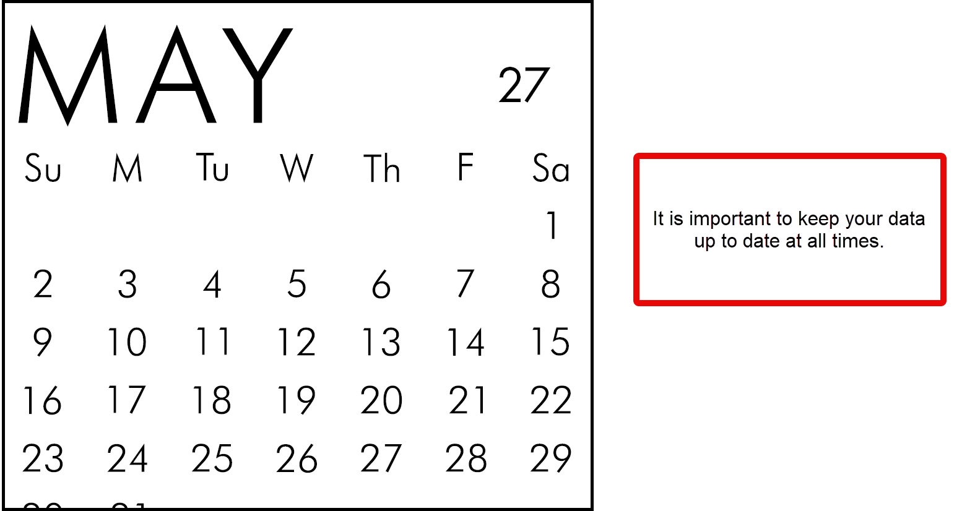

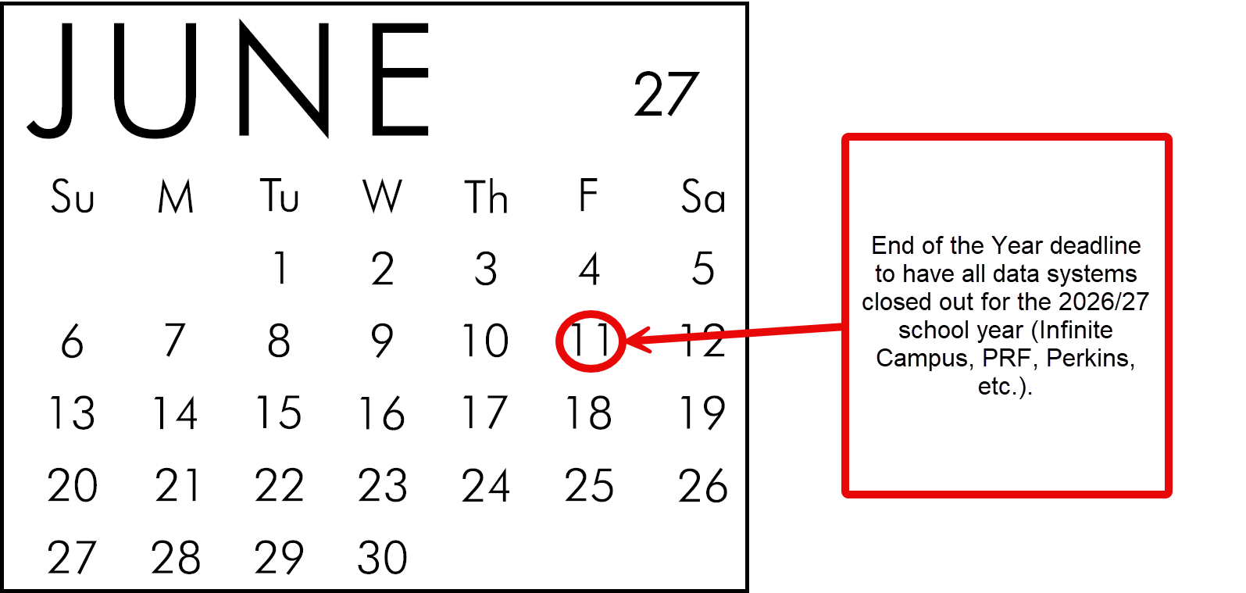

Section I - Fall Enrollment

Timeline
In accordance with 24:17:03:02 and 24:17:03:08 – Fall Enrollment student data must be reported in the Statewide Information Management System (Infinite Campus) according to the below timelines:
- Calendar Data: All school calendars for all attendance centers must be entered or uploaded into Infinite Campus by the last Friday in August. This includes any calendars that you have for your Preschool programs. Calendars for Summer School are due in the Infinite Campus system by the last Friday in April.
- Fall Data: All student enrollments must be entered or uploaded into Infinite Campus no later than 15 business days following the last Friday of September.
- State Aid Fall Enrollment Count: Is final on the last business day of October. No students may be added to the State Aid Fall Enrollment after this date but students may be removed if found to be reported in error.

Criteria for Fall Enrollment – State Aid (Used for funding purposes)
- Students must be enrolled on the last Friday in September. Students who exit or fail to return to school by this date and students enrolling after this date WILL NOT be included.
- If you operate a 4-day school week, the student must be enrolled and receive instruction on the Thursday prior to the last Friday in September to be included.
- Students enrolled for any percent of the day will be included. Only whole numbers are to be entered in the Percent Enrolled field.
- Enrollment in Alternative Instruction/Home School is not included in the Fall Enrollment – State Aid count.
- Students assigned out of district but for whom the district pays a tuition cost for are included.
- Out of state students (except for open enrolled students from ND and MN) are excluded from the Fall Enrollment – State Aid count.
- Open enrolled students are included in the count for the school or district in which they are enrolled and served.
- Fall Enrollment – State Aid count is applicable to public school districts only.
- Enrollment in Pre-School is not included in the Fall Enrollment State Aid count.

Criteria for Fall Enrollment – Census Count (Used for statistical reporting purposes)
- Students must be enrolled on the last Friday in September. Students who exit or fail to return to school by this date and students enrolling after this date WILL NOT be included.
- Students must be enrolled greater than 49% to be included in the Fall Enrollment – Census Count.
- Enrollment in Alternative Instruction/Home School is not included in the Fall Enrollment – Census Count.
- Open enrolled students are counted in the school in which they are enrolled and served.
- Out of state students enrolled in South Dakota schools are included in this count.
- Enrollment in Pre-School is included in the Fall Enrollment Census Count.

Required Data Elements for Infinite Campus District Edition and State Edition Schools

Calendars
The first step in making sure your Fall Enrollment data is entered accurately is by creating a calendar for EVERY attendance center in your district. All school calendars are due by the last Friday in August according to 24:17:03:08. **This includes any calendars that you have for your Pre-School programs. Calendars for Summer School are due in the Infinite Campus system by the last Friday in April.
- Additional information regarding how to create a new calendar or modify an existing calendar in Infinite Campus can be found on the Campus Community at the following link: Infinite Campus Knowledge Base | Infinite Campus. Please contact your district’s Infinite Campus Tech Coordinator if you have any trouble accessing the information at the above link.
Please note: Both District Edition and State Edition users MUST roll forward their calendar information from school year to school year. State Edition users do not have the functionality to roll forward their students; therefore, Infinite Campus will roll forward your students after you have completed the calendar roll forward function.
Important Calendar elements that MUST be entered include:
- A calendar must be entered for EVERY attendance center including Pre-Schools, Sped Out of District Placements, Virtual Schools, Private Schools and Summer Schools.
- Check your school calendar dates and your student day minutes under Calendar Information.
- At a bare minimum, your calendar must include the following:
- Start date of the school year
- End date of the school year
- Student Day (instructional minutes) – It is important that this information is correct as your attendance rate for Accountability is determined by the information in this field.
- Whole Day Absence (minutes)
- Half Day Absence (minutes)
- Type
- Title 3 – Only check if this is a Title 3 School calendar.
- Summer School – Only check if this is a Summer School calendar.
- 4 Day School Week – Only check this area of the calendar if the entire district is operating a 4-day school week.
- Virtual – Only check if this calendar is specifically for your students who are attending your school virtually.
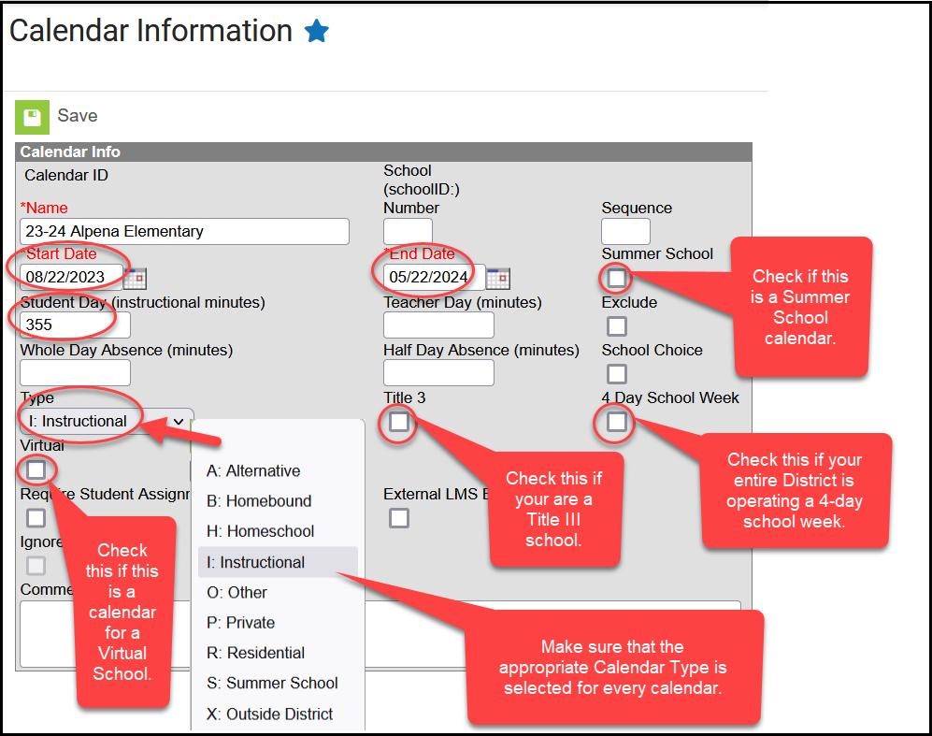
Virtual Calendars - Districts are allowed to create a separate calendar within an already existing school to house their students who are choosing to receive their educational services virtually.
To provide consistency throughout the state, the DOE is asking for districts to name these virtual calendars as follows: Calendar Name = Name of School Virtual (Example = Alpena Elem Virtual).
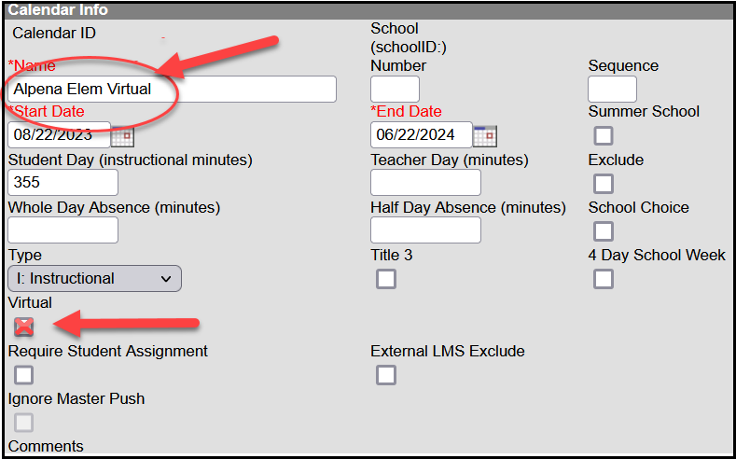
Districts must utilize their existing school structure and create separate virtual calendars for each attendance center. (Example: Alpena Elem Virtual calendar, Alpena Middle School Virtual calendar, Alpena Virtual High School calendar). Districts CANNOT create one virtual calendar for all their K-12 virtual students.
Alternative Instruction Activities Calendars - If Alternative Instruction (Home School) students are involved in any extracurricular activities/fine arts activities sanctioned by the SD High School Activities Association, districts MAY record those students in Infinite Campus. You will need to create a separate calendar and name it “Home School Activities” and the enrollment for the students in that calendar will be at 0%.

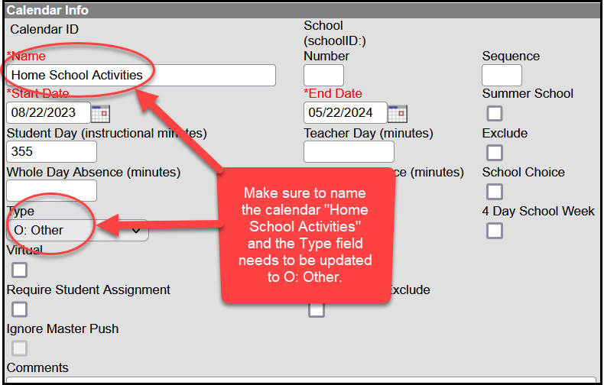
Grade Levels - Make sure that all grade levels that are being served within your school(s) are entered under the Grade Levels Setup. The district MUST then map all their local grade levels to the state grade levels. It is the district’s responsibility to make sure that the grade levels are mapped accurately.
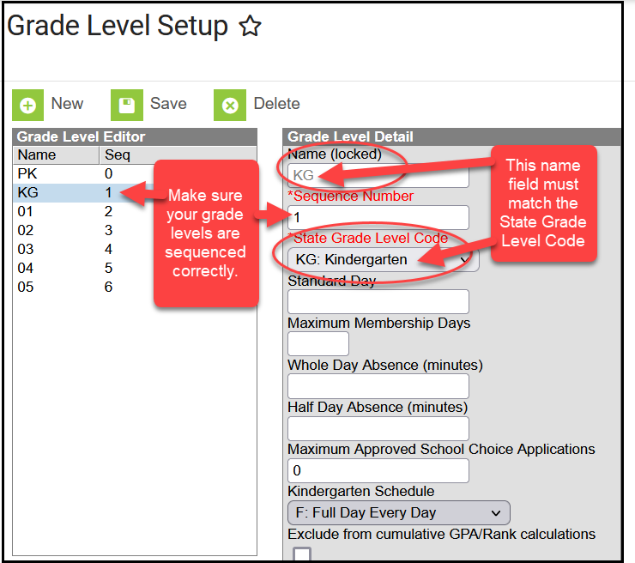
Terms - Do you operate on quarters, semesters, trimesters, etc.? Make sure that the start and end dates of your terms are correctly entered under the Term Setup.
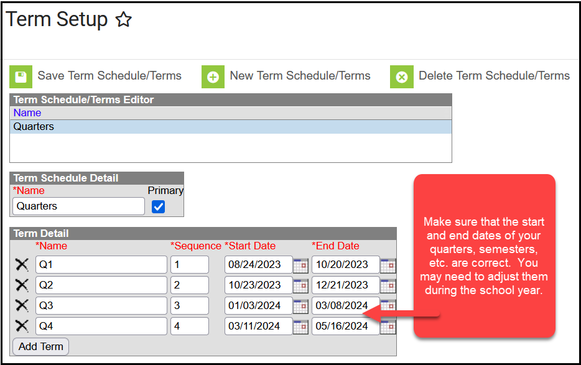
Periods - On the Period Setup screen enter your period schedule for a day. When entering the period minutes, you cannot overlap minutes. You are not allowed to count a class that is being held prior to the start of the school, home room minutes, lunch minutes, recess minutes, passing minutes or after school tutoring sessions as instructional minutes. Once you have entered your period schedule, it will automatically calculate the total instructional minutes for you.
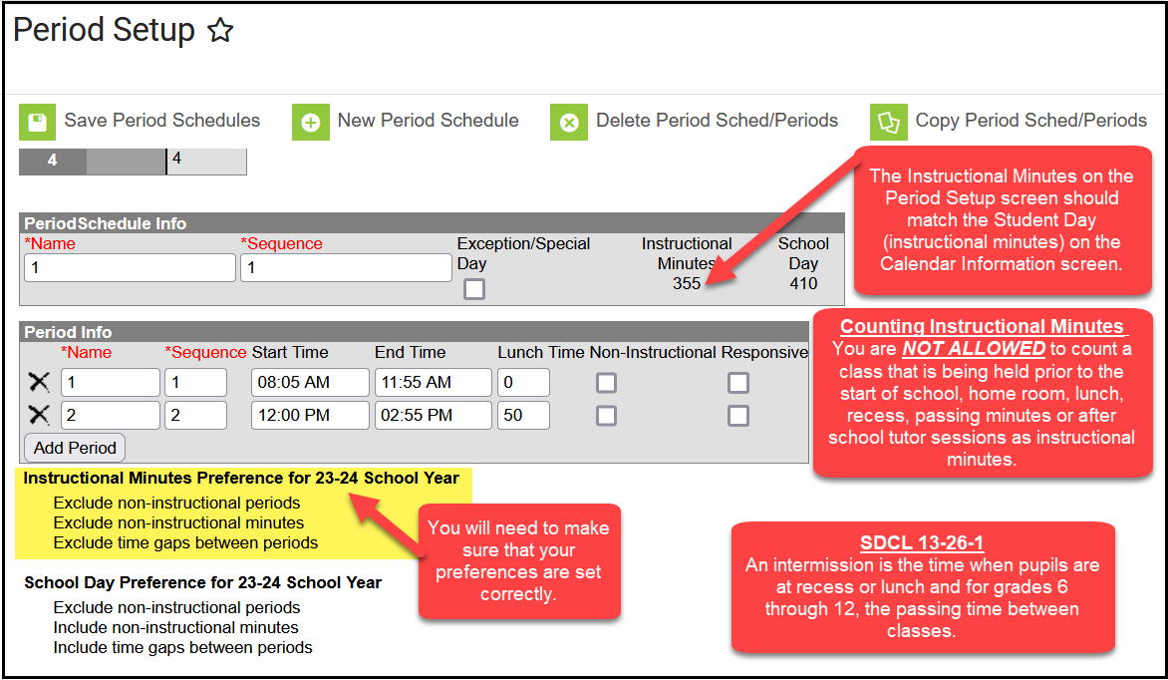

Days - If the Instructional Minutes are not calculating correctly you will need to check your preferences on Day Setup. The instructional minutes should read the same on the Calendar tab as they do on the Periods tab.
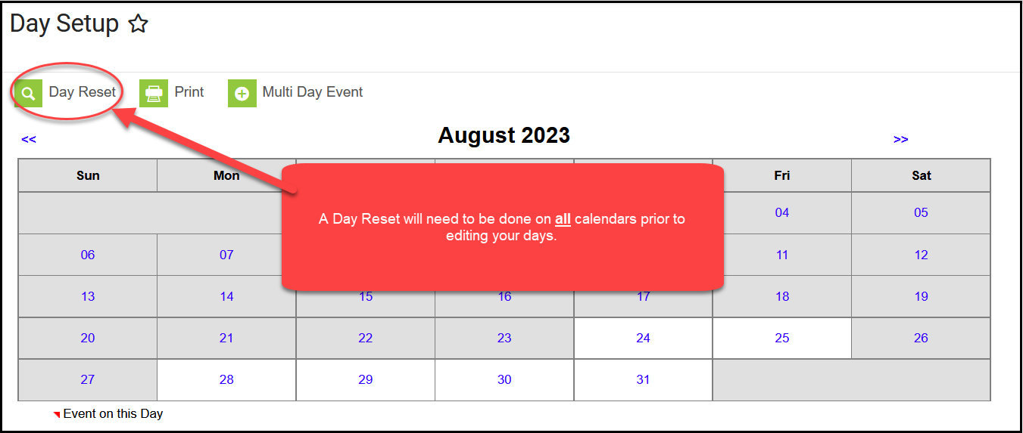
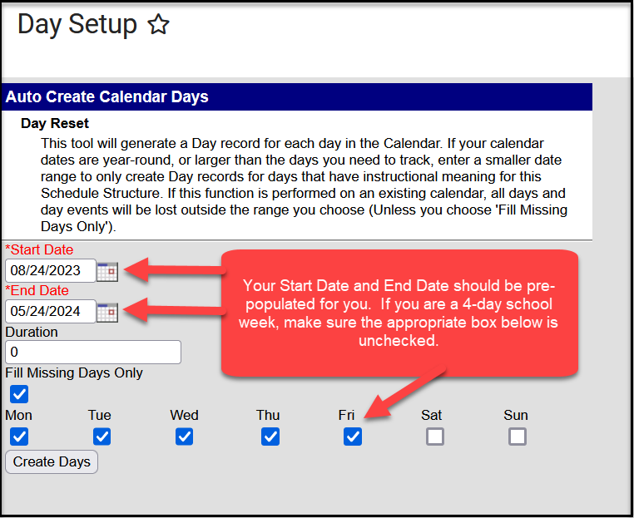
Enter the start and end dates and select the days that should be included in the reset (Monday, Tuesday, etc.). Select “Create Days”.

You will need to edit the start/end dates of the terms and any vacation days, etc. You can also set up day events such as Parent Teacher Conferences, In-Service Days, Holidays, etc. A “Day Reset” will need to be done for every calendar that you have in your District. If a “Day Reset” is not done, your numbered calendars days will not start over for the new school year.
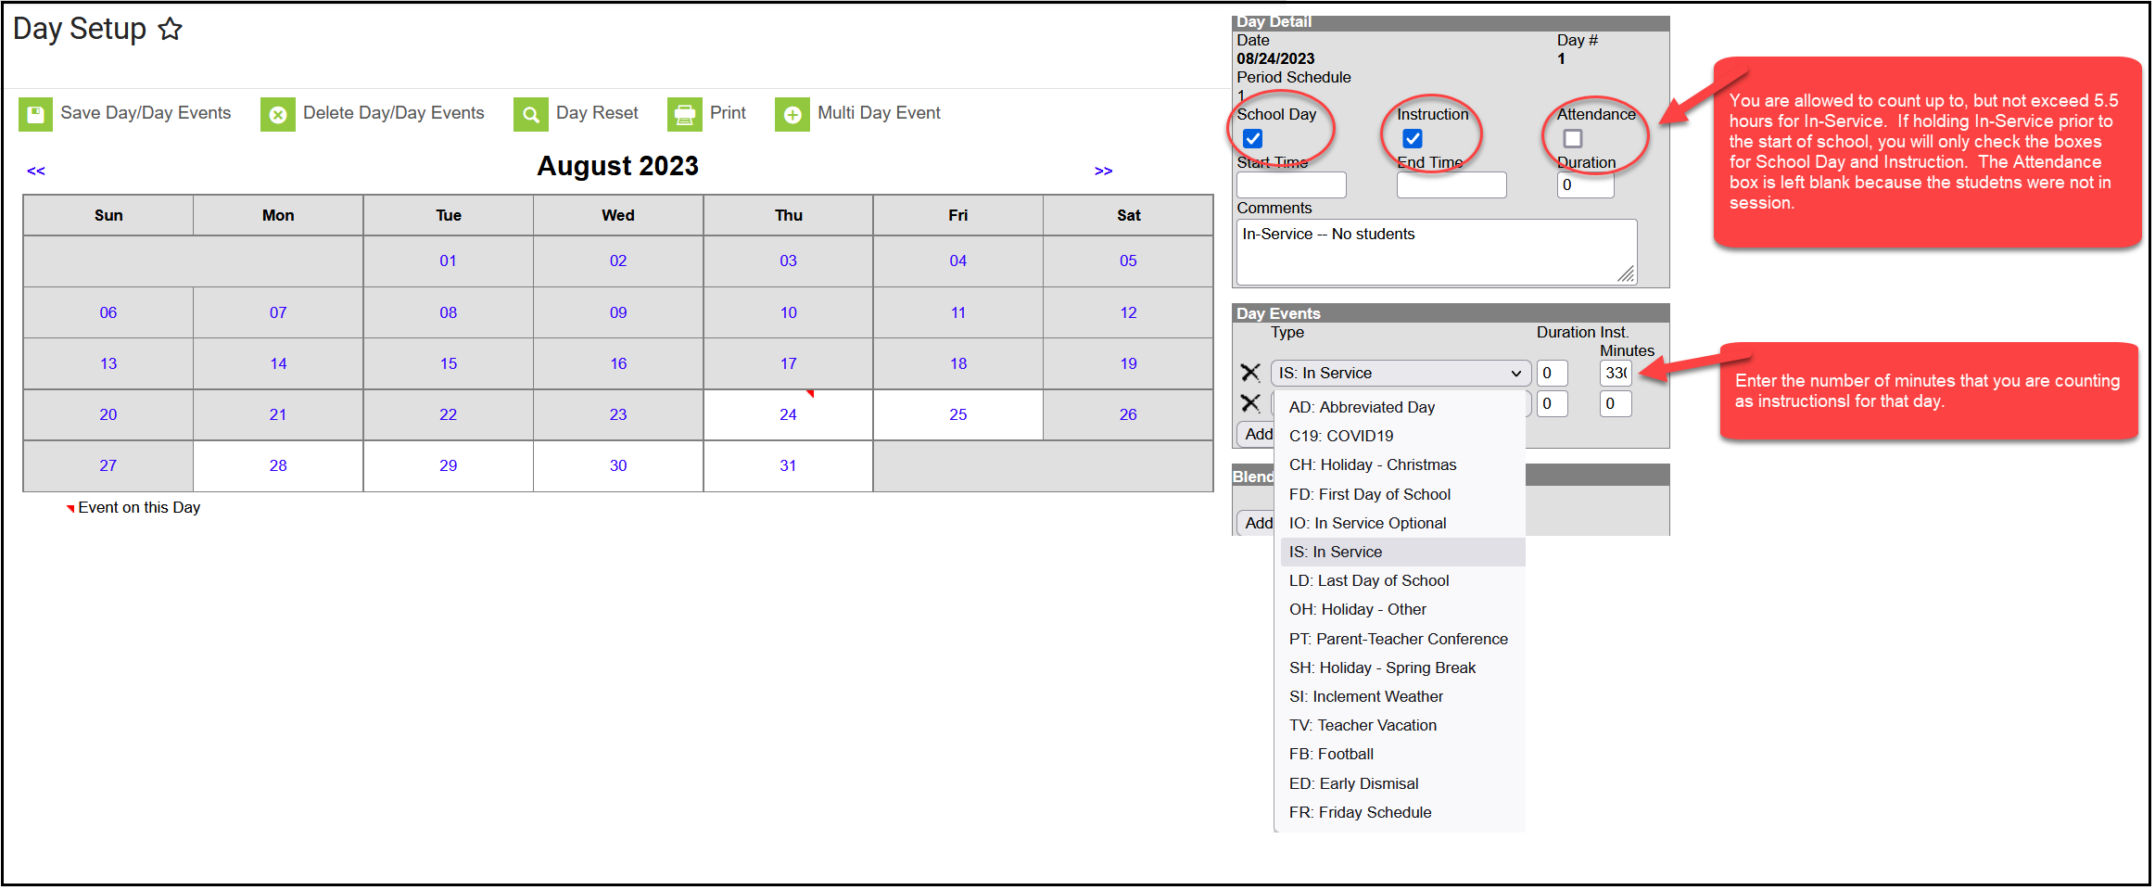

Deleting a Calendar
There are times when you may need to delete a calendar that was created in error. Select the calendar that you want deleted.
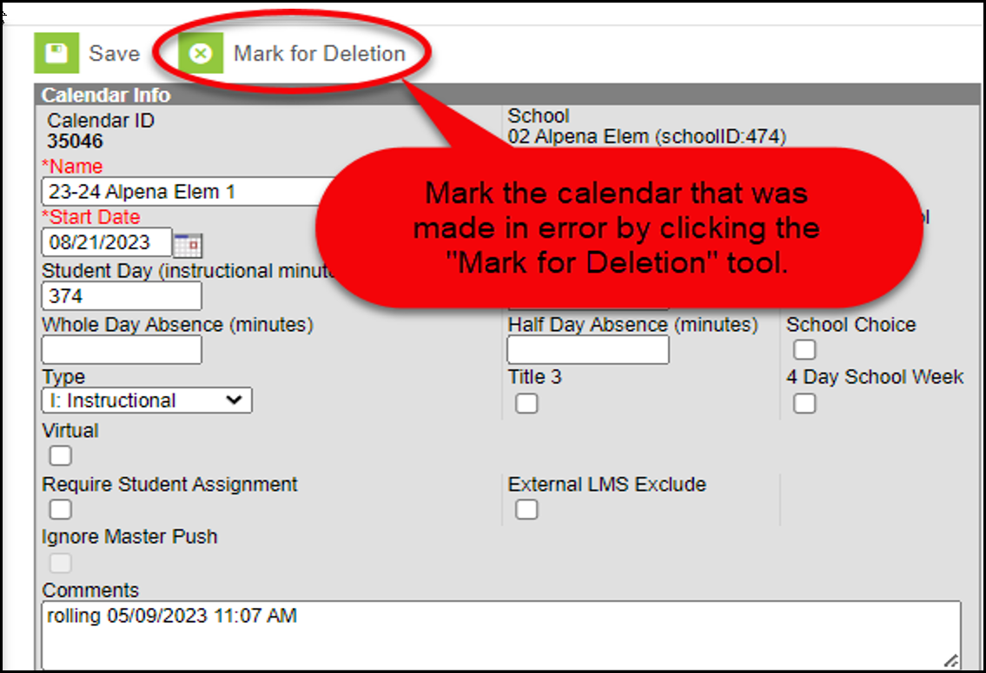
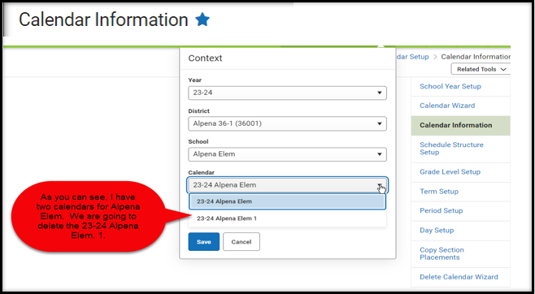
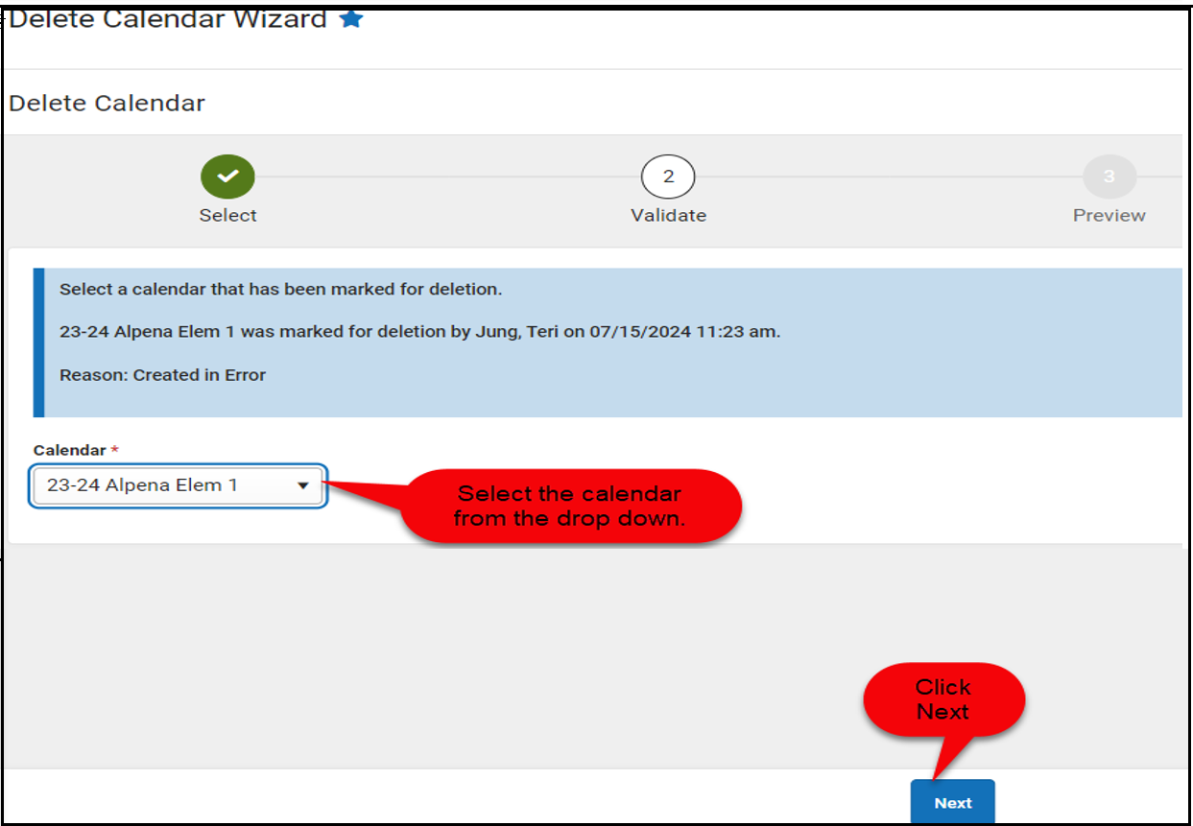
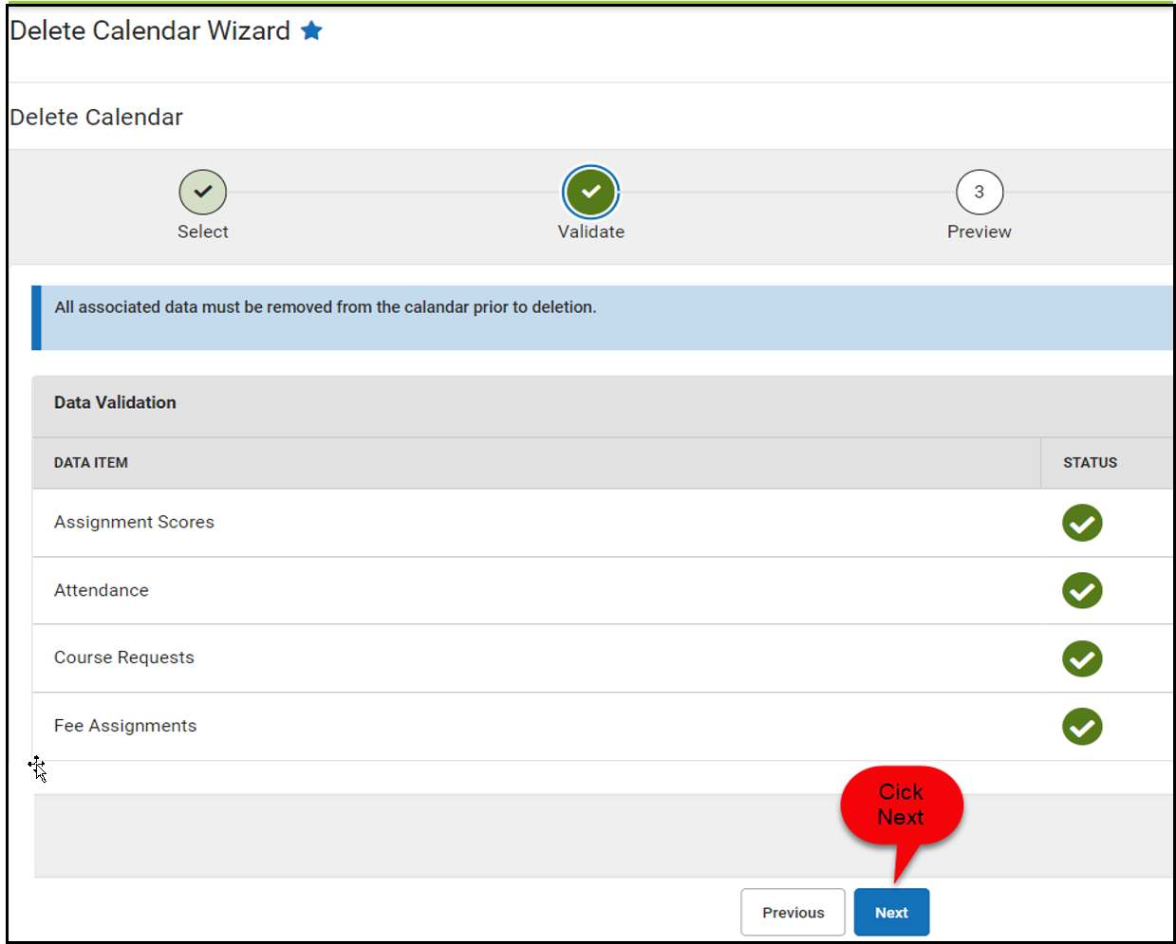
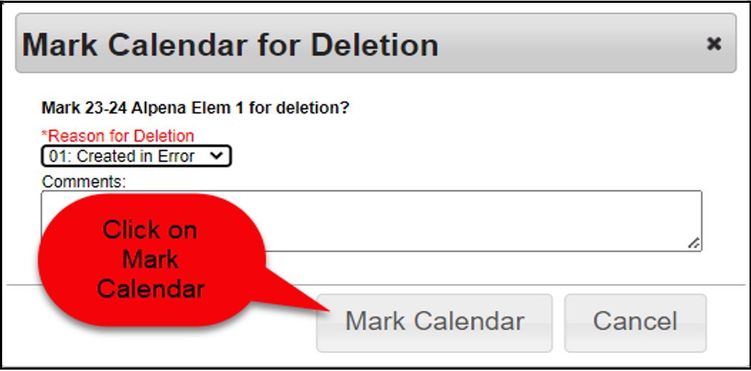

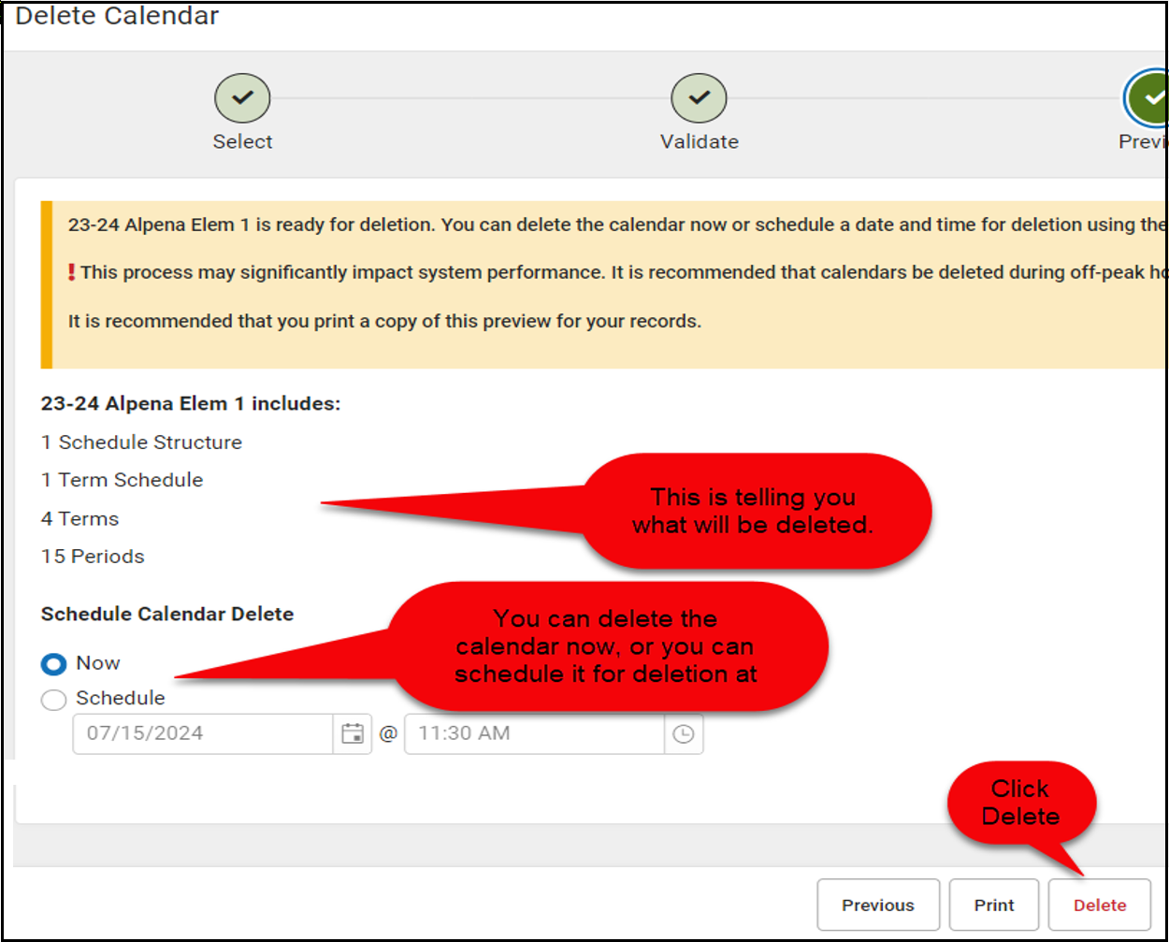
District and School History
It is important to check the District and School History information at the start of each new school year to see if there are any changes you need to report from the prior year. On the District Information screen, click on the + sign next to your district name and click on the Original Record to review current District History information. In the Program Participation area of the screen, if your district is a Title III district or accepts McKinney-Vento funding, make sure to place a check mark in the Title III and/or the McKinney-Vento checkbox.
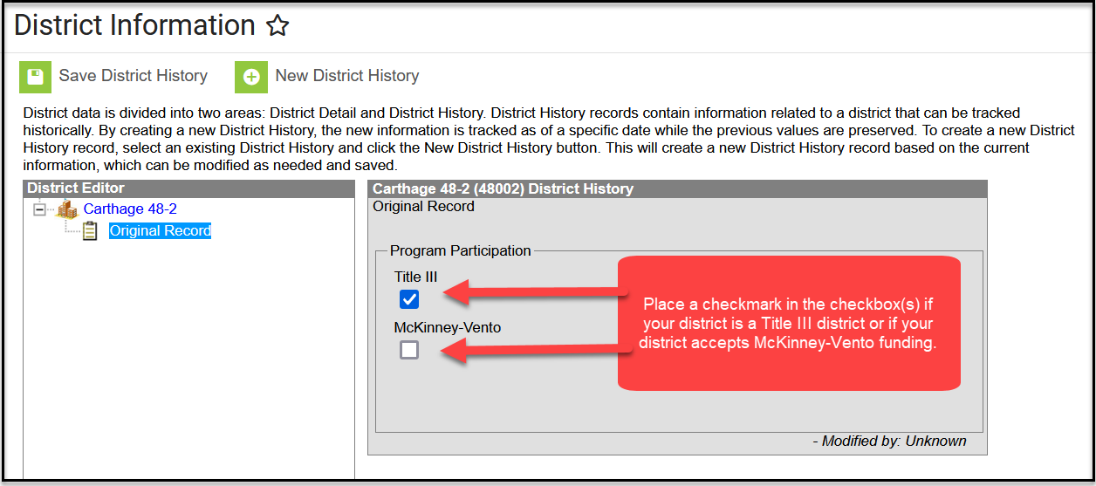
To check your School Information, go to the School Information screen and click on the + sign next to each of your schools and click on the Original Record to review current School History information. In the Program Participation area of the screen, if you are a Title I School, make sure the appropriate dropdown item is selected. If you are a Title III School, make sure you place a check in the Title III checkbox. You should also complete the USDA Programs area of the screen if your school is participating in the National School Lunch Program. More information on how to complete the USDA Programs area of the screen can be found in the FRAM section of this Desk Guide.
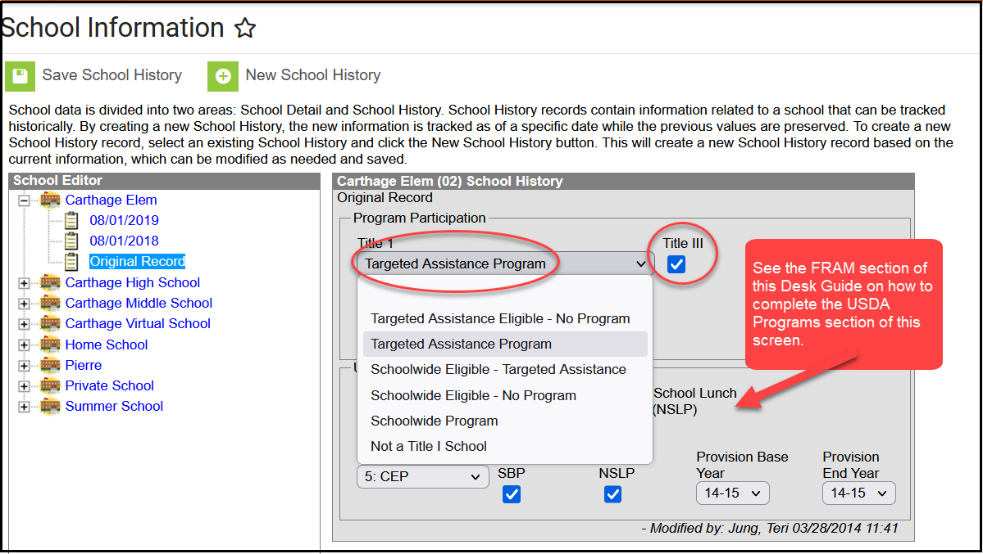

Records Transfer Process
To eliminate unnecessary data entry and to ensure all student data is properly transferred from one district to another, it is vital that districts use the Records Transfer process within Infinite Campus.
A records transfer may be requested any time after the transfer student has been enrolled in the new district. Immediately after the student’s new enrollment is saved, the records transfer page will display.

Requesting Records Through the Student Locator
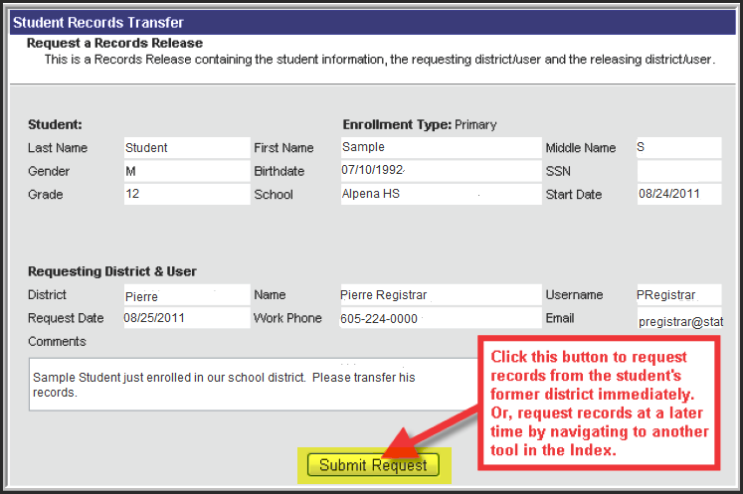
Clicking the Submit Request button will initiate a request for the student’s records. After a request is made, the Process Inbox and the student Records Transfer tab of the requesting district will both display a “Waiting” status until the former district responds with the records. During this time, the new district will have no indication of which district the student previously attended. As a courtesy to your fellow districts, please respond to all requests for transfer within 5 business days AND be sure to End Date the student record before you release the record to the requesting district.

Requesting Records Through the Records Transfer Tab
The transfer can be performed at the time of enrollment or at a later date. Requesting a transfer at a later date may be done by navigating to the student’s Records Transfer tab, selecting the New State Transfer Request icon (if applicable) and selecting the Submit Request button.
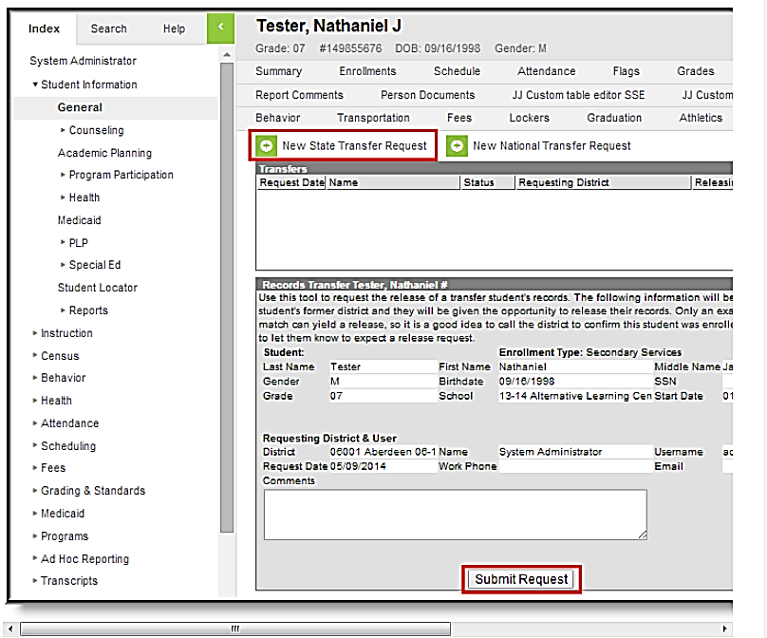
After a request is made, the Process Inbox and the student Records Transfer tab of the requesting district will both display a “Waiting” status until the former district responds with the records. During this time, the new district will have no indication of which district the student previously attended.

Completing the Process
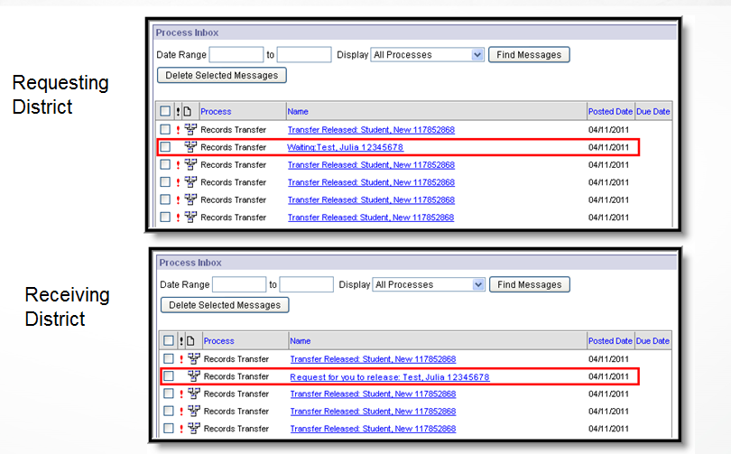

Completing the Process (cont.)
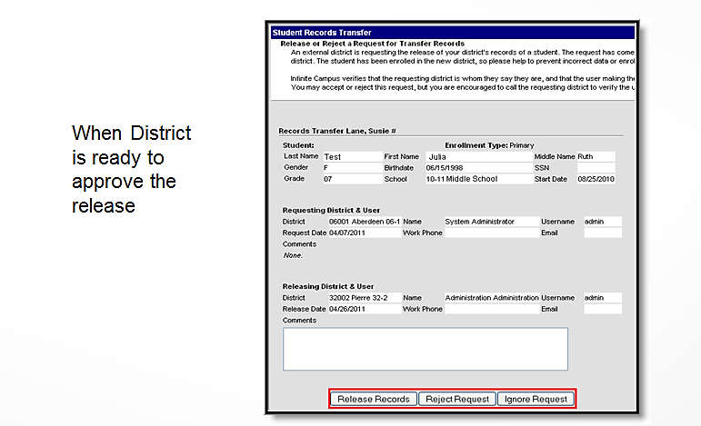
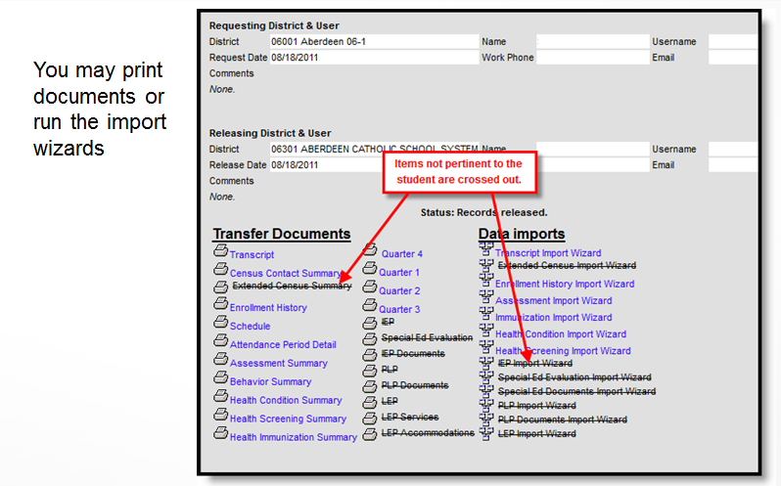
You will want to bring in all data fields that are not crossed out.
For additional information on the Records Transfer process, please see the documentation and the simulation videos available within the Infinite Campus Community at: https://kb.infinitecampus.com/help/records-transfer-student

Student Enrollments
To process accurate payments and get accurate Fall Enrollment counts, it is absolutely necessary that districts enter ALL student enrollments including Sped Out of District, Early Childhood (EC), Pre-School (PK), Junior Kindergarten (K1), After School and Summer School students into Infinite Campus in a timely manner. All students who attend your school district (even for a short time) must have an enrollment record in Infinite Campus.
Students not yet enrolled in Kindergarten but who are enrolled in a Pre-School program and are receiving a pre-school curriculum must be entered into Infinite Campus using PK as the grade level in the grade level field. Students must be at least 3 years of age prior to September 1st to be considered a pre-school student. Students who are not enrolled in Pre-School or Kindergarten and who are receiving ONLY Special Education services through your school district must be entered into Infinite Campus using EC as the grade in the grade level field.
School districts ARE required to take attendance for all pre-school (PK) students for the proper payment of certain funding. Attendance is not required for those young students receiving only Special Education services (EC). Attendance IS REQUIRED for students enrolled in Summer School.

Enrolling a Student
The first step in enrolling any student is to search the Infinite Campus system to see if the student was ever previously enrolled in South Dakota. This includes doing a search for those entering Kindergarten as they may have previously been enrolled in Pre-school (PK) or may have previously received Early Childhood Special Education services (EC). These students will have already been assigned a State Student ID. To search for a student, you will use the Student Locator Wizard. Remember, if a student is transferring to your district from another SD district, the student should appear when you do a student locator search. If the student does not appear after the first search, try again using the “All People” search criteria. If you are still not able to locate the student, check and see if the student goes by a nickname or a different last name. If you still are unable to find the student in Infinite Campus and you know for certain that the child previously attended school in South Dakota, call DOE Data Management at 605-773-3134 for assistance.
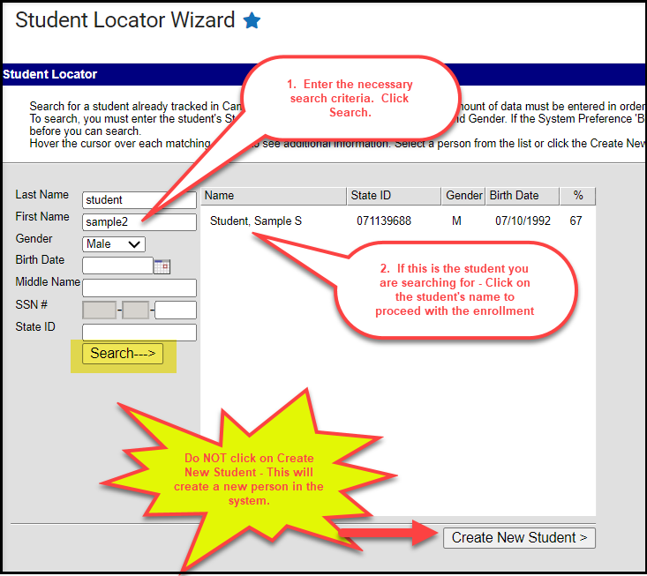
When enrolling a student, the student’s name should ALWAYS be entered as it appears on the student’s birth certificate or other legal documents. When entering student names, do not use commas. If the student goes by a nickname (ex: Chris instead of Christopher), you still need to enter “Christopher” in the First Name field and you can add “Chris” to the Nickname Field. If there is a hyphenated last name, you can use a hyphen (Merriman-Koch) or you can just use a space (Merriman Koch). Jr and Sr should be entered in the Suffix box. Do not “space” after the first or last name as the space is a character in Infinite Campus.
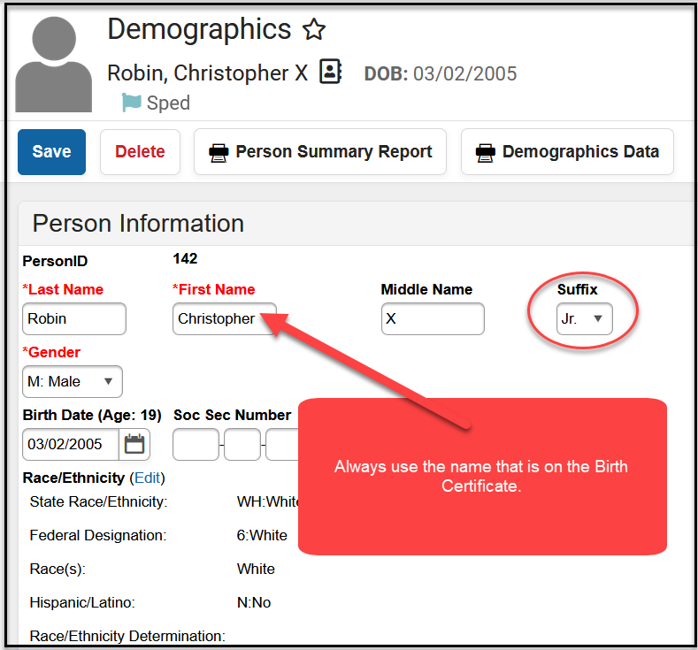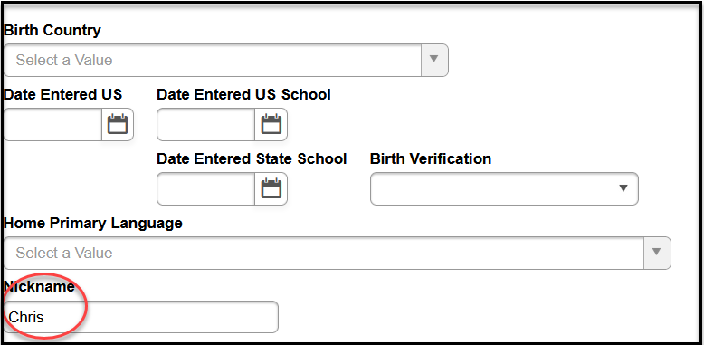

Please note that for transgender students, there is the option for you to enter the student’s legal name and legal gender as identified on the student’s birth certificate in the Protected Identity Information fields. This information DOES NOT sync to the State Edition. For data entry of the name and gender for transgender students and tool rights to the Protected Identity Information, please follow your school district’s policy.
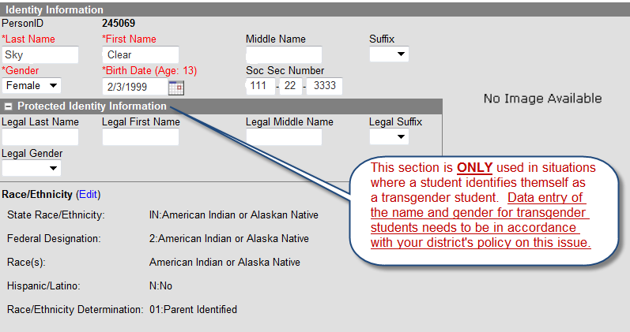

Race/Ethnicity
Within Infinite Campus, Race/Ethnicity data is located on the student’s Demographics and Identities screens. To enter or make a change in the Race/Ethnicity, click on the Edit button.
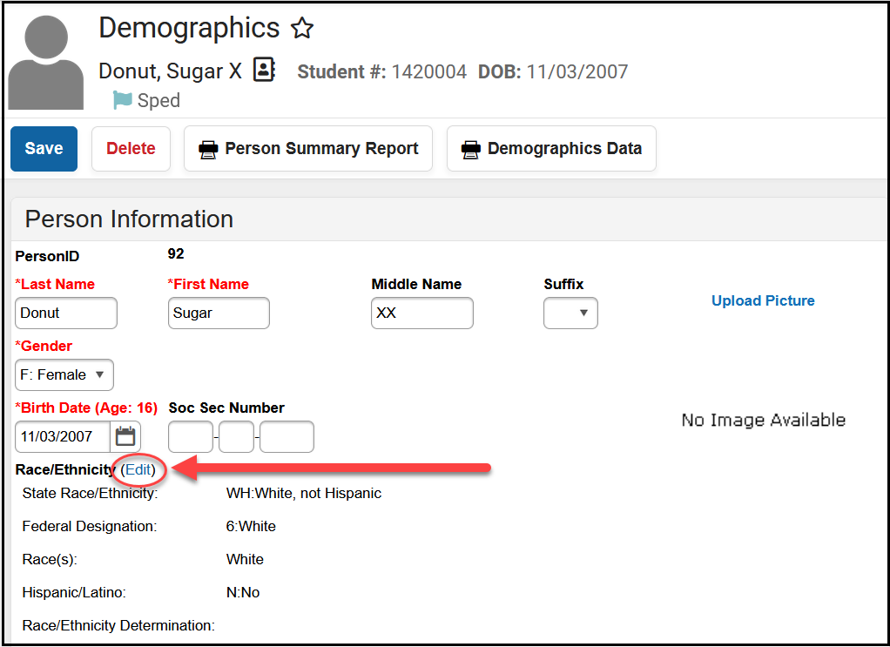

The below fields need to be populated for all students.
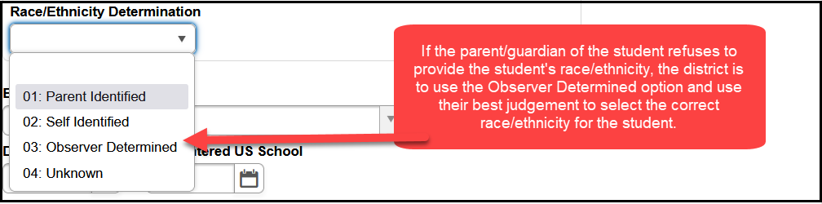
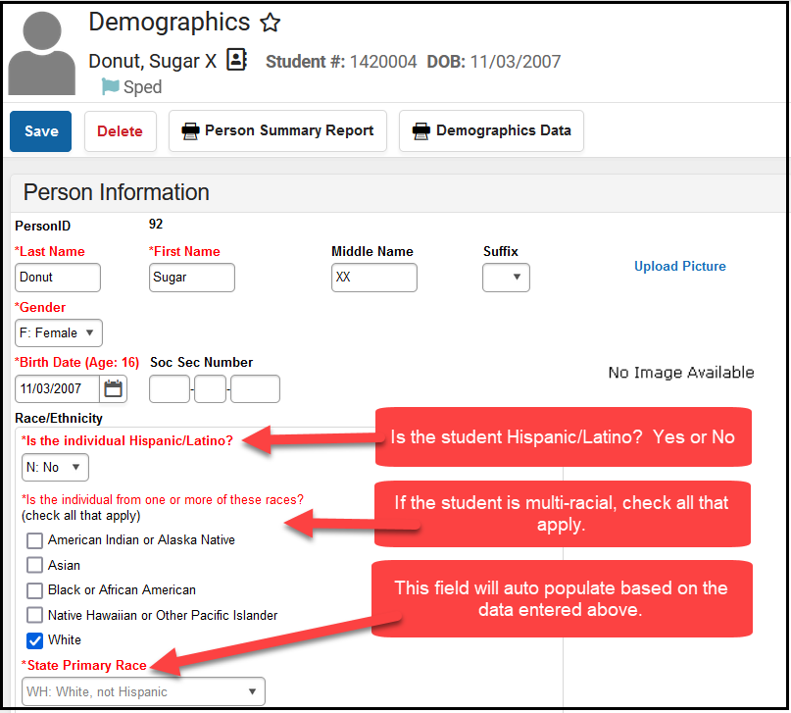
If a parent/guardian of a student refuses to self-identify the race/ethnicity of the student, it is the district’s responsibility to use the Observer Determined Identification method to determine the race/ethnicity of the student. The Observer Determined Identification method means the district staff are using their best judgement as to what the correct race/ethnicity of the student is. This is then what is recorded in Infinite Campus.

Race/Ethnicity Designation for Alternative Instruction/Home School Students
If an Alternative Instruction/Home School student is dually enrolled in the public-school district for any classes, then the Alternative Instruction/Home School student’s correct race/ethnicity must be recorded just like every other student. If the parent/guardian of the Alternative Instruction/Home School student refuses to self-identify the race/ethnicity of the student, it is the district’s responsibility to use the Observer Determined Identification method to determine the race/ethnicity of the Alternative Instruction/Home School student.

Immunizations
Immunization records from Infinite Campus are printed on the Board of Regents (BOR) High School transcript. The BOR asked for this enhancement, as they regularly must ask the districts for immunization records. If your district has not kept up on entering immunization records into Infinite Campus, our suggestion is to enter immunizations for the incoming Kindergarten class and for the current seniors. You could then enter two grades a year until you are caught up. This will help to eliminate the situations where schools are asked to respond to the BOR for immunization information on a case-by-case basis.

Enrollment Tab
Much of the information DOE needs to complete its state and federal reporting comes from data fields found on the Enrollment Tab. Below you will find screen shots of the Enrollment Tab along with the required data fields and possible entries highlighted.
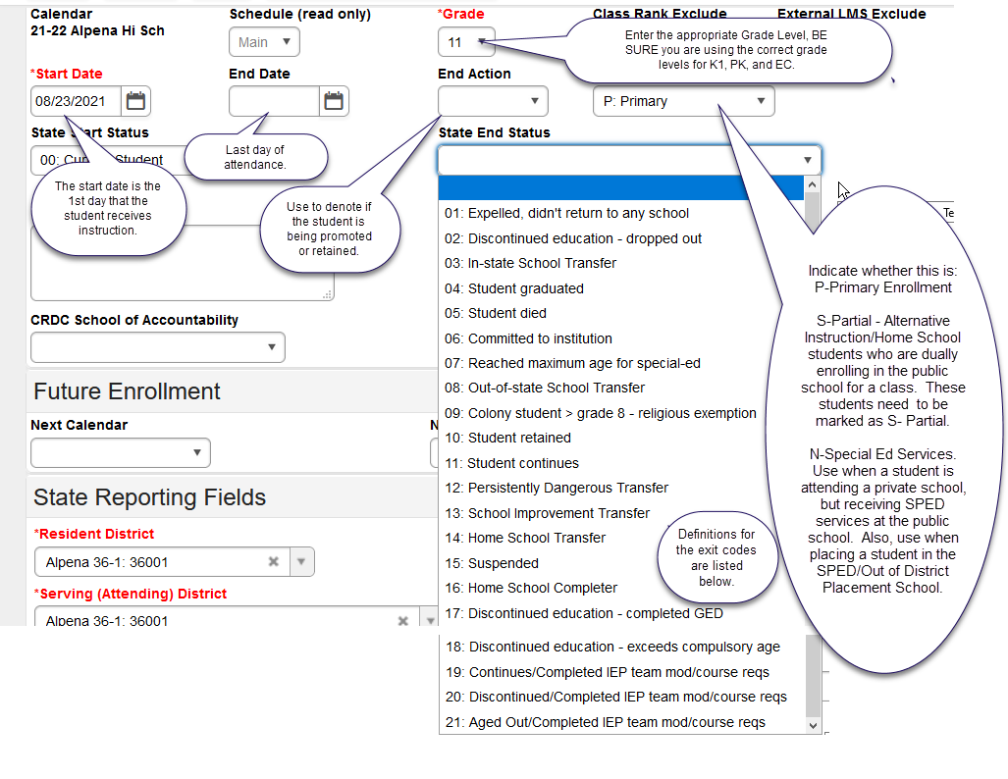

Grade Level - Definitions:
EC is used when a child is receiving special education services through your district and is NOT enrolled in PK or Kindergarten. EC grade level is most often used for children participating in IDEA Part B (ages 3-5) program. However, EC grade level also includes children who are participating in IDEA Part C (ages birth – 3) if identified as “in need of prolonged assistance”. Attendance IS NOT required for EC students.
PK is used when a student is attending Pre-school. Students must be 3 or older prior to September 1st of the school year. These students are those participating in a pre-school curriculum. Attendance IS required for PK students.
K1 is used Junior Kindergarten. If your district offers a Junior Kindergarten program, a student enrolled in Junior Kindergarten would be considered the same as a Kindergarten student for data collection purposes. The student must be at least 5 years old by September 1st to be counted for State Aid funding purposes. Attendance IS required for K1 students.

Service Type - Definitions:
Service Type describes if the enrollment is Primary (P), Partial (S), or Special Ed Services (N).
Primary (P) In most cases, students cannot have multiple primary enrollments. If a student has dual enrollments, the school districts must agree to identify one enrollment as the primary enrollment and the second enrollment as partial. Dual enrollments CANNOT be split 50/50. Instead, the split should be 51/49 with the 51% enrollment marked as primary and the 49% enrollment marks as partial. The exception to this rule is when a student has an enrollment in one of the 11 facilities (ex: JDC) as allowed in Administrative Rule 24:17:03:05. If this is the case, both enrollments would be allowed to have the service type marked as Primary (P).
*Please note: ONLY enrollments marked as Primary (P) are pulled into the Assessment system and are identified as a student in grades 3 – 8 and grade 11 who are to be tested for Accountability purposes.
Partial (S) A student’s enrollment should be marked as Partial (S) if the student is enrolled 49% or less in the public school district. Alternative Instruction/Home School students who are dually enrolling in the public school district for a class need to be marked as S-Partial.
Special Ed Services (N) A student’s enrollment should be marked as Special Ed Service (N) if the student is attending a private school but is receiving SPED services at the public school district. You will also use this code for those students who are placed in a SPED/Out of District Placement school.
***The Service Type for students enrolled in a Summer School program should be Primary (P).

End Status – Definitions:
01: Expelled, didn’t return to any school - The action of the school board that terminates a pupil’s membership in school for not more than 12 consecutive months.
02: Discontinued education – dropped out (any student that is under the compulsory age of 18). This is used if a student is under age 18 and (1) the student/parent indicate that they are dropping out or (2) if the student does not show for the school for 15 consecutive school days. Dropouts count for the year they fail to show up for. For example, a student may have completed the 2024/25 school year but fails to show up for the 2025/26 school year. In this case, the school would create a 2025/26 enrollment record. Both the start AND end dates would be the first day of the 2025/26 school year and the End Status would be updated to 02-Discontinued education- dropped out.
03: In-state School Transfer - Transferring from your district to another SD district.
04: Student graduated - A student who has attained sufficient credits to receive a regular high school diploma. This end status code can only be used for students who are enrolled in the 12th grade.
**DO NOT mark your Kindergarten or 8th grade graduates as graduates.
**DO NOT mark your special education students who plan to continue receiving services until the age of 21 as graduates. You should use the End Status Code of 11: Student Continues for these students. Once a student is marked as a graduate, that student is not eligible to receive services until age 21 nor is the district eligible to receive State Aid for these students.
**DO NOT mark your foreign exchange students as graduates as chances are they did not meet the criteria to obtain a regular high school diploma in SD. If they are returning to their home country, you should use the End Status Code of 08: Out of State School Transfer.
**DO NOT mark Alternative Instruction/Home School students as graduates if they are completing Alternative Instruction/Home School course work. If the Alternative Instruction/Home School student is dually enrolled in your district, you should use the End Status Code of 16: Home School Completer on the S-Partial Enrollment record. If the Alternative Instruction/Home School student is more than 50% enrolled in your district, you can mark the student as a graduate on the student’s P-Primary enrollment record.
05: Student Died
06: Committed to institution - Student is being served at: SD Human Services Center or the State Penitentiary.
07: Reached maximum age for special ed - 21 years of age.
08: Out of state School Transfer - Student moving out of state.
09: Colony student > Grade 8 - Religious exemption
10: Student retained
11: Student continues
12: Persistently Dangerous Transfer – Only to be used if your public school has been designated as a Persistently Dangerous School and the student is choosing to transfer to a different school due to this designation.
13: School Improvement Transfer
14: Home School Transfer - Student leaving public school and transferring to Alternative Instruction/Home School.
15: Suspended - The exclusion of a pupil from a class or classes for not more than 90 days.
16: Home School Completer - Student completes their Alternative Instruction/Home School course work. This is used if a student is receiving Alternative Instruction/Home School through the 12th grade. Since they do not receive a regular high school diploma, this code indicates they are completing their Alternative Instruction/Home School program.
17: Discontinued education – completed GED - When a student has completed their GED credential through an approved high school equivalency test preparation program, the enrollment record can be ended with the end status code of “17: Discontinued education – completed GED”. This end status code should not be used prior to the student completing the GED credential.
18: Discontinued education - Exceeds compulsory age (18 years of age).
19: Continues – Completed IEP team modified Course requirements – Students with disabilities whose requirements differed to those required for all students. These students may participate in graduation ceremonies, but the students are not considered graduates for reporting purposes and are still eligible to receive SPED services until age 21.
20: Discontinued education – Completed IEP team modified course requirements – In the Special Ed Summary, these students would be coded 13- Discontinued/Completed IEP team mod/course req – This means that a student has dropped out of school without obtaining a regular diploma. The student can return unless they have met the age out requirement.
21: Aged Out – Completed IEP team modified course requirements - These students will have been previously coded as 03- Continues – Completed IEP team modified course requirements for high school. These students have completed IEP goals, have turned 21, and this code is used to end their record.
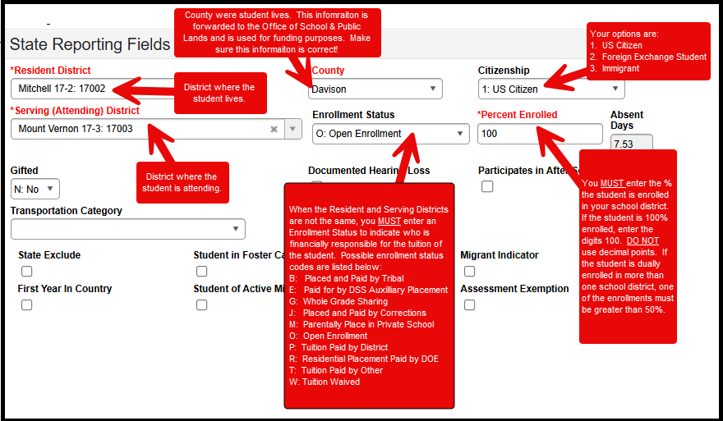

Resident District
This is the school district where the student lives.

County
This is the county where the student lives NOT the county where the school district they are attending is located.

Serving (Attending) District
This is the school district where the student is attending school at.

Citizenship box
Be sure all your students have the correct citizenship status reflected for their situation.
1: US Citizen – the student is a citizen of the United States.
2: Foreign Exchange Student – the student is not a citizen of the United States but is participating in a foreign exchange program and is attending your school.
3: Immigrant – The term immigrant children and youth mean individuals who:
- Are aged 3 through 21;
- Were not born in any State; and
- Have not been attending one or more schools in any one or more States for more than 3 full academic years. “Three full academic years: = cumulative”. A student can only be considered an immigrant for three full academic years for the Title III funding purposes.
- Please note the term “immigrant “as used in Title III is not related to an individual’s legal status in the United States.

Enrollment Status – Definitions
The Enrollment Status field is used to identify how the student came to your school and who is financially responsible for the student. If the Resident and Attending districts are the same, typically there is no need to complete this field. However, D: Persistently Dangerous refers to the rare case when a student switches schools as described at https://doe.sd.gov/ofm/sdgf.aspx. A: School Choice is no longer a valid option.
B: Placed and Paid by Tribal
- Used primarily by BIE schools.
- In few cases, public schools could use the code if the student is attending a residential treatment program operated by public school districts but paid for by the tribe.
E: Paid for by DSS Auxiliary Placement
- Use when the student is placed by the Department of Social Services. Resident district for students with E code must be either Custody of the State (90090) or DSS Aux Placement (68302).
- If the student is a Foster Child placed with a family in your school district, this Enrollment Status code SHOULD NOT be used. A Foster Child should be coded as any other resident student in your school district.
G: Whole Grade Sharing
- Refer to SDCL 13-15-31. All school districts shall adopt the contract or agreement no later than February 1st of the school year proceeding the school year for which the agreement will take effect. The Department of Education must approve the agreement for whole grade sharing. The only districts currently approved to use this Enrollment Status are:
  - Burke and South Central
  - Bowdle and Edmunds Central
J: Placed and Paid by Corrections
- Use when the student is placed by the Department of Corrections. Resident district for students with J code must be either Custody of State (90090) or Department of Corrections (49321).
M: Parentally Placed in Private School
- Use when the student is attending a private school paid for by the parent.
O: Open Enrollment
- Use when a student lives in one South Dakota school district but chooses to attend another South Dakota school district.
- Use for “cross-border” enrollments with North Dakota and Minnesota.
- If the student changes address during the school year that results in a change in their resident district, then the previous enrollment must be ended and a new enrollment entered with the updated resident district and the correct county of residency. In addition, Open Enrollment does not apply to students who are homeless and remain in the school of origin after moving to a different district.
- PK students CANNOT be coded as Open Enrolled.
P: Tuition Paid by District
- Use when the resident district is paying for the student’s placement in another school district/facility.
- Use for an Iowa student enrolling in South Dakota.
R: Residential Placement Paid by DOE
- Use for students placed in one of the below facilities associated with a SD public school district, for whom DOE is paying the tuition for their placement. Psychiatric Residential Treatment Facility (PRTF)
  - Plankinton – Aurora Plains Academy (Intensive PRTF)
  - Huron – Our Home ASAP (PRTF)
  - Mitchell – Abbott House (PRTF)
  - Parkston – Our Home (PRTF)
  - Spearfish – Spearfish Academy at Canyon Hills (Elementary and High School) (PRTF)
  - Sioux Falls – Summit Oaks Residential (PRTF)
  - Rapid City – Abbott House West (PRTF)
T: Tuition Paid by Other
- Use for students attending the School for the Deaf in Harrisburg & Brandon Valley
- Use for a South Dakota student enrolling in Iowa. (This pertains to Alcester-Hudson & Elk Point-Jefferson only).
- If the student’s tuition is being paid by an outside entity, such as a foundation or a program.
- PK non-resident students attending a public school and tuition is charged. “T: Tuition Paid by Other” is needed as PK students cannot have the enrollment status of “O: Open Enrollment”.
W: Tuition Waived
- This code is used for students attending the School for the Blind.
- PK non-resident students attending a public school and no tuition is charged. “W: Tuition Waived” is needed as PK students cannot have the enrollment status of “O: Open Enrollment”.

Percent Enrolled
According to 24:17:01:06, you must report the percentage of the day that the student is enrolled. A full-time student or 100 percent enrolled student is any student who is carrying a full course load. The term, full course load, means any student who is enrolled in at least five courses or is scheduled for a full school day. The term, full school day, means the amount of time in the day between the start and end of classes during an average school day. If any student is enrolled in less than five classes or does not attend school for the full school day, the student shall be reported based on the percentage of classes taken OR the portion of the full school day that the student is in school.
ENROLLMENT PERCENTAGE BASED ON AT LEAST 5 COURSES
Standard or Block Schedule  # OF CLASSES (8 Periods) | Trimester Schedule  # OF CLASSES (5 Periods) | % ENROLLED
1 CLASS | 1 CLASS | 20%
2 CLASSES | 2 CLASSES | 40%
3 CLASSES | 3 CLASSES | 60%
4 CLASSES | 4 CLASSES | 80%
5-8 CLASSES | 5 CLASSES | 100%

Enrollment % Changes during the School Year
During the school year a student’s enrollment percentage may change. A student may add a class, drop a class, or their resident district may have changed, etc. For Average Daily Membership (ADM) to be calculated correctly, it is important to maintain a history of all enrollment records with the different enrollment percentages.
When a change occurs, the original enrollment record must be ended (using Exit Code 11: Student continues) as the end status and a new enrollment record created with the new enrollment percentage. In order to maintain the schedule and attendance information, it is important to create the new enrollment first before ending the old enrollment. The creation of the new enrollment record is required to maintain the history of the student’s enrollment records through the school year.

Alternative Instruction/Home School Students
Due to substantial changes made by the 2021 SD Legislature to SDCL 13-27, parents/guardians must submit their Alternative Instruction/Home School notification through the Alternative Instruction Notification/Home School online system.
When parents/guardians enroll their students in Alternative Instruction/Home School via the Alternative Instruction Notification/Home School online system, the district’s Business Manager and Main Infinite Campus contact will be notified by an automatically generated email when a family chooses your district as their “Resident District”. A separate email will be generated for each student that is reported.
Parents/guardians are encouraged to utilize the online system. However, there may be times when a parent/guardian will choose to submit the Alternative Instruction/Home School notification in paper form to the district. If a notification form is initially submitted to a school district, the district must complete the notification and provide the parent/guardian with a final copy as proof of notification. A copy of the notification must then be sent to the Department of Education (attn: Megan Tatum). If the department receives the initial notification, the department will complete the form and provide the parent/guardian a final copy as proof of notification and share a copy with the school district. All notifications must be kept confidential. For questions regarding Alternative Instruction/Home School, contact Megan Tatum at (605) 773-4771.
**Remember, the enrollments of Alternative Instruction/Home School students in Infinite Campus should be as follows:
ALTERNATIVE INSTRUCTION/HOME SCHOOL STUDENTS
SERVICES PROVIDED BY THE DISTRICT | Educational  Services | SPED Services | Athletics | Fine  Arts | Other  Activities | No  Services
District may enter a student record in Infinite Campus | Required | Required | Optional | Optional | Optional | No

Open Enrollment
If a student is wanting to Open Enroll into your district, be sure to adhere to all procedures outlined on the DOE website at: https://doe.sd.gov/openenrollment.aspx
If at any time during the school year, a student who is Open Enrolled has a change of address which results in a change in their resident district, the previous enrollment record must be ended and a new enrollment record established to identify the student’s current resident school district and correct county of residency. This must be correct to ensure proper payment of State and County Apportionment funding (both are based on the resident district and/or county rather than serving district).
Pre-school students cannot be Open Enrolled. If you have a PK student coming into your district from another school district for pre-school, you will need to use the Enrollment Status code of either T – Tuition Paid by Other or W – Tuition Waived depending on whether the district charges for pre-school.

Open Enrollment for Alternative Instruction/Home school Students
Guidance for districts for Alternative Instruction/Home School students who want to Open Enroll can be found at: https://doe.sd.gov/oatq/documents/HS-SDAltInst-FAQ-0422.pdf.

Cross Border Enrollment Agreements
The South Dakota Department of Education has negotiated enrollment agreements with three bordering states: North Dakota, Minnesota and Iowa. Copies of these agreements can be found on the DOE website: https://doe.sd.gov/openenrollment.aspx.
Our agreements with both North Dakota and Minnesota are “open enrollment” type programs and allow students to choose cross border attendance. Once approved by the receiving school district, the eligible students are allowed to enroll in the neighboring state without the permission or any financial obligation of their resident district. Students are counted for funding purposes in the state in which they are enrolled. The reconciliation process of counting how many students come and go from each state is determined by the State Education agencies. Only students whose resident district is a “contiguous/bordering” school district, (i.e.: touching the state line boundary), are eligible for this “cross border-open enrollment” arrangement. This is a requirement for both a SD district and a ND or MN district. For student reporting purposes please see the below examples:

SD student enrolling in MN or ND |  |  |  | MN or ND student enrolling in SD
Resident district |  | 25003 |  | Resident district | 99086
Attending district |  | 99085 or 99086 |  | Attending district | 25003
Enrollment status |  | “0” open enrolled |  | Enrollment status | “0” open enrolled
% of day enrollment |  | 100% |  | % of day enrollment | 100%

If you have students that are a resident of your district, but are attending school in ND or MN, you MUST have an open enrollment form from the district they are attending on file in your district, and you will need to enter them into your Out of State/Private School calendar to track them.

Our agreement with Iowa is not an “open enrollment” type agreement. This agreement sets a standard and uniform amount of tuition to be paid by DOE for each student that may be placed out of district/state by their resident district. This agreement does not allow for students to move freely between South Dakota and Iowa. Only eligible students from the SD districts of Alcester-Hudson and Elk Point-Jefferson are included in this agreement. All other SD districts that border IA must agree to the placement and pay tuition to the Iowa school district. If you have questions about whether a student is eligible for our agreement with Iowa, please contact Bobbi Leiferman at 773-5407.
IA student enrolling in SD |  |  |  | SD student enrolling in IA |  |  | SD student enrolling in IA
 |  |  |  | (Alcester-Hudson & Elk Point-Jefferson students ONLY) |  |  | (All other students)
Resident district |  | 99087 |  | Resident district | 61001 |  | Resident district | Student’s SD resident district
Attending district | 61001 |  |  | Attending district | 99087 |  | Attending district | 99087
Enrollment status | “P” tuition paid by district |  |  | Enrollment status | “T” tuition paid by other |  | Enrollment status | “P” tuition paid by district
% of day enrollment | 100% |  |  | % of day enrollment | 100% |  | % of day enrollment | 100%

Overlapping enrollments
Overlapping enrollments are permissible for up to 90 consecutive days according to South Dakota Administrative rule 24:17:03:05 if the student is dually enrolled at any of the following entities:
Short Term Group Care | JDC’s (Juvenile Detention Centers)
Avera Adolescent Addiction Care Program: Sioux Falls – 49005 | Aberdeen JDC – 06001
Avera Behavioral Health Program: Sioux Falls – 49005 | Huron JDC – 02002
ARISE Shelter Care: Sioux Falls – 49005 | Pierre JDC – 32002
Our Home Rediscovery: Huron – 02002 | Rapid City JDC – 51004  Sioux Falls JDC - 49005
 | Wanbli Wiconi Tipi (Todd County) JDC - 66001
Resident District – The resident district is to keep the student enrolled at 100% with the Service Type field marked as P: Primary. The resident district needs to track how long the student is placed at the Short-Term Group Care or JDC facility and must drop the student at the resident district on the 91st consecutive school day if the student is still attending the Short-Term Group Care or JDC facility.
Attending District – The attending district will create an enrollment record showing their district as both the Resident and the Serving/Attending district for the period in which the student is attending the Short-Term Group Care or JDC facility. The Percent Enrolled field should be marked as 100% and the Service Type field should be marked as P: Primary.
***This will allow for State Aid to be paid to both the Resident and the Attending District if the student is dually enrolled in both districts on the last Friday in September.

504 Students
If you have a student who is on a 504 Plan, you will need to check the 504 Plan box. The check box can be found on the Enrollment tab in the State Reporting Fields Section as shown below. To be eligible under 504, a student must be determined to: (1) have a physical or mental impairment that substantially limits one or more major life activities; or (2) have a record of such an impairment; or (3) be regarded as having such an impairment. Once a student is determined eligible, they should have a written plan to document eligibility and services to be provided.
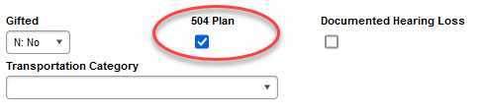

Documented Hearing Loss
Districts have the responsibility to identify and report any students with hearing loss. There is a check box on the Enrollment tab in the State Reporting Fields Section. This applies to all students, birth to 21 years of age. It does not require testing. If a student has a documented hearing loss (audiological report) of 35 db or more regardless of whether they have an IEP or 504 plan, then the box will be checked.
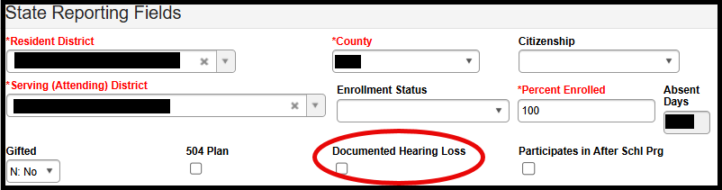
There is a canned report under SD State Reporting named “Documented Hearing Loss Extract” that you can use to verify the students that you have flagged as having a Documented Hearing Loss. You must have rights to this report to run it.

Students Participating in After School Program
Students who participate in After School programs offered and funded by a school district need to be flagged by the district. This checkbox replaces the need for districts to add these students to an After School calendar and to take attendance.
The definition of an After School Program is: Programs that provide academic enrichment opportunities during non-school hours that serve children and youth of all ages. After School programs help students meet state and local content standards in core academic subjects, such as reading and math; offer students a board array of services such as social emotional supports or family programs.
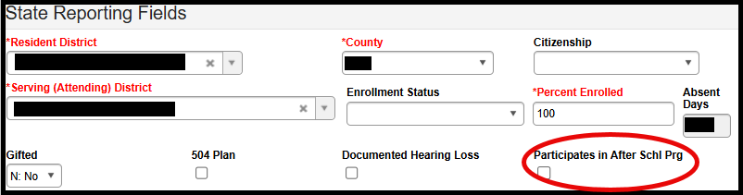

Students in Foster Care
Districts do not need to worry about updating the Foster Care field. The DOE obtains a file from the Department of Social Services and works with Infinite Campus to flag each Foster Care student on a biannual basis. If a student is flagged as a Foster Care student, they are to retain this status for the entire school year even if their living arrangements change during the school year. When you have a student marked as a Foster Care student, you need to make sure they are marked as receiving FREE lunch on the FRAM tab.
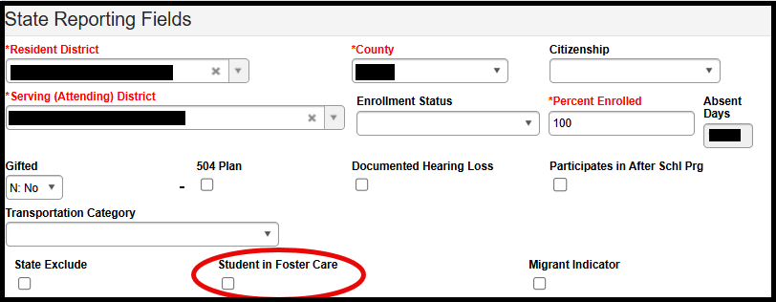

students with parent serving in the armed forces
School districts are required to collect whether a student has a parent serving in the Armed Forces on an annual basis. This information is normally collected during the start of year enrollment process. At the beginning of the 2025/26 school year, Infinite Campus and South Dakota began implementing the core solution product associated to this data collection, the Military Connections Tab. Infinite Campus has indicated that the needed development to the Military Connections Tab will take considerable time to complete (2-3 years). Therefore, beginning with the 2026/27 school year, districts will again be required to flag all “Students of Active Military Parent” by placing a check in the checkbox on the Enrollment Tab.

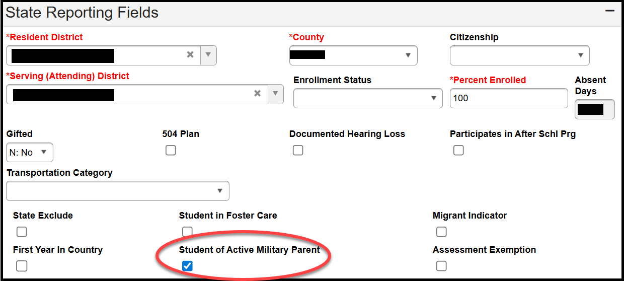

The definition of “Armed Forces” includes the Army, Navy, Air Force, Marine Corps, Space Force, and Coast Guard. This also includes their respective reserve components (i.e., Army National Guard, Air National Guard, and Army, Navy, Air Force, Marine Corps, and Coast Guard Reserves). It DOES NOT include a parent who is a retiree, a veteran, or in the Retired Reserves. Once the student has been identified as having a parent serving in the Armed Forces, they are to retain that status for the entire school year.

According to SDCL 13-28-9 if the parent or guardian of a child is transferred to or is pending transfer to a military installation within the state while on active military duty pursuant to an official military order, the child meets the residency requirement for free school privileges in the school district in which the parent or guardian resides or will reside. For the purposes of this section, a military installation is a base, camp, post, station, yard, center, or other installation under the jurisdiction of the United States Department of Defense.

Once notified by the parent or guardian that their child/children will be attending your school district once their move is complete, the district will enter an enrollment record(s) in Infinite Campus even though the student(s) is not yet officially attending school in your district. The reason for this is to provide for a seamless transition for these students and it also helps these military families establish necessary residency to help secure military housing. In these situations, the district will enter an enrollment record with the Percent Enrolled listed at 0%. Once the student is present and begins attending school, the original 0% enrollment record will be closed, and a new record created with the correct Percent Enrolled entered in Infinite Campus.

Enrollment Record of Military Student While Pending Transfer
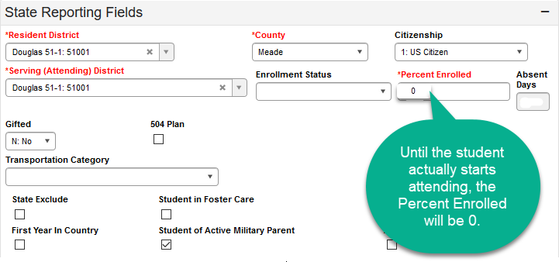
Enrollment Record of Military Student Once Transfer is Complete

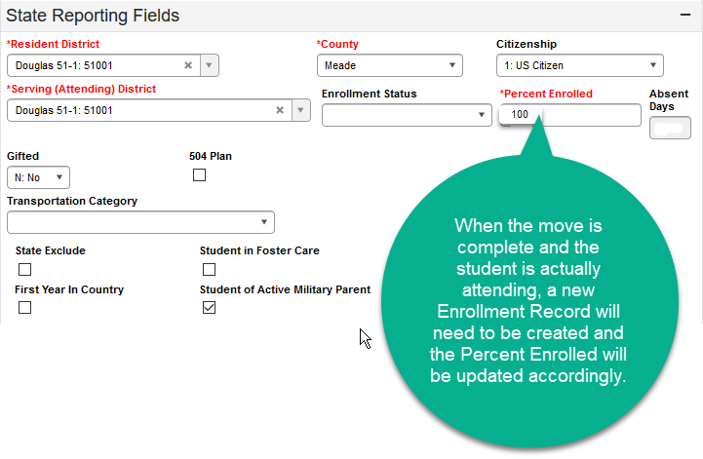
According to SDCL 13-33-23.1, if the parent/guardian of a student is ordered to transfer to a military installation in South Dakota pursuant to a military order, the student is eligible, upon issuance of the order, to be registered and enrolled with a state-approved distance learning provider by the school district in which the parent or guardian will reside.

FERPA Program Screen
Information regarding whether the district can share student directory information, that is protected by FERPA, is collected via the FERPA program screen in Infinite Campus. Districts are required to obtain parental consent on student directory information on an annual basis. This information is normally collected during the start of year enrollment process. The FERPA program screen collects the following information:
Question 1: Do you grant permission for your student’s contact information to be provided to the US Military for the sole purpose of informing students of potential career opportunities? Required for grades 9 – 12 in compliance with ESSA/Title 10 (10 U.S.C. 503).
Question 2: Do you grant permission to share information with SD BOR/SD Tech Colleges? Required for grades 7 – 12 in compliance with SDCL 13-28-50.
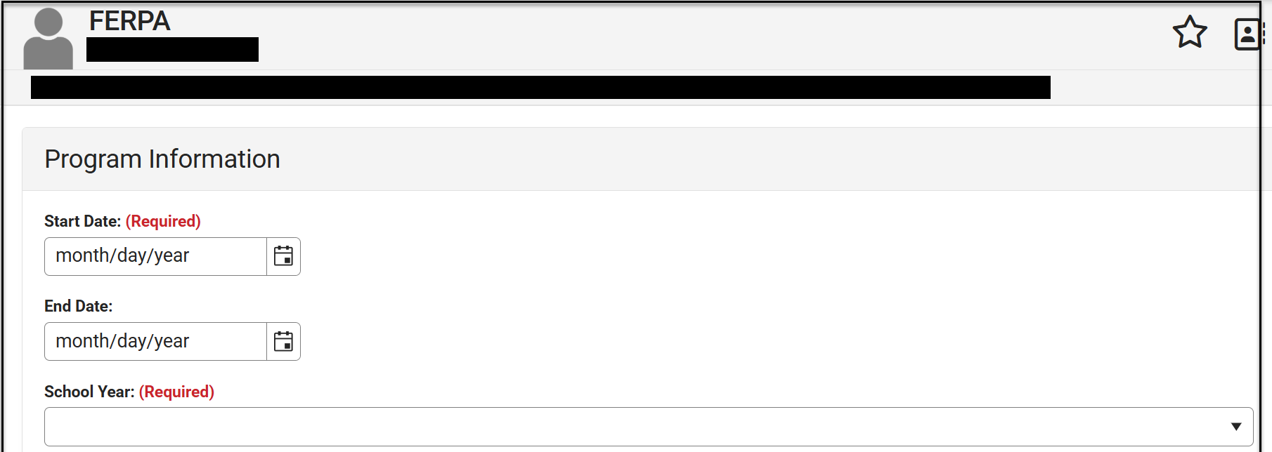
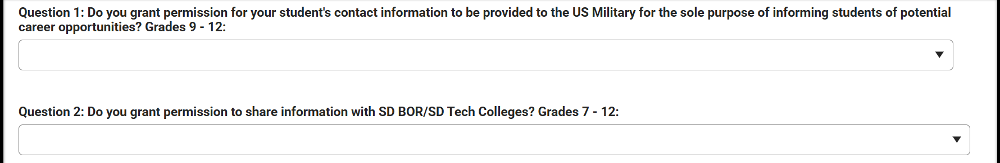
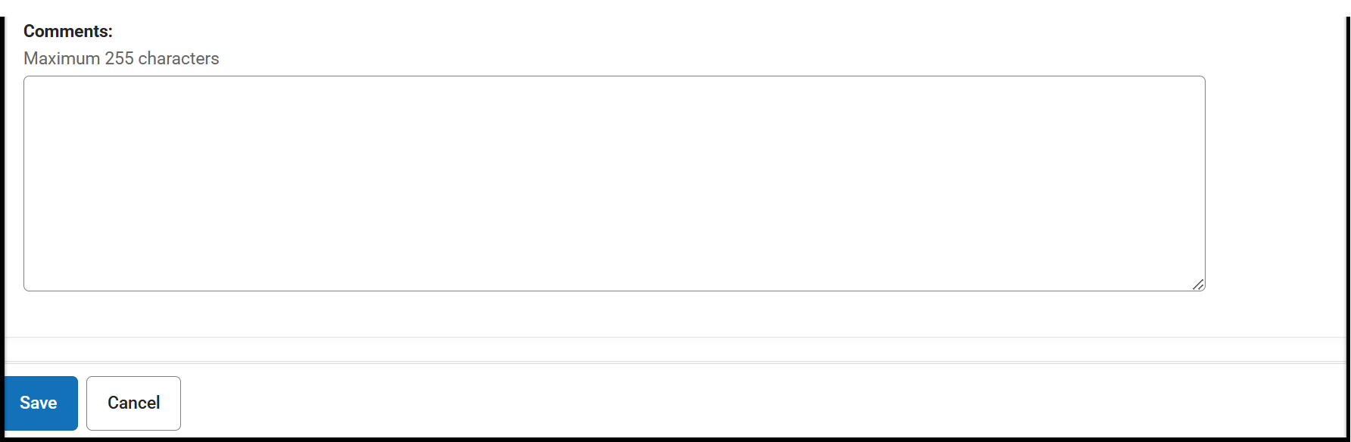
**If using the Federal/State Program Update Wizard in Infinite Campus to create your FERPA tabs, make sure to check the box to prevent over-lapping enrollments.

Example of Completed FERPA Program Screen
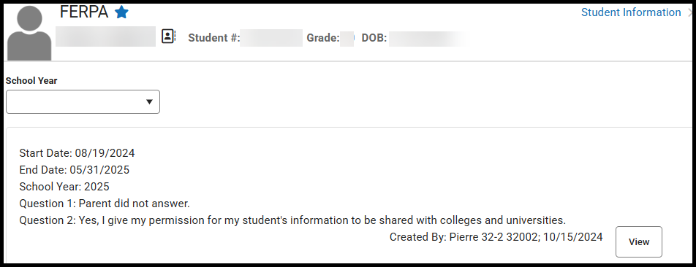

Enrollments for Students who are 100% Enrolled in Online/Virtual Courses
For enrollment/state-aid purposes, students who are 100% enrolled in online/virtual courses are treated like every other student in the district. For school districts agreeing to provide these alternatives to “traditional education”, the district is agreeing to be accountable for these students in all capacities just like every other student in their district. To be counted as a student enrolled at 100% for State Aid Fall Enrollment, the student needs to be enrolled in five online/virtual classes and have logged into at least one of the five courses prior to the end of the day on the last Friday in September. Recording the attendance in Infinite Campus is REQUIRED for all students enrolled in online/virtual courses. The Attendance policy is a local decision. In addition to attendance, the school district is responsible for annual standardized testing, providing SPED services, Title I services, etc. Online/virtual students will be included in all Accountability determinations for the school and district that they are enrolled in. Districts who accept Open Enrolled students so that the student(s) can take advantage of these alternate educational opportunities, are required to have all normal open enrolled paperwork completed and on file.

Enrollments in Infinite Campus
- Students participating in online/virtual programs must have an enrollment record in Infinite Campus in the calendar (elementary, middle school, & high school) in the school that the student will be attached to. As noted previously, you can create a separate calendar to house these online/virtual students, if you wish.
- The student will be coded as 100% enrolled.
- This will be considered the student’s Primary enrollment.
- These students MUST be tested. You will need to work directly with the DOE Assessment Office to ensure all testing requirements are met.
- Recording the attendance in Infinite Campus is required.

Enrollment Record of a student who is a resident within your school district and participating in Online/Virtual Courses 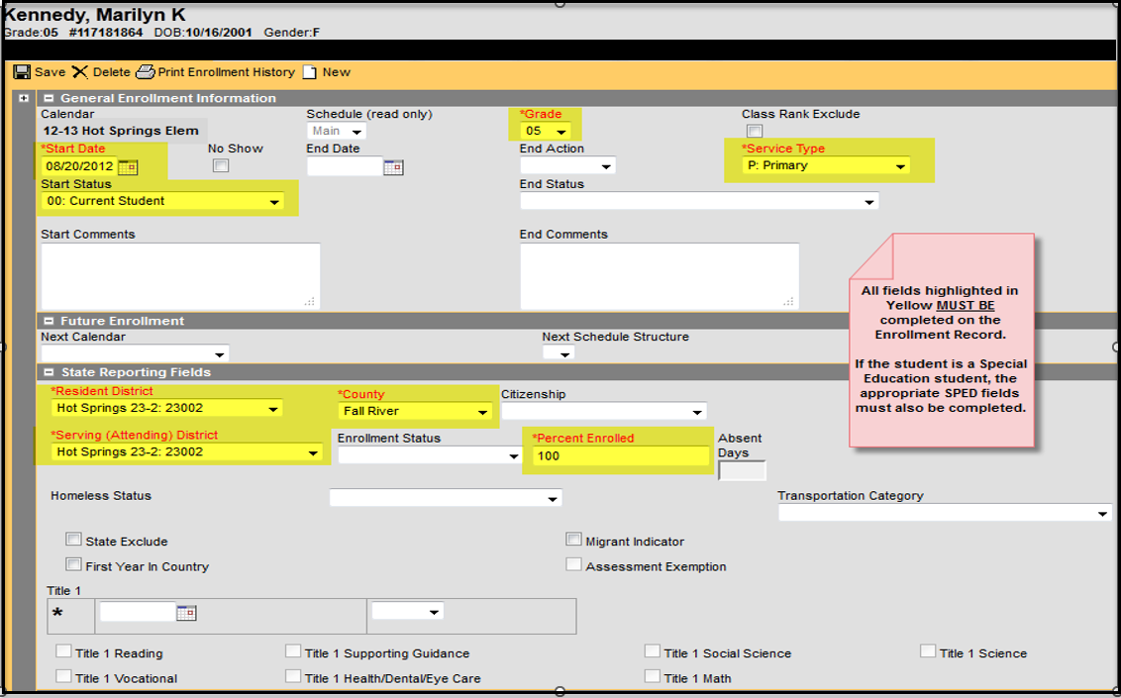

Enrollment Record of a student who is open enrolling into your school district to participate in Online/Virtual Coursework
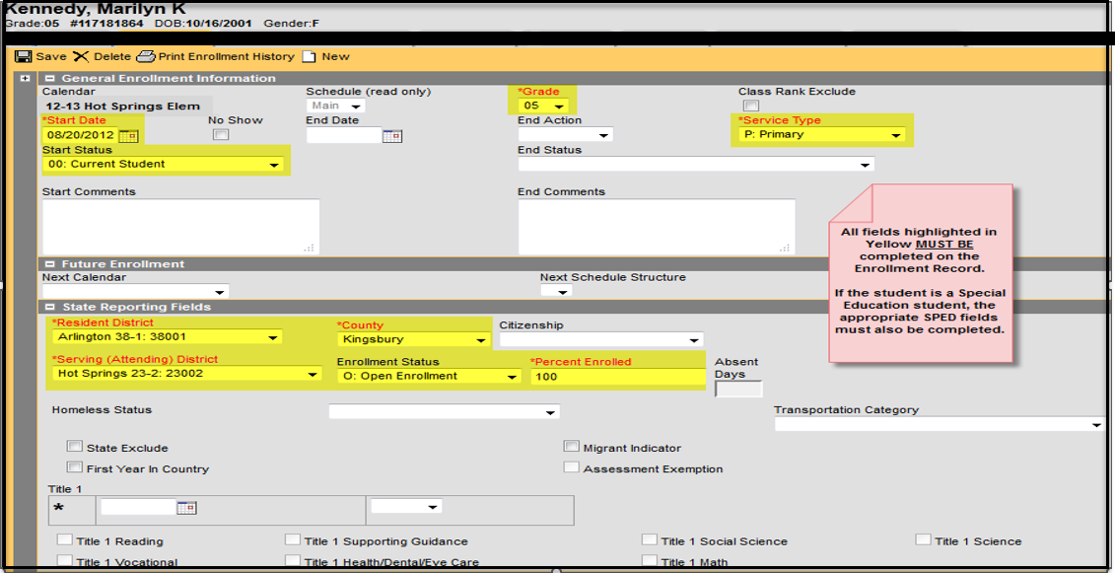

Entering Online/Virtual Courses into Infinite Campus
As a reminder: For all courses that are offered via the South Dakota Center for Virtual Education, please use the same course title/code as if the course is being offered in-district.
There are two fields that need to be completed to ensure that the course is designated as an online/virtual option. The first field is a drop-down menu that asks you to select if the course is online/virtual. Select “Yes.” The second field is a drop-down menu that asks you to select the provider from which the course is offered. Please select the appropriate provider. South Dakota Center for Virtual Education course titles and codes are the same as regular courses and you need to be sure to enter the correct State Course Code.
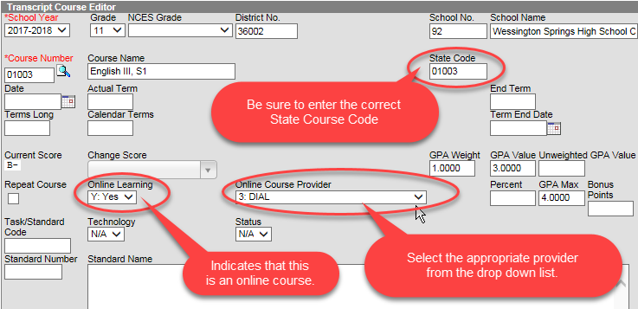

Course Schedules for Students taking Online/Virtual Courses
Districts are to enter the course schedule into Infinite Campus for all student’s opting for these online/virtual educational opportunities just like you would for a student who is being educated in a “traditional educational” setting.

Title I
If your district is receiving Title I funding, you will need to update each school’s Program Participation information in Infinite Campus. Please verify the type of Title Program by going to the Title I page (https://doe.sd.gov/title/) on the DOE website prior to entering information into the system. To update your Title I information in Infinite Campus go to the School Information screen.
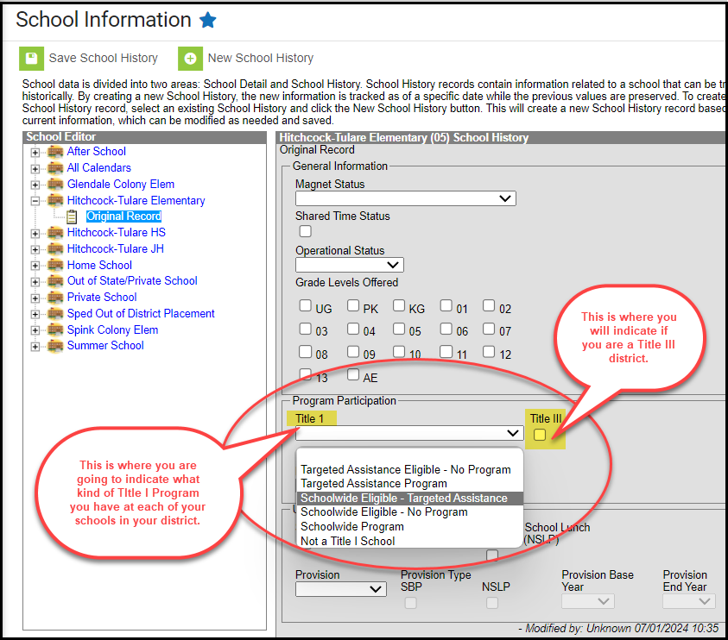

If your school is a School-Wide Title I school, you do not need to update the Title I fields on the Enrollment Tab for each student in Infinite Campus. The DOE will provide the list of School-Wide Title I schools to Infinite Campus, and they will flag each student as receiving Title I services.
If your school is a Targeted Assistance Title I school, it is the school’s responsibility to update the Title I fields on the Enrollment Tab for each of the students in all your schools who are receiving Title I services.
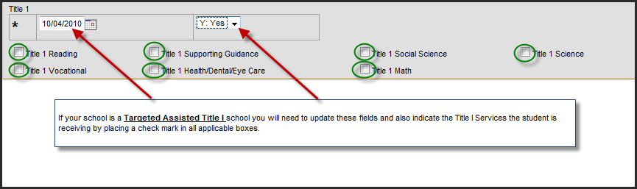
When a student transfers from one district to another or from one school to another school within the district, the Title I status does not transfer. It is the responsibility of the receiving school to update these fields.

Homeless (McKinney-Vento Eligible)
Every district is required to have a McKinney-Vento Liaison to assist children and youth and their families who may be McKinney-Vento eligible. The liaison determines who qualifies.
The McKinney-Vento Act
- means individuals who lack a fixed, regular, and adequate nighttime residence (42 USC §§11431-11435, 2001).; and
- includes:
  - children and youths who are sharing the housing of other persons due to loss of housing, economic hardship, or a similar reason; are living in motels, hotels, trailer parks, or camping grounds due to the lack of alternative adequate accommodations; are living in emergency or transitional shelters; or are abandoned in hospitals;
  - children and youths who have a primary nighttime residence that is a public or private place not designed for or ordinarily used as a regular sleeping accommodation for humans;
  - children and youths who are living in cars, parks, public spaces, abandoned buildings, substandard housing, bus or train stations, or similar settings; and
  - migratory children (as such term is defined in section 1309 of the Elementary and Secondary Education Act of 1965) who qualify as homeless for the purposes of this subtitle because the children are living in circumstances described in clauses (i) through (iii).
After identification by the liaison, the student must be designate as homeless in Infinite Campus on the Homeless Program Screen.
Possible Secondary Identification – Unaccompanied Homeless Youth
Nearly all homeless students will be living with a parent or guardian. However, districts may identity a homeless student who is living without a parent or guardian; the student may be identified as “unaccompanied homeless youth”.
The Act defines unaccompanied homeless youth as, “a youth not in the physical custody of a parent or guardian” (42 USC §11434a(6), 2001). This includes youth who are residing with a caregiver who does not have legal guardianship and youth who are living on their own.
Age Restrictions - The McKinney-Vento Act includes no program-specific age requirements to qualify as an unaccompanied homeless youth. If a youth is eligible for K-12 public education in South Dakota, he or she may be enrolled and served as an unaccompanied homeless youth.
Begin/End Dates
The liaison will have a “begin” date or the date the student was identified. The date should be recorded in Campus. Likewise, should a student become permanently housed that date should be entered as the “end” date. (The student continues to receive services until the end of the school year). For a student who remains homeless all school year, no end date is needed. The DOE will work with Infinite Campus to end date all of the Homeless students as of June 30th.
Ensuring Accurate Homeless Data
The district liaison should check Infinite Campus for a list of students identified to ensure it is correct. Don’t wait until the last day of school to check on students. 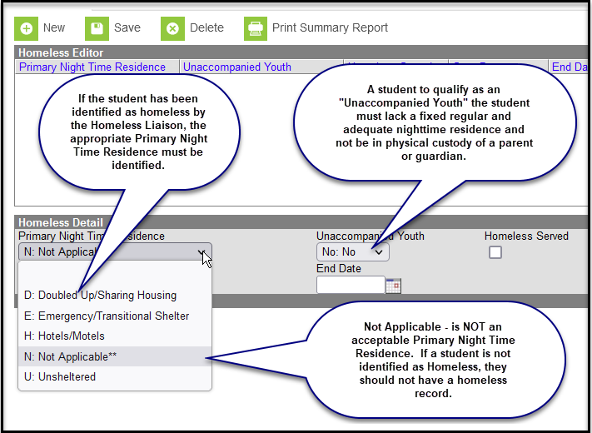
Remember: When you have a student marked as a Homeless student, you need to make sure they are marked as receiving FREE lunch on the FRAM tab.
There is a canned report under SD State Reporting named “Homeless Extract” that will list the homeless students in your school district. You must have rights to this report to run it.

Migrant Students
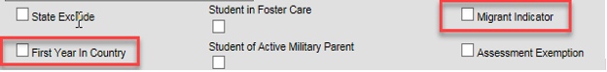
The DOE Migrant office provides files quarterly that identifies all migrant students. Once these files are received, they are submitted to Infinite Campus to flag all students identified as a migrant. When you have a student marked as a migrant student, you need to make sure they are marked as receiving FREE lunch on the FRAM tab.

First Year in Country
A special exemption is granted for students who are EL (English Learner) and in their first year of enrollment in the United States. The criteria to be considered First Year in Country is:
- Must be an identified EL student.
- Have been enrolled in a school in one of the 50 states in the United States or the District of Columbia for less than 12 months.
- Must participate in ACCESS for ELL 2.0 English language proficiency assessment if enrolled during the testing window.
- If the student arrives after the ACCESS of ELLs 2.0 testing window, then the student must participate in the WIDA Screen assessment.
If the student meets the above criteria, then the student is exempted from participating in the South Dakota English Language Arts Assessment, however, the student is required to participate in Math and Science. Scores are not included in Accountability. If the student meets the criteria for First Year in Country, you will need to check the appropriate box below on the student’s Enrollment tab and indicate the date entered US School on the student’s Demographics tab.
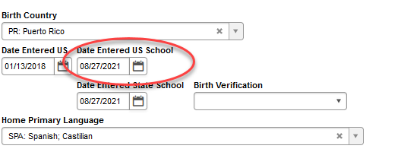

EL (English Learner)

Creating an EL Record
- Ensure the Home Primary Language and Date Entered US School fields are populated on the student’s Demographics screen.
- Home Primary Language: To be identified as EL the “Home Primary Language” field must be selected as a language other than English. The list of language codes can be found at: https://doe.sd.gov/title/documents/ELA_langs.pdf .
- What is a Home Primary language defined as? A home primary language is another language other than English that is spoken in the home. This information is obtained from the Home Language Survey.
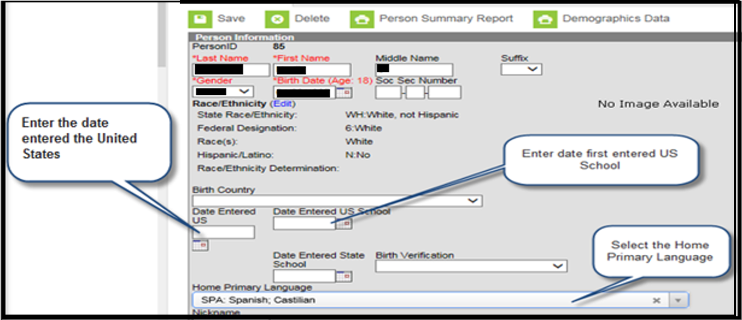
- On the EL screen you will need to select a Program Status. This value indicates the student’s current EL status and is based on the student’s KG WIDA Screener scores. This value indicates the student’s current EL status.
- EL - Student is currently receiving EL services.
- Exited EL - Student has exited the EL program.
- Pending - Student has been identified as possibly needing EL services by the school but no formal EL determination has been conducted.
- Not EL - The student is not eligible/does not require an EL program.
- If the student has taken a placement test (KG WIDA Screener) and was deemed eligible for EL services, enter the Identified Date. This date should reflect the date the student took the test and was identified as eligible for EL services.
- If the student is eligible and currently receiving EL services, you can enter the Expected Exit Date. (This is not a required field). This is the date the student is expected to exit the EL program. Remember that EL students are expected to reach English language proficiency within five to seven years of instruction in the EL program.
- If the student took the placement test (KG WIDA Screener test), enter the Parent Notified date. The Parent Notified date is the date the student’s parents were notified of screener results and whether the student is deemed eligible for services or not. A parent notification letter must be shared with parents within the first 30 calendar days of the beginning of the school year or within two weeks of enrollment during the school year. You can find a sample notification letter at https://doe.sd.gov/title/el.aspx.
- Parents have the right to deny services; however, if identified as an EL student, the student will need to participate in the ACCESS for ELLs 2.0. If the parents declined services, mark the Parent Declined checkbox. This is an annual process.
- Enter KG WIDA screener scores in Comments section. Also, enter any comments about the student’s EL record.
- Select the Save button.
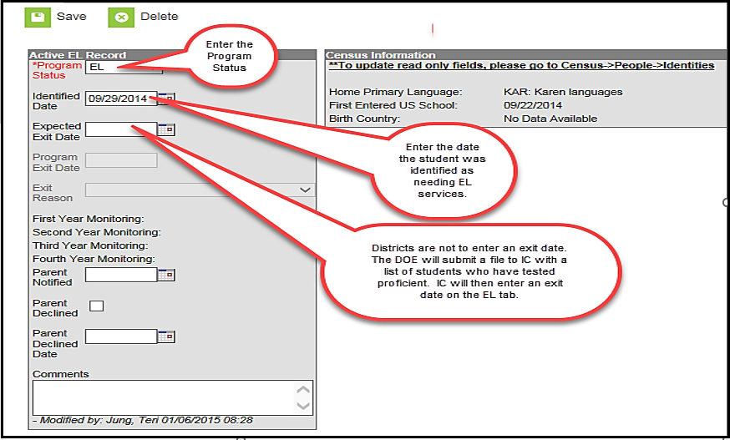

Exited EL
- Exited EL student refers to students who have met South Dakota’s exit criteria on the ACCESS for ELLs 2.0 English language proficiency assessment.
- There are two ways to exit a student from EL status:
  - The student must obtain an Overall Proficiency Level of 5.0or higher on the ACCESS for ELLs 2.0 Assessment.
  - The student must obtain an Overall Proficiency Level of 4.0 or higher on the ACCESS for ELLs 2.0 as well as a 3 or 4 on the ELA State Assessment.
- DOE submits a file to Infinite Campus with a list of students who are deemed proficient on the ACCESS for ELLs 2.0 English language proficiency assessment. Infinite Campus will exit all students from the EL program and will populate an Exit Date on their EL tab.
- The Exited date record will calculate:
  - First Year Monitoring-A read-only field calculated exactly one year from Program Exit Date.
  - Second Year Monitoring-A read-only field calculated as exactly two years from the Program Exit Date.
  - Third Year Monitoring-A read-only field calculated as exactly three years from the Program Exit Date.
  - Fourth Year Monitoring-A red-only field calculated as exactly four years from the Program Exit Date.
- LEAs are required to monitor Exited EL students for two consecutive years after the student has tested proficient on the ACCESS for ELLs 2.0 assessment. LEAs are responsible for evaluating the progress made by children in meeting challenging State academic content and student academic achievement standards for each of the two years after the student is no longer receiving EL services.
- If we are only required to monitor Exited students for two years, why does it populate for four years? The reason for this is that under ESSA, LEAs are required to report on the achievement of Exited EL students for four years.

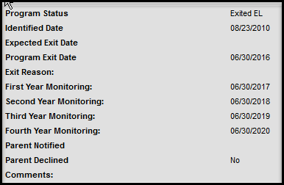

EL Re-Entry
Exited EL students are to be monitored for two consecutive years after testing proficient in English. School districts are responsible for evaluating the progress made by children in meeting challenging State academic content and student academic achievement standards for each of the two years after the student is no longer receiving services. Items such as a teacher referral, a parent referral, test scores and mainstream classroom success might indicate a need to discuss the possibility that the student needs to be re-integrated into the EL program.
If the school district has determined that the student is still struggling due to a language barrier, then the school district may re-enter the student back into the EL program. The student would need to enter the program the same way they entered the very first time. The school district would need to administer the screener test again.
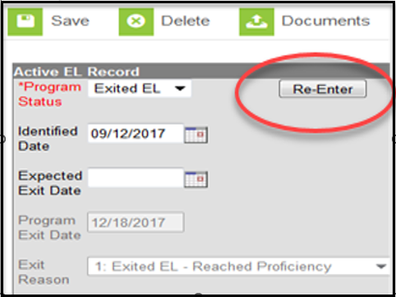
The following screen will display when clicking the Re-Enter button.
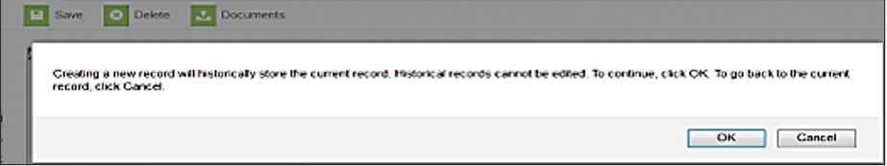
After clicking OK, the following screen will appear. You will need to complete the required fields to re-enter the student back into the EL program.
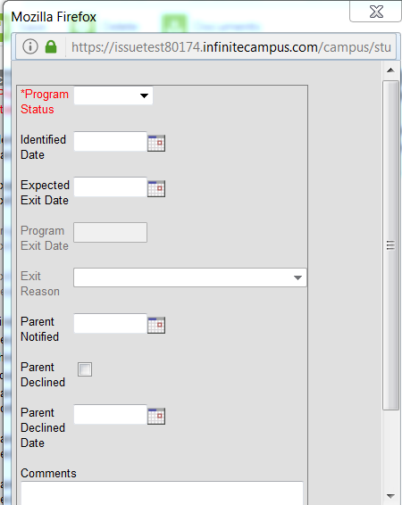

EL Services Record

School districts have the responsibility to provide English language development services to all identified English Learner students. It is a requirement to enter what services are being provided on the EL Service Types screen in Infinite Campus.
If you select “Other” please indicate in the comments section of type of EL services that are being provided.
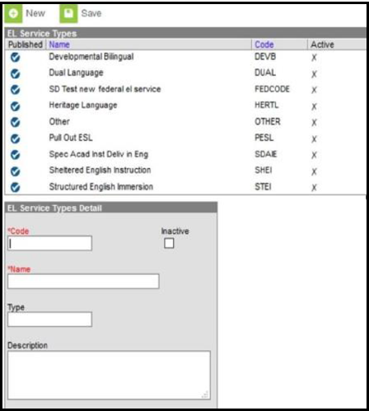

Title III
If your district is operating a Title III program in any of your schools the Title III check box on the District Information Screen must be checked. Being a Title III district means you receive your own Title III grant, or you are part of a South Dakota Statewide Title III consortium.
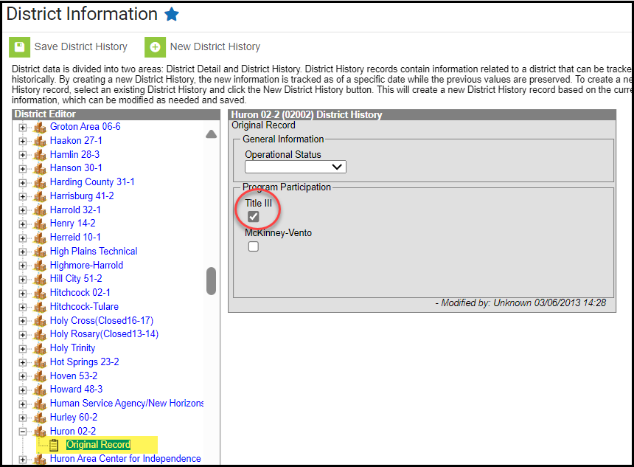

Transfer of State Reporting Fields
A process is in place on the South Dakota District Edition of Infinite Campus that transfers several State Reporting fields on the student’s enrollment when an individual student transfers within South Dakota. We have defined the process as to which state reporting elements transfer/do not transfer in the below scenarios.
- Same Year, same district: during the same school year, a student re-enrolls in a school or transfers to a different school that is part of the same district. (e.g., student in 2024/2025 school year at Aberdeen District drops out of Central HS and re-enrolls during the 2024/2025 at Central HS, or student in 2024/2025 school year at Aberdeen District C.C. Lee Elementary transfers to Aberdeen District Simmons Elementary in 2024/2025.
- Same year, different district: during the same school year a student transfers to a different district that is part of South Dakota schools on Infinite Campus. (e.g., student in 2024/2025 school year at Aberdeen District C.C. Lee Elementary transfers to Pierre District Jefferson Elementary in 2024/2025).
- Different year, same district: during the next school year a student enrolls or transfers to a different school that is part of the same district. (e.g., student in the 2023/2024 school year at Aberdeen district drops out of Central HS and re-enrolls during 2024/2025 at Central HS, or a student in the 2023/2024 school year at Aberdeen District C.C. Lee Elementary transfers to Aberdeen District Simmons Elementary in 2024/2025). Only data from the school year directly before the current year will transfer.
- Different year, different district: during the next school year, a student transfers to a different district that is part of the SD schools on Infinite Campus. (e.g., student in the 2023/2024 school year at Aberdeen District C.C. Lee Elementary transfers to Pierre District Jefferson Elementary for the 2024/2025 school year) Only data from the school year directly before the current year will transfer.
Below are the fields from the State Reporting section of the student enrollment tab that transfer/do not transfer in certain scenarios. The appropriate DOE Program Office has determined the transfer/do not transfer status based on the four transfer scenarios outline above.
- Citizenship Status
- Same year, same district: TRANSFER
- Same year, different district: TRANSFER
- Different year, same district: DO NOT TRANSFER
- Different year, different district: DO NOT TRANSFER
- Gifted Status
- Same year, same district: TRANSFER
- Same year, different district: TRANSFER
- Different year, same district: TRANSFER
- Different year, different district: TRANSFER
- 504 Plan - checkbox
- Same year, same district: TRANSFER
- Same year, different district: TRANSFER
- Different year, same district: TRANSFER
- Different year, different district: TRANSFER

- Hearing Loss Indicator
- Same year, same district: TRANSFER
- Same year, different district: TRANSFER
- Different year, same district: TRANSFER
- Different year, different district: TRANSFER
- Student in Foster Care – checkbox
- Same year, same district: TRANSFER
- Same year, different district: TRANSFER
- Different year, same district: DO NOT TRANSFER
- Different year, different district: DO NOT TRANSFER
- Migrant Indicator – checkbox
- Same year, same district: TRANSFER
- Same year, different district: DO NOT TRANSFER
- Different year, same district: DO NOT TRANSFER
- Different year, different district: DO NOT TRANSFER
- First Year in Country – checkbox
- Same year, same district: TRANSFER
- Same year, different district: TRANSFER
- Different year, same district: DO NOT TRANSFER
- Different year, different district: DO NOT TRANSFER
- Title I – Current: Date, Yes/No, All Title I checkboxes
- Same year, same district: DO NOT TRANSFER
- Same year, different district: DO NOT TRANSFER
- Different year, same district: DO NOT TRANSFER
- Different year, different district: DO NOT TRANSFER
- Participates in After Schl Prg - checkbox
- Same year, same district: TRANSFER
- Same year, different district: DO NOT TRANSFER
- Different year, same district: DO NOT TRANSFER
- Different year, different district: DO NOT TRANSFER

Creating an Enrollment History
To populate the graduation tab with the first point of entry into 9th grade for a student who transfers in from an Out-of-State school, a BIE school or a Private school, or from Rapid City or Brandon Valley, you will need to create an Enrollment History. First you will need to use the Student Locator and enroll the student. Once you have done that, you will open the enrollment record and click on “New Enrollment History”.
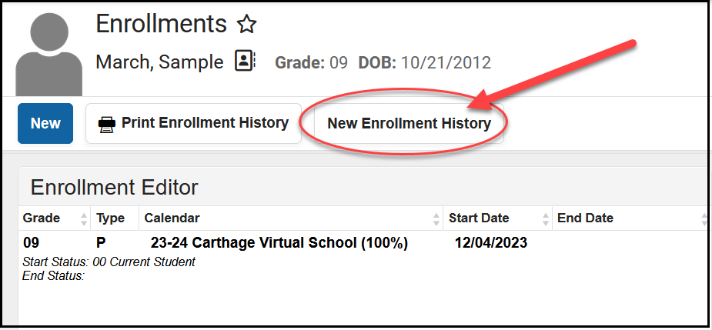
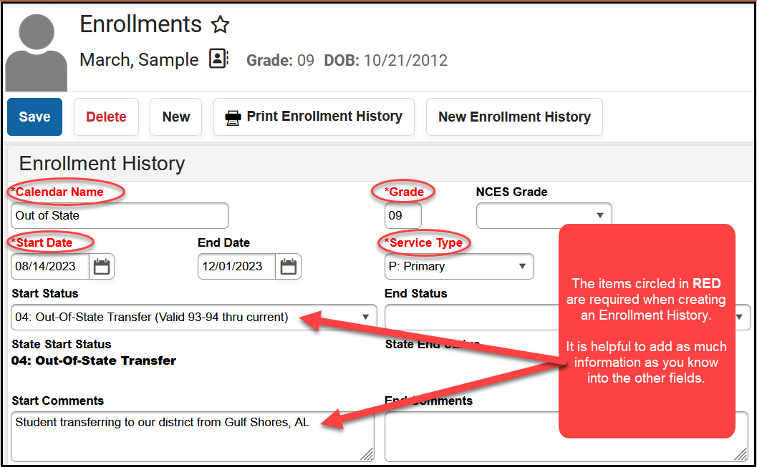
You will be required to complete the fields that are labeled in RED. It is also helpful if you can add as much information as you know into the Start Status and the Start Comments fields.

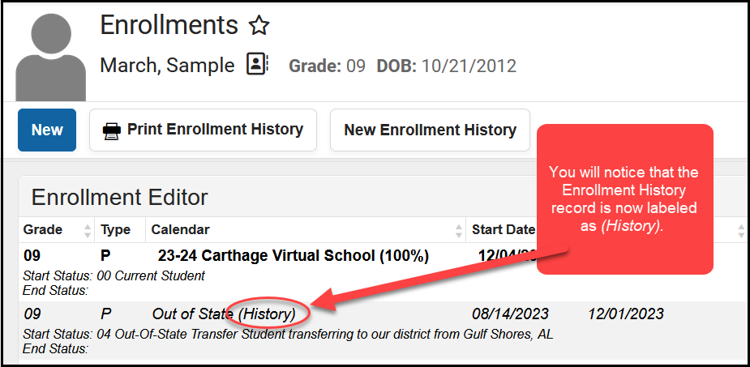
Once you have saved the record, you will see a 9th grade enrollment for your student. If you look closely, you will see that the Enrollment History record is now flagged as a historical record. This tells you that you were successful in creating the Enrollment History record.
If you go to the student’s Graduation screen, you will see that the Date First Entered the 9th Grade, the NGA Cohort End Year and the NCLB Cohort End Year have all been populated.
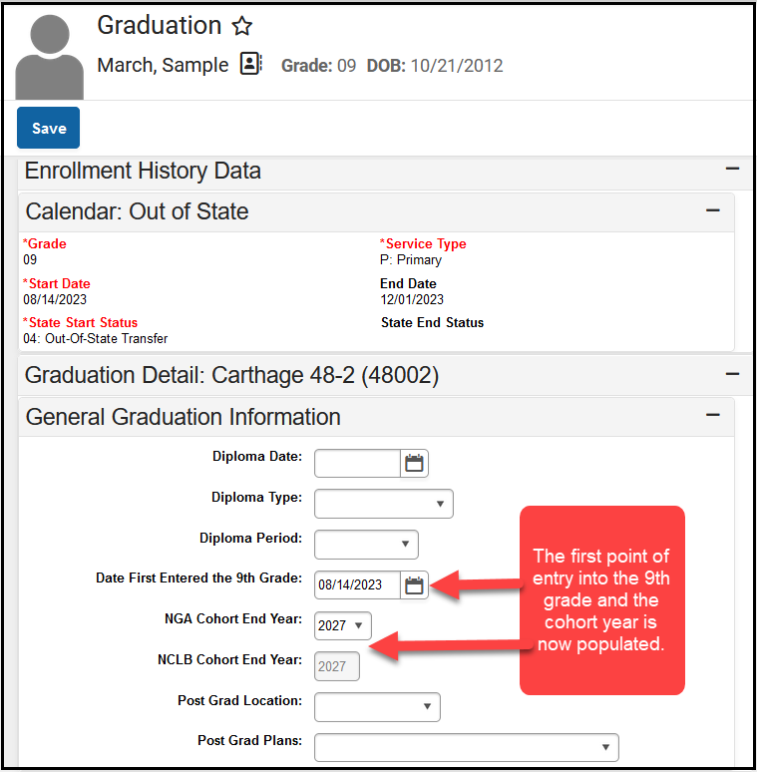

How to Enter an 8th Grader Taking 9th Grade Course
8th graders should only have one enrollment record. This should be a primary enrollment in the middle school/junior high as an 8th grader.
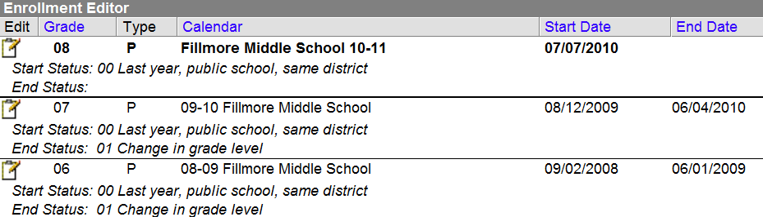
**No 9th grade enrollment exists**
Student’s schedule should include all courses taken at the middle school and/or any courses taken at the high school.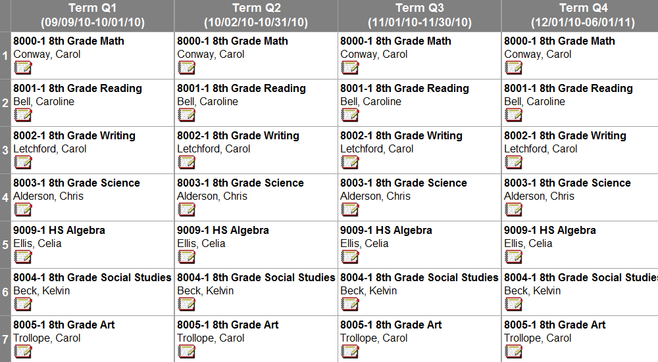
**HS Algebra will show up on the HS Transcript, but a 9th grade enrollment at the high school is not needed. This is causing the incorrect cohort year to populate on the graduation tab.**

If a High School teacher is teaching the course at the middle school/jr. high
Follow these steps to replicate this type of scheduling:
- Create the HS course at the middle school.
  - Same course number
  - Same course name
  - Same state code
  - Make sure the transcript box is checked.
  - Make sure the GPA weight box is populated if the course should count towards GPA.
- Create a section of this course with the high school teacher as the primary teacher (teacher of record)
  - High school teacher will need a district assignment at the middle school (make sure the teacher box is checked for this assignment)
  - High school teacher will need to choose the middle school from the toolbar to grade the student/students and to take attendance.
- Schedule all pertinent students into this section
- Make sure the grading task associated with this course has the following:
  - Same score group that is being used at the high school.
  - Same credit amount as the high school
  - Same credit type as the high school (If the HS credit group is not currently available for selection in the middle school, it can be made available by checking the box in Grading and Standards>School Standards>Credit Groups)

If a Middle School/Jr. High teacher is teaching the course at the middle school/jr. high
Follow these steps to replicate this type of scheduling:
- Create the HS course at the middle school.
  - Same course number
  - Same course name
  - Same state code
  - Make sure the transcript box is checked.
  - Make sure the GPA weight box is populated if the course should count towards GPA
- Create a section of this course with the middle school teacher as the primary teacher (teacher of record)
  - Middle school teacher will need a district assignment at the middle school (make sure the teacher box is checked for this assignment)
  - Middle school teacher will need to choose the middle school from the toolbar to grade the student/students and to take attendance.
- Schedule all pertinent students into this section
- Make sure the grading task associated with this course has the following:
  - Same score group that is being used at the high school.
  - Same credit amount as the high school
  - Same credit type as the high school (If the HS credit group is not currently available for selection in the middle school, it can be made available by checking the box in Grading and Standards>School Standards>Credit Groups)

Entering the Grade Level to the High School Calendar
You will need to add the grade level of 8 to your High School calendar, but you WILL NOT add an enrollment in the High School. When adding the grade level to the High School calendar, you will also need to check the two boxes in the screen shot below.
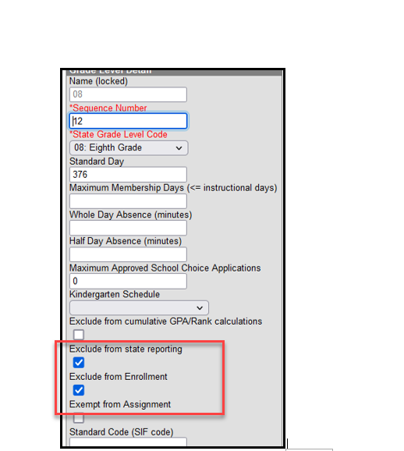
**When the student enters high school, the school’s name in the upper left-hand corner will update to the high school when the transcript report is run for the high school calendar and an 8th grade level exists in the Calendar with the “Exclude from State Reporting” and “Exclude from Enrollment” boxes selected (see screenshot above). The transcript record will identify that the student took this course during his/her 8th grade year, but credits will count toward high school graduation requirements. **
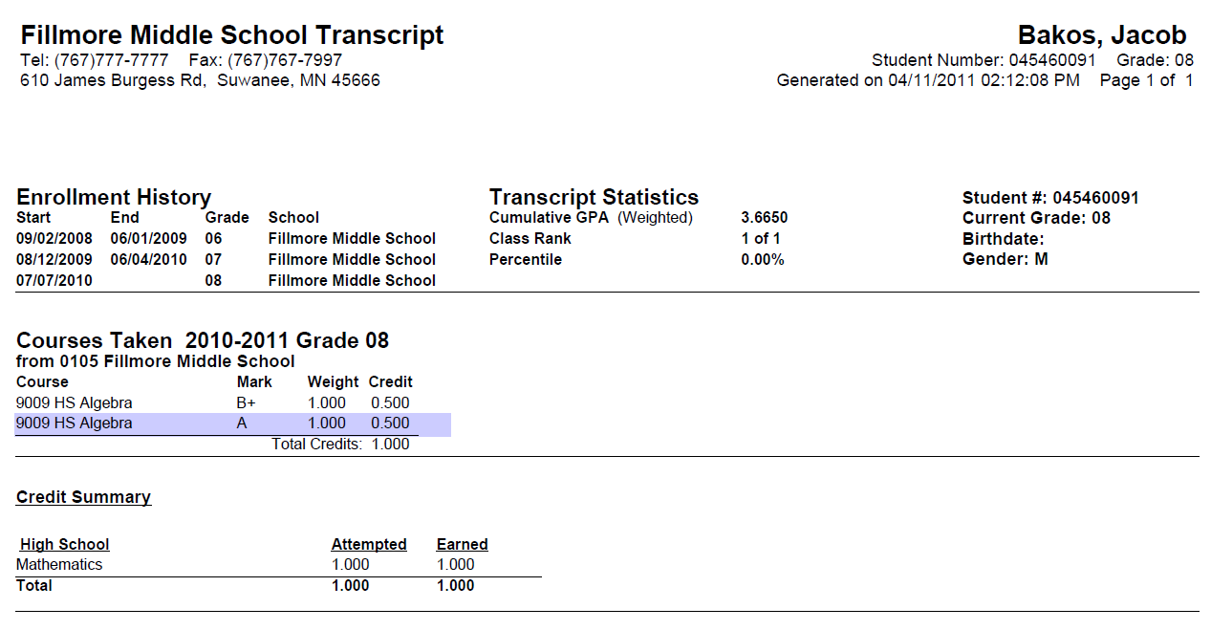

State Course Codes
The Department of Education has implemented a common course numbering system (State Course Code), which provides consistency in student transcripts across the state. South Dakota utilizes the National Center for Educational Statistics’ SCED codes. Districts are required to align all their high school courses to the appropriate State Course Code. If you come across one of your regular high school courses that is not aligned to one of our State Course Codes, you will need to designate the course by using 88888 as the State Course Code. For questions regarding alignment of courses, contact the DOE’s Division of Learning and Instruction at 605-773-2490.
The department is only requiring the common course numbering process for high school courses and transcripts. However, the Infinite Campus system will not allow the district to save a K-8 course without a state course code. To accommodate this, the DOE has created the state course code of Bypass to be used for all K-8 courses in the Infinite Campus system. When editing an existing K-8 course or entering a new K-8 course into the Infinite Campus system, the district will simply enter the word Bypass in the required State Code field. This “Bypass” code is ONLY to be used on K-8 courses. All high school courses must be aligned to the appropriate state course code from the master course code list. The master course code list can be found on the DOE website at: https://doe.sd.gov/contentstandards/commoncourse.aspx
Within the Infinite Campus District Edition, there are 2 Validation Reports that can be run to verify that all your courses have an appropriate State Course Code. Under Data Validation Report you will find a Data Validation Group field dropdown box with 2 options: (1) Courses with Expired State Codes (2) Courses with No State Code. Select the appropriate report that you want to run and click on the Generate Report button.
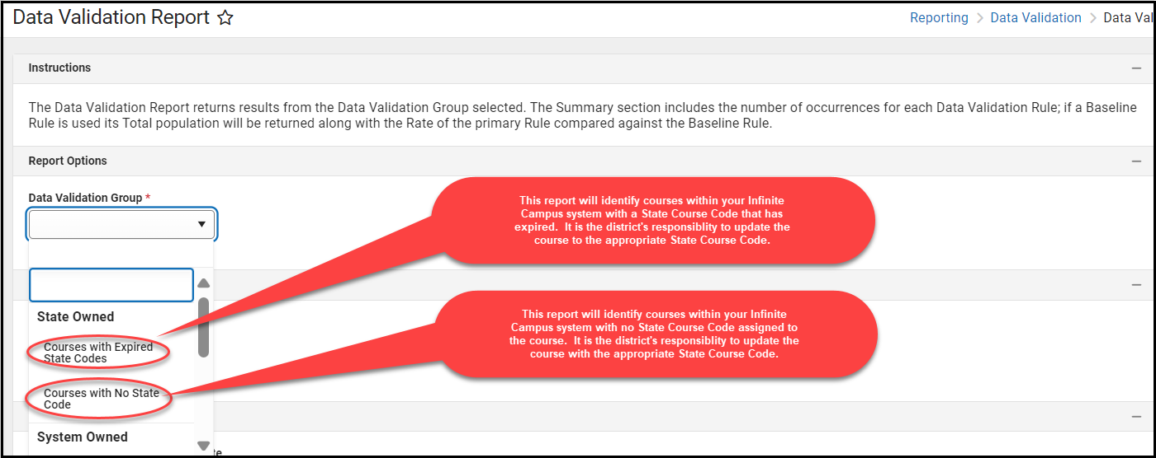

Dual Credit
Dual credit is an opportunity for high school students who meet admissions standards to enroll in postsecondary institutions in South Dakota and simultaneously earn credits for both their high school diploma and postsecondary degree or certificate.
Students can earn dual credit by directly enrolling into a postsecondary institution’s coursework. These courses are offered by the postsecondary institution’s faculty members, are governed by the postsecondary institution’s policies, and follow the postsecondary institution’s established processes for admissions, registration, billing, and grade reporting.
Students can choose from many classes, including general education and career and technical education courses. Each of the participating institutions has its own registration process. Local school districts help to facilitate that process and must agree that the dual credit coursework will be recorded on the student’s high school transcript and will be used to calculate academic standing.
For Out-of-state Courses:
- If a student is taking a dual-credit course from an out-of-state institution, the district should use the State Course Code of 99999 to designate the dual-credit course on the student’s transcript.
For Concurrent Courses:
- College level courses taught by a teacher in your district.
- Courses may or may not be listed on the Dual Credit course offerings on SDMyLife.com.
- If the course is not listed on SDMyLife.com – use the code 99999 to transcribe the course.
For Private College Dual Credit Offerings
- Use the code 99999 to transcribe the course.

Dual Credit Courses for Alternative Instruction/Home School Students
Alternative Instruction families who are interested in enrolling students in the state’s reduced tuition dual credit program must have a notification on file with the SD Department of Education and work directly with the department to start the enrollment process for the reduced-cost courses. Local school districts are not able to enroll alternative instruction students in dual credit courses.
A signed memorandum of understanding (MOU) and registration form must be submitted to the Department of Education to start the enrollment process. These can be accessed through the Alternative Instruction Notification System or by contacting the Department.
After verifying a correct Alternative Instruction notification, a registration form, and signed MOU are on file, the department will forward the students’ registration to the public university or technical college for approval. Once the student meets the admission requirements at the postsecondary institution, he/she can enroll in dual credit courses.

**Remember, the enrollments of Alternative Instruction/Home School students in Infinite Campus should be as follows:
ALTERNATIVE INSTRUCTION/HOME SCHOOL STUDENTS
SERVICES PROVIDED BY THE DISTRICT | Educational  Services | SPED Services | Athletics | Fine  Arts | Other  Activities | No  Services
District may enter a student record in Infinite Campus | Required | Required | Optional | Optional | Optional | No

For more information regarding Dual Credit please visit:
- https://ourdakotadreams.com/k12-students/dual-credit/
Dual Credit courses, contact Tracia Rentsch at:
- Tracia.Rentsch@state.sd.us or 605-220-6612
Core Content course alignment, contact Vera Tipton at:
- Vera.Tipton@state.sd.us or 605-295-0433
Technical assistance with Campus, contact Chris Booth at:
- Christina.Booth@state.sd.us or 605-773-4727

How to transcribe Dual Credit Courses to the Board of Regent’s (BOR) Transcript
Districts technically have two options to choose from to get the dual credit courses to appear on the student’s BOR Transcript as shown below.
Option #1
- Use the course code editor within Infinite Campus to add each Dual Credit Course into your school’s offerings. (like other state course codes)
- Enroll students like other courses.

Screen Prints showing how the State Course Code flows through the Infinite Campus System when the courses are set up within the Course Code Editor:
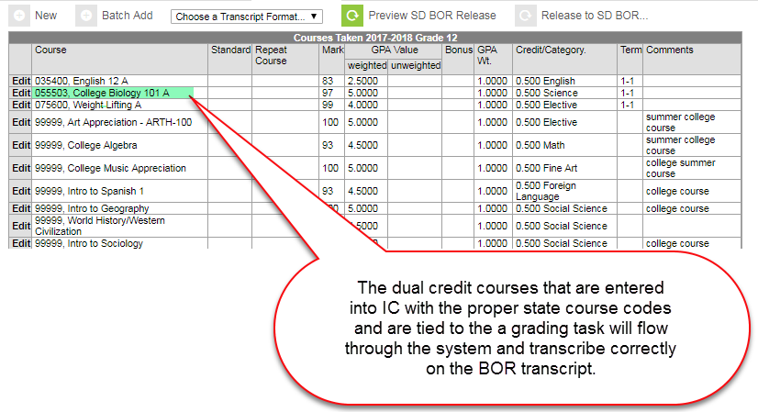
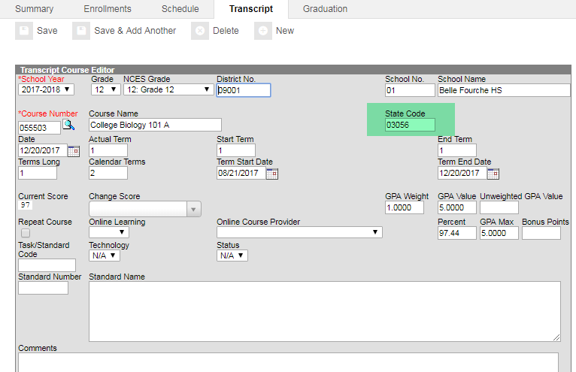
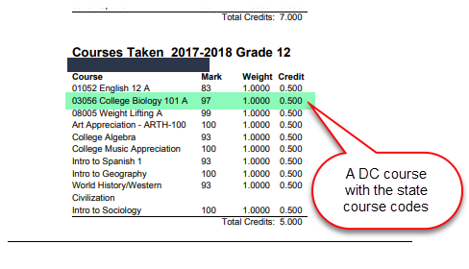

Option #2
- Use the transcript tab in Infinite Campus and add the course after the student has completed the course.
We know Option #1 is a lot of work and can become cumbersome when dual-credit courses change from year to year therefore, if districts decide to go with Option 2, that is perfectly ok but you need to realize this requires a 2 -step process to get the State Course Code on the BOR transcript.
Screen Prints showing the extra step that districts must complete in order to transcribe the course directly to the BOR transcript. (when the dual credit course IS NOT set up within the Course Code Editor):
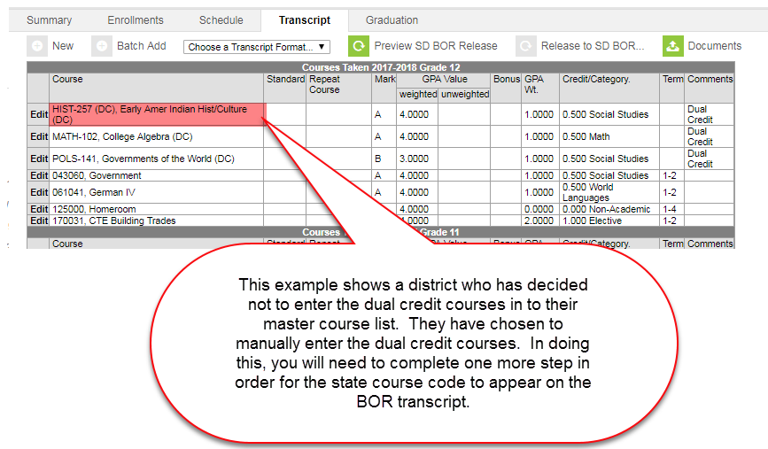
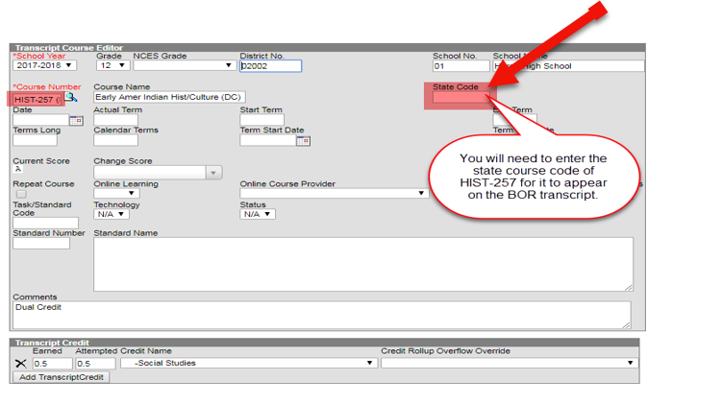
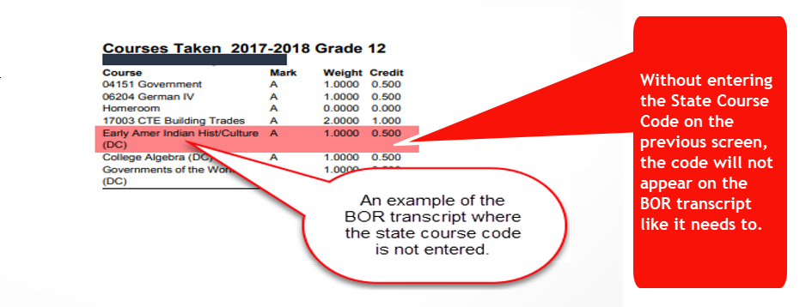
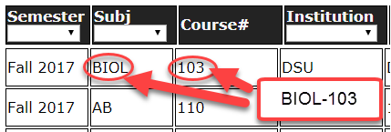
When transcribing dual credit courses, it is essential that you use the right coding and the codes be entered exactly! For all South Dakota BOR/Technical Institutes Dual Credit Courses, the State Code is a “alpha code” such as BIOL-103 and WLD-114. (letters-dash-numbers) – NO SPACES. Names can be abbreviated. Codes are found at https://apps.sd.gov/de68dual/index.aspx.

Industry-Recognized Credentials
To meet the requirements of the South Dakota High School Graduation Advanced Career Endorsement a student must earn at least one industry-recognized credential. If the student is meeting the requirements of the endorsement through coursework in an approved CTE program (either in part or in full), the credential must be from the same cluster as the student’s coursework.
How should districts record industry-recognized credentials on the transcripts?
- Districts must note students’ industry-recognized credentials on the transcript of student’s who earn the Advanced Career Endorsement. Industry-recognized credentials should be recorded only after students have earned the credentials.
- We do encouraged districts to note industry-recognized credentials for all students on a transcript.
State Approved Industry-Recognized Credentials: https://doe.sd.gov/cte/industry.aspx
Course Numbers for Industry Recognized Credentials: https://doe.sd.gov/contentstandards/commoncourse.aspx
Districts will first need to set up a score in their High School Score Group in Infinite Campus. The pathway to do this is: Grading & Standards>Score Groups & Rubrics. How you set up your Scoring for Industrial-Recognized Credentials is a District decision.

Absolute Minimum Fields Required to SAVE an Industry-Recognized Credential
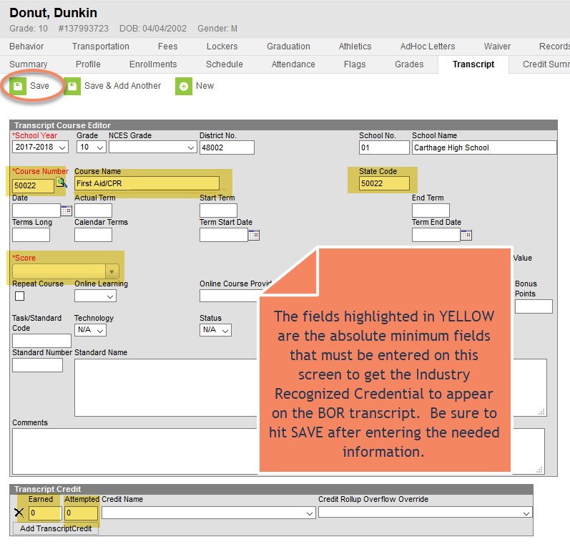

BOR Transcript
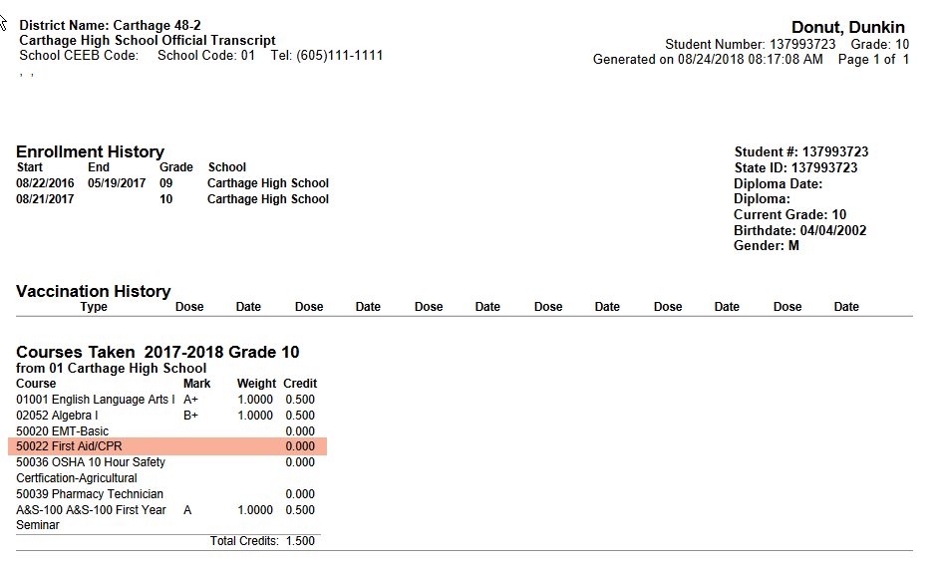

High School Grade Progression
Districts are to progress students through all high school grade levels (9, 10, 11 and 12). The progression from one grade level to the next doesn’t always need to coincide with the start/end of the academic school year but rather should occur as the high school credits are earned. The enrollment records of all students graduating from high school with the 04: Student Graduated code, should be in the 12th grade, even if the student is graduating in less than 4 years. Remember, students need to be progressed through all grade levels.

Enrollments for the Board of Regents’ Jump Start Scholarship
For a student to be eligible for the Board of Regents’ Jump Start Scholarship, the student must graduate from high school in three academic years. As stated above, districts still need to progress the student through all high school grade levels (9, 10, 11 and 12) and the progressions should occur as the credits are earned. A student should not be exited from a high school with a 04: Student Graduated code when their enrollment record shows that they are an 11th grader, as they must progress through all grade levels within three academic years.

Releasing the Board of Regents Transcript
The South Dakota Board of Regents worked with the DOE and Infinite Campus to develop a transcript that contains the necessary student information needed for college admissions. In Infinite Campus, districts do have the capability to create a “local” transcript for their own use, but it is the SD BOR transcript that is to be provided by the school district to the South Dakota Board of Regents when one of your students is applying for admission into a BOR institution.
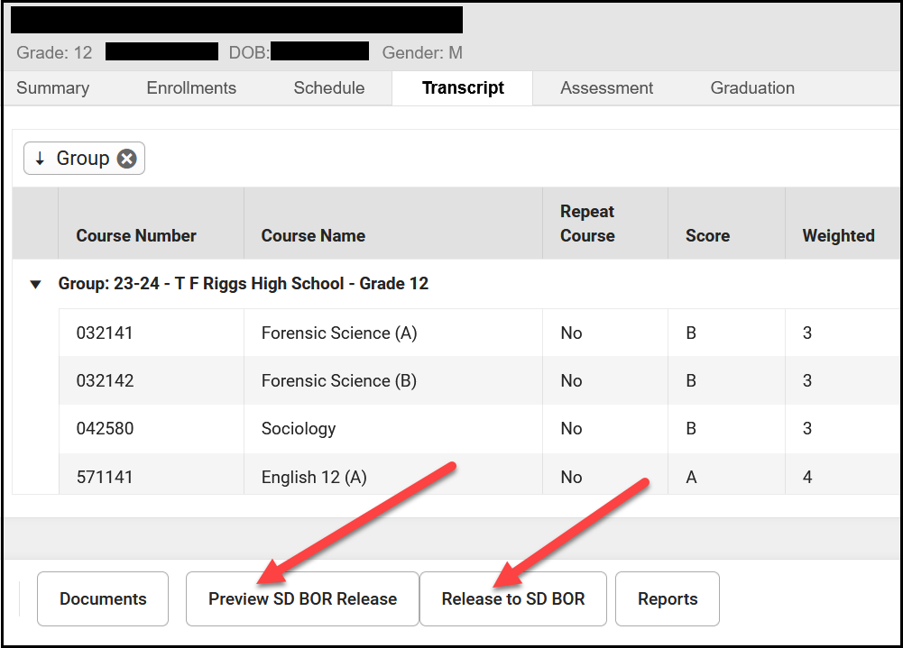
On the Transcript Tab, there are two buttons related to the SD BOR transcript. The first button is “Preview SD BOR Release” which when clicked on will display a PDF copy of the BOR transcript. The second button is “Release to SD BOR” which is the button that needs to be clicked on for the transcript to be sent to the BOR.

Graduation Endorsements/State Seals
South Dakota’s current requirements for graduation were passed by the Board of Education Standards on July 16, 2018. Those requirements are outlined in South Dakota Administrative Rule 24:43:11. The requirements include a base of required coursework and the ability for students to earn advanced endorsements on top of that base. The requirements are designed to provide flexibility for students to meet their postsecondary and career aspirations within a framework of general requirements.
Districts are REQUIRED to indicate on the student’s GRAD Tab in Infinite Campus if a student has earned one or more of the three Graduation Endorsements.
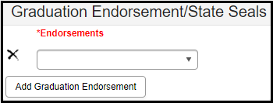
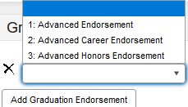
There is a canned report under SD State Reporting named “Graduation Data Extract” that will list the Graduation Endorsement that a student has earned. You must have rights to this report to run it.\

Advanced Endorsement
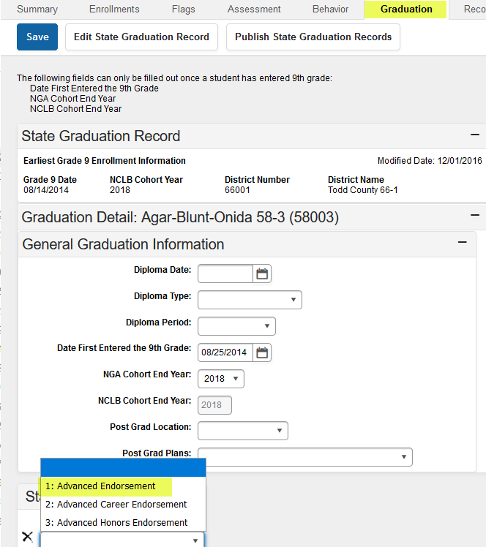
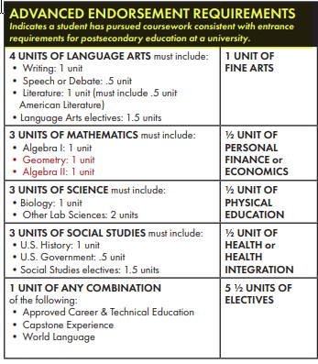

Advanced Career Endorsement
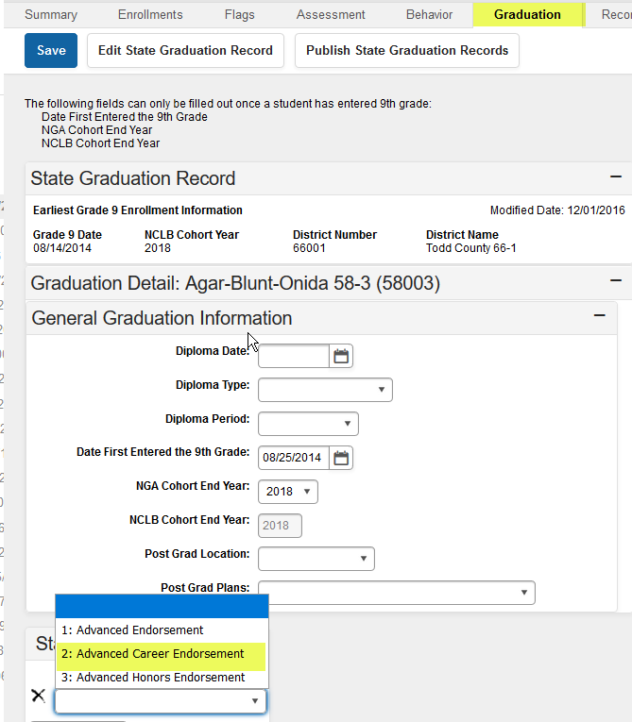
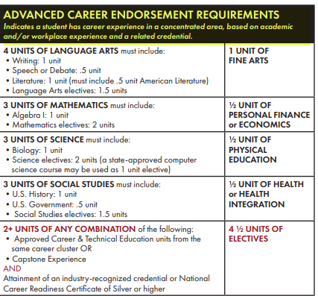

Advanced Honors Endorsement
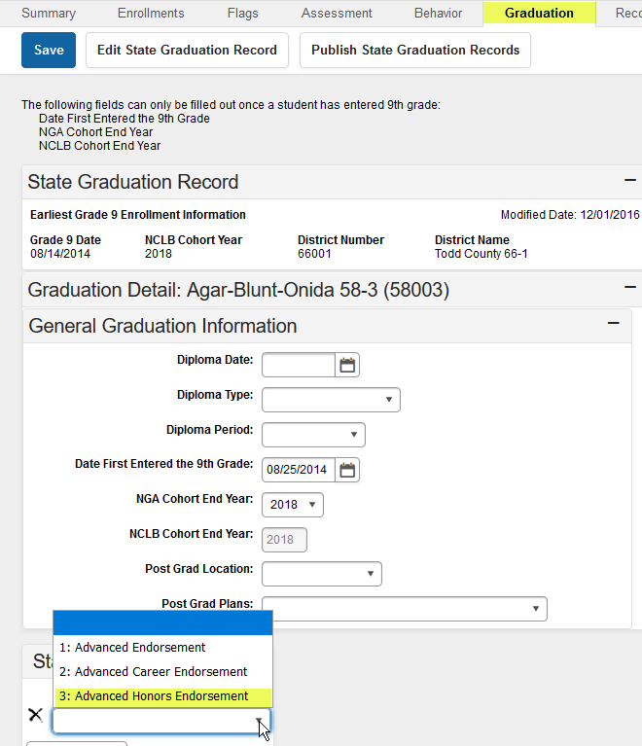
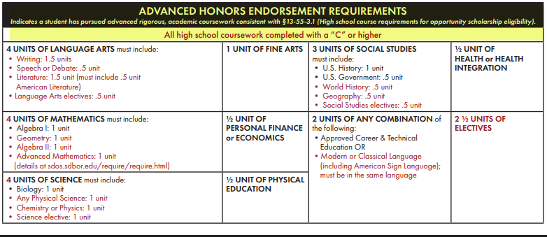

State Seal of Biliteracy
To recognize South Dakota’s growing diverse population of students and highlight the importance of mastering multiple languages, the SD DOE has developed the SD State Seal of Biliteracy. While participation in this program is completely VOLUNTARY, DOE will provide a specific seal to schools that request them for their students’ diplomas. Additional information regarding eligibility requirements is available at: https://doe.sd.gov/biliteracy/.
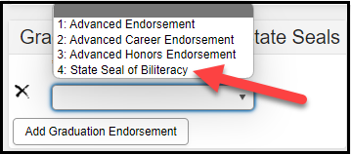
Districts who are participating are required to update the Graduation Endorsements/State Seal field for each student who qualifies to received it.

FRAM (Free and Reduced Priced Lunch)
The Eligibility tool under FRAM (Index>FRAM>Eligibility) shows a student’s eligibility for receiving free or reduced-price meal services. Eligibility records are updated when a household applies for benefits, generally at the start of a school year or during the school year. When a household is approved for free or reduced meal benefits, the student is eligible for the current school year, plus an additional 30 days into the next school year.
Schools are responsible for updating each students FRAM tab with their lunch eligibility status by October 1st of each year. Pathway is: Student>FRAM>Eligibility.
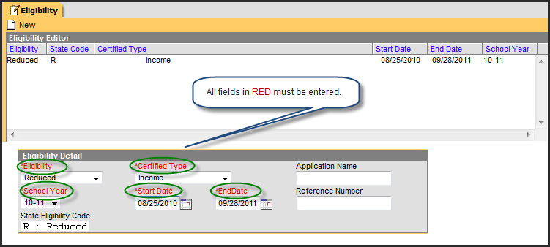

Eligibility for Free/Reduced Priced Lunch are entered through one of the following methods:
- Manually Entered Eligibilities – New eligibility records can be created manually on the Eligibility tool. This method is most often used when a district does not use the FRAM (Application Wizard).
- Updated/Imported Eligibilities – Existing student eligibilities can be imported to the Eligibility tool through use of the Eligibility Import Wizard. The Eligibility Import Wizard may have been used to upload direct certification information received through the iMATCH process.
- Auto-Populated Eligibilities – When a FRAM application is processed through the (Application Wizard), the resulting eligibility will be directly populated from the wizard to the Eligibility tool. These records will display as read-only information and cannot be modified or deleted.
Additional information on how to enter your Free/Reduced Price information into Infinite Campus can be found on the Campus Community.

Community Eligibility Provision in Infinite Campus
The Community Eligibility Provision (CEP) provides an alternative approach for offering school meals to districts and schools in low-income areas, instead of collecting individual applications for free and reduced-price meals.
The CEP allows schools that predominantly serve low-income children to offer free, nutritious school meals to ALL students attending that school through the National School Lunch and School Breakfast Programs. The CEP uses information from other programs, including the Supplemental Nutrition Assistance Program (SNAP) and the Temporary Assistance Program for Needy Families (TANF) instead of traditional paper applications. If your district is participating in CEP or any other Provisional food program, you will need to update each school’s USDA Programs information in Infinite Campus. The pathway to do so is: System Administration>Resources>School.
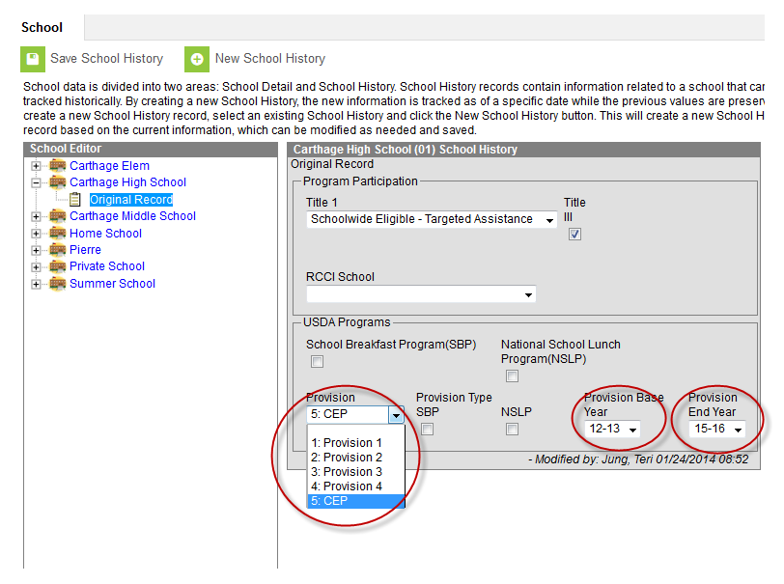
Schools need to update the USDA Programs area of Infinite Campus with the appropriate information. Schools must select the correct Provisional program or CEP to populate the Provision box along with updating their correct Provision Base Year and Provision End Year.
There are 3 ways a student can be receiving a FREE lunch. They are:
- The student is eligible for a free lunch because they are attending a school who is participating in a Provisional program or CEP. In this case, ALL students in the school receive a free lunch regardless of their household’s income. (See Screen Print #1 below on how the student’s record should appear in Infinite Campus).
- The student is eligible for a free lunch because they are automatically eligible due to receiving TANF and/or SNAP (food stamps) from the Department of Social Services through the Direct Certification process. This information comes through the iMatch system which includes a data match between DSS and DOE. Students in Foster Care, students who are Homeless and students who are Migrant also fall in the Direct Certification category and need to be coded as receiving a free lunch. (See Screen Print #2 below on how the student’s record should appear in Infinite Campus).
- The student is eligible for a free lunch through the normal application process. (See Screen Print #3 below on how the student’s record should appear in Infinite Campus).
Students may also be eligible for REDUCED PRICED lunch through the normal application process. (See Screen Print #4 below on how the student’s record should appear in Infinite Campus).

Screen Print #1 - Free/Non-Direct/Income = Community Eligibility Provision or Provision II or Provision III
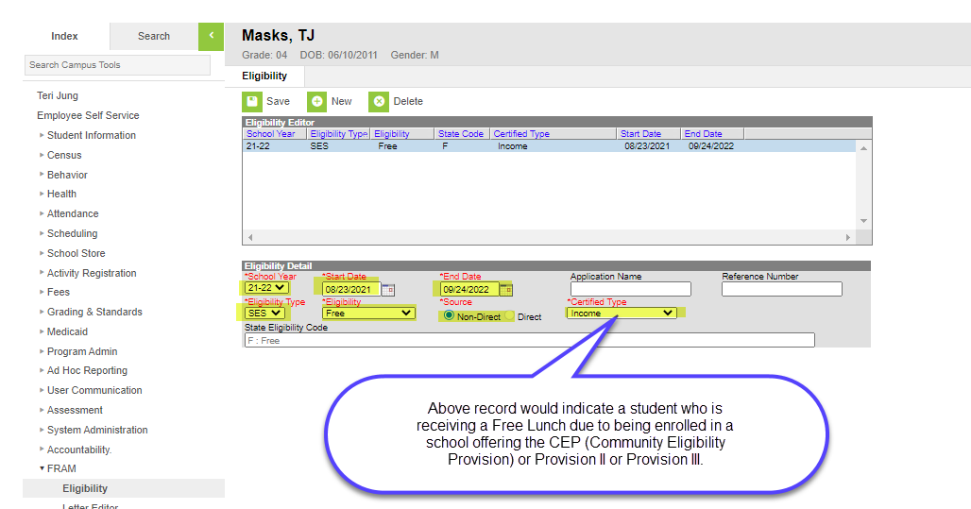

Screen Print #2 - Free/Direct/SNAP (or TANF, Foster Child, Homeless, Migrant) = Direct Certification
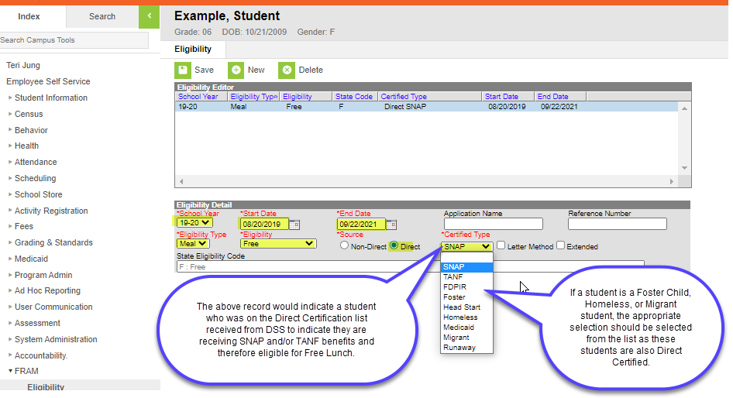

Screen Print #3 - Free/Non-Direct/Income = Normal application process
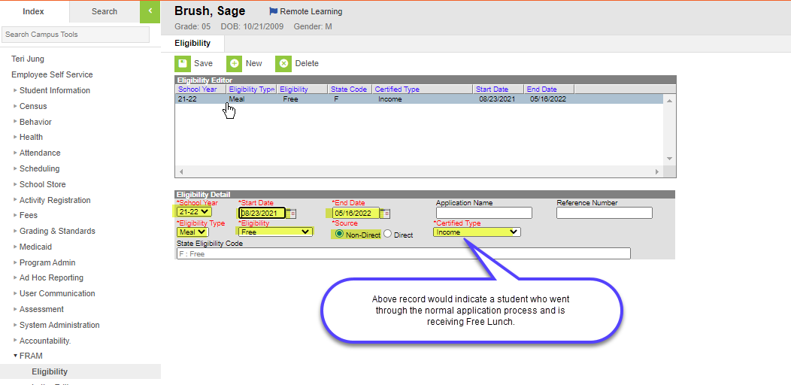

Screen Print #4 - Reduced/Non-Direct/Income = Normal application process
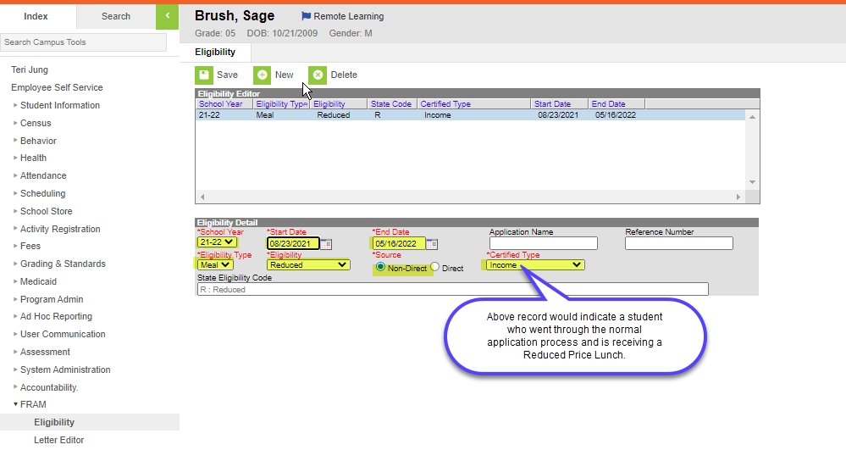

Required Data Elements for Upload School Districts

Calendars
Prior to uploading a file, a calendar for each attendance center for the current year and all required grade levels for that calendar must be setup within the SD State Edition user interface. If this is not done, an error message will be displayed when an upload is attempted.

Student Enrollments
Upload districts must utilize the most current File Interface Specifications when uploading their data into the State Edition. The more frequently upload districts complete an upload of your data, the more current your data will be in Infinite Campus State Edition. The link to access the most recent upload file specs is: Upload Wizard (South Dakota) | Infinite Campus. Please see the previous guidance provided regarding unique enrollment situations.

Section II – Accountability – Year End Data

Timeline
Accountability - Year End Data: Final student data must be reported by the second Friday in June.
If you have been diligent about keeping your student data current throughout the school year, the end of the year data collection will not be overwhelming for your school district. To review the proper coding of important data fields within each student’s enrollment record, be sure to review the Fall Enrollment and Child Count sections of this Desk Guide. Important end of the year items that must be reviewed and updated are highlighted on the following screen prints.

Student Enrollments
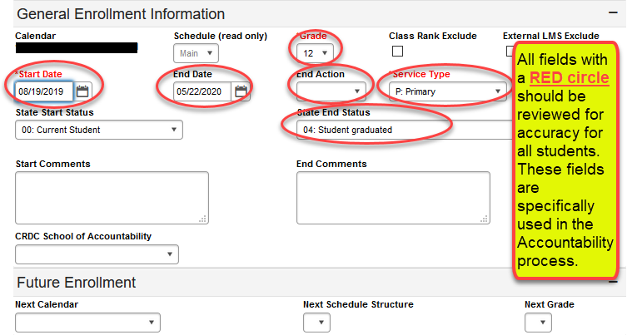
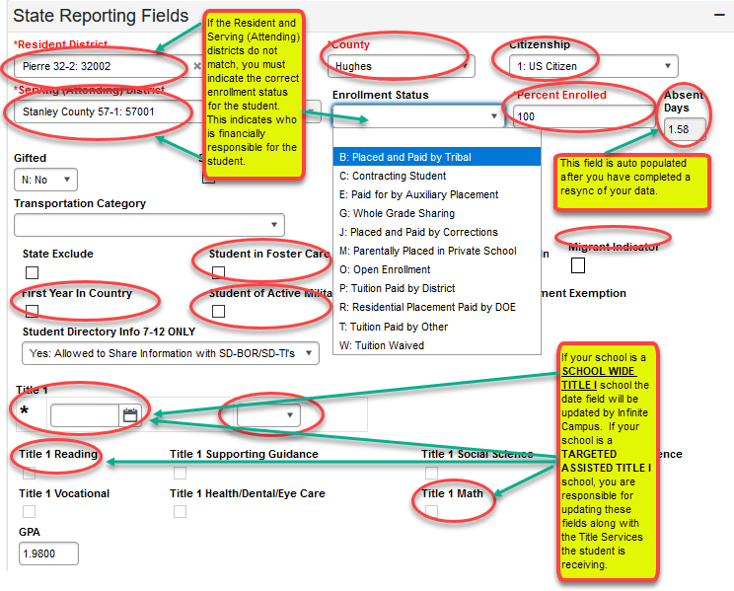

If students are receiving special education services, all fields highlighted correlate to accountability reporting and should be reviewed for accuracy.
If a student is graduating with a regular diploma, the student will need an end date and exit code.
The alternate assessment box should only be checked for students who participate in the alternate assessment. It should not be checked for students who take the regular state assessment with or without accommodations.
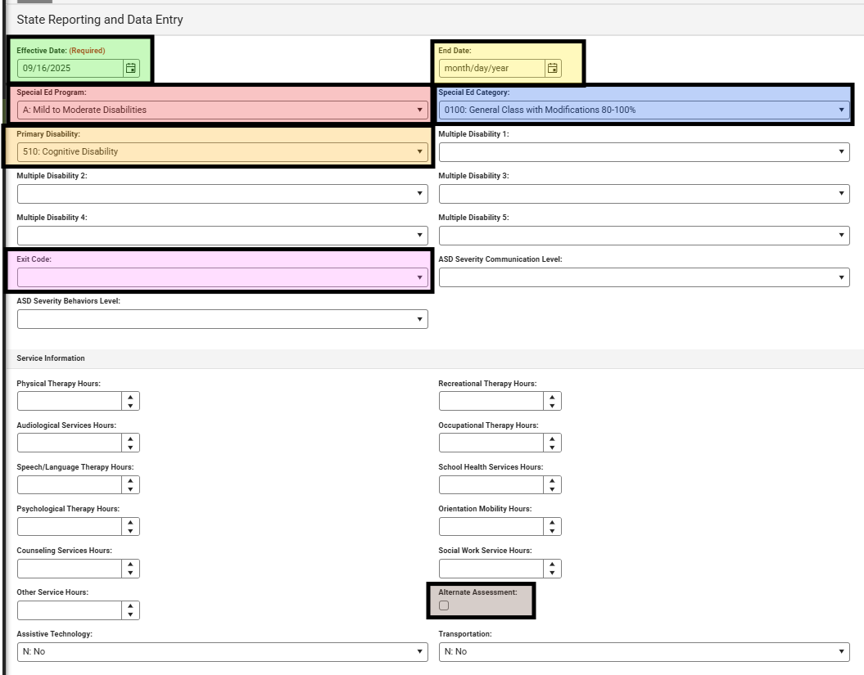

Students who are Graduating
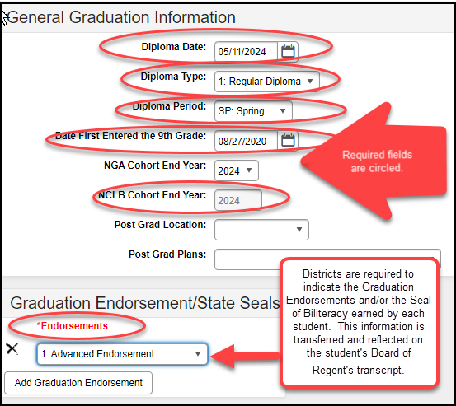
The student’s graduation cohort year is determined by the student’s 1st point of entry into 9th grade. Students are expected to graduate within 4 years. The graduation cohort year on the GRAD screen cannot be changed just because a student is not going to meet the 4-year expectation. There have been a few instances where the cohort year is truly incorrect. If you find a situation like this, please contact the DOE at 605-773-3134 and we will help you get the cohort year corrected.

Accountability related data elements to check include:
Every calendar that your district has in Infinite Campus has the correct calendar "Type" selected, and they have all been adjusted to account for snow days, Christmas vacation, in-service days, parent/teacher conferences, etc.
All students who attended your school district, including EC students, PK students and K-12 students (even for a short time) have an enrollment record in Infinite Campus.
All student demographic information is entered and verified on the Demographics tab, including first and last name (matching birth certificate), gender, date of birth, and race/ethnicity.
All foreign exchange students have been identified by updating the Citizenship field on the student’s Enrollment tab.
All student enrollments have an End Date and the appropriate End Status for the current school year on each student’s Enrollment tab. This includes ALL STUDENTS enrolled in all your school calendars including your EC students, PK students, Alternative Instruction Activity students, Private School students, etc.
Attendance is entered for every student (PK-12) and a resync of the data has been completed. The Absent Days box on each student's Enrollment tab is correctly reflecting the number of days the student was absent during the current school year. System Administration>Data Utilities>Resync State Data.
All high school graduates for the current school year have their End Date and State End Status fields updated on their Enrollment tab. Remember: Enter the last day of your school year, NOT the date of the graduation ceremony in the End Date field. The State End Status should be updated to a 04 - Student Graduated.
If the student is a Special Education student and is graduating, you must also update the SPED fields with an End Date and Exit Code. Remember: The SPED codes are different. The correct SPED Exit code is: 2 – Graduated (high school diploma). If you code a SPED student as a graduate, the student is no longer eligible to receive services in the next school year.
**DO NOT classify students in 8th grade and lower as Graduates.
All high school graduates for the current school year have their Diploma Date, Diploma Type and Diploma Period updated on their Graduation tab. South Dakota only recognizes a “regular diploma.”
All high school graduates NCLB Cohort End Year have been checked to ensure that it is accurately reflecting the correct graduation cohort year on the Graduation tab.
All high school graduates who have earned one or more Advanced Endorsements must be updated on their Graduation tab.
EL (English Learners) students have been identified and their data entered in Infinite Campus on the English Learner (EL) tab. Student Information>General>Program Participation>English Learners (EL).
First Year in Country students have been identified by placing a check in the checkbox on the Enrollment tab and their Date Entered US, Date Entered US School, and Date Entered State School has been entered into Infinite Campus on the Demographics tab. Census>People>Demographics.
Immigrant Children and Youth have been identified by their Date Entered US, Date Entered US School, Date Entered State School, and Country of Birth has been entered into Infinite Campus on Demographics tab. For the definition of Immigrant Children and Youth, refer to the Title III webpage.
If student is identified as an English Learner, home primary language (other than English) must be identified in the Demographics tab.
All Students with Disabilities (SPED) have been properly identified and their data entered in Infinite Campus in the Special Education Summary.
All students with a Documented Hearing Loss have been identified by checking the checkbox on the Enrollment tab. This applies to all students, birth to 21 years of age and includes students who have a documented hearing loss (audiological report) of 35 db or more regardless of whether they have an IEP or 504 plan.
All Homeless students have been properly identified, and the Homeless fields have been updated on the Homeless tab. Student Information>General>Program Participation>Homeless.
**NA cannot be used as a primary nighttime residence.
All Military Connected students have been properly identified by placing a check in the Student of Active Military Parent checkbox on the Enrollment tab.
Students receiving Free or Reduced Priced Lunch have been identified and have had their lunch eligibility entered on the FRAM tab. This includes all students in Provisional and CEP schools.
If you are operating a Targeted Assistance Title I Program in any of your schools, all students receiving Title I services are properly updated in Infinite Campus on the student’s Enrollment tab. If you are a Title I Schoolwide Program, all students will be flagged by Infinite Campus.
If you are operating a Title III program in any of your schools, the Title III Program Participation checkbox in Infinite Campus must be checked. System Administration>Resources>District Information. Title III district means you receive your own Title III grant, or you are part of a Title III consortium.
The Resident District, Serving (Attending) District, and County (where the student lives) have been entered on the Enrollment tab for each student. These data are forwarded to each county within the State and to the Office of School and Public Lands for funding purposes for your school district.
All student enrollment overlaps have been resolved between your district and any private and/or BIE schools.
Run the Student Enrollment Extract report. Index>SD State Reporting>Student Enrollment Extract. This report can be used to quickly identify if you have end dated all your students and have entered attendance for all students.
Run the state published Ad-Hocs and resolve all identified errors. Index>Ad Hoc Reporting>Filter Designer>State Published. Most of these Ad-Hoc reports are related to the data used for your district’s Accountability Report Card.
For Rapid City and Brandon Valley ONLY - All Accountability Ad Hoc reports built for your districts have been run and all errors have been resolved. These Ad-Hoc reports are found at: Index>Ad Hoc Reporting>Filter Designer>District Level AYP Accountability Queries.

Required Data Elements for Upload School Districts

Student Enrollments
Upload districts must utilize the most current File Interface Specifications when uploading their end of the year student data into the State Edition. The link to access the most recent upload file specs is: Upload Wizard (South Dakota) | Infinite Campus. Please see the previous guidance provided regarding important end of the year data reporting responsibilities. Upload districts are also required to utilize all the Accountability Ad-Hoc Queries built for your use and available within the State Edition of Infinite Campus. All errors must be resolved.

Section III – Students with Disabilities State Reporting Data and December Child Count

Requirements for Special Education State Reporting Data and Child Count
Public school districts are responsible to report special education data for ALL students – which includes those served in the district, those placed out of district and eligible students parentally placed in private schools within the district boundaries regardless of whether they are receiving services or not. Child Count is an unduplicated count of all children with disabilities ages 3 – 21 receiving special education and related services according to an individualized education program (IEP) on December 1st of each year.
From the Reporting section of Infinite Campus, districts utilize the SD December Child Count Report to extract all active students with special education state reporting and data entered on the Special Education Summary section. This file is uploaded to a DOE database, verified, and the district completes a sign off.
For more information on how to extract, upload and submit a Child Count data file to DOE, see the following website https://doe.sd.gov/ofm/data-childcount.aspx For additional assistance please contact Shri Yeddula, the Special Education Programs’ Data Manager , at Shri.Yeddula@state.sd.us or 605-773-3783, or contact your region representative.

Entering the Special Ed Fields
The Special Ed Reporting information was relocated from the General tab under Enrollment to the Special Ed tab under Special Education Summary.
Special Education start and end dates are no longer based on the school calendar year, rather they reflect the effective date of the annual IEP or the effective date of a change impacting the special education elements based on amendments, evaluations or student enrollment status.
The Special Ed Data Fields are entered in the Special Education Summary. The Special Education Summary is found in the Special Ed section.
*If you are not able locate the Special Ed tab or the Special Education Summary section the district infinite campus administrator may need to assign permissions.
Search for student, select record and navigate to the student information link at the top of the record:
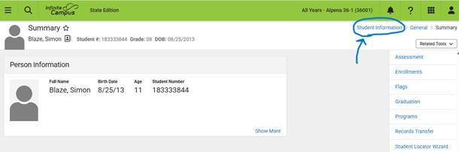
- Navigate to the Special Ed section
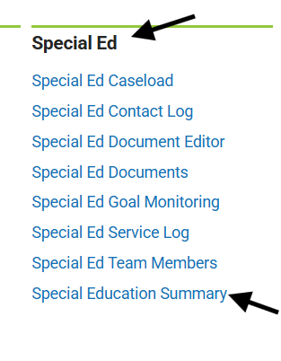
- Select the Special Education Summary.
- Under the State Reporting and Data Entry click the new button which will open the screen.
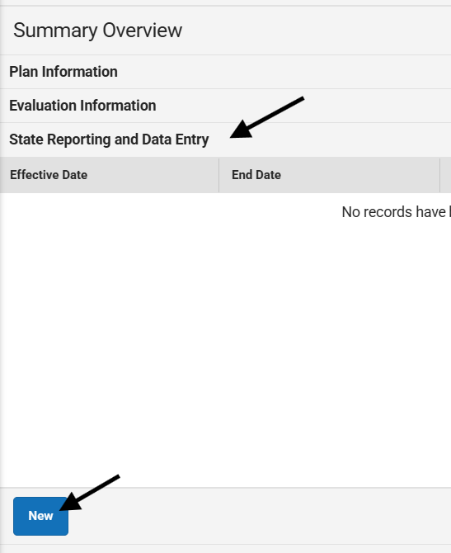

Data Elements for Students with Disabilities
The following data elements must be reported for students with disabilities to accurately and timely report child count, to compute your district’s Special Education State Aid allocation, and to complete other required state and federal reporting.
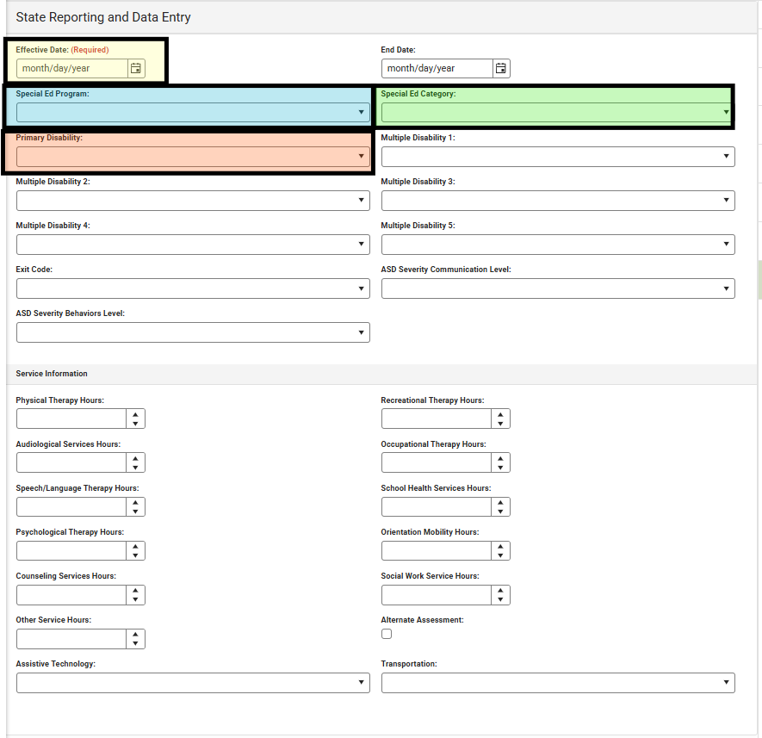

Effective Date
Used to document:
- Date student first begins to receive special education services
- Date a transfer student begins receiving special education services
- Date a change in category or disability takes effect
- Date a new IEP takes effect (at least annually)
The effective date can span multiple school years, but the effective date cannot exceed one year as all students with disabilities must, at minimum, have an annual IEP.

Special Ed. Program/Instructional Program Type
This data field is used to correlate a type of instructional program identified for each special education student to expenditures reported on the annual financial report. The instructional program type should not be assigned by a student’s primary disability. Below are examples and guiding principles to determine instructional type; however, it is up to each district to allocate their costs and identify a student’s special education instructional program in a way that best suits their district’s programs and staffing patterns.
- Programs for Mild to Moderate Disabilities (A) – typically this will include students who spend most of the day in the general class settings and/or provided special education services for less than 50% of the regular day (for example, a district operating a 6-hour school day, a student provided special education services for less than 15 hours a week). Generally, these students will fall into the category of 0100: General Class or 0110: Resource Room.
- Programs for Severe Disabilities (B) – student receiving special education for more than 50% of the day. This should not include students placed in day or residential programs. Generally, these students will fall into the category of 0120: Self Contained or 0110: Resource Room.
- Speech Only (C) - Primary disability of 0550: Speech, only receiving speech/language.
- Early Childhood (ages 3-5) (D) – special education programs for preschool children ages 3-5.
- Day Program (E) - programs for students assigned to day programs offered by the district or assigned out of district. This may include students placed in community-based service centers, cooperative day programs, etc.
- Residential Program (F) – programs for students served in a 24-hour residential school, such as Lifescape.
- Homebound Program (G) – special education services provided in the student’s home, i.e., programs for severely ill students unable to attend school for a period time.

Special Education Category (Least Restrictive Environment –LRE)

AGES 6-21- and 5-year-olds attending Junior Kindergarten and Kindergarten – The categories are as follows:
- General Classroom with Modifications (0100): Inside the general class 80% or more of the day. (These are children who received special education and related services outside the general classroom for less than 21% of the school day). This may include children with disabilities placed in:
  - General class with special education/related services provided within regular classes
  - General class with special education/related services provided outside regular classes
  - General class with special education services provided in resource rooms
  - Educational time spent in age-appropriate community-based settings that include individuals with and without disabilities, such as college campuses or vocational sites, should be counted as time spent inside the regular classroom.
- Resources Room (0110): Inside general class no more than 79% of the day and no less than 40% percent of the day. (These are children who received special education and related services outside the general classroom for at least 21% but no more than 60% of the school day). Do not include children who are reported as receiving education programs in public or private separate school or residential facilities. This may include children placed in:
  - General rooms with special education/related services provided within the general room
  - General rooms with part-time instruction in a regular class
  - Educational time spent in age-appropriate community-based settings that include individuals with and without disabilities, such as college campuses or vocational sites, should be counted as time spent inside the general classroom.
- Self-contained Classroom (0120): Inside the general class less than 40% of the day. (These are children who received special education and related services outside the general classroom for more than 60% of the school day). Do not include children who are reported as receiving education programs in public or private separate school or residential facilities. This category may include children placed in:
  - Self-contained special classrooms with part-time instruction in a general class; or
  - Self-contained special classrooms with full-time special education instruction on a general school campus
  - Educational time spent in age-appropriate community-based settings that include individuals with and without disabilities, such as college campuses or vocational sites, should be counted as time spent inside the regular classroom.
- Separate Day School (0130): Includes students who received education programs in public or private separate day school facilities made up solely of students with disabilities. This includes children with disabilities receiving special education and related services, at public expense, for greater than 50 percent of the school day in public or private separate schools. This may include children placed in:
  - Public and private day schools for students with disabilities:
  - Public and private day schools for students with disabilities for a portion of the school day (greater than 50 percent) and in general school buildings for the remainder of the school day; or
  - Public and private residential facilities if the student does not live at the facility.
- Residential Facility (0140): Includes students who received education programs and lived in public or private residential facilities made up solely of students with disabilities during the school week. This includes children with disabilities receiving special education and related services, at public expense, for greater than 50 percent of the school day in public or private residential facilities. This may include children placed in:
  - Public and private residential schools for students with disabilities; or
  - Public and private residential schools for students with disabilities for a portion of the school day (greater than 50 percent) and in separate day schools or general school buildings for the remainder of the school day.
  - Do not include students who received education programs at the facility, but do not live there.
- Home/Hospital Program (0150): A student is in this category if he/she is homebound/hospitalized and is receiving special education/related services as specified on an IEP.

AGES 3 THROUGH 5 YEARS OLD IN PRESCHOOL – THE CATEGORIES ARE AS FOLLOWS:
Ages 3 through 5 in Preschool – (Until a student turns 6 or is 5 years old and enrolls in Junior Kindergarten or Kindergarten, they must use the 3 through 5-year-old codes. Upon turning 6 or 5 years of age if enrolled in Junior Kindergarten or Kindergarten the appropriate age 6-21 code needs to be used). Use the following decision rules to determine the appropriate educational environment category for reporting each 3 through 5-year-old in preschool. Please note that the order of the categories as listed does not reflect a continuum from least to most restrictive.
- Regular Early Childhood Program: A Regular Early Childhood Program is a program that includes a majority (at least 50 percent) of nondisabled children (i.e., children not on IEP’s). This category may include, but is not limited to:
  - Head Start
  - Preschool classes offered to an eligible pre-kindergarten population by the public-school systems
  - Private preschools; and
  - Group child development center or childcare.
- If the child is attending a Regular Early Childhood Program, he/she is to be reported within codes 0310, 0315, 0325, or 0330 as directed below. If the child does not attend a Regular Early Childhood Program at all, skip to the next section.
  - EC 10 Hours+, services in EC (0310): Children attending a regular early childhood program 10 hours or more per week and receiving the majority of hours of special education and related services in the regular early childhood program.
  - EC 10 hours+, services in other location (0315): Children attending a regular early childhood program 10 hours or more per week and receiving the majority of hours of special education and related services in some other location.
  - EC less than 10 hours, services in EC (0325): Children attending a regular early childhood program less than 10 hours and receiving the majority of hours of special education and related services in the regular early childhood program.
  - EC less than 10 hours, services in other location (0330): Children attending a regular early childhood program less than 10 hours and receiving the majority of hours of special education and related services in some other location.
- If the child is NOT attending a Regular Early Childhood Program as defined above, the child is to be reported within codes 0335, 0345, 0355, 0365, or 0375. Such children would be either ‘Attending a Special Education Program’ OR ‘Attending neither a Regular Early Childhood Education Program or a Special Education Program’ of any kind.
- If the child attends a Special Education Program, as defined below, report the child in category 0335, 0345, or 0355.
  - Special Education Program: A Special Education Program includes less than 50 percent nondisabled children (i.e., children not on IEP’s). Special education programs include, but are not limited to:
    - Special Education Classrooms (0335) in
      - Regular school buildings
      - Trailers or portables outside regular school buildings
      - Childcare facilities
      - Hospital facilities on an outpatient basis
      - Other community-based settings
    - Separate schools (0345)
    - Residential facilities (0355)
- If the child does not attend a Regular Education Preschool Program or a Special Education Program, report the child in category 0365 or 0375, defined below.
  - Home (0365): A student is in this category if he/she receives special education and related services in the principal residence of the child’s family or caregivers, and who did not attend an early childhood program, or a special education program provided in a separate class, separate school or residential facility.
  - Service Provider Location (0375): A student is in this category if he/she receives special education and related services from a service provider, and who did not attend an early childhood program, or a special education program provided in a separate class, separate school, or residential facility. Examples:
    - Specialized instruction provided in the service provider’s office, in school buildings, on an outpatient basis in hospital facilities, libraries and other public locations.

Disability
In most cases, students will have been identified as eligible under one disability category (even if other categories may have been considered). This should be coded in the primary disability.
Multiple Disabilities – Do not select this disability just because a student has additional disabilities or services (such as Autism and receiving Speech/Language services). Multiple Disabilities should only be used if the IEP team during the eligibility determination meeting determines that the student is eligible under the Multiple Disabilities category. All disability categories identified should be coded. However, multiple disabilities does not include deaf-blind or speech as one of the disability categories if it is only a related service.
If the Primary Disability is 530: Multiple Disabilities; you must also identify all of the disability categories the student has been determined eligible in under Multiple Disability 1 and Multiple Disability 2, etc.
Autism Spectrum Disorder– If a student is identified with a disability of Autism, the fields for ASD Severity Behaviors Level and ASB Severity Communication Level are also required to be completed. This information can be changed over time but will most likely be entered at the time of initial eligibility and at the three-year reevaluation. The severity levels should not be utilized if Autism is not the primary or one of the multiple disability categories.
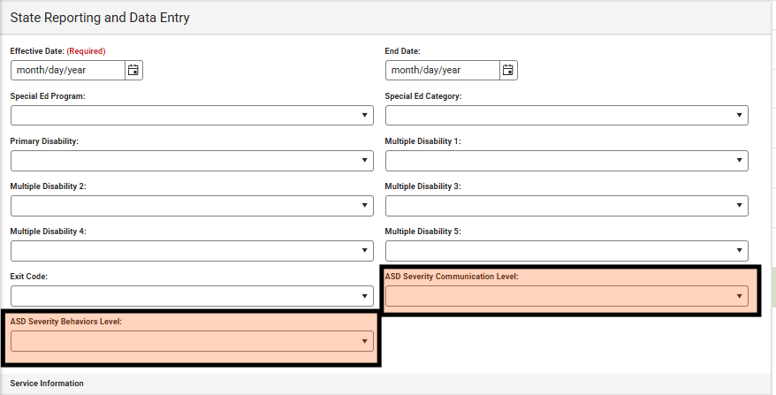

State Special Ed Aid funding
Level for disability  funding calculation | Disability
Level 1 | Specific Learning Disabled, Speech/Language Impairment,  Other Health Impaired, and Developmental Delay
Level 2 | Emotional Disability, and Cognitive Disability
Level 3 | Deaf/Blind, Hearing Impairments, Orthopedic Impairments,  Visually Impaired, Deafness, and Traumatic Brain Injury
Level 4 | Autism Spectrum Disorder
Level 5 | Multiple Disabilities (must include 2 or more level 2, 3 or 4  disabilities, not including Deaf/Blind)
SD State Statute 13-37-35.1

Special Education Services: Therapy Hours
Note: All therapy hours need to be reported based on hours per week.
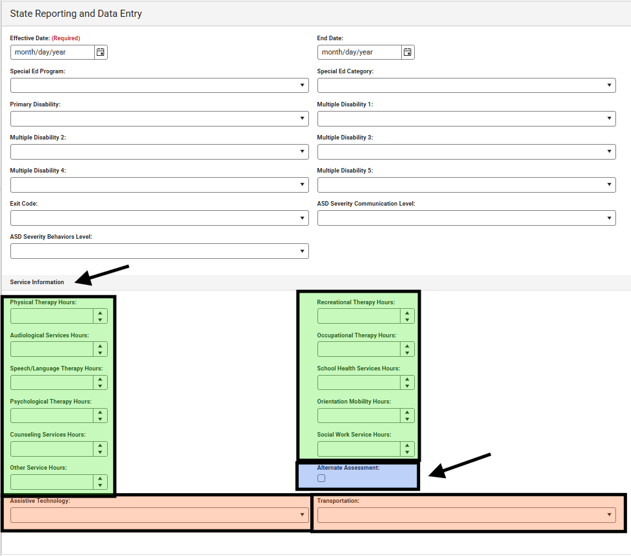
Report all therapy services documented in the IEP based on hours per week. Report the number of hours per week for each service. (If services are provided based on another increment, such as on a monthly basis, the hours will need to be calculated to reflect hours per week. In the case of hours per month, divide the monthly hours by 4 to calculate hours per week. You should always code speech hours regardless of whether Speech is the primary disability or a related service.
Assistive Technology and Transportation do not require the number of hours but are simply check boxes. Transportation should only be marked yes if it is documented in the IEP as a special education service.

Students Participating in the State Alternate Assessment
If a student will participate in the state alternate assessment, then the “Alternate Assessment” box in State Reporting and Data Entry must be marked. The decision for alternate assessment participation is made by the student’s IEP team by using the Alternate Assessment Participation Form and Alternate Assessment Participation Guidelines found at https://doe.sd.gov/assessment/alternate.aspx. The IEP team decision must be documented in the assessment section of the student’s IEP.
The state alternate assessment student list is pulled in mid-December. If a district makes a change to the “Alternate Assessment” box after December 1st, the district must also email the student SSID number to DOEassessment@state.sd.us.

How to make a change in the Special Ed Fields within the Special Education Summary
As a result of special education information being reported in the Special Education Summary the Effective Date and End Dates are no longer bound to the school calendar. The Effective Date and End Date will reflect when there are changes to special education (such as the annual IEP meeting) or enrollment (such as first eligibility, transfer, or change in category or disability). It will be possible for the Effective Date to be in the previous school year if that is when the last change was made.
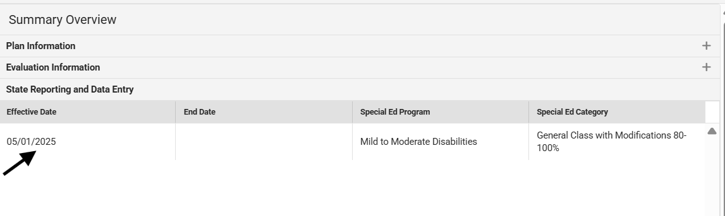

Making a change
- When a student has a change in their IEP, the correct way to make the change is, by ending the Special Ed Fields with an exit date and an exit code: 11: change in IEP
- You will then create a new Special Ed record by clicking on new and entering the new information.
- When ending and starting a record, please do not use the same end/start date.
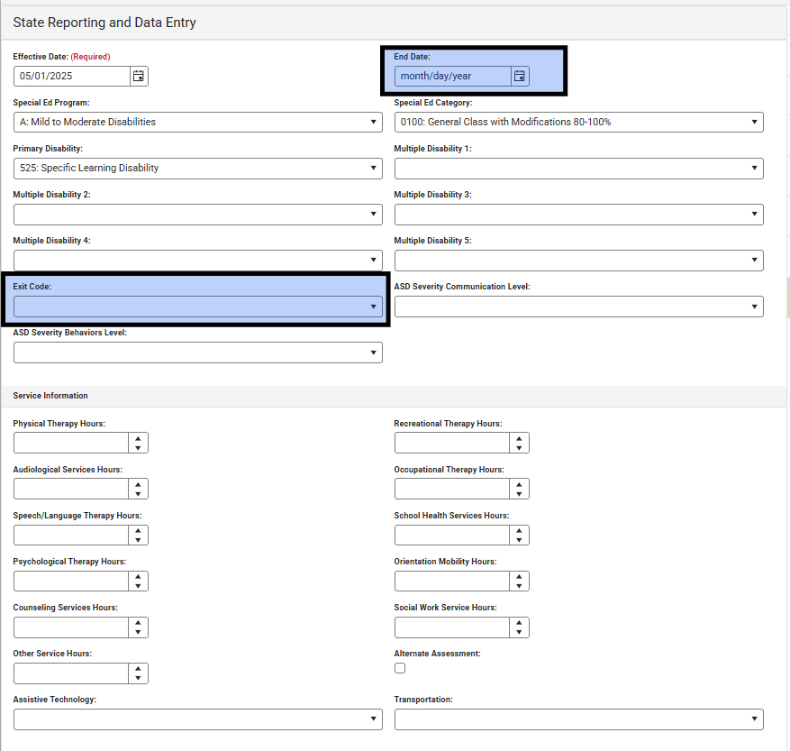

IEP Program Exit Reason
- Not receiving SE Services: Use this code when the IEP team determines that the student is no longer eligible to receive Special Education services or dismissed.
- Graduated (high school diploma): Students with disabilities who exited an educational program through receipt of a high school diploma identical to that for which students without disabilities are eligible. These students met the same standards for graduation as those students without disabilities. Participation in graduation ceremonies to receive a certificate does not qualify the student as a graduate.
- Continues: Completed IEP team modified course requirements for high school. (This exit code is no longer needed and shouldn’t be used it was necessary when special ed record was tied to the enrollment record) The code reflected students with disabilities whose requirements differed to those required for all students. These students may have participated in graduation ceremonies, but the students were not considered graduates for reporting purposes and would continue to receive services in the next school year.
- Reached maximum age: Students are eligible to receive services to the end of the fiscal year (July 1 to June 30) in which they turn 21.
- Died
- Moved known to be continuing: Students with disabilities that moved out of the catchment area or otherwise transferred to another district and are known to be continuing in an educational program. There need not be evidence that the student is continuing in special education, only that he/she is continuing in an education program. This definition includes students with disabilities in residential drug/alcohol rehabilitation centers, correctional facilities, or charter schools if those facilities operate as separate districts, excluding normal matriculation.
- Moved not known to be continuing: This is used when the student says they are transferring but it is not known if they will be attending a new education program/school.
- Dropped out: This includes dropouts, runaways, GED recipients, expulsions, status unknown, and other exiters.
- Refused services: Use this code to document students who are an Alternative Instructions/Home Schooled student, or a Colony student completed > grade 8 with a religious exemption. These students would still be eligible for services if they re-enrolled in public school.
- Completed IFSP prior to reaching maximum age (3) for Part C
- Change in IEP: When a student has a change in their IEP, the current State Reporting and Data Entry record in the Special Education Summary section should be ended with an exit date and an exit coded: 11: change in IEP. Then a new Special Ed record would be created with the new information. When ending and starting a record, please do not use the same end/start date, in most cases the next day would be the effective date to show continued eligibility even if that date falls on the weekend. A change should be made at least annually after the annual IEP meeting.
- Student continues: (This exit code is no longer needed and shouldn’t be used. It was necessary when special ed record was tied to the enrollment record)
- Discontinued/Completed IEP team mod/course req: Completed IEP team modified course requirements for high school. This means that a student has dropped out of school without obtaining a regular diploma. The student can return unless they have met the age out requirement.
- Aged Out/Completed IEP team mod/course req: Completed IEP team modified course requirements for high school. These students have completed IEP goals, have turned 21, and this code is used to end their record.
- Revocation of consent: These students will have been eligible for special education until the point when the parent/guardian/or adult student signs off that they are revoking consent for services. This code is used to end the special ed record and the students are no longer considered a student with a disability.

Ending enrollment for seniors who are in Special Education
First, determine if the student is a graduate with a regular high school diploma and will end school eligibility.
- Graduate with a regular high school diploma
  - Met the same state course and content requirements.
  - With or without provided accommodations using general education curriculum
Graduation Exit Coding  (Met the regular diploma requirements) | General Enrollment Exit Codes | Special Ed Fields Exit Codes
 | 04: Graduated | 2: Graduated (high school diploma)
**Please note that the exit codes differ between the General Education on the enrollment tab and the Special Ed on the Special Education Summary tab. Both areas MUST BE updated appropriately.**
The Graduation tab also needs to be updated.
If a student received a signed regular diploma, the student is no longer eligible to receive special education services and the school district is not eligible to receive State Aid for the student in the coming year.
Second, if the student did not meet the requirements for a regular diploma but met IEP team modified requirements, the district can issue a certificate, but the student’s enrollment eligibility does not end. The students is still eligible to receive special education services until the end of the fiscal year in which he/she turns 21 and have not received a regular signed diploma.
- Student met IEP team modified requirements.
  - Did not meet the same requirements as peers.
  - IEP team made course modification to state graduation requirements (documented in IEP) ARSD 24:05:27:11
  - Courses were aligned to Core Content Connectors
  - Modified curriculum/content standards
  - No Code is needed as the student will be returning to school and the special ed record will still be active in the Special Education Summary section.
Seniors who are Special Education students and have not met modified IEP requirements nor received a regular signed diploma will continue to receive special education services until the end of the fiscal year in which they turn 21.
Third, students who turn 21 during the fiscal year that did not receive a regular diploma would use one of the following codes depending on if they met IEP requirements or not.
Age Out Exit Code | General Enrollment Exit Codes | Special Ed Fields Exit Codes
Age Out Exit Code | 07: Reached maximum age for special education (21) | 4: Reached the Maximum Age (did not meet IEP modified requirements)
Age Out Exit Code | 21: Aged Out – Completed IEP team modified course requirements | 14: Aged Out: Completed IEP Team Mod/Course Requirements
Fourth, at the beginning of the following year, if the student does not return, the fall enrollment record is created and after not attending for 15 consecutive school days, the student should be coded as dropped out
Exit Code  (Did not return in fall) | General Enrollment Exit Codes | Special Ed Fields Exit Codes
Exit Code  (Did not return in fall) | 20: Discontinued education – Completed IEP team modified course requirements | 13: Discontinued education – Completed IEP team modified course requirements
Exit Code  (Did not return in fall) | 02: Discontinued education – dropout | 8: Dropped out  or  7: Moved not known to be continuing
**(These codes will be used in the fall if the student does not return)

General Enrollments to SPED Enrollment Crosswalk of Exit Codes
General Enrollment Field | Special Education Field
01 Expelled – (District is obligated to provide FAPE for students with disabilities. Student may have an end date in the regular school calendar but then should be entered into calendar #97). | District is obligated to provide FAPE; no exit code is needed.
02 Discontinued education - dropout | 8- Dropped out  or  7 - Moved not known to be continuing (counts as a dropout for graduation and dropout rates)
03 In-state school transfer | 6- Moved known to be continuing
04 Student graduated, must receive a regular high school diploma (Not a GED or certificate of completion) | 2 - Graduated, must receive a regular high school diploma (Not a GED or certificate of completion)
05 Student died | 5- Died
06 Committed to Institution | 6 - Moved known to be continuing
07 Reached maximum age for special education (21) | 4 - Reached maximum age
08 Out-of-state school transfer | 6 - Moved known to be continuing
09 Colony student completed > grade 8 – religious exemption | 9 - Refused services
10 Student retained | Do not end the special ed record
11 Student continues | Do not end the special ed record
12 Persistently Dangerous Transfer | 6 - Moved known to be continuing  or  11 - Change to IEP (if the transfer was due to an IEP team decision)
13 School Improvement Transfer | 6 - Moved known to be continuing
14 Alternative Instruction/Home school Transfer | 9 - Refused services (Use this code if student is still eligible but not currently attending public school).  or  12- Student continues (Use this code if the school will still be providing special education services).
15 Suspended (District is obligated to provide FAPE for students with disabilities. Student may have an end date in the regular school calendar but then should be entered into calendar #97). | District is obligated to provide FAPE; no exit code is needed.
16 Alternative Instruction/Home school completer | 9 - Refused services (Use this code if student is still eligible but not currently attending public school).  or  12- Student continues (Use this code if the school will still be providing special education services).
17 Discontinued Education – completed GED | 8- Dropped out
18 Discontinued Education – exceeds compulsory age | 8- Dropped out
19 Continues – Completed IEP team modified course requirements for high school | No code needed as Special Ed record will still be active in Special Education Summary Section
20 Discontinued Education – Completed IEP team modified course requirements for high school | 13 – Discontinued education – Completed IEP team modified course requirements for high school
21 Aged Out – Completed IEP team modified course requirements for high school | 14 – Aged Out – Completed IEP team modified course requirements for high school
Does not necessarily require exit code on Enrollment field | 1 - Not receiving Special Ed Services (Use this code if the IEP team determines the student is no longer eligible for special education).
Does not necessarily require exit code on Enrollment field | 11 – Change in IEP (Use this code to end the current special ed record in order to enter a new special ed record any time special education information changes or is an annual IEP meeting has been held).
Does not necessarily require exit code on Enrollment field | 15 – Revocation of consent (Use this code to end the special education record if the parent or adult student signs off to no longer be considered eligible for special ed).

Reporting sped out of district

Creating a Sped out of district calendar
In order to report students placed out of district, each district should have a school #97 – Sped Out of District as the school in which to document enrollment.
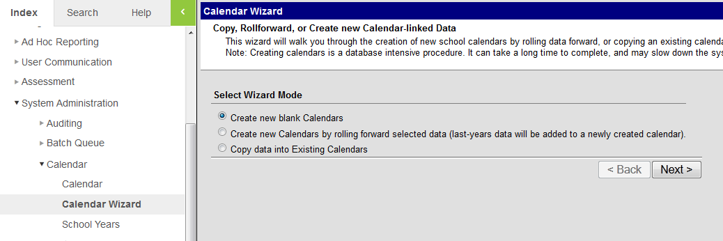
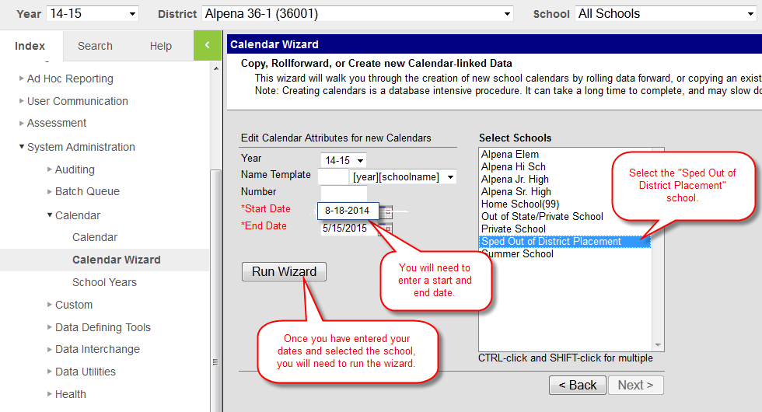

Once the wizard is done running, go to Calendar tab. Verify that your dates are correct.
The next step is to enter grade levels. You will need to enter EC-12.
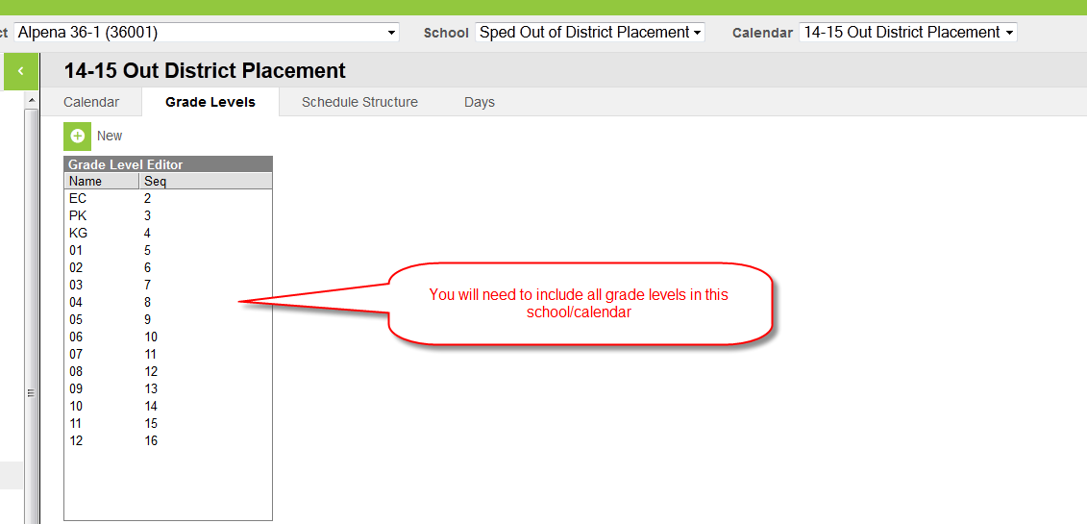The public school district must enroll any student eligible for special education for which the district is responsible to provide a FAPE (Free and Appropriate Education) and who is placed out of district. The student will be enrolled in the Sped Out of District Placement school as follows.

Key Data Reporting Fields for Students in School #97
Key Data Fields for this school are as follows:
- Percent Enrolled = 1% (this will create an allowable overlap, if the student has an enrollment of 0% they will not be included in Child Count)
- Service Type of “N”
- Serving (attending) District = identify the school in which the student is placed and,
- Enrollment Status = “P – tuition paid by district”

The Out of District Placement facility will continue to enter a general enrollment record and the student will be reported as enrolled 100%. This will cause an overlap, but DOE will allow when created based on students also reported in the Sped Out of District school.
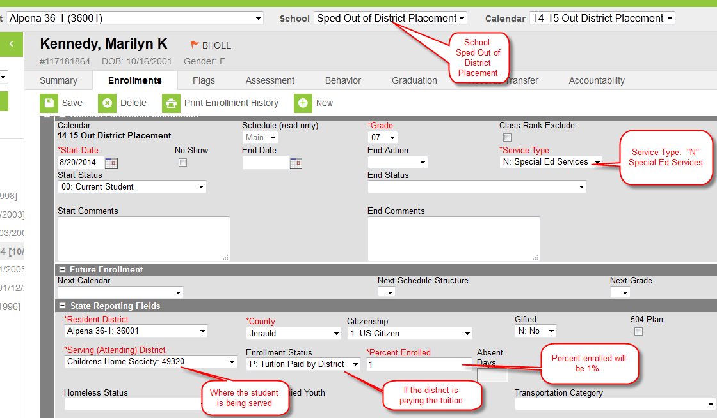
IMPORTANT NOTE: Students served at either; the School for the Blind & Visually Impaired (06302) or SD Human Services Center (63304) for which the resident district continues to serve as the LEA for the IEP during the placement should enroll the student as follows:
- Student will have an enrollment record at HSC (district 63304) at 100% with an enrollment status of “W”.
- The resident district will have an enrollment record in school 97- SPED Out of District Placement as 1% enrolled with an enrollment status of “P” (the P is necessary in order for the child count extract to include the student on the child count report
  - This does not obligate the resident district to pay any tuition but does allow the student to be included in the district child count.
  - The district does have some financial responsibility on behalf of these placements for transportation and to monitor the IEP – therefore it is appropriate for this record to reflect an enrollment status of P.
The special education information should also be completed to report and reflect ALL the services that are on the IEP for accurate reporting for child count.

Parentally placed private School Enrollment
If the school district has an accredited private school(s) within the school district boundaries, the district must create a school calendar to enroll students who are eligible for special education who attend the private school(s). The district should have a process established through the consultation process to communicate any student(s) enrolled in the private school(s) who is eligible for special education, regardless if they are receiving special education services or not. If students are participating in general education programing at the private and public school, they should be dually enrolled in the public school they are attending and the private school at the percent they are participating. Student(s) should be enrolled based on if they are receiving special education services from the district or not as follows:
- Students receiving special education services:
  - Percent Enrolled = 1% or more if appropriate based on the amount of time receiving special education services.
    - The private school and district should coordinate to ensure the percentage of enrollment does not exceed 100%.
  - Service Type of “N”
- Students eligible for special education who are not receiving services:
  - Percent Enrolled = 0%
    - The district is responsible to report on parentally placed private school (PPPS) child count, all students determined eligible for special education regardless of whether they are receiving services or not.
    - Service Type of “N”
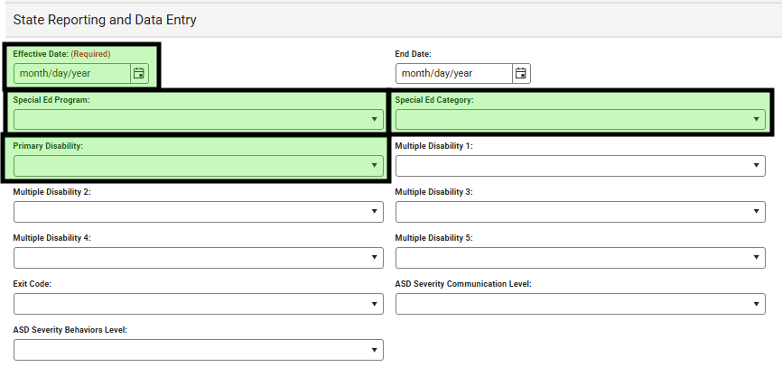

Required Data Elements for Upload School Districts

Student Enrollments
Upload districts must utilize the most current File Interface Specifications when uploading their Students with Disabilities December Child Count data into the State Edition. The more frequently upload districts complete an upload of your data, the more current your data will be in Infinite Campus State Edition. The link to access the most recent upload file specs is: Upload Wizard (South Dakota) | Infinite Campus. Please see the previous guidance provided regarding unique enrollment situations and guidance on Out of District Placements for Students with Disabilities.

Section IV – Certified Staff

Staff Members within Infinite Campus
As the South Dakota Department of Education continues to enhance our Statewide Longitudinal Data System (SD-STARS), it is important to make links for certified staff between different systems. To maintain FERPA compliance the SDDOE is requesting that all public-school districts populate the “email” field and birthdates for all certified staff member in Infinite Campus. To clarify, the SDDOE would like to have the highest possible match rate to ensure that a) we are identifying the right teacher for the right school and b) teachers are seeing the children they serve in the classroom.
The SDDOE has submitted an enhancement to have the birthdate field become a requirement for all staff members. We do not know at this time when the enhancement will be made available in Infinite Campus. Currently, we are asking you to enter or correct the birthdates for the staff members that are currently in your system.

Searching for a Staff Member
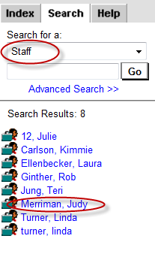
When the profile appears, open the Demographics screen and you will enter the birthdate and the e-mail address. Please enter the appropriate (school) e-mail address.
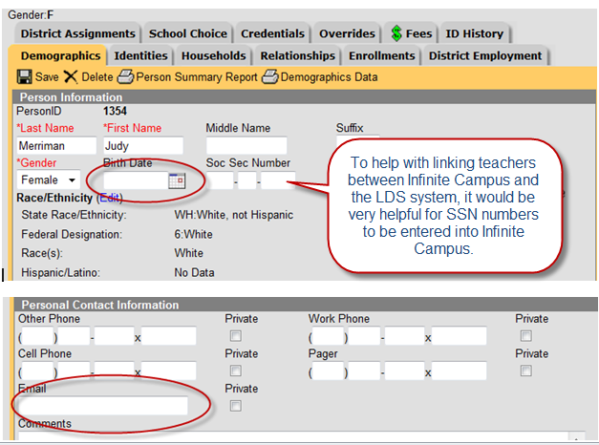

Former Students Who Are Now Staff Members or Parents
- Find the students State ID number and copy and paste that into the Comments Section on the Demographics screen. This way you will have it for your records.
- Go to their Census screen and take out the Local Student Number and save. If the Local Student Number is grayed out, you will need to submit a ticket to Support so they can update it on the backend.
- Go to their Enrollment record to see when their end date was for graduation and make that the end date as a member to their parent’s household.
- Go to the Relationships screen and uncheck all parent/guardian information to the former student and their guardians.
- Delete any doctor or emergency contact relationships from when the former parent was a student and no longer needed.
- You can keep the history of the parent household and the relationship history of parents/grandparents/siblings.
- If the former student has a new name go to the Identities screen and click on New and type in the new name and comment as to why.
- Make a new household for this former student and their new child and setup like any other household.

Section V – SD Infinite Campus Listserv
If you are not a member of the SD Infinite Campus Listserv, you can subscribe at: http://k12.sd.us/MailingList/ Scroll down and click on SD Infinite Campus from the Mailing List menu. Follow the directions given on how to subscribe to the SD Infinite Campus listserv.
This Listserv is a great resource in putting you in touch with your co-workers across the state who are also responsible for the student data within Infinite Campus. This is also the listserv that the DOE uses to communicate upcoming training opportunities, updates to the Infinite Campus system, etc.

