Staffing Instructions

Teachers/Administrators/Education Specialist

School Year 2022-2023

TABLE OF CONTENTS

Updating personnel records 2
No longer employed staff 18
Staff who change positions within the district 20
Adding an employee 21
Retention of Records 24
Attachment A–Updating Personnel Record Checklist 25

A personnel record is required to be submitted for ALL individuals employed in a position for which certification is offered through the Department of Education (DOE).
This includes all instructional, administrative and education specialist positions.

If a person is hired for a position for which he/she is certified through another agency or professionally certified and DOE also offers the certification (i.e., School Psychologist) please complete a personnel record form for these individuals.

If you have specific questions about whether an individual should be included, please contact Jantina at 605-668-2904.
School Districts who contract personnel through cooperatives or virtual providers in South Dakota should not report those personnel. Each cooperative/virtual provider is required to report their staff. The Division of Accreditation and Certification will check to make sure staff is properly certified.

Personnel data is collected from the following types of schools:
- Public School Districts
- State Special Schools
- Cooperatives and Multi-Districts
- Non-Public School Systems
- Alternative Programs
- Tribal/Bureau of Indian Affairs Schools
- Approved Virtual School Providers
  - Black Hills Online Learning Community,
  - DIAL,
  - NSU Center for eLearning, and
  - High Plains Alternative School

Updating Personnel Records
HELPFUL SUGGESTION:

Print the report “Report: By Staff Person (School Year 2019 and Beyond)” and select the criteria “2023”.

Use these printouts to review your updates before beginning the process of encoding the changes for 2022-2023.

It is recommended you staple this form with the Staff Position and Assignment Collection Form, which contains a blank record for those additional staff hired. This can be accessed at https://doe.sd.gov/prf/documents/22-SSS-Form.doc
Reviewing the Report

- The picture below is an example of what is included on the report.

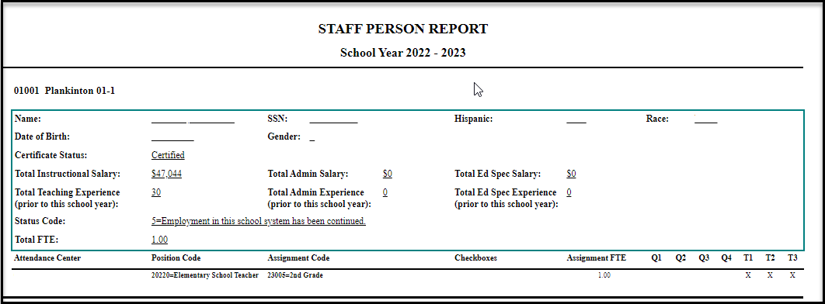

- Print the Report to view it better and using a red or blue pen, add the updates

- Areas that need to be reviewed and updated, if needed, in the staffing screen:
  - Race/Ethnicity
  - Total Instructional Salary
  - Total Admin Salary
  - Total Ed Specialist Salary
  - Total Teaching Experience
  - Total Admin Experience
  - Total Ed Spec Experience
  - Assignments
  - Checkboxes located in the Assignment Screen (filtered by assignment)

- Login to the PRF Database and select the Staffing -Teacher/Admin/Ed Spec Screen. Locate the below menus in the pane and then click on:

  - Actions
  - District Information
  - Staffing – Teacher/Admin/Ed Spec

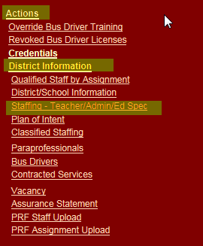

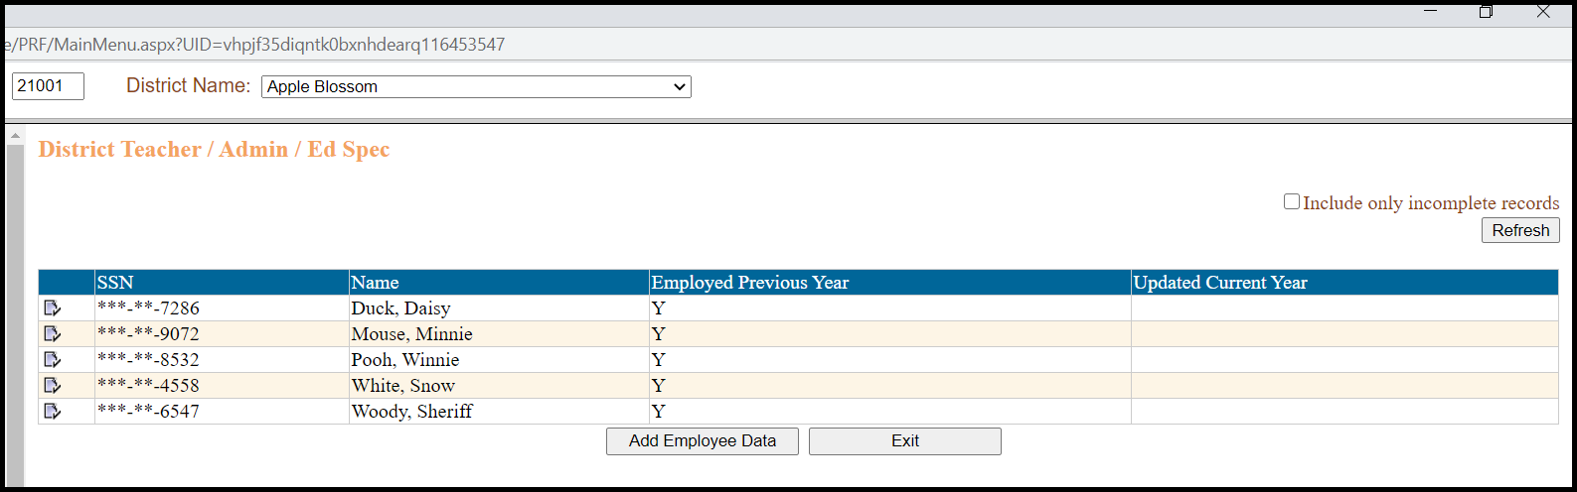
NOTE: A District has been created to use for testing and training. The names, social security numbers and other identifying information are not real people.

For large districts, a partial listing of your records is now an option. Below is an example:

- To update a person’s information, complete the following steps:

  - Click on the icon next to the person you need to edit.

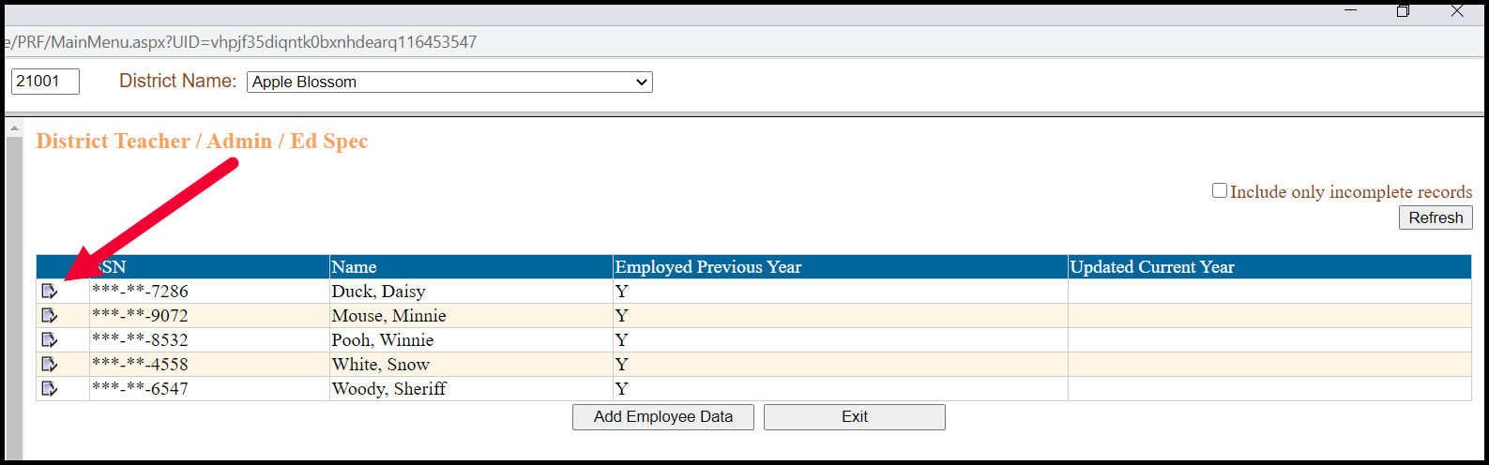

  - This will take you directly to the individual’s record. The information on the screen is pulled from the previous school year.

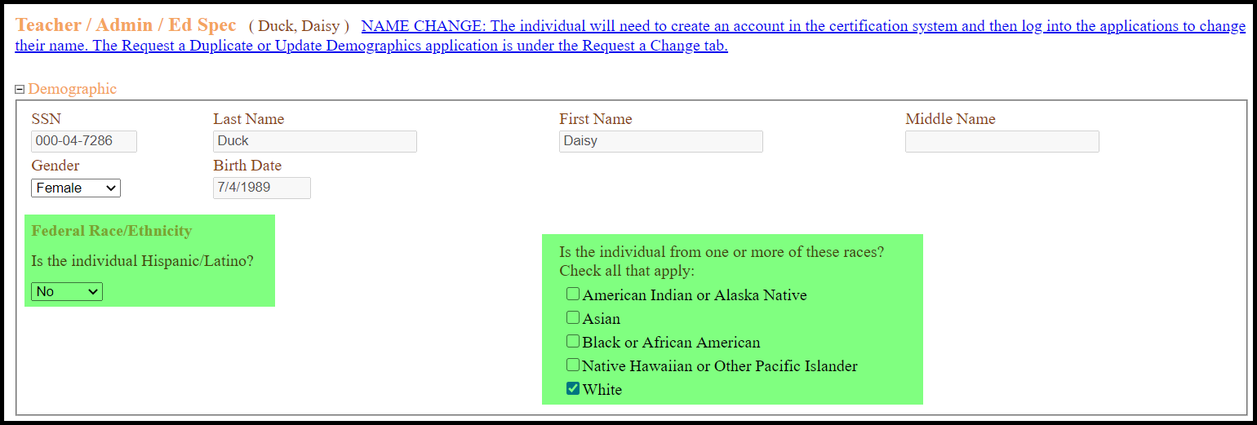

  - Demographic Information: If you click on the + symbol, the screen will expand so you can update the demographics if needed.

- If you previously completed the Race/Ethnicity question, there will be a plus sign by the Demographic information and you will not see the detailed information.

- Answer the question – “Is the individual Hispanic/Latino?" (Yes or No) and then select the Race. You should check all that apply.

- After the Race/Ethnicity is completed, click on the – symbol to minimize the screen.

  - Employment Information:

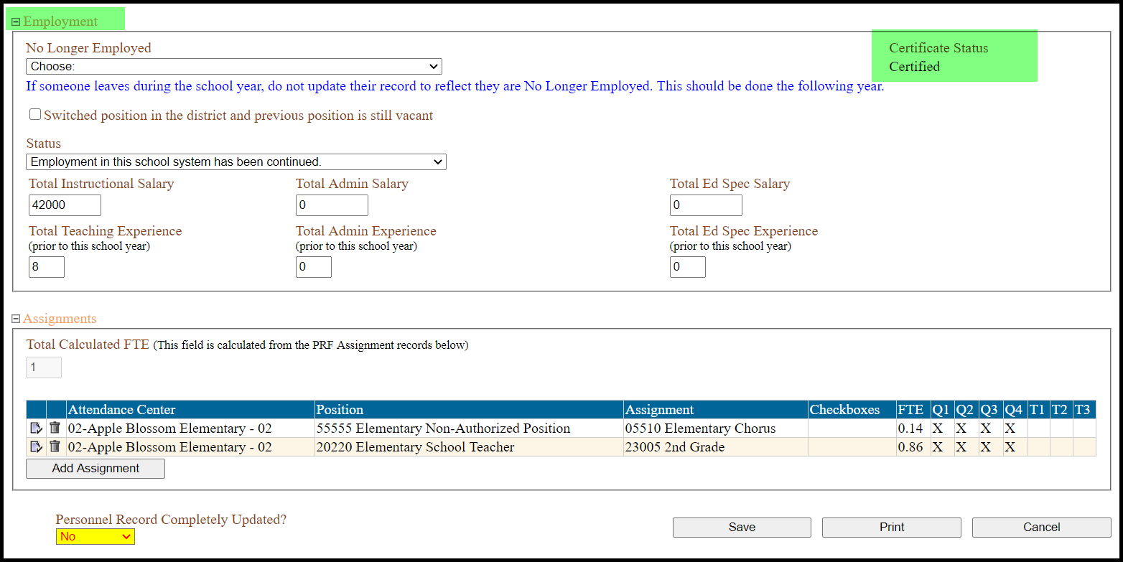

- Certificate Status: The certificate status identifies if the person has a valid certificate.

  - Certified means the individual has an active certificate.

  - Non-Certified means the individual does not have an active certificate. There are 4 reasons this could occur. You must ensure the individual becomes certified.

    - Reason 1: The staff person’s certificate expired on July 1st of the current year and has not been renewed.

You should follow up with the staff person to ensure they have applied for a renewal certificate.

- Between July 1st and October 1st of the year of expiration the renewal requirements remain the same, however beginning October 1st the renewal requirements increase to 6 transcripted credits.

    - Reason 2: The staff person’s certificate is invalid.

- If the individual has allowed their certificate to become invalid, and is not able to meet the renewal requirements, they must apply for a one-year non-renewable Temporary certificate. This will allow them to be considered certified while completing the renewal requirements.

    - Reason 3: The staff person has an alternative preliminary certificate.

- If you have hired someone who will be going through alternative certification you must make sure they have applied for alternative certification.

  - Step 1 of alternative certification is to apply for an Alternative Preliminary certificate. This allows the applicant to be hired by a district to go through alternative certification, but this certificate does not allow them to be considered certified.

  - Step 2 of alternative certification is to apply for the appropriate alternative certification route. Once they have received the alternative certification certificate, they will be considered certified for the school year.

    - Reason 4: The staff person is non-certified.

- All staff should have a certificate to be an administrator, teacher, or education specialist. In 2017, the certification rules were updated to include additional flexibilities for districts who are not able to fill a position requiring a certificate.

- A document outlining these options can found on the certification website at https://doe.sd.gov/certification/documents/Admin-FlexOptions.pdf.
- Below is a list of common occurrences when substitutes are hired and whether they need to be reported for this data collection:
Description | Submit a Long-Term Substitute Waiver | Personnel Record (PRF) Submitted for this Individual | Reason
Substitute hired to replace a teacher on maternity leave/FMLA for less than 45 days. | No | No | The teacher for whom the substitute was hired was reported on PRF and the substitute will be "temporary" and not hired for more than 45 cumulative school days.
Substitute hired to replace a teacher on maternity leave/FMLA for more than 45 days. | No | Yes | The teacher for whom the substitute was hired was reported on PRF and the substitute will be "temporary" and hired for more than 45 cumulative school days. The plan-of-intent will still say “temporary”, and the reason hired would be “long-term sub without waiver”.
Substitute with a valid or inactive teaching license hired to replace a teacher for more than 45 days. | No | Yes | The teacher for whom the substitute was hired was reported on PRF and the substitute will be "temporary" and hired for more than 45 cumulative school days. The plan-of-intent will still say “temporary”, and the reason hired would be “long-term sub without waiver”.
An individual acting as a teacher of record for no more than 45 cumulative school days in a vacant teaching position while a school district pursues a contract for a teacher | No | No | This person is not "replacing" an existing teacher but was hired for this teaching position with the intent of finding a certified teacher.
An individual without a valid or inactive certificate acting as a teacher of record for more than 45 cumulative school days in a vacant teaching position while a school district pursues a contract for a teacher | Yes | Yes | The plan-of-intent will still say “temporary”, and the reason hired would be “long-term sub with waiver”. If the PRF is closed, contact Jantina at 605-668-2904 to manually add a PRF record.
Teacher is sick for 3 days and substitute was hired. | No | No
Substitute replaces Teacher "A" for 23 days and then Teacher "B" for 22 days. | No | No | Substitute must replace the SAME teacher for 45 cumulative school days.
Substitute hired to replace paraprofessional. | No | No | State law defines a long-term substitute as a "substitute teacher" and "Other School Personnel" (i.e., paraprofessionals) are NOT teachers.

- Answer the question – “Is the individual Hispanic/Latino?" (Yes or No) and then select the Race. You should check all that apply.

  - Status Code is pre-filled to #5 if the person was reported in the PRF the previous year. If not, choose one of the following codes:

- New Employee: 1st year hired as a certified staff in any school district, in any state

- New Employee: Previously employed out of state

- New Employee: Previously employed in another SD School District

- New Employee: Has been absent from field of education 1 or more year(s)

- Employment in this school system has been continued

- Re-employed in a school district following an absence of 1 year or more
  - Total salary must be reported as instructional, administrative, and education specialist (whichever is appropriate).

- DO NOT INCLUDE BONUS MONEY, LONGEVITY PAY, EXTENDED CONTRACT PAY, STIPENDS AND EXTRA-DUTY PAY. Note: These are not used when calculating salaries, average salaries, etc.

- Round all salaries to the nearest whole dollar.

- If there is not yet an agreement regarding salaries (impasse), report the salary they were paid last year and notify Jantina Nelson-Stastny when you will update your records.

- If an administrator also teaches a course, the breakout of the instructional salary and the administrative salary should reflect the actual salary for each job responsibility. The administrator is paid on a schedule higher than the instructional staff, so don't allocate the salary by a simple percentage. You need to determine the full-time salary schedule for a teacher by the bumps for "step and lane" increases so you can determine what percentage is instructional pay and then put the rest in administrative pay.

- If the athletic director also teaches a course, the breakout of the instructional salary should be the only salary accounted for in the PRF.

NOTE: If the instructional staff are given periods during the school day to carry out classified duties, you do not include this time or salary on the PRF staffing screen. For example, if someone is an athletic director and teaches two courses for two periods in the day, you should account for the instructional time and the salary for only those two courses.

- If a teacher has unpaid leave days but is returning to the district to teach, a district should NOT adjust the contract salary amount reported to the actual cost to the district.

- Salary step increases should be reflected in the PRF database

- If you received a conditional waiver from the School Finance Accountability Board and paid out additional funds to your teachers, you must update the personnel record forms to include the additional contract amounts.

Only report years of experience PRIOR to the 2022-2023 school year.
  - Total experience must be reported as instructional, administrative, and education specialist (whichever is appropriate). Update the years of experience. Years reported should not include current school year!

- Total Instructional Experience: Total years of classroom teaching experience with actual instructional time in front of the class, prior to this school year. This should include time teaching at another district or school.

If a part-time principal and part-time teacher, count one year instructional and one year administrative.

Include years of experience for Alternative Certification to count towards the years of total "teaching experience”.

Do not include years as a long-term substitute as years of service.

- Total Administrative Experience: Total years as an administrator prior to this school year including CEO.

If full-time principal and teach 1 class, count one-year administrative experience and one-year instructional experience.

- Total Education Specialist Experience: Total years as an education specialist prior to this school year.

  - Total Calculated FTE - This field will be automatically calculated. An FTE of greater than 1.00 is not valid. Please be sure to check this FTE before saving your record.
NOTE: Do not change the question - Personnel Record Completely Updated? to a Yes until all assignments for this staff person have been updated.

  - The Assignment Screen Summary provides basic information about all assignments for the staff person.

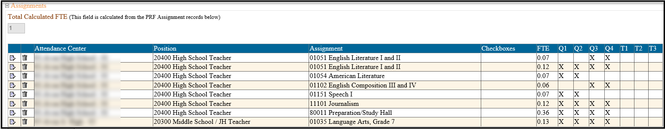

  - This includes:

    - Total Calculated FTE (automatically calculated)

    - Attendance Center

    - Position Code

    - Assignment Code

    - Checkboxes

    - FTE

    - Quarters or Trimesters

  - To enter the person's class assignment, click the "Add Assignment" button.
NOTE: If the person you are updating was reported last year, their assignment information will be pre-filled.

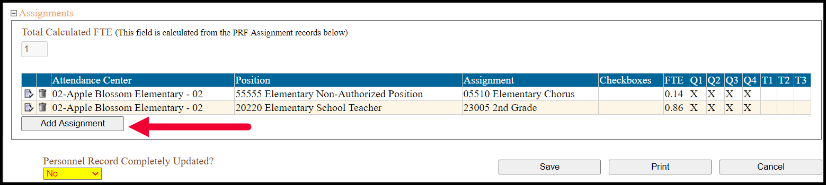

  - Below is a picture of the Assignment Information Screen. The checkboxes listed on the right side of the picture varies, depending on the assignment selected.
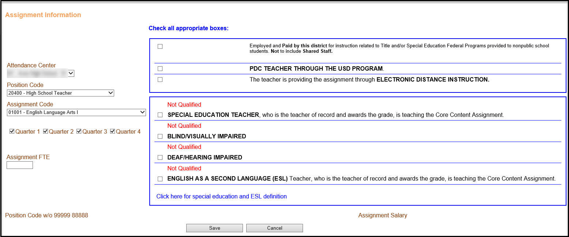

  - To add an Assignment:

- Select the appropriate Attendance Center
- Select the appropriate Position Code
- Select the appropriate Assignment

Note 1: When entering the assignment code, if you do not see the assignment code you are wanting to add, this means the person is not authorized to teach that assignment. You must select the Position Code of Non-Authorized and then all assignments will be shown. This will trigger a Plan of Intent for most assignments.

Note 2: A Title I Teacher/Interventionist is defined as a teacher who provides supplemental instruction and interventions based on student’s needs in the areas of reading, language arts, and math.

In a Title I Schoolwide Program or Title I Targeted Assistance Program, staff providing interventions should be coded as one of the following options:

• 26001 Elementary Title/Interventionist

• 26002 Grades 5-8 Title/Interventionist

• 26003 High School Title/Interventionist
In a non-Title I school, staff providing interventions should be coded as one of the following options:

• 26004 Elementary Interventionist

• 26005 Grades 5-8 Interventionist

• 26006 High School Interventionist
Note 3: The code ‘99999’ should be used for dual credit/concurrent credit courses. This only applies to situations where the teacher is employed by the school district but is offering coursework from a Postsecondary Institution (university or technical school). These types of courses typically have a teacher that has signed an agreement with the Postsecondary Institution. The agreement ensures the teachers meets the certification requirements for the Postsecondary Institution and the credit s applied at both the secondary and postsecondary level.

Note 4: If you are receiving an Electronic/Distance class offered by another district and have someone monitoring the classroom, report the time for this individual with an assignment code of E-Mentor.

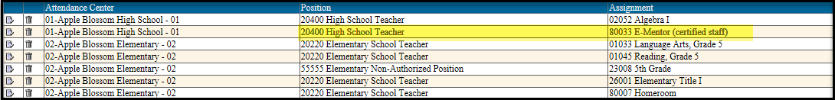

Note 5: Elementary teachers in departmentalized setting should be counted like the middle and secondary teachers and thus be given a Study Hall/Preparation period in addition to the subjects they teach.

Elementary teachers in a self-contained setting should be listed as only self-contained (1st grade, 2nd grade, etc.) and no study hall/preparation period should be added.

Note 6: Preschool teachers should be listed as 23002 Pre-kindergarten. You should not multi-grade list preschool teachers as teaching in a combination room or junior kindergarten. There are no certification requirements for pre-school teachers and the system will not generate a plan of intent.

Note 7: Reminder: Assistant Superintendents and Assistant Principals must be certified, or a plan of intent will be triggered.
- If the position evaluates the effectiveness of teachers, then they need to be coded as assistant principal and work toward licensure.
- If the position assigns suspensions for disciplinary reasons, then you can list them under Classified as "Other District Administrator”.

Note 8: Holders of a CEO permit may not complete teacher evaluations or be designated as a superintendent, assistant superintendent, principal, or assistant principal.

Note 9: If the position isn’t a librarian but work with other teachers only, you can code them as Library/Media Support Staff under “Classified”. If the position isn’t a librarian but work with students, then code then as a paraprofessional with the job duty of “Provide Instructional Support in a Library or Media Center”.

  - Quarters or Trimesters: The quarters or trimesters will be pre-filled. Click on the button if you need to remove a quarter or trimester (i.e., teaches a course the first and second semester).

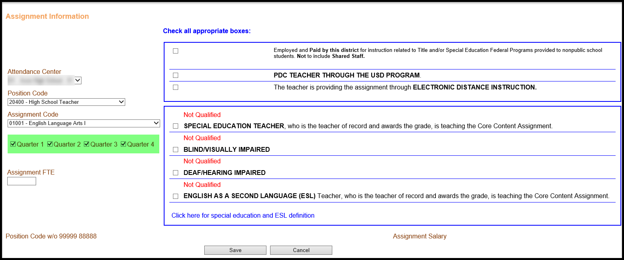

Note: Quarters or Trimesters will be displayed based on what your school uses. The academic term must be selected to coincide with each assignment. Examples include semester, trimester, or quarter.

- Assignment FTE is based on the Full-time equivalency of the position.

FTE (full-time equivalent) is a way to measure the number of hours required to perform the work. One definition of FTE indicates it is the number of working hours that represents one full-time employee during a school day and a school year. It is also defined as a unit that indicates the workload of an employed person in a way that makes workloads comparable across various contexts.

    - How to report FTE: Report staff in terms of FTE (full-time equivalent). FTE should be counted in hundredths. For example, if a teaching position is filled by four people, each working the same amount of time, each person would count as 0.25 FTE. The total FTE counts for instructional staff must be reported to the nearest hundredth, with an EXPLICIT decimal (e.g., 59.20).

    - How are teachers reported who work at multiple schools during the school year? A district may choose to either associate the full FTE at the school where the teacher spent the majority of their time, or they may divide the FTE across the schools where they spent their time based on the proportion of time spent at each school for shared employees.

    - An individual staff member’s total FTE can exceed 1.00 overall at the state level. For example, if FTE is defined as a 40 hour week, and a teacher teaches 40 hours at one school each week and an additional 4 hours teaching elementary/ secondary classes at a virtual school, that teacher’s total FTE would be 1.10 (44 hours / 40 hours) and the teacher would be counted as 1.00 FTE at the first school and 0.10 FTE at the virtual school.

    - If a staff member has more than one assignment, count the staff member in terms of the assignments. An assignment could be a school, a position, or a teacher category. For example:

        - If a school staff member worked three-quarters of the time as a teacher, and one-quarter of the time as a librarian, he or she would be counted as a 0.75 teacher FTE and a 0.25 librarian FTE.

        - If a teacher teaches both prekindergarten and kindergarten, his/her total FTE should be proportionally divided between those two teacher categories (PKTCH and KGTCH). Similarly, if a state or an LEA offers both prekindergarten and kindergarten, but does not distinguish between PK and KG teachers, the total FTE for these two categories should be divided proportionally between them.

CHECKBOXES: The options that show on the screen are based on the assignment selected

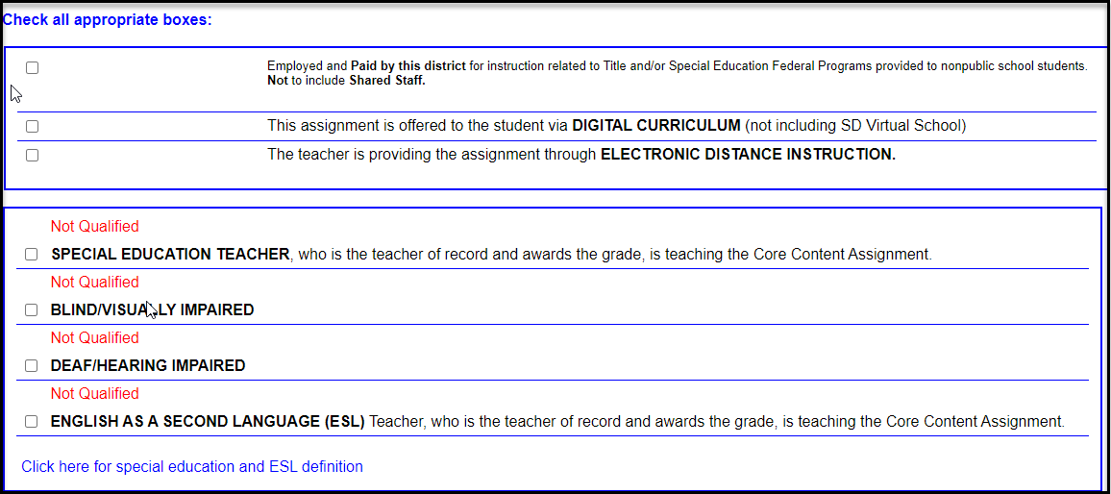

Checkbox: Employed and Paid by this district for instruction related to Title and/or Special Education Federal Programs provided to nonpublic school students. Not to include Shared Staff:
This box should be checked when a district sends one of their paid employees to another district/school to provide an assignment. An example is when a district employs a teacher, paid with Title funds, to teach the assignment at a Private School.

For example, students enrolled in nonpublic schools attend public school for title services. Some public school uses their Title I funds to pay for transportation instead of the teacher carrying out the assignment at the nonpublic school. Take for example; a teacher that is employed and paid by “Apple Blossom”, but their assignment isn’t carried out at Sacred Heart. For Title I purposes, that teacher is employed to provide services to private school Title I students. The public school district needs to show the teacher is providing services to private school students as it is part of the district’s Title I responsibility.

Checkbox: This assignment is offered to the student via DIGITAL CURRICULUM (not including SD Virtual School):

This code should be checked when a district offers a class through the purchase of a specific online curriculum (Example – Edgenuity, Time4Learning, etc.). The digital curriculum does not provide a teacher to work with the student, therefore a state certified teacher in the content area should be identified as the teacher of record who is providing instruction. This does not include South Dakota Virtual School.

Checkbox: The teacher is providing the assignment through ELECTRONIC DISTANCE INSTRUCTION:

This should be checked when the teacher is providing the instruction to a class located in another district or attendance center. If this is checked then you will need to identify the district and attendance center which is receiving instruction via electronic distance education.

Checkbox: Assignment carried out at another District/School and the salary of the staff person is paid by the "Receiving District":

This box will be seen only by Cooperative/Multi-Districts and should be checked when the Coop employs a staff person who goes to other districts to provide services through a 3rd Party Contract. Previously, many of these assignments would have been collected in the SPED Contracted Services Screen and encoded by the "receiving district". Choose the district and school the teacher will be providing services to and click ‘Save’.

The following checkboxes determine whether the person is endorsed for the assignment:

Checkbox: Special Education Teacher:

A check in the SPED box reflects the assignment is being taught to Special Education Students and requires the teacher to be certified in the content area and special education.

        - Assignment Code is the content assignment

        - You will only check the SPED box if the teacher is providing case management services to the special education students in addition to teaching the core content subject.

Checkbox: Blind/Visually Impaired:

Blind/Visually Impaired Teacher, who is the teacher of record for the assignment and awards the grade.

Checkbox: Deaf/Hearing Impaired:

Deaf/Hearing Impaired Teacher, who is the teacher of record for the assignment and awards the grade.

Checkbox: English as a Second Language (EL):

EL Teacher, who is the teacher of record and awards the grade, is teaching the assignment.

Once you enter your staff total instructional or administrative/education specialist salary along with the FTE, the system will reflect the wage per assignment.
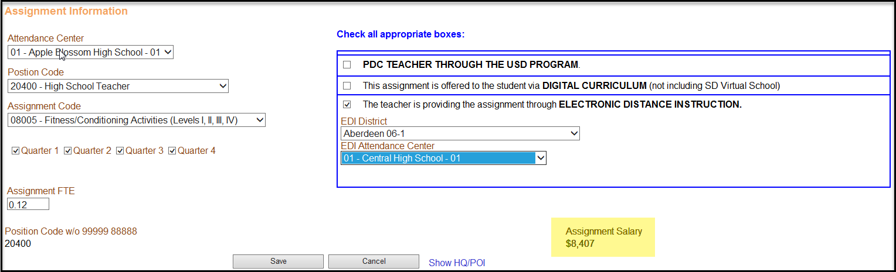

- Click Save

- Continue with the above steps if you need to enter another assignment.

  - To Edit an Assignment click on the icon on the far left of the assignment.
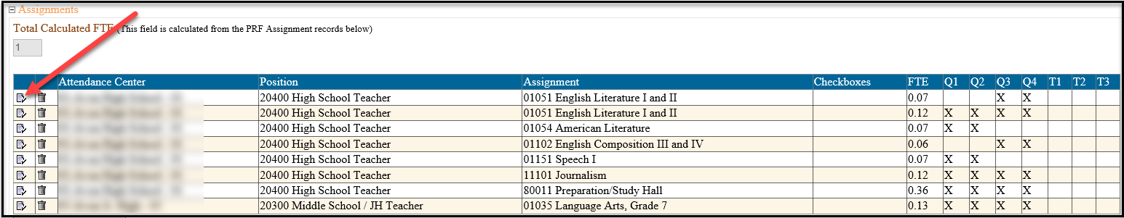

- Adjust the FTE by assignment and Click on Save.

  - To Delete an Assignment click on the icon of the trash can next to the assignment you want to delete.

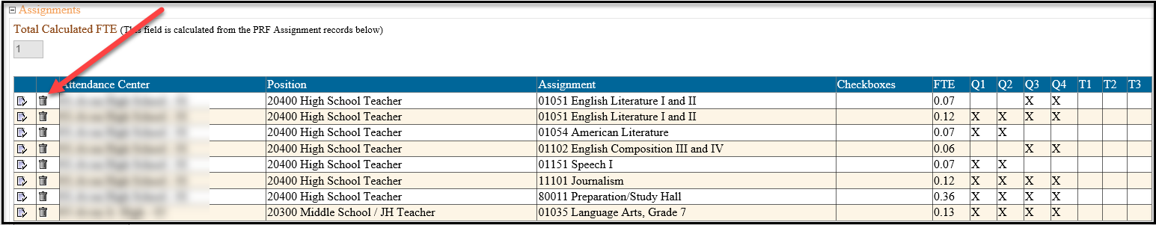
- Click on Save.
No Longer Employed Staff

- For all staff employed during the 2021-2022 school year but are “No Longer Employed” for the 2022-2023 school year you should select the appropriate reason.
- It is recommended you have a list of all employees from the previous year who are No Longer Employed and complete them at one time. You can use the No Longer Employed Data Collection Form to help gather the needed data. This is located on the PRF website at https://doe.sd.gov/prf/documents/STAFF-NotEmpl.doc.
NOTE: If someone leaves during the school year, do not update their record to reflect they are No Longer Employed. This should be done the following year.

- After selecting a no longer employed code, you will need to fill in whether this vacant position was filled the first day of school. To provide accurate information to the legislature and the Teacher Compensation board, it is critical that districts choose the most appropriate reason for the vacancy.
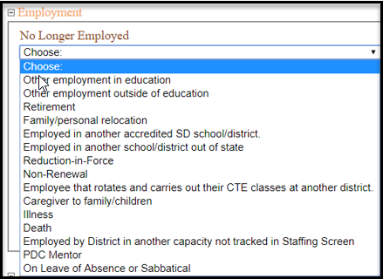

  - Yes, it was filled (this includes rotational courses). For employees that rotate and carry out their CTE classes at another district every other school year, do not mark them as vacant.
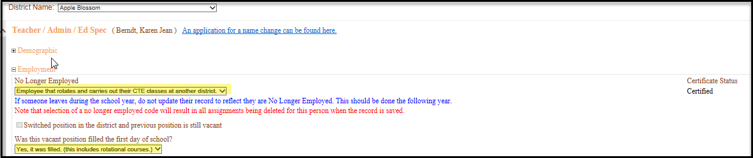

  - No, it was left vacant.

    - If you select “No, it was left vacant”, then you will need to select the decision that was made because of the vacant position.

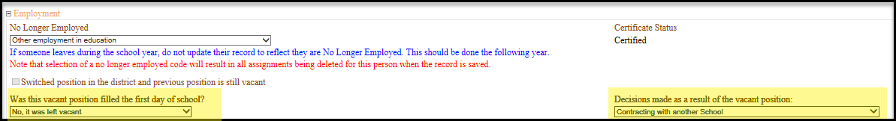

- After completing this data field, indicate the personnel record form has been completely updated and Click on the Save Button. There is no need to update any other fields unless the employee has 0 years of experience. In this case, the system will require you to enter years of experience before it will allow you to save.

- By doing this, you create a record in the “Vacancy” menu. You can access this menu by clicking on the Vacancy Screen.

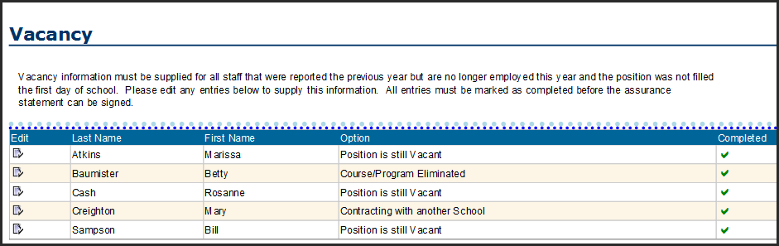

Staff who change positions within the district:

If you have a staff person who continues to be an employee in the district, however has changed jobs, you will need to check the box “Switched position in the district and previous position is still vacant”. This box should be checked if the employee received a promotion or accepts a different position in the district. An example is if a teacher was a self-contained 5th grade teacher and becomes a Special Education teacher.

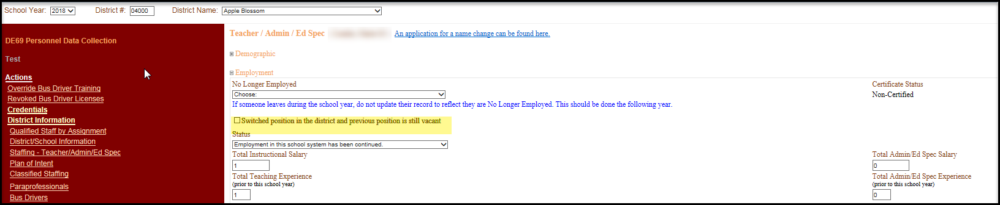

Once you check the box, the below answers will automatically fill in for the two questions regarding the previous position.

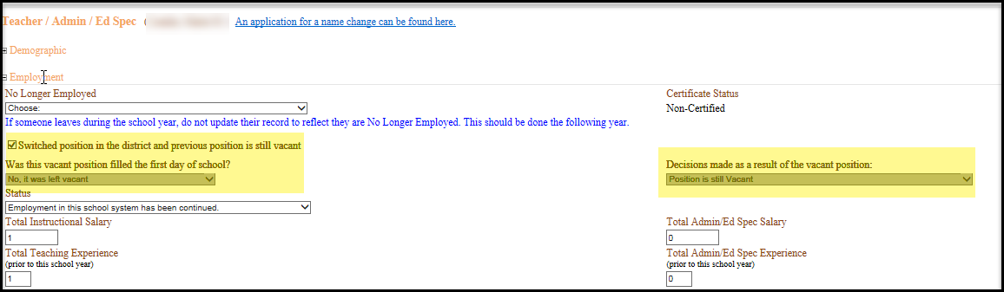

Personnel Record Completely Updated?

- After completing all data fields, indicate that the personnel record form has been completely updated.

- Click on the Save Button.

- Continue editing other personnel.
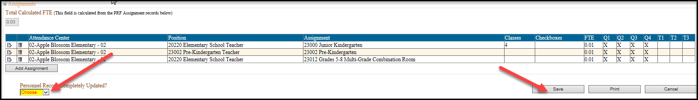

NOTE: Do NOT complete this field until you have updated the entire record including the assignments.

Adding an Employee

Many of the steps are similar to editing an employee.

- Login to the PRF Database and go to the Staffing – Teacher/Admin/Ed Spec Screen:
  - Actions
  - District Information
  - Staffing – Teacher/Admin/Ed Spec

- Click on the "Add Employee Data" button. 

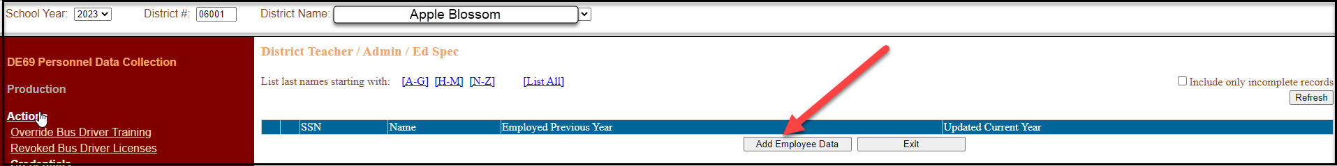

- Add the Employee Social Security Number

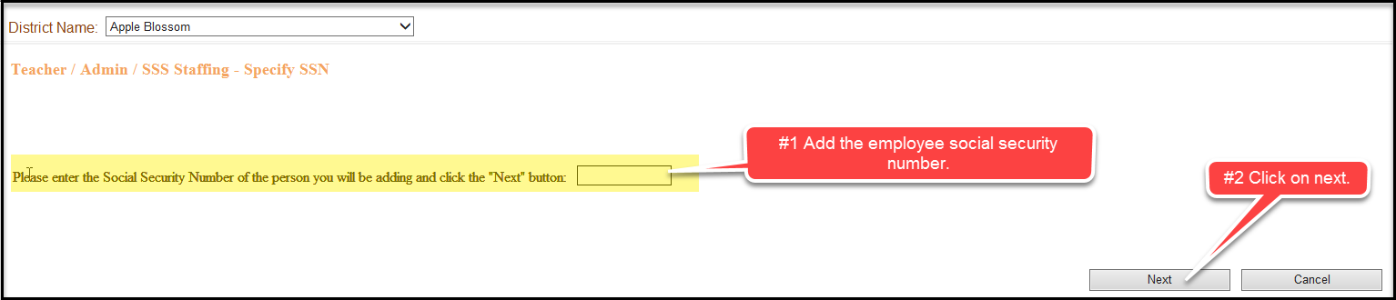

NOTE: If the system does not recognize the SSN and you know the staff person has a certificate, stop and determine if the SSN is correct. If yes, have the staff person contact the Office of Educator Certification to determine if the SSN associated with their certificate is incorrect.
- Click on Next

- Data Fields

- If the person has an active certificate through Office of Educator Certification (EX: Teacher, Administrator, Education Specialist, and Educator Permit), the personal data fields will be completed for you.

- If this person does not currently have an active certificate through Office of Educator Certification (EX: School Psychologist who is licensed through a Board other than Department of Education), you will be required to enter the personnel data fields.
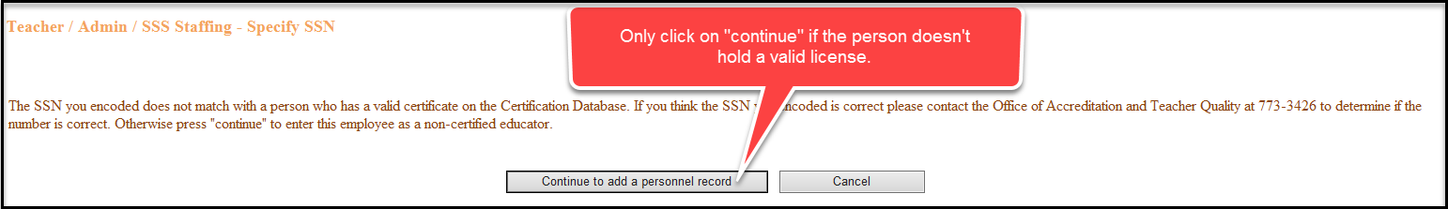

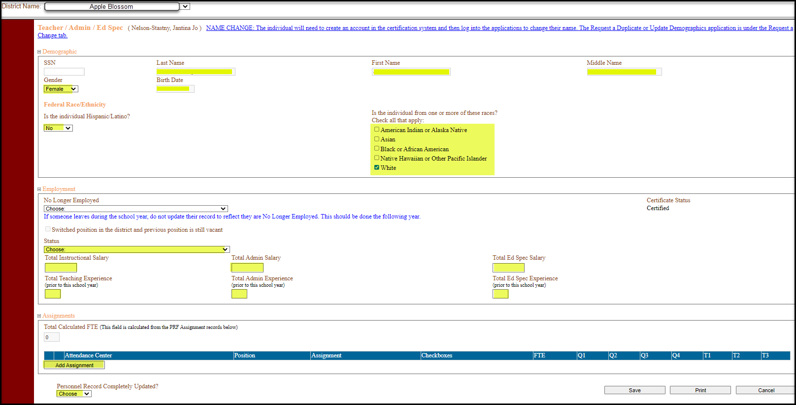

  - From this point forward, follow the directions for updating employee data.

- Continue the above steps to add another new employee.

Retention of Records

The local school’s retention manual was revised at our December 12, 2013 Record Destruction Board Meeting. Here is the new link to the REVISED retention manual for Local Schools.

https://boa.sd.gov/central-services/records-management-polSubRetentionManuals.aspx

The retention for Personnel Files was changed from destroy 2 years after termination to destroy 3 years after termination.

SCL-80. PERSONNEL FILES: 13-012
This series contains a folder for each employee in the school district. Information may include, but is not limited to: application for employment, personal data sheet, personnel action notices, position description questionnaires, authorizations for payroll deductions,
letters of reprimand and commendation, resume', service record, notice of resignation, W-4 forms, I-9 forms, transcript, teacher's certificate, performance appraisals, teacher evaluations, and supervisor's report of employee separation. The record series serves as a history of the employee's service.

RETENTION: Retain current employee files in office. Transfer terminated employee files to storage for 3 years. Destroy by shredding 3 years after termination provided sufficient data on hours worked and compensation received has been maintained by the school district; and no litigation or grievance is pending.

(Note: Review files at least once a year to avoid a build-up of
superseded or obsolete material.

If you have any other questions, please contact Dana Hoffer at (605)773-3589.

ATTACHMENT A
UPDATING PERSONNEL RECORDS CHECKLIST

- Review the previous year’s report – “Report: By Staff Person” and add additional required information which can be collected using the Staffing Collection Document.

- Identify if the following information is correct for each individual and collect what is missing or has changed.

  - Race/Ethnicity field is mandatory. This field should be updated if it was not completed last year.

  - Review Certificate Status

  - Instructional Salary

  - Admin Salary

  - Ed Specialist Salary

  - Total Teaching Experience

  - Total Admin Experience

  - Total Ed Specialist Experience

  - Assignments

    - Review the listing of Assignment Codes and make sure they reflect the correct assignments being taught.

    - Review the FTE per assignment to ensure they are correct

    - Review SPED, EL and other checkboxes

- Open the PRF Database and go to the Staffing – Teachers/Admin/Ed Spec Screen and click on the icon by the employee that should be edited.

- Update Total Instructional Salary, Total Admin Salary, and/or Ed Specialist Salary

- Update Total Teaching Experience, Total Admin Experience, and/or Total Ed Specialist Experience

- Update all Assignments

  - Review Attendance Center

  - Review Position Code

  - Review Assignment Code

  - Review Quarters/Trimesters

  - Put a check in the appropriate check boxes.

- Personnel Record Completely Updated should be changed to Yes.

