Updates to the Personnel Record Form (PRF)
School Year 2025-26

📢 State Department Certificate Expiration Notification Update

• What’s Changing:
The State Department will no longer send mailing lists of expiring certificates to districts.

• New Process:
A certificate expiration report is now available directly on the district portal.

• Action Required:
You can access this report to identify staff members with certificates expiring on July 1, 2026.
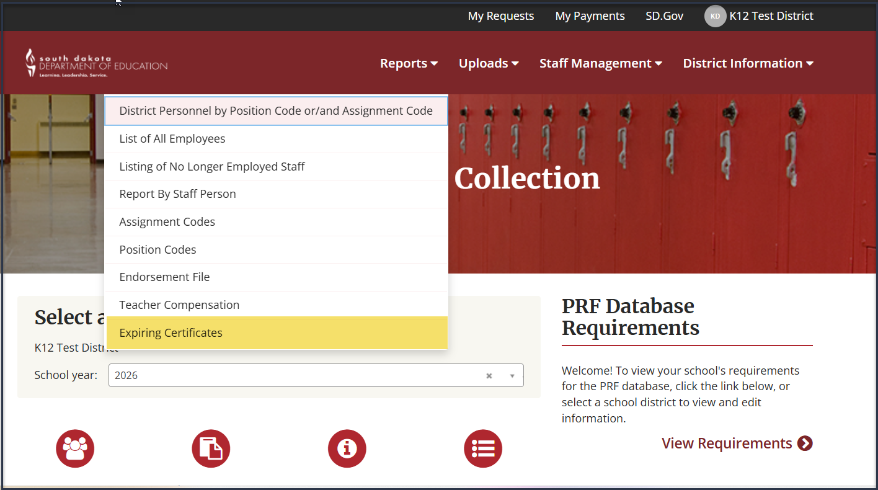

• Why This Matters:
This change:

Enables direct and immediate access to expiration data

Reduces reliance on the certification office

Aims to streamline and improve efficiency in tracking certifications

• Recommendation:
Visit the district portal to locate the report and review the staff who will need to renew.
The earliest recommended renewal date is January 1, 2026, to avoid losing a year on the renewal cycle.

📝 What’s Changing for Paraprofessionals?
- The ParaPro test is being updated to the new ParaPathways.
- During the transition period, candidates can choose to take either test.
- Both tests meet federal requirements for paraeducators working in Title I-supported programs.

✅ Important Notes
- Not all paraeducators are required to take this test.
- Passing the test is NOT required for certification.
- For questions about federal para qualifications, contact Jordan Varilek at jordan.varilek@state.sd.us.

🎁 Incentives (Sept. 1 – Dec. 31, 2025)
- Free testing for all candidates.
- Free Interactive Practice Test included.
- District and candidate incentives available for early participation

🆕 Assignment Code Changes
- Disabled Code:
  - 80011 – Preparation/Study Hall
  - 80034 Study Skills (K-12)
- New Codes:
  - 04112 – AP African American Studies
  - 01013 – English 10: AP Seminar
  - 22006 – Preparation/Study Hall (replaces 80011)
  - 22003 Study Skills (K-12) (replaces 80034)

