CLASSIFIED STAFF

School Year 2022-2023

TABLE OF CONTENTS

Adding a New Position 2
Editing an Existing Position 5
Position/Titles/Codes for Staff 6
Running a Report 17
Personnel information is part of the annual fall accreditation reporting process. The personnel included in Classified Staff are staff not required to be certified through Department of Education but may obtain licensure through another entity. This menu will only be available to the following districts:

- 10-Public School Districts
- 40-Cooperatives and Multi-Districts
- 80-State Special Schools

Accessing School Personnel Staff
- Open the PRF and Click on:
- Actions
- District Information
- Classified Staff

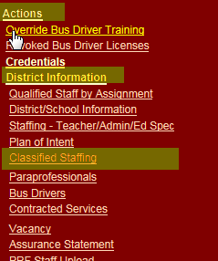
- You will see the following screen. If your district continues to employ classified staff, then select yes as this shows that you agree to enter these staff. However, if your district no longer employs classified staff, select no.
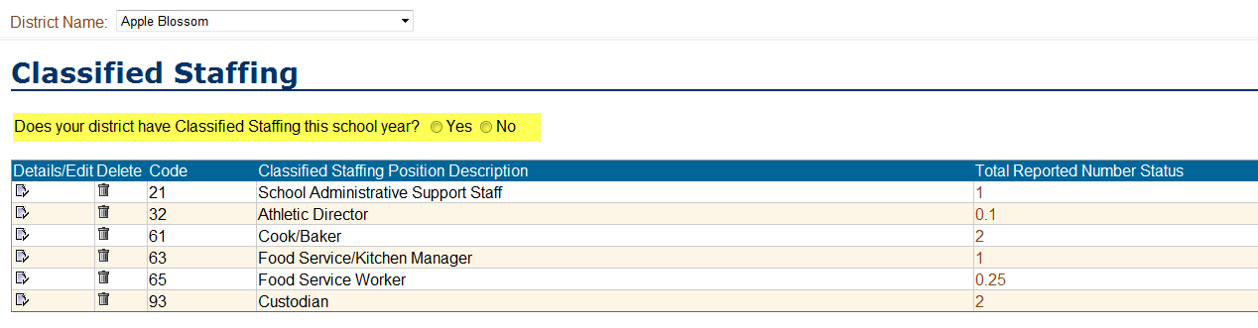

Note: Information from the previous year is pulled into the database for the current school year. You can do the following:
- Add new Positions Codes
- Edit previous Position Codes
- Delete Position Codes you no longer use.

- Adding a new Position

  - Click the Add Button

  - You will see the following screen

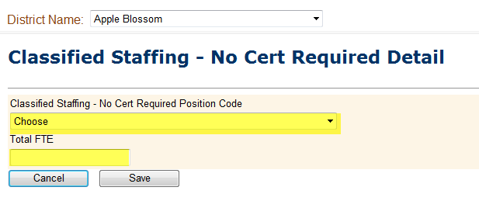
  - Click on the Classified Staffing Position Code drop down box.

  - You will see a list of options similar to the list below.

The list you see will include only those positions which have not been previously selected in your Classified Staffing List. For example, if Athletic Director was added the previous year and was pulled into the current year’s list, then you would not see it when you click on the Add Button.
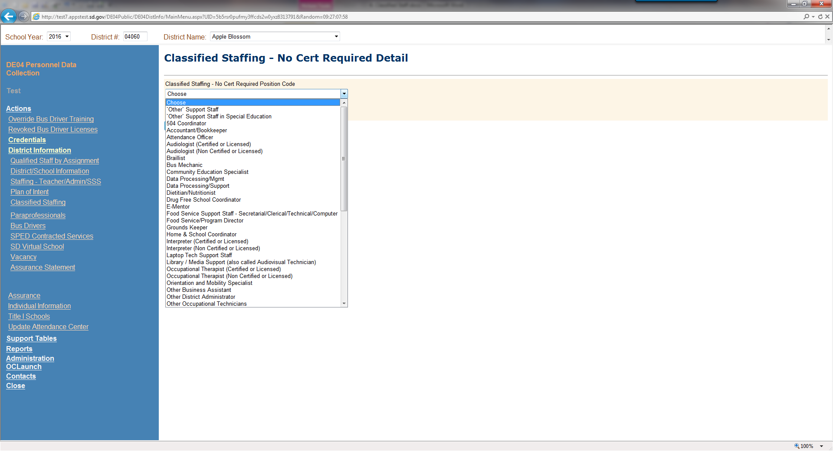
A description of each position is listed on Page 6.

- Select the correct code for the position

- Add the Total FTE

NOTE: The Total FTE Counts for staff categories must be reported to the nearest hundredth.

- Count part-time staff in terms of full-time equivalency (example = 0.50 is half time)

- A Full-time employee having more than one assignment should be counted in terms of full-time equivalency for each assignment.

  - Example: Person assigned 6 hours per day as a bus mechanic and 2 hours per day as a custodian = 0.75 for the bus mechanic position and 0.25 for the custodian position.

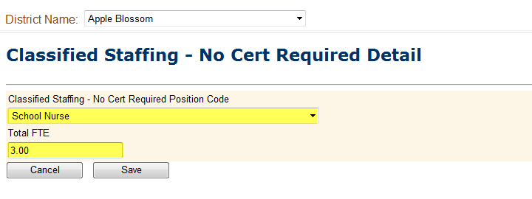

- Click Save.

- The information will be added to the Classified Staffing List. Note: If you click on a column heading it will put it in ascending/descending order.

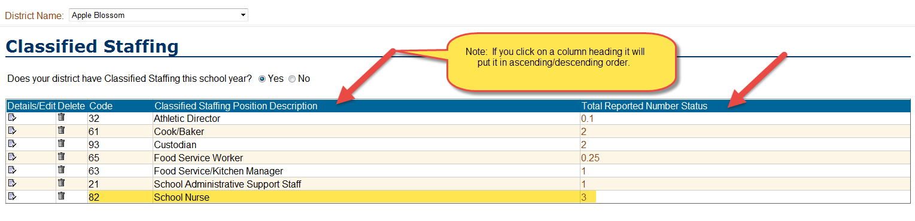
- Editing an Existing Position

  - Click the icon that looks like a piece of paper

  - You will see the following screen

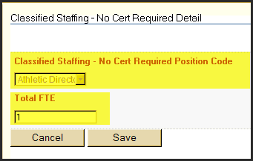

  - The system will not allow you to change the Position, but you can change the Total FTE.

  - Click Save.

  - Continue the above steps to update the position FTE for ALL positions reported last year.

Position Titles/Codes for Staff Not Required to be Certified

Guidance on who to Include/Exclude as Classified Staff

- Include only positions that are filled during the school year
- Exclude Contract Positions
- Exclude Paraprofessionals (they are coded to the Paraprofessional Screen)
- Exclude Vacant Positions
- Exclude Volunteers
- Exclude staff that work outside the hours of a regular school day
  - An example is an after-school program.

  - Another example is someone is assigned bus mechanic during the school year and custodian in the summer they should be reported only for the bus mechanic position.
Position Titles/Codes for Classified Staffing

- Library/Media Support Staff
Staff members who render other library or media services, such as preparing and caring for and making available to members of the instructional staff the equipment, films, filmstrips, transparencies, tapes, TV programs, and similar materials (whether maintained separately or as part of an instructional materials center).

  - 11 – Library/Media Support Staff
    - If the position isn’t a librarian but work with other teachers only, you can code them as Library/Media Support Staff under “Classified”.
    - If the position isn’t a librarian but work with students, then code then as a paraprofessional with the job duty of “Provide Instructional Support in a Library or Media Center”
- District Administrative Support Staff
Staff members who provide direct support to school district administrators, business office support, data processing, secretarial and other clerical staff.

  - 21 – School Administrative Support Staff

  - 24 - Data Processing/Mgmt

  - 25 - Purchasing Agent
Prepares annually a schedule for receiving bids during the year and advises
principals and department heads of appropriate deadlines.

  - 26 - Warehouse Administrator
Processes incoming deliveries, stocks shelves, picks orders and prepares for
delivery to buildings.

  - 31 - Accountant/Bookkeeper
Prepares bank deposits. Maintains cash book. Maintains accounts receivable records. Prepares all billings. Maintains cash receipts records. Balances cash. Prepares and enters journal entries. Prepares cash reports for Board meeting. Assists in reconciling bank statements. Prepares monthly financial statements. Posts payroll to the general ledger. Prepares portions of finance report. Keeps log of bad checks and prepares collection letters. Maintains advance pay checking account. Prepares expense vouchers. Audits deposits from other departments. Posts budget transfers. Advises Accounts Payable clerks on problems. Audits petty cash claims. Prepares year-end journal entries. Closes books for the year.

- District/School Administrators
Staff members who provide administrative duties with the district such as fiscal, human resources, etc. Also include individuals with district-wide responsibilities, such as professional instructional support staff.

  - 30 - Testing/Assessment Coordinator
Coordinates and supports all district and state-mandated assessments.

  - 32 - Athletic Director
Coordinates activities within the building

  - 33 - Other Business Assistant

  - 34 - Program Director/ Supervisor
Serves as program supervisor of district wide agency programs.

  - 35 - Program Director/ Supervisor Assistant
Serves as assistant program supervisor of district wide agency programs.

  - 37 - "Other" District Administrator
    - If the position evaluates the effectiveness of teachers, then they need to be coded as assistant principal and work toward licensure.
    - If the position assigns suspensions for disciplinary reasons, then you can list them under Classified as "Other District Administrator”.

  - 42 – RTI Coordinator (works with Staff)

- School Administrative Support Staff
Persons whose activities are concerned with support of the teaching and administrative duties of the office of the principal or department chairpersons, including clerical staff and secretaries.

  - 41 - School Secretary
Handles the Accounts: balances money, deposits, writes checks, writes receipts, and sends collection letters. Schedules and supervises the office staff and trains new clerical staff. Answers phones, assists visitors at counter, and takes messages. Orders office supplies and publications. Prepares letters, memos, handbooks, and other communications. Opens and sorts mail. Assists with office equipment, troubleshoots problems with fax machine, copier, and printers. Attends staff meetings and takes attendance. Provides care/first aid for students with injury and/or illness. Provides care for students with chronic health conditions, in accordance with student’s care plan as delegated by the school nurse. Processes student immunizations in accordance with SD state law and district procedures.

- Food Service

  - 61 - Cook/Baker
This employee is directly responsible for preparation of food items. Minimal amount of time spent on record keeping. Reports to manager or director.

  - 62 - Dietitian/Nutritionist
Licensed nutritionist or registered dietitian involved in menu planning and/or oversee program administration or operation.

  - 63 - Food Service/Kitchen Manager
This employee is responsible for one physical preparation or service site. Reports to a director/administrator in systems with more than one physical site. In large single-site operations, reports to other administration. Main portion of work is administration.

  - 64 - Food Service/Program Director
Single person at district/school responsible for supervision of food service related activities at more than one physical preparation and/or service site or at single-site operations has been given responsibility and authority for total operation of food service program. May or may not be considered part of “administrative team” at district level. Titles might include nutrition or program director, dietitian, etc.

  - 65 - Food Service Worker
Time is spent on various food service responsibilities that may be combined including serving, assisting cooks, dishwashing, janitorial, and/or meal delivery. Minimal amount of time spent on record keeping. Reports to manager or director

  - 66 - Food Service Support Staff - Secretarial/Technical/Computer
Time spent on various food service related responsibilities such as ticket sellers, menu analysis (computerized or manual), processing applications for free and reduced price meals, food-service accounting, secretarial. Title might include office worker, administrative staff, secretary, accounting assistant, etc.

  - 67 - Special Education Specialized Food Service Worker
Personnel who provide specialized or supportive services required to assist in the meal service for children with disabilities. This could include such personnel as a dietician planning students’ meals.

- Student Support Staff
Professional and supervisory staff providing non-instructional services to students. Includes attendance officers, staff providing health, psychology, audiology, or social services; and supervisors of the preceding staff and of health, and transportation.

  - 70 – 504 Coordinator
Collaborative teacher that implements the 504 plans for regular education students to make sure those students receive their services. This includes home visits at times. The majority of her duties include home school coordination but it also includes the TAT (Teacher Assistance Program) which is the referral process, behavior plans, etc.

  - 71 - Attendance Officer
Scans absence forms. Enters absence and tardy data into computer. Communicates with parents of absentees and writes/distributes discipline letters

  - 72 – E-Mentor (previously called Attendant / Monitor)

  - Audiologist
  - 73 – Audiologist (Certified or Licensed)
  - 91 – Audiologist (Non Certified or Licensed)
Provides the following services:
    - Identification of children with hearing loss;
    - Determination of the range, nature, and degree of hearing loss, including referral of medical or other professional attention for the habilitation of hearing;
    - Provision of habilitative activities, such as language habilitation, auditory training, speech reading (lip reading), hearing evaluation, and speech conversation;
    - Creation and administration of programs for prevention of hearing loss;
    - Counseling and guidance of children, parents, and teachers regarding hearing loss; and
    - Determination of the children's needs for group and individual amplification, selecting and fitting an appropriate aid, and evaluating the effectiveness of amplification."

  - 74 - Community Education Specialist
- Works with District administrators and community organizations to develop Community Education programs to foster the vision of schools as community learning centers for all ages.

  - 75 - Home & School Coordinator
- Serves as a liaison between the District and multi-lingual or migrant families relative to attendance, school enrollment, health issues, tardiness, and cultural programs.

  - Interpreter
- 76 – Interpreter (Cetified or Licensed)
- 100 – Interpreter (Non Certified or Licensed)
Provide services to children, who are deaf or hard of hearing, including:
- Oral transliteration services;
- Cued language transliteration services; and
- Sign language interpreting services

  - Occupational Therapist
- 79 – Occupational Therapist (Certified or Licensed)
- 78 – Occupational Therapist (Non Certified or Licensed)
- 122 -Occupational Therapist Assistant
Provides the following services:
- Improving, developing or restoring functions impaired or lost through illness, injury, or deprivation;
- Improving ability to perform tasks for independent functioning if functions are impaired or lost; and
- Preventing, through early intervention, initial or further impairment or loss of function.

  - Physical Therapist
- 80 – Physical Therapist (Certified or Licensed)
- 90 – Physical Therapist (Non Certified or Licensed)
- 123 - Physical Therapist Assistant
Provides the following services:
- Screening, evaluation, and assessment of children "… to identify movement dysfunction;
- Obtaining, interpreting, and integrating information appropriate to program planning to prevent, alleviate, or compensate for movement dysfunction and related functional problems; and
- Providing individual and group services or treatment to prevent, alleviate, or compensate for movement dysfunction and related functional problems."

- 81 - Plant Engineer
Performs corrective (repair) and preventive maintenance on items at all District facilities such as mechanical systems and equipment; heating and cooling systems and equipment; temperature control systems; fire alarms and automatic sprinkler systems; electrical systems and equipment; plumbing and sewer systems and equipment; program clocks and signal systems, including building communication systems; lawnmowers, snowblowers and other grounds care equipment; general repair of building furnishings.

- 82 - School Nurse
Consults with administrators to determine goals and services. Serves as a team member in identifying, evaluating, and providing services for children. Collects information about the health and developmental status of the student in a systematic and continuous manner. Uses data collected about health and developmental status of the student to determine a nursing diagnosis (eCare school nurse utilizes electronic communication, equipment, and UAP assistance in the nursing assessment and care of students). Develops and maintains a nursing care plan with specific goals and interventions that are unique to that student’s needs. Serves as a liaison between the school and community health and welfare agencies and the medical profession. Focuses on prevention of illness, disability, and the early detection and correction of health problems. Assists with the development and maintenance of student health records. Provides cares for students with scheduled and unscheduled health needs such as administering medications, treatments, and procedures as directed by the student’s physician and District policy.

- 05 - Nursing Assistant
To support the immediate health needs of the students, working under the direction of the school nurse, to ensure medical care is supplied as needed. To keep correct student health records.

- 83 - Supervisor, Bldg. & Grounds
Formulates plans for improving custodial programs and implementing seasonal custodial projects. Recommends and initiates the purchase of custodial supplies and equipment. Advises Director of Operational Services on custodial standards and procedures Prepares and monitors the annual budget for custodial personnel, supplies and equipment. Processes custodial supply and equipment requests, monitors inventory and reorders as necessary. Develops custodial procedures and work methods. Initiates and maintains records of all productivity information, prepares pertinent reports and processes daily paperwork. Monitors custodial staff job performance by scheduled building visits and conducts periodic inspections of all custodial work shifts. Designates custodial work shifts and work area assignments and authorizes use of custodial overtime. Directs the maintenance, repair and replacement of all custodial equipment.

- 84 - Transportation Supervisor

- 86 - Special Education Recreation and Therapeutic Recreation Specialist
Certified, licensed, or otherwise qualified professional who provides the following services;
- Assessment of leisure function;
- Therapeutic recreation services;
- Recreation programs in schools and community agencies; and
- Leisure education.

- 87 - Rehabilitation Counselor
Provide the following services to children with disabilities:
- Provide services in individual or group sessions that focus specifically on career development, employment preparation, achieving independence, and integration in the workplace and community of a student with a disability.
- Vocational rehabilitation services provided to a student with disabilities by vocational rehabilitation programs funded under the Rehabilitation Act of 1973, as amended.

- 88 - Special Education Work Study Coordinator (Job Coaches)
Personnel that plan and conduct special education work-study programs, confers with school and community personnel to impart information about the program and to coordinate program functions with related activities. These personnel are typically
non-certified through the Department of Education. They may have certification through the Department of Rehabilitation Services after completing the approved training.

- 89 – Drug Free School Coordinator

- Social Worker
- 115 - Special Ed School Social Worker (Certified or Licensed)
- 116 - Regular Ed School Social Worker(Certified or Licensed)
- 117 - Special Ed School Social Worker (Non Certified or Licensed)
- 118 - Regular Ed School Social Worker (Non Certified or Licensed)
Provide the following services to children with disabilities:
- Preparing a social or developmental history on a child with a disability;
- Group and individual counseling with the child and family;
- Working in partnership with parents and others on those problems in a child’s living situation (home, school, and community) that affect the child’s adjustment in school;
- Mobilizing school and community resources to enable the child to learn as effectively as possible in his or her educational program; and
- Assisting in developing positive behavioral intervention strategies.

- Speech/Language Pathologist
  - 111 - Speech/Language Pathologist ages 3-5 (Certified or Licensed)
  - 112 - Speech/Language Pathologist ages 6-21(Certified or Licensed)
  - 113 - Speech/Language Pathologist ages 3-5 (Non Certified or Licensed)
  - 114 - Speech/Language Pathologist ages 6-21(Non Certified or Licensed)
  - 119 - Speech/Language Pathologist Birth – Age 2 (Certified or Licensed)
  - 120 - Speech/Language Pathologist Birth – Age 2 (Non Certified or Licensed)
Provide the following services to children with disabilities:
- Identification of children with speech or language impairments;
- Diagnosis and appraisal of specific speech or language impairments;
- Referral for medical or other professional attention necessary for the habilitation of speech or language impairments;
- Provision of speech and language services for the habilitation or prevention of communicative impairments; and
- Counseling and guidance of parents, children, and teachers regarding speech and language impairments.

- 121 - JAG coordinator
Provide the following services:
  - Jobs for America’s Graduates (JAG) courses provide students a competency-based support system to develop career readiness and job survival skills. In addition, leadership, personal responsibility, and life survival skill competencies are developed. JAG course projects may vary according to student, school and community needs. Intended for students who have been identified as having multiple barriers to graduation and have met the JAG requirements through recommendations by administration, other teachers, and a personal interview.

- All Other Support Staff
Support staff not reported in other categories, such as, data processing, plant and equipment maintenance and security.

  - 10 – Laptop Tech Support Staff

  - 92 - Bus Mechanic

  - 93 – Custodian
Sweeps, dusts, arranges furniture, empties trash and pencil sharpeners, cleans chalkboards and sets up for activities. Washes walls, woodwork, and windows, and cleans and polishes metal surfaces. Cleans and maintains hard and soft surface floors. Wet mops and spot clean hard and soft surface floors. Cleans, sanitizes, and deodorizes restrooms and locker rooms.

  - 94 - Data Processing / Support
The Data Engineer will be responsible for improving the district's data infrastructure to support critical decisions made by stakeholders. This position will design and maintain data warehouses, and build sustainable data pipelines between the warehouses, select information systems, and various reporting and analysis tools.

  - 95 - Grounds Keeper
Maintains lawns, trees, shrubs, landscaping, sidewalks, steps, entrances and keeps other areas as determined free of snow or ice. Removes bottles, trash, paper and cans from entire site.
  - 96 – Printer
Is responsible for district production work utilizing technical expertise where the knowledge, understanding and application of specific rules and/or regulations are necessary to perform the job and delegation of work to other personnel. Oversees recordkeeping, cost accounting, statistical reports, production meetings and prioritization of workload. Purchases supplies and outside bids and printing in the management of the production facility. Operates and maintains all equipment including presses, plate maker, folder, paper cutter, padder, drill, stapler, spiral binder, and any further equipment that is introduced.

  - 97 - Security Personnel
Develop and implement a comprehensive Emergency Management Plan that establishes uniform guidelines districtwide with building specific processes and is coordinated with community members
  - 98 - Vehicle Operator

  - 99 - "Other" Support Staff

- Other Professional and Non-Professional Staff in Special Education
Professional staff whose activities are providing special education and related services for children with disabilities ages 3-21. Include the personnel who provide specialized health services such as nurses or psychiatrists. Non-professional personnel would include the personnel not already reported in this report who provide special education and related services for children with disabilities ages 3-21.

- 102 - Other Occupational Technicians
Professional personnel who “performs assignments requiring a high degree of knowledge and skills usually acquired through at least a baccalaureate degree or its equivalent obtained through special study and/or experience, but not necessarily requiring skills in the field of special education. The professional provides special education and related services for children with disabilities, ages 3-21. These professionals should not be reported elsewhere in this collection. Ie: A professional that repairs, designs or programs adaptive equipment.

- 103 - Psychiatrist
A psychiatric evaluator must be a psychiatrist licensed by the State Board of Medical and Osteopathic Examiners in South Dakota." These services are provided by the professional and documented on the student’s individual education plan (IEP) by goals and instructional objectives

- 104 - Special Education School Nurse
Personnel who provide medical and nursing services including:
- Medical services for diagnostic and evaluation purposes provided to determine whether a child has a disability and the nature and extent of the special education and related services that the child needs.
- Nursing services designed to enable a child with a disability to receive FAPE as described in the child’s IEP, with the exception of services related to medical devices that are surgically implanted (e.g., cochlear implants).

- 105 - "Other" Support Staff in Special Education
Non-professional personnel who provide special education and related services for children with disabilities, ages 3-21. The non-professionals should not be reported elsewhere in this collection. This could include a Special Education Transportation Assistant. Do not include special education aides or paraprofessionals as they are reported in the Paraprofessional menu.

- 106 - Special Education Department Manager
Professional personnel who supervise a special education department and provide no direct special education and related services to children with disabilities ages 3-21. The Special Education Department Manager is under the supervision of the Special Education Director. DO NOT use this position title/code for reporting a special education director position.

- 107 - Special Education Bus Drivers not required to have a CDL
Personnel who provide specialized pupil transportation as per a student’s individual education plan (IEP) indicated as transportation as a related service. Personnel is not required to have a CDL due to the vehicle used for transportation purposes (i.e.: small passenger van or car), but must have a valid drivers license.

- 108 – Braillist
Professional personnel who transfer written script to Braille script for use by students with visual impairments or blindness.

- 109 – Orientation and Mobility Specialists
Personnel who provide orientation and mobility services including:
- Services provided to blind or visually impaired students by qualified personnel to enable those students to attain systematic orientation to and safe movement within their environments in school, home, and community; and
- Teaching students the following, as appropriate:
- Spatial and environmental concepts and use of information received by the senses (such as sound, temperature and vibrations) to establish, maintain, or regain orientation and line of travel (e.g., using sound at a traffic light to cross the street);
- To use the long cane or a service animal to supplement visual travel skills or as a tool for safely negotiating the environment for students with no available travel vision;
- To understand and use remaining vision and distance low vision aids; and
- Other concepts, techniques, and tools.

- 110 – SPED Academic Assessor

Running a Report

SUGGESTION: Print the "Report: FTE Summary of 'Other Staff’

- Open the PRF and Click on:
- Actions
- District Information
- Classified Staffing

- You will see the following screen:

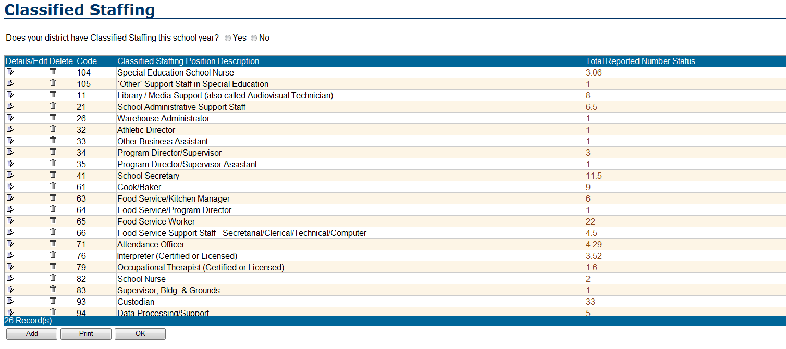

- Click on the Print Button



