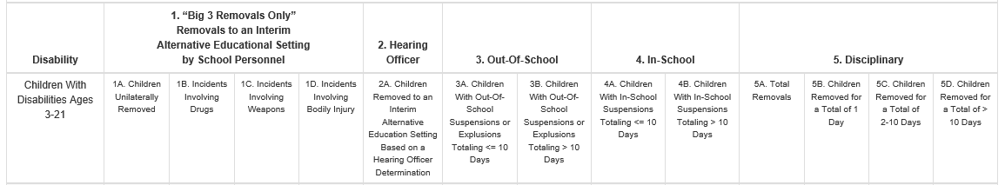

**Columns 1A-1D:** Only enter students here if they have been removed to an Interim Alternative Education Setting by School Personnel

Tips:

1. 1A is the number of CHILDREN with a “Big Three” removal
2. 1B-1D are the number of INCIDENTS- a child can be reported once in 1A and multiple times in 1B-1D

**24:05:26:08.01.  Authority of school personnel -- Weapons, drugs, and serious bodily injury.** School personnel may remove a student to an appropriate interim alternative setting for not more than 45 school days, without regard to whether the behavior is determined to be a manifestation of the student's disability, if:

1. The student carries a weapon to or possesses a weapon at school, on school premises, or at school or to a school function under the jurisdiction of a state or local education agency;
2. The student knowingly possesses or uses illegal drugs or sells or solicits the sale of a controlled substance while at school, on school premises, or at a school function under the jurisdiction of a state or local educational agency; or
3. The student has inflicted serious bodily injury upon another person while at school, on school premises, or at a school function under the jurisdiction of the state education agency or a school district.

The term “[dangerous weapon](https://www.law.cornell.edu/definitions/uscode.php?width=840&height=800&iframe=true&def_id=18-USC-1256923314-971201194&term_occur=999&term_src=title:18:part:I:chapter:44:section:930)” means a weapon, device, instrument, material, or substance, animate or inanimate, that is used for, or is readily capable of, causing death or serious bodily injury, except that such term does not include a pocket knife with a blade of less than 2½ inches in length.

The term “controlled substance” means a drug or other substance identified under schedules I, II, III, IV, or V in section 202(c) of the [Controlled Substances Act](https://www.law.cornell.edu/topn/controlled_substances_act) ([21 U.S.C. 812(c)](https://www.law.cornell.edu/uscode/text/21/812#c)).

The term “Illegal drug” means a controlled substance; but does not [include](https://www.law.cornell.edu/definitions/index.php?width=840&height=800&iframe=true&def_id=f31b6027283ea1d85fcbbf0ce99cf4e9&term_occur=999&term_src=Title:34:Subtitle:B:Chapter:III:Part:300:Subpart:E:Subjgrp:60:300.530) a controlled substance that is legally possessed or used under the supervision of a licensed health-care professional or that is legally possessed or used under any other authority under that [Act](https://www.law.cornell.edu/definitions/index.php?width=840&height=800&iframe=true&def_id=489c155f025894392da6d6d45ae93d7d&term_occur=999&term_src=Title:34:Subtitle:B:Chapter:III:Part:300:Subpart:E:Subjgrp:60:300.530) or under any other provision of Federal law.

The term “[serious bodily injury](https://www.law.cornell.edu/definitions/uscode.php?width=840&height=800&iframe=true&def_id=18-USC-402227300-849253639&term_occur=999&term_src=title:18:part:I:chapter:65:section:1365)” means [bodily injury](https://www.law.cornell.edu/definitions/uscode.php?width=840&height=800&iframe=true&def_id=18-USC-64633832-849253638&term_occur=999&term_src=title:18:part:I:chapter:65:section:1365) which involves-a substantial risk of death;(B) extreme physical pain;(C) protracted and obvious disfigurement; or(D) protracted loss or impairment of the function of a bodily member, organ, or mental faculty;

**24:05:26:09.02.  Determination of interim alternative educational setting.** The student's IEP team shall determine the interim alternative educational setting in which a student is placed under §§  24:05:26:08.01, 24:05:26:02.01, and 24:05:26:09.05.

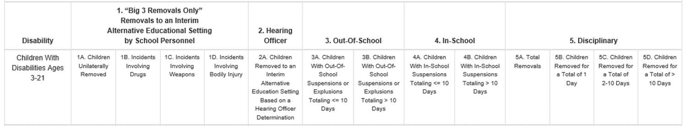

**Column 2:** Only enter students removed by a hearing officer.

**24:05:26:08.02.  Authority of hearing officer.** A hearing officer under this article hears and makes a determination regarding an appeal under this chapter. In making the determination under this section, the hearing officer may:

(1)  Return the student with a disability to the placement from which the student was removed if the hearing officer determines that the removal was a violation of this chapter or that the student's behavior was a manifestation of the student's disability; or

(2)  Order a change of placement of the student with a disability to an appropriate interim alternative educational setting for not more than 45 school days if the hearing officer determines that maintaining the current placement of the student is substantially likely to result in injury to the student or to others.

The procedures under this section may be repeated if the school district believes that returning the student to the original placement is substantially likely to result in injury to the student or to others.



**Column 3A** Report the NUMBER of STUDENTS who have been out of school suspended (OSS) for 10 days or less

Tips:

1. Students reported in 3A should only be reported ONE time in 3A
2. Students reported in 3A cannot be reported in 3B
3. Students reported in 3A might also be reported in either 4A or 4B
4. Students reported in 3A MUST be reported again in either 5B, 5C, OR 5D, depending on how many days TOTAL their suspension(s) is.

**Column 3B** Report the NUMBER of STUDENTS who have been out of school suspended (OSS) for MORE than 10 days

Tips:

1. Students reported in 3B should only be reported ONE time in 3B
2. Students reported 3B cannot be reported in 3A
3. Students reported in 3B might also be reported in either 4A or 4B
4. Students reported in 3B MUST be reported in 5D (removed for greater than 10 days)



**Column 4A** Report the NUMBER of STUDENTS who have been in school suspended (ISS) for 10 days or less

Tips:

1. Students reported in 4A should only be reported ONE time in 4A
2. Students reported in 4A cannot be reported in 4B
3. Students reported in 4A might also be reported in either 3A or 3B
4. Students reported in 3A MUST be reported again in either 5B, 5C, OR 5D, depending on how many days TOTAL their suspension(s) is.

**Column 4B** Report the NUMBER of STUDENTS who have been suspended for more than 10 days

Tips:

1. Students reported in 4B should only be reported ONE time in 4B
2. Students reported 4B cannot be reported in 4A
3. Students reported in 4B might also be reported in either 3A or 3B
4. Students reported in 4B MUST be reported in 5D (removed for greater than 10 days)



**Column 5A** Report the total number of INCIDENTS of REMOVALS (not number of children, not the number of days)

Tips:

1. You MUST report a number in this column
2. The total number of removals in each row needs to be greater than or equal to the number of students reported in 1B+1C+1D+3A+3B+4A+4B for each row
3. Each student removed may have multiple removals to report here

**Columns 5B-5D** Report the LENGTH of suspensions

Tips:

1. Column 5B- Number of children removed for a total of 1 day (total their ISS and OSS time)
2. Column 5C- Number of children removed for a total of 2-10 days (total their ISS and OSS days)
3. Column 5D- Number of children removed for greater than 10 days (total their ISS and OSS days)
   1. Remember: Students in 3B and/or 4B MUST be reported in 5D
   2. You may also have students who have a total of greater than 10 days when you add their ISS and OSS days

**Additional tips:**

1. I do not have access to the password you created when you signed on to the site for the first time. If you don’t remember your password, please email me at [Rebecca.cain@state.sd.us](mailto:Rebecca.cain@state.sd.us) and I will reset it.
2. If you click the submit button and you do not receive the message below, you have errors somewhere in your data.

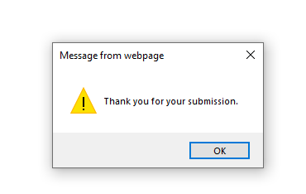

1. If you have errors in your data, you will receive a message like the one below:



At the bottom of each tab there is a “Totals” row. These numbers must be the same for each of these tabs:





1. You must enter your students in the LEP Tab. This is asking-for those students with disabilities who have been suspended, are they also Limited English Proficient (now called English Learners). If they are not, you will need to enter all your special education students who have been suspended in the “no” row.

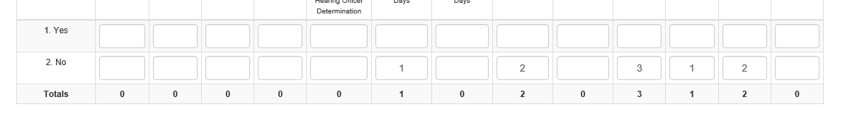

1. Tab E is only for students who have been EXPELLED. Do **not** enter the number of students who have been suspended in Tab E.

