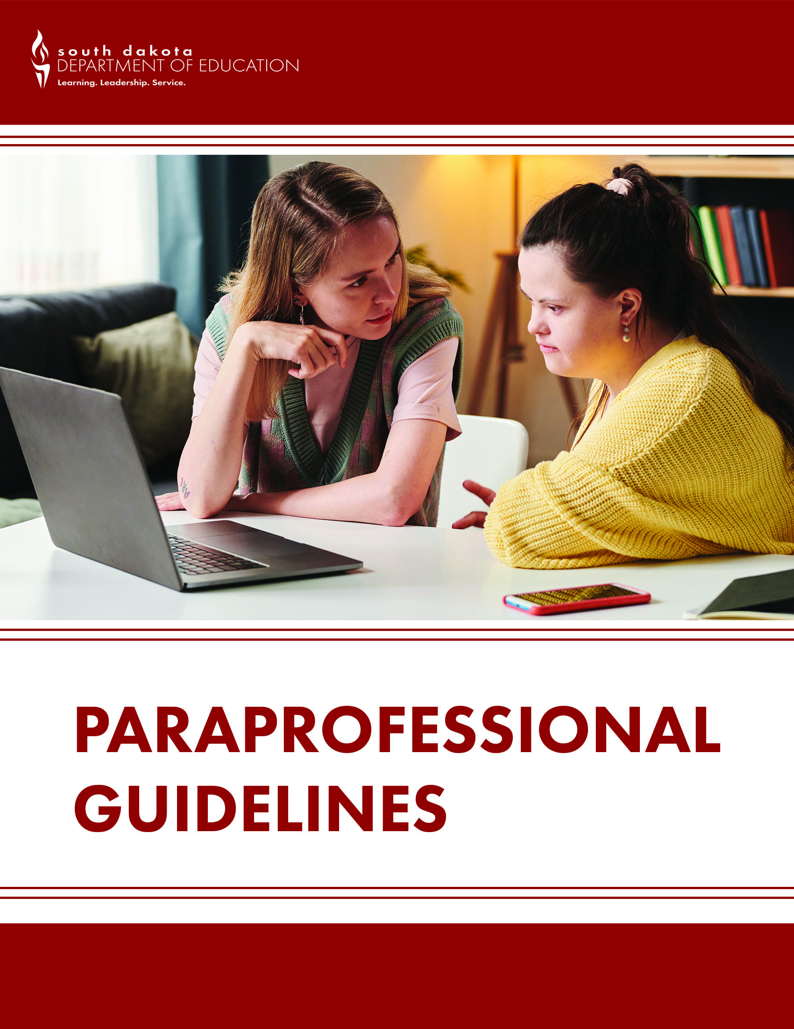
OFFICE OF SPECIAL EDUCATION PROGRAMS

Paraprofessional Guidelines

Purpose

Paraprofessional refers to an individual who works alongside a licensed or certificated educator to assist in providing support to students related to behavior and safety, medical, instruction, and disability specific needs. These services might be class wide, or a paraprofessional might be assigned to an individual child to support their needs in various school settings. A recommendation for a paraprofessional is a significant programmatic decision and one that should only be made after a comprehensive discussion of other options considered and clear documentation of why those options are not appropriate. While some students may temporarily need the support of a one-to-one paraprofessional to receive a Free Appropriate Public Education (FAPE), for other students, the assignment of a paraprofessional may be unnecessary and inappropriately restrictive.
The goal of this resource document is to assist Individual Educational Program (IEP) teams in:
- Determining whether a paraprofessional is appropriate to meet a student’s needs.
- Developing and documenting appropriate levels of paraprofessional support.
- Accessing available paraprofessional tools and resources.
- Considering the benefits and risks of having a paraprofessional to a student.
- Creating a plan to fade or reduce the amount of time a paraprofessional offers support to a student.

Resources:
Online Resources:
- Web modules are available on the SELPA’s Online Learning Center: https://charterselpa.org/online-learning-center/

Roles and Responsibilities

Ethics and Confidentiality
The Federal Educational Rights and Privacy Act (FERPA) mandates that confidentiality of student information be maintained. This law requires that school personnel are informed of and follow this ethical code of conduct. As is the case with all educators and school personnel, paraprofessionals are expected to respect the legal and human rights of children and their families, therefore maintaining confidentiality is essential to the role of a paraprofessional. If a paraprofessional is ever in doubt of sharing student information with someone requesting the information, it is recommended that they discuss the situation with the supervising teacher in order to determine if the individual has an educational interest in the information. The supervising teacher will then contact the individual requesting the information.

Paraprofessional Responsibilities
The roles and responsibilities of a paraprofessional can vary widely within each district/Local Education Agency (LEA) due to the needs of the student population at each school site. As such, the IEP teams will have intentionally discussed and documented the role and function of the paraprofessional, which will increase awareness of the roles and responsibilities of those involved with the student. Such documentation also explicitly shows the extent to which paraprofessional support is necessary for each student. The following non-exhaustive list details some examples of behavior/safety/medical/academic responsibilities that a paraprofessional may be assigned under the direction of the supervising teacher:
- Provide pre-teaching instruction,
- Assist during teacher-directed lessons,
- Monitor student during independent work or group activities,
- Prepare curriculum materials as directed by a certified staff member,
- Monitor safety in a variety of settings such as the cafeteria, bus loading area, playground, hallway, or auditorium,
- Implement and reinforce classroom programs,
- Implement and reinforce behavioral management strategies,
- Collect data as directed by a certified staff member,
- Support students with personal care/health needs such as toileting/feeding,
- Support inclusion with non-disabled peers,
- Provide re-teaching to individuals or small groups of students after teacher-directed instruction,
- Monitor student progress in instruction programs and relate findings to supervising teacher.
A paraprofessional may assist in the providing instructional support and the implementation of a behavioral intervention plan. While a paraprofessional may assist in related instructional work, primary instruction must be provided to the student by a certified teacher(s). A paraprofessional should not be used as a substitute for an appropriately developed and implemented behavioral intervention plan or as the primary staff member responsible for implementation of a behavioral intervention plan.

Resources
Appendix A:
- A.) Paraprofessional Qualifications
- B.) Paraprofessional Guidelines
- C.) Outline
- D.) Student’s Abilities and Supports Matrix
- E.) Paraprofessional Assistance Checklist
- F.) Techniques to Promote Independence and Fade Paraprofessional Support
Online Resources:
Family Educational Rights and Privacy Act (FERPA): https://www2.ed.gov/policy/gen/guid/fpco/ferpa/index.html
SD Paraprofessional Personnel Reporting and Requirements
https://doe.sd.gov/prf/parapro.aspx

individual Educational Program COnsiderations
As is the case with the provision of all special education and related services, determination of paraprofessional support is made based on an individual student’s identified area of need, which is determined through assessment and data collection. Recommendation of a paraprofessional must weigh the factors of both (1) the student’s individual needs and (2) the available supports in the setting where the student’s IEP will be implemented. The IEP team must consider the following:
- Ways to support the student without having an individual paraprofessional.
- Assistance as needed throughout the school day that does not require a paraprofessional but will provide expanded support to the child.
- Support for multiple students or the entire classroom.
  - Paraprofessional will not just be there for an individual student, but for other children (with or without disabilities) who may be in need of assistance.
If an IEP team determines, through data collection, that paraprofessional support is necessary for a student to receive a free and appropriate public education (FAPE), the team will consider the full continuum of service options to ensure that the student is educated within the least restrictive environment (LRE). Data will inform the IEP team regarding potential considerations such as the time of day, activity, or transition(s) during which additional adult support is required.
If the decision is made that a student requires a paraprofessional, the IEP team should consider:
- The duties of the paraprofessional as they would pertain to the student through relevant goals and objectives.
- Documentation of the decision of implementing a paraprofessional in the student’s IEP.
- A plan for progressively reducing the support provided to the student and the student’s dependence on the paraprofessional over time.
Presence of a paraprofessional can impact the frequency and types of peer interactions that take place throughout the day. Therefore, the team should consider the impact the paraprofessional will have on the ability for the student to access the least restrictive environment, build independence, and develop relationships with peers. The utilization of a paraprofessional should not be seen as the only way a student can successfully be included in a general education classroom. The IEP team should consider a plan to limit reliance and foster independence where possible.
When hiring and assigning a paraprofessional, the district/LEA should consider:
- Qualifications of the individual that would be necessary to meet the needs of the student and any training that may be necessary.
- Plan to monitor the assignment of the paraprofessional and the student’s continuing need for the paraprofessional.
- Plan for substitutes to serve as the student’s paraprofessional to cover staff absences in order to ensure the student receives the recommended IEP services of the paraprofessional.
Gaining independence and fading paraprofessional support may have a positive impact on relationships with peers and class participation. It may also eliminate some of the potential harmful effects associated with a paraprofessional.

Parent Request
If paraprofessional support is requested by the parent, it is important for the IEP team to document how the parent request has been addressed. Refusing to consider and appropriately document the decision may be considered a denial of FAPE. Meaningful discussion and consideration should be given to the request prior to making final recommendations to either assess for need or refuse the request.
Upon receipt of a parent request, the district/LEA should convene an IEP meeting to consider the parent’s request, review student’s progress on goals, and review additional data. The district/LEA should carefully consider each academic area or time of day in which paraprofessional support may be needed for the student.
The goal for all students is to encourage, promote, and maximize independence. Therefore, natural and existing environmental supports should be used whenever possible prior to assigning additional paraprofessional support.
After data has been reviewed the IEP team should identify student areas of need.
If parents still disagree with the decision of the team, there are resources and dispute resolution options available as outlined at https://doe.sd.gov/sped/complaints.aspx.

Resources
Appendix B:
- A.) Intensive Needs Checklist
- B.) Implementation of a Paraprofessional
- C.) Paraprofessional Considerations

Online Resources:
Parental Rights Procedural Safeguards
https://doe.sd.gov/sped/parentalrights.aspx

Appendix A: Paraprofessional Resources

Paraprofessional Qualifications
Administrative Rule South Dakota (ARSD) Article 24:05 Special Education
24:05:16:16. Personnel qualifications. To ensure that all personnel necessary to carry out the purposes of Part B and Part C of the Individuals with Disabilities Education Act are appropriately and adequately prepared and trained, including ensuring that those personnel have the content knowledge and skills to serve children with disabilities, the department shall determine that all personnel providing special education or related services, including related services, paraprofessionals and assistants, early intervention, and early childhood personnel, perform these functions under state-approved or state-recognized certification or licensure or other comparable requirements that apply to the area in which the person is providing special education or related services. The department shall ensure that related services personnel who deliver services in their discipline or profession meet the requirements of this section and have not had certification or licensure requirements waived on an emergency, temporary, or provisional basis.
Source: 16 SDR 41, effective September 7, 1989; 19 SDR 29, effective August 30, 1992; 23 SDR 31, effective September 8, 1996; 26 SDR 150, effective May 22, 2000; 33 SDR 236, effective July 5, 2007.
General Authority: SDCL 13-37-1.1.
Law Implemented: SDCL 13-37-1.1.

24:05:16:16.01. Paraprofessionals and assistants. Paraprofessionals and assistants who are appropriately trained and supervised in accordance with this section may be used to assist in the provision of special education and related services to children with disabilities under Part B of the Individuals with Disabilities Education Act. At a minimum, the following standards must be met:

(1) Paraprofessionals must have a high school diploma or GED;
(2) Paraprofessionals must work within defined roles and responsibilities as identified by the school district;
(3) Paraprofessionals must work under the supervision of, and be evaluated by, certified staff; and
(4) Each school district must describe the training to be provided paraprofessionals in the staff development component of the district's comprehensive plan under § 24:05:16:05.

Source: 26 SDR 150, effective May 22, 2000; 40 SDR 40, effective September 11, 2013.
General Authority: SDCL 13-37-1.1.
Law Implemented: SDCL 13-37-1.1.

**The minimum qualifications for paraprofessionals for special education are outlined in ARSD. Other programs, such as Title, may have additional requirements. It is up to the district/LEA to appropriately identify the funding source, qualification requirements, training and reporting related to statue and administrative rules that are applicable.

Paraprofessional Guidelines

The following are areas of consideration when determining paraprofessional support.

- Behavior/Safety
  - A paraprofessional may be considered when the IEP team determines that the behavior of the student is such that continual monitoring by an individual staff member is required.
  - Examples
    - Self-injurious behavior,
    - Injurious behavior toward other students,
    - Injurious behavior toward staff,
    - Suicidal threats or previous suicide attempts,
    - Chronic theft and/or fire starting.
- Medical/Safety
  - A paraprofessional may be considered when the IEP team determines that a student is so medically fragile that continual monitoring of individual health needs and/or equipment is required.
  - Examples
    - Need for frequent catheterization,
    - Need for continual suctioning,
    - Brittle diabetic,
    - Monitoring of eating disorder,
    - Monitoring of ventilator dependent students,
    - Profound and multiple physical limitations (e.g., toileting, changing or maintaining positions, ambulation).
- Deaf or Hard of Hearing
  - A paraprofessional may be considered when the IEP team determines that a student uses sign language and requires an interpreter to facilitate communication in order for the student to adequately function within their school environment. The paraprofessional is not an interpreter for the student but may assist the student in the school environment.
- Academic
  - A paraprofessional may be considered when the IEP team determines that a student has severe to profound disabilities and requires significant curricular modifications. The assignment of an assistant would enable the student to be educated for all or part of the day in a general education classroom.

C. Outline
- Who is the supervising teacher?
- Who are the students the paraprofessional will be supporting?
- What is the chain of command for staff/parent communication?
- What does the daily schedule look like?
- What are the locations the paraprofessional will be placed in?
- Will any duties be assigned outside of the classroom? If so, where?
- When are breaks given? When is lunch?
- When the teacher is absent, what are the paraprofessional’s responsibility to the class?
- Is the paraprofessional expected to attend school activities such as open house, special events, etc.?
- How will the paraprofessional document participation in professional development?
- If a paraprofessional cannot attend work one day, whom should they call?
- What records are the paraprofessional responsible for keeping?
- Where are supplies kept and how does the paraprofessional access them?
- What are the emergency procedures?
- What are effective strategies for communicating with the student?

D.) STUDENT’S Abilities and Supports Matrix
Activity | What student can do without assistance.  What should the paraprofessional be doing when the student is working independently. | What student can do and needs accommodations to complete.  How does it look when accommodations are provided? | What student cannot do and needs assistance with.  How that assistance will be provided? | Identify areas to promote social acceptance and how peers will be utilized. | Identify areas you will target for independence (should be identified in IEP).
Arrival/Time
Period 1/Time
Period 2/Time
Period 3/Time
Period 4/Time
Period 5/Time
Period 6/Time
Period 7/Time
Period 8/Time
Departure / Time

E.) Paraprofessional assistance checklist
Student Issues/Needs Profile | Logistics | Who could assist? | Training Plan | Who to contact with questions.
- Safety Issues  - Wanders off/ runs away  - Hurts self  - Falls  - Puts inedible items in mouth  - Hurts others | Place:  Time(s): |  | Indicate training needed / Who delivers: | Who will take lead if situation is beyond paraprofessional’s knowledge and skill.
- Physical Needs  - Restroom / diapers  - Orientation / Mobility  - Eating / Feeding  - Dressing  - Breathing / Respiration  - Medication  - Equipment (e.g., hearing aids, wheelchairs)  - Posture, positioning,  - Medicaid-billable procedures  - Has individualized Health Plan in place  - Other | Place:  Time(s):  Duration:  Permanent  Temporary |  | Indicate training needed / Who delivers: | Who will take lead if situation is beyond paraprofessional’s knowledge and skill.
Student Issues/Needs Profile | Logistics | Who could assist? | Training Plan | Who to contact with questions.
- Social Needs  - Wanders off/ runs away  - Prompts / cues to interact with peers  - Social Instruction  - Protection from peers  - Peer instruction how to interact with student  - Adult instruction how to interact with student  - Other: | Place:  Time(s): |  | Indicate training needed / Who delivers: | Who shares supervisory responsibility / name lead person.
- Academic Needs  - Cues to attend to teachers  - Cues to begin tasks  - Cues to remain on task  - Physical use of instructional materials  - Modifications of instructions / directions  - Modification of materials, tasks (including Braille)  - Adaptive Equipment  - Community-based activities  - Job shadow, exploration  - Work / job skill development  - Other | Place:  Time(s):  Duration:  Permanent  Temporary |  | Indicate training needed / Who delivers: | Who shares supervisory responsibility / name lead person.

F.) Techniques to promote independence and fade paraprofessional support
- Observe whether the student can ask for help from the teacher or peers first? Can the student problem solve on his/her own?
- Give the student extra time to process and respond before assisting.
- Have high expectations as to what the student understands or can do independently.
- Provide a consistent classroom schedule (posted, visual, at desk if needed, reinforcement periods included). Teach student how to use the tools.
- Teach independence skills (raising hand, asking for help, modeling other students).
- Direct the student to speak directly to the classroom. The paraprofessional should not voice the student’s answer or questions unless required by the IEP.
- Prompt the student to listen to the teacher’s instructions. Repeat only when necessary.
- Encourage age-appropriate work habits. Teach the student to socially reference what their peers are doing.
- Be aware of proximity. Sit with the student only when necessary.
- Encourage peer assistance and partnering. Teach peers how to help, not enable.
- Color-code materials to assist with organization.
- Use transition visuals or objects to help student anticipate/complete transition.
- Break big tasks into steps. Have the student assist as appropriate.
- Give choices.

Appendix b: Planning and Support resources

A.) Intensive Needs Checklist
- Is there a safety concern for self or others? Please Describe. | Yes | No
- Does the student require continual teacher prompts:  - During instruction and/or  - After instruction | Yes  Yes | No  No
- Does the student require assistance with basic functional skills?  - Toileting  - Mobility  - Feeding  - Dressing  - Following basic safety rules | Yes | No
- Is the student’s performance consistent with his or her aptitude? | Yes | No
- Do his or her peers include the student in classroom activities? | Yes | No
- Is the student currently receiving specialized small or individualized group instruction in specific academic areas? Please describe. | Yes | No
- Please note what interventions or program changes you have tried and describe their rate of success (e.g., cooperative learning, behavior management plan, re-grouping within the classroom, pairing with other students).  - If these interventions are not an option, please explain why. | Yes | No
- Has an administrator observed the student?
  - Ensure all identified accommodations/modifications and supports are being implemented.
  - Is an aide necessary or can other supports or environmental changes be made to support student?
Please describe observation:

- List the reason(s) for requesting a 1:1 assistant. Please refer to the attached guidelines.
Please include data to support this request.
- List modifications/accommodations used to support the students’ needs in the current placement. Include timelines and level of progress (if any).

- Describe in detail at least two strategies used to meet the students’ needs. Include timelines and level of progress (if any).

- Describe in detail the plan for phasing out the 1:1 paraprofessional. Include specific strategies/timelines that need to be implemented.

Implementation of a paraprofessional
- Who is the student(s) the paraprofessional will be supporting?
- What, if any, medical issues does the student(s) have that the paraprofessional should know prior to working with them?
- Describe the level of prompting the student(s) should be receiving.
- Describe the level of supervision/support the student(s) will need.
- Describe how the paraprofessional will assist with facilitating peer relationships.
- Determine how the paraprofessional will collect and report student progress.
- Determine the paraprofessional’s role in implementing and enforcing school wide and classroom behavior systems. What training is necessary for the paraprofessional to effectively implement the behavior system?
- Review the individual behavior plan(s). Determine the target behaviors, rewards, and consequences of the student(s).
- Review IEP(s) (summary of IEP goals, objectives, accommodations, and modifications). Specify what components the paraprofessional will be responsible for implementing.
- Define the safety considerations for the individual student(s).
- Provide direction and training on any assistive technology, including how to effectively prompt a student to use their assistive technology and fade prompting and who to contact if there are needs regarding the assistive technology.
- Define how instructional plans for the student(s) supported will be reviewed and the frequency of the review.
- How will the paraprofessional collect and report student progress?

Paraprofessional considerations
The following sentences are recommended questions to ask and review while considering the application of a paraprofessional:
What are the needs of the student which necessitate the assignment of a paraprofessional?
What skills and goals must the student achieve to reduce or eliminate the need for a paraprofessional?
What are the potential harmful effects of the assignment of a paraprofessional?
What role will the paraprofessional fulfill (e.g., instructional; behavior support; personal hygiene assistance)?
For what specific activities (e.g., toileting) and/or times of day (e.g., transition to and from the bus) is the paraprofessional needed?
What qualifications of the individual (i.e., paraprofessional) is necessary to meet the needs of the student?
What is the plan to monitor the student’s progress toward the goals to be addressed by the assignment of the paraprofessional and the student’s continuing need for the paraprofessional?
What is the plan for progressively reducing the support provided to the student and his or her dependence on a paraprofessional over time?
If student’s paraprofessional is absent, who will cover in order to ensure the student receives the recommended IEP services of the paraprofessional or how will substitute staff support be arranged?
Who/how will paraprofessionals have access to a copy of the student’s IEP, and be informed of their responsibilities for IEP implementations for the student?
What, if any, professional development and supervision will paraprofessional need to carry out these responsibilities?

Sources:
Considerations for the effective use of paraprofessionals in schools. Kansas State Department of Education Webpage. (n.d.). https://www.ksde.org/Portals/0/ECSETS/Para/ConsiderationsEffectiveUseParaprofessionals.pdf
Determination for 1-1 paraprofessional - speed school ... SPEED S.E.J.A. District 802. (n.d.). https://www.speed802.org/assets/1/7/Determination_for_1-1_Para.pdf
Elledge, K. (2019, November 19). Paraeducator guidelines. El Dorado Charter SELPA. https://charterselpa.org/paraeducator-guidelines/
Guidelines for determining a student with a disability’s need for a one-to-one aide. New York State Education Department. (n.d.). https://www.nysed.gov/special-education/guidelines-determining-student-disabilitys-need-one-one-aide#:~:text=Each%20decision%20to%20recommend%20a,student’s%20IEP%20will%20be%20implemented
One-on-one aide in special education. PEATC. (n.d.). https://peatc.org/wp-content/uploads/2022/01/One-to-One-Aide.pdf
Paraprofessional resources. Missouri Department of Elementary and Secondary Education. (n.d.). https://dese.mo.gov/special-education/effective-practices/paraprofessionals
Paraprofessional Support. Davison Community School Webpage. (n.d.). https://www.davisonschools.org/site/Default.aspx?PageType=6&SiteID=8&SearchString=paraprofessional
Planning Tool to Determine Need for Paraeducator Support. Fort Dodge Community School District Webpage. (n.d.). https://www.davisonschools.org/cms/lib/MI02211530/Centricity/Domain/84/GuidelinesforEnhancedStaffing.pdf
Special Education Paraprofessional Resources. Georgia Department of Education. (n.d.). https://www.gadoe.org/Curriculum-Instruction-and-Assessment/Special-Education-Services/Documents/Sp%20Ed%20homepg/Paraprofessional%20Resources%209272021_.pdf
Special education paraprofessional support checklist. The Paraprofessional Resource and Research Center. (n.d.). https://paracenter.org/files/SPED_Paraeducator_Support_Checklist.pdf

