

English Learners in South Dakota:


English Learner Data Elements in Infinite Campus

Updated October 2025

Shari Lord

Title III English Language Acquisition Coordinator
shari.lord@state.sd.us

605-280-4011

doe.sd.gov/title/el.aspx

English Learner (EL) Data Elements in Infinite Campus

This manual is designed to serve as a reference and to be used in conjunction with the SD DOE Title III webpage, EL Assessment webpage, and the Identification and Screening Manual. This manual provides specific information regarding the important EL data elements in Infinite Campus.

Table of Contents
Creating EL Records 3
How do I create an EL record? 3
Program Status 4
EL Services……………………………………………………………………………………………………………………………………………..7
Exited EL 8
Re-Entry 9
First year in country 10
Immigrant Children and Youth… 13
Requesting Record 14
Definitions 16
Contact Information 17

Creating EL records

Creating an EL record: Demographics Tab
Infinite Campus Path: | Census > People > Demographics
Ensure the Home Primary Language and Date Entered U.S. School fields are
populated on the student’s Demographics tab.

Home Primary Language: To be identified as EL the “Home Primary Language”
field must be selected as a language other than English. Visit EL languages for a list of language codes.
What is a Home Primary language defined as?
A home primary language is a language other than English that is spoken in the home.

Where is this information obtained from?
This information is obtained from the Home Language Survey.

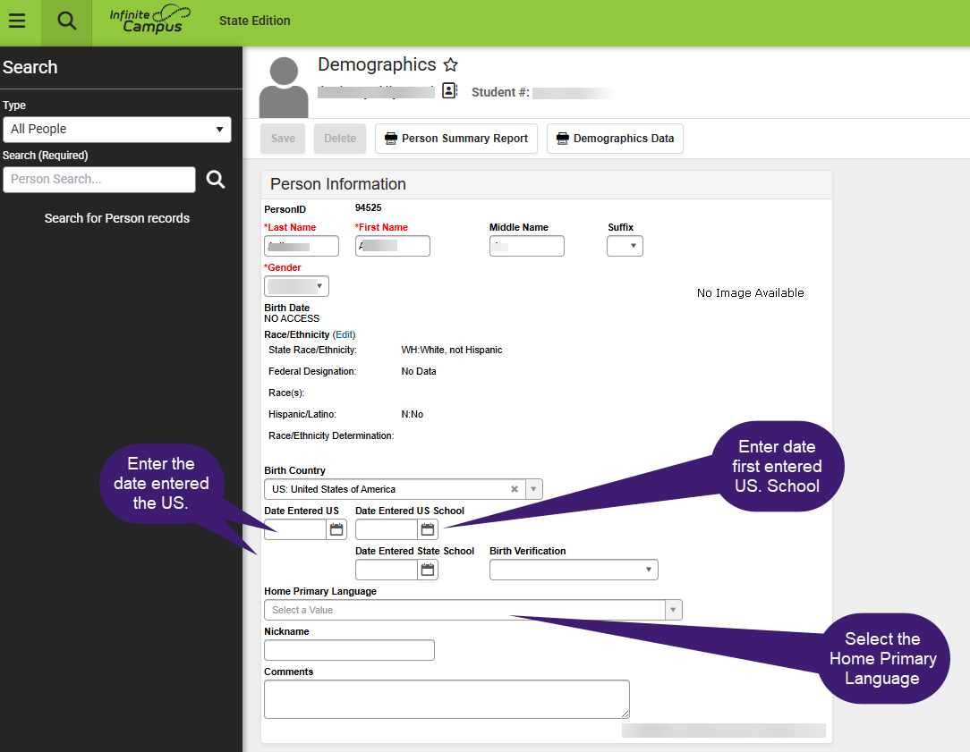

Creating an EL record: Program Status
Infinite Campus Path: | Student Information >English Learners > English Learners (EL)
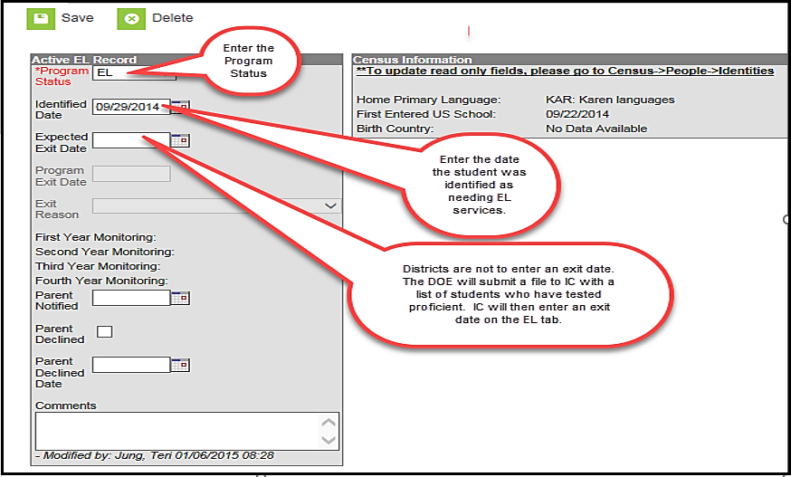
- Select the current Program Status based on the student’s WIDA Screener for KG or
WIDA Screener scores. This value indicates the student’s current EL status.
- If the student has taken the initial screener assessment (for example, the WIDA Screener for KG or WIDA Screener) and was deemed eligible for EL services, enter the Identified Date.

What is the identified date?
The identified date is the date that the student was deemed eligible for EL services.
What is the expected exit date?
The expected exit date is the date the student is expected to exit the EL program. Remember that EL students are expected to reach English language proficiency within five to seven years of instruction in the EL program.
- If the student is deemed eligible for EL services through one of the WIDA Screeners, enter the Parent Notified date.

What is the Parent Notified date?

The Parent Notified date is the date the student’s parents/guardians were notified of screener results and whether the student is deemed eligible for services or not. A parent notification letter must be shared with parents within the first 30 calendar days of the beginning of the school year or within two weeks of enrolment during the school year.

You can find a sample notification letter here.

- Parents have the right to deny services; however, if identified as an EL student, the student will need to participate in the WIDA ACCESS assessment. If the parents declined services, mark the Parent Declined checkbox. This is an annual requirement.
- Enter WIDA Screener scores in Comments section. Also, enter any comments about the student’s EL record.

Creating an EL Services Record
Infinite Campus Path: | Student Information > English Learners > English Learner (EL) Services

Who enters the EL Services?

School districts have the responsibility to provide English language development services to all identified English learner students. It is a requirement to enter what services are being provided on the EL Service Types tab.

If you select “Other” please indicate in the comments section of type of EL services that are being provided.

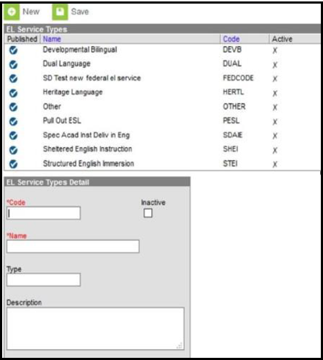

EL Record: Exited EL
Infinite Campus Path: | SD DOE inputs Exit Records
Exited EL

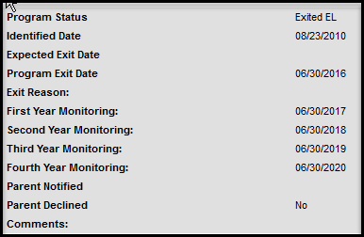

What is the definition of an Exited EL student?
Exited EL student refers to students who have met South Dakota’s exit criteria
on the WIDA ACCESS assessment.

What is South Dakota’s exit criterion?
- To exit a student from EL status, the student must obtain an Overall Proficiency Level of 5.0 or higher on the WIDA ACCESS assessment or
- obtain an Overall Proficiency Level of 4.0 on WIDA ACCESS or higher AND either a 3.0 or 4.0 on ELA SD State Assessment.

Who inputs the exit date for the student?
SD DOE submits a file to Infinite Campus with a list of students who are deemed proficient on the WIDA ACCESS assessment. Infinite Campus will exit all students from the EL program and will populate an Exit Date.

What is the First, Second, Third, and Fourth year monitoring?
The Exited date record will calculate:
First Year Monitoring- A read-only field calculated exactly one year from

Program Exit Date
Second Year Monitoring- A read-only field calculated as exactly two years from the Program Exit Date.
Third Year Monitoring- A read-only field calculated as exactly three years from the Program Exit Date.
Fourth Year Monitoring- A read-only field calculated as exactly four years from the Program Exit Date.

How long are LEAs required to monitor Exited EL students?
LEAs are required to monitor Exited EL students for two consecutive years after the student has tested proficient on the WIDA ACCESS assessment. LEAs are responsible for evaluating the progress made by children in meeting challenging State academic content and student academic achievement standards for each of the two years after the student is no longer receiving EL services.

If we are only required to monitor Exited students for two years, why does it populate for four years?
Under ESSA, LEAs are required to report on the achievement of Exited EL students for four
Creating an EL Record: Re-Entry
Infinite Campus Path: | Student Information > Program Participation > EL
EL Re-Entry

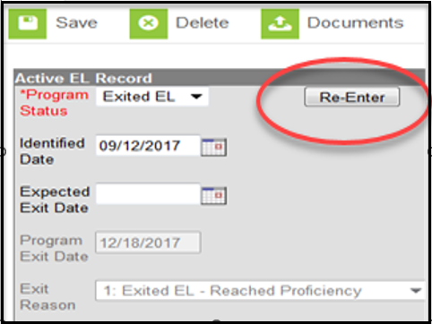

The Following screen will display when clicking the Re-Enter button:
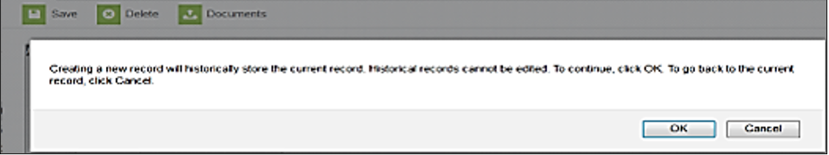
After clicking OK, the following screen will appear. You will need to complete the required fields to re-enter the student back into the EL program.
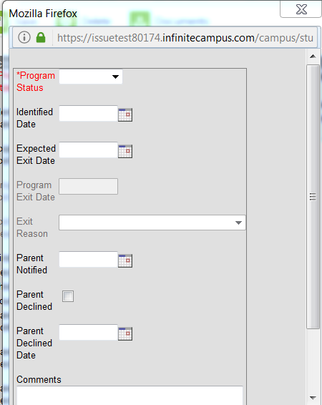

Why is an EL student re-entered into the EL program?
Exited EL students are to be monitored for two consecutive years after testing proficient in English. School districts are responsible for evaluating the progress made by students in meeting challenging State academic content and student academic achievement standards for each of the two years after the student is no longer receiving services. Items such as a teacher referral, a parent referral, test scores, and mainstream classroom success might indicate a need to discuss the possibility that the student needs to be re-integrated into the EL program.

The LEA has monitored the student and there is enough evidence that the student is still struggling due to language, what should the LEA do?

If the school district has determined that the student is still struggling due to a language barrier, then the school district may re-enter the student back into the EL program. The student would need to enter the program the same way they entered the very first time. The school district would need to administer the WIDA Screener assessment again.

Creating First Year in Country Record
Infinite Campus Path: | Index > Census > People
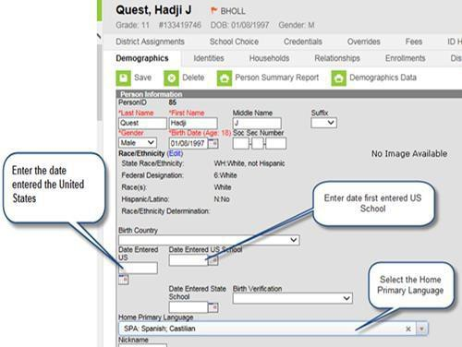

The first year in country box can be found by clicking on the student’s enrollment and going to State Reporting Fields

What is First Year in Country (FYIC) criteria?

- must be an identified EL student
- have been enrolled in a school in one of the 50 states in the United States or the
District of Columbia for less than 12 months
- must participate in WIDA ACCESS assessment if enrolled during the testing
window
- for students arriving after the WIDA ACCESS testing window, the WIDA Screener
must be administered to provide evidence for SD ELA assessment exemption
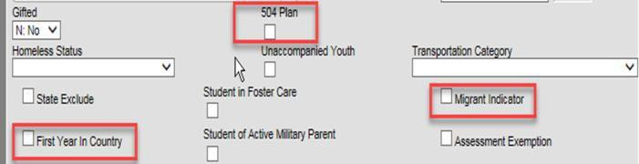

If the student meets the above criteria, then…

The student is exempted from participating in the ELA portion of the SD state assessment; however, the student is required to participate in Math and Science. Scores are not included in accountability.

What do we need to indicate in Infinite Campus if the student meets the First Year in Country criteria?

The LEA will need to include the Date Entered U.S., Date Entered U.S. school, and First Year in Country check box.

Does a student need to be an EL student?

Yes, the student needs to be an EL student.

Do students from Puerto Rico get this first-year exemption?

Yes, if the student is from Puerto Rico and is an identified EL student and has not attended a
U.S. school for more than 12 months.

Qualifying Dates for ELA Exemption for School Year 2025-2026
May 2, 2025 – May 1, 2026

Creating an Immigrant Children and Youth Record
Infinite Campus Path: | Student Enrollment > State Reporting Fields
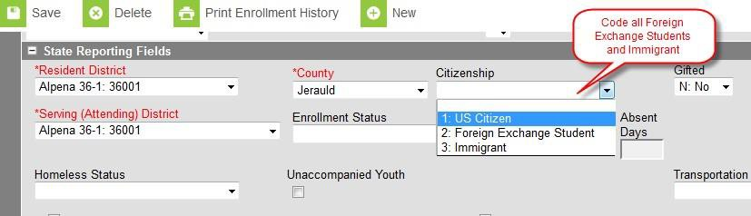

What is the definition of an Immigrant Children and Youth student?
Immigrant Children and Youth

What do we need to indicate in Infinite Campus if the student meets the Immigrant Children and Youth definition?
The LEA will need to include the Date Entered U.S., Date Entered U.S. school, and select
Immigrant under State reporting fields.

Why do we collect this information?
This information is collected because there is a Title III-Immigrant Children and Youth Grant that LEAs can qualify for if they have a significant impact of Immigrant Children and Youth students.

Please note that the term “immigrant” as used in Title III is not related to an
individual’s legal status in the United States.

Requesting Records

To eliminate unnecessary data entry and to ensure all student data is properly transferred from one district to another, it is vital that districts use the Records Transfer process within Infinite Campus. A records transfer may be requested any time after the transfer student has been enrolled in the new district. Immediately after the student’s new enrollment is saved; the records transfer page will display.

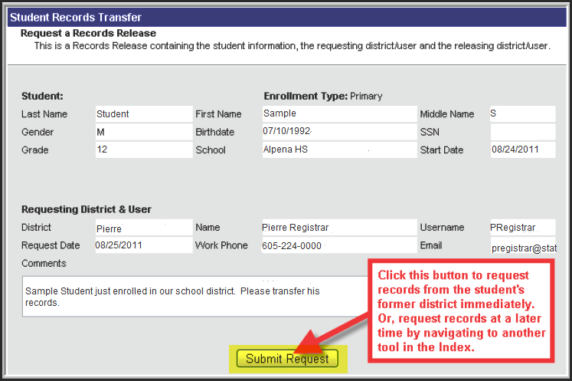

Clicking the Submit Request button will initiate a request for the student’s records. After a request is made, the Process Inbox and the student Records Transfer tab of the requesting district will both display a “Waiting” status until the former district responds with the records. During this time, the new district will have no indication of which district the student previously attended. As a courtesy to your fellow districts, please respond to all requests for transfer within 5 business days AND be sure to End Date the student record before you release the record to the requesting district.

Requesting Records Through the Records Transfer Tab
The transfer can be performed at the time of enrollment or at a later date. Requesting a transfer at a later date may be done by navigating to the student’s Records Transfer tab, selecting the New State Transfer Request icon (if applicable) and selecting the Submit Request button.
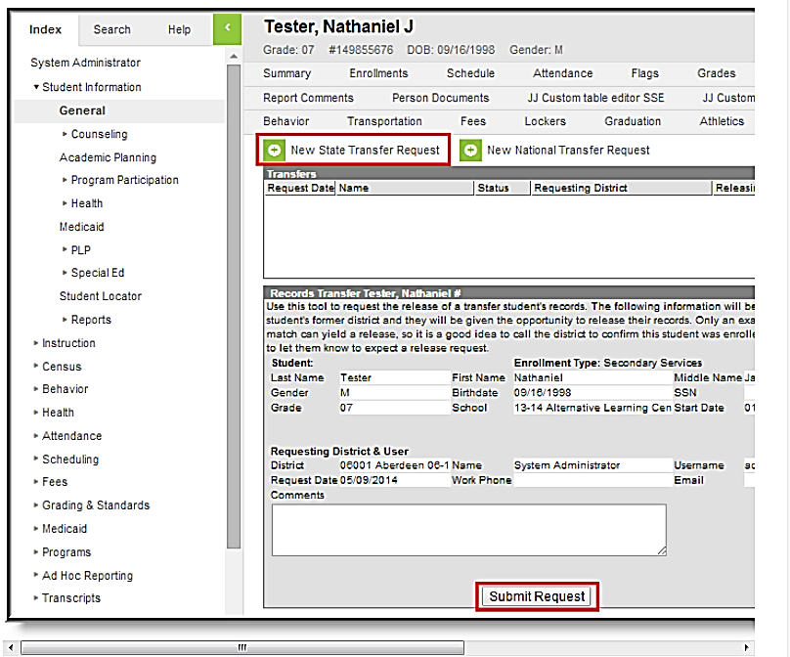

After a request is made, the Process Inbox and the student Records Transfer tab of the requesting district will both display a “Waiting” status until the former district responds with the records. During this time, the new district will have no indication of which district the student previously attended.

Completing the Process
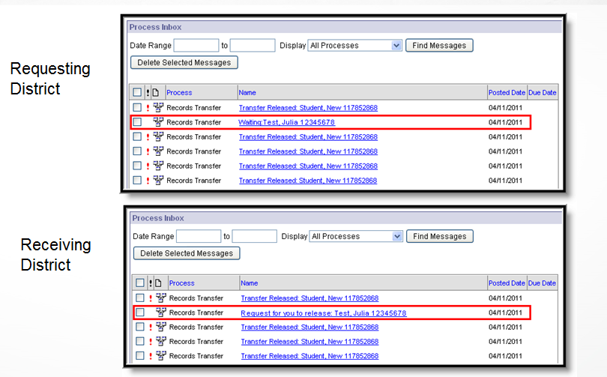

Completing the Process (cont.)
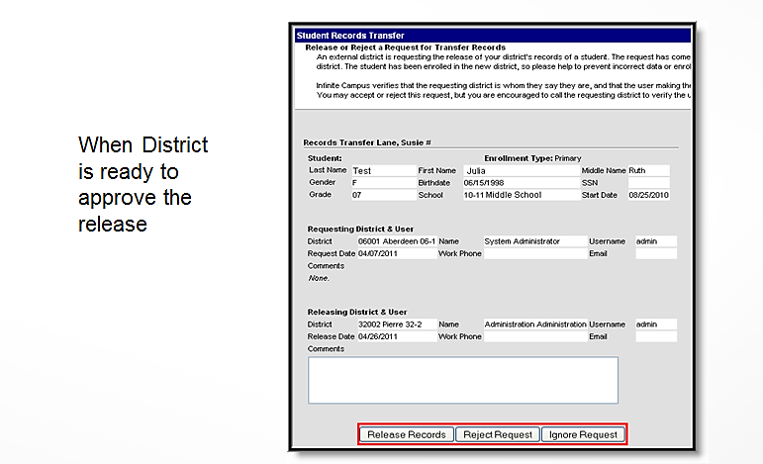
A released records transfer message will contain two methods of receiving the transferred student records.

It is the responsibility of the new district to complete the records transfer by importing and/or entering the relevant data. The Data Imports method directly writes the former district's data to the new district database using Data Import Wizards.

To execute a data import, click the hyperlinked blue text. An Import Wizard will open.

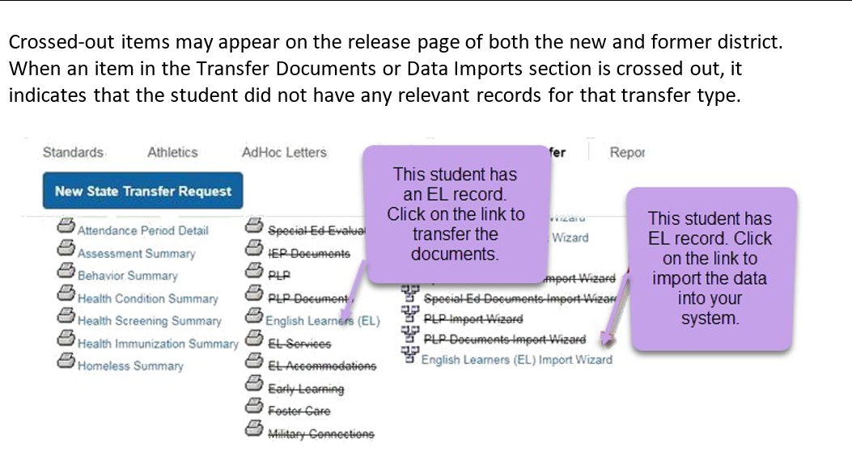

Definitions

English Learner

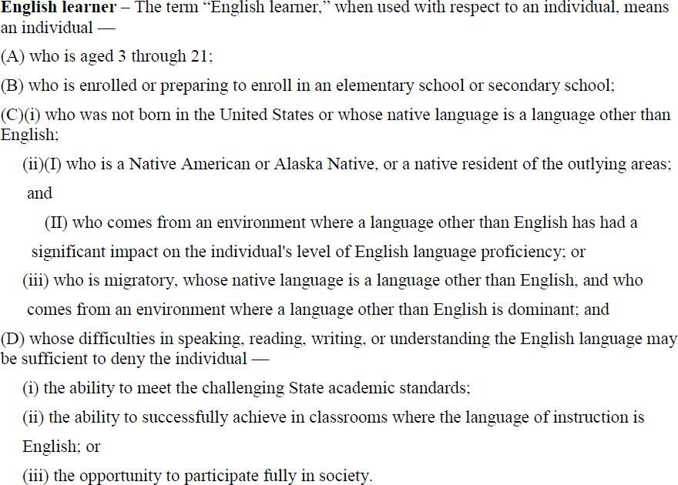

Immigrant Children and Youth
Definition of Immigrant Children and Youth
The term ‘Immigrant children and youth’ means individuals who-
“(A) are aged 3 through 21;
“(B) were not born in any State; and
“(C) have not been attending one or more schools any one of more States for more than 3 full academic years.
“Three full academic years” = cumulative

First Year in Country
- must be an identified EL student

- has not attended schools in the United States (not including Puerto Rico) for less than 12months

- Must participate in WIDA ACCESS assessment if enrolled during the testing window

- If the student arrives after the WIDA ACCESS testing window, then the student must participate in the WIDA Screener assessment

Resources

SD DOE Title III page | http://doe.sd.gov/title/el.aspx
SD DOE Infinite Campus- Student  Information Management System | http://doe.sd.gov/ofm/sims.aspx

Contact Information

Shari Lord

Title III English Language Acquisition Coordinator Shari.Lord@state.sd.us
605-280-4011

Teri Jung

Management Analyst Teri.Jung@state.sd.us
605-773-8197

