English Learners in South Dakota:

English Learner Data Elements in Infinite Campus

Updated July 2024

Shari Lord

Title III English Language Acquisition Coordinator
shari.lord@state.sd.us

605-280-4011

https://doe.sd.gov/title/el.aspx

English Learner (EL) Data Elements in Infinite Campus

This manual is designed to serve as a reference and to be used in conjunction with the SD DOE Title III webpage, EL Assessment webpage, and the Identification and Screening Manual. This manual provides specific information regarding the important EL data elements in Infinite Campus.

Table of Contents
Creating EL Records 3
How do I create an EL record? 3
Program Status 4
EL Services……………………………………………………………………………………………………………………………………………..7
Exited EL 8
Re-Entry 9
First year in country 10
Immigrant Children and Youth… 13
Requesting Record 14
Definitions 16
Contact Information 17

Creating EL records

Creating an EL record: Demographics Tab
Infinite Campus Path: | Census > People > Demographics
Ensure the Home Primary Language and Date Entered U.S. School fields are
populated on the student’s Demographics tab.

Home Primary Language: To be identified as EL the “Home Primary Language”
field must be selected as a language other than English. Visit EL languages for a list of language codes.
What is a Home Primary language defined as?
A home primary language is a language other than English that is spoken in the home.

Where is this information obtained from?
This information is obtained from the Home Language Survey.

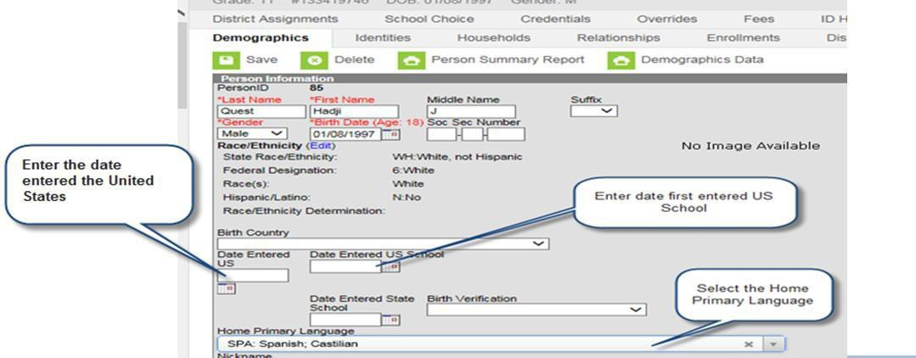

Creating an EL record: Program Status
Infinite Campus Path: | Student Information > Program Participation > EL
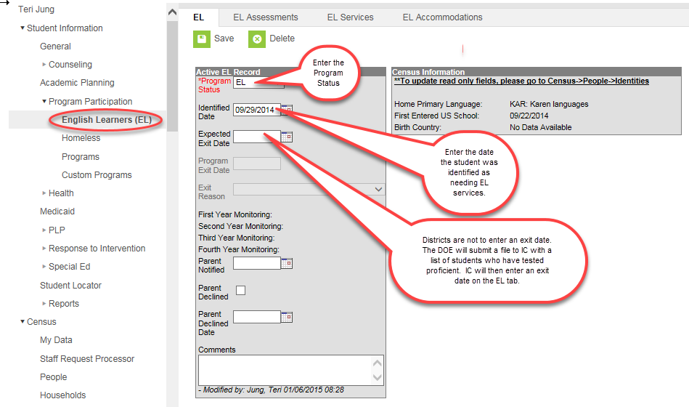

- Select the current Program Status based on the student’s WIDA Screener for KG or
WIDA Screener scores. This value indicates the student’s current EL status.
- If the student has taken the initial screener assessment (for example, the WIDA Screener for KG or WIDA Screener) and was deemed eligible for EL services, enter the Identified Date.

What is the identified date?
The identified date is the date that the student was deemed eligible for EL services.
What is the expected exit date?
The expected exit date is the date the student is expected to exit the EL program. Remember that EL students are expected to reach English language proficiency within five to seven years of instruction in the EL program.
- If the student is deemed eligible for EL services through the WIDA Screener for KG or WIDA Screener, enter the Parent Notified date.

What is the Parent Notified date?

The Parent Notified date is the date the student’s parents/guardians were notified of screener results and whether the student is deemed eligible for services or not. A parent notification letter must be shared with parents within the first 30 calendar days of the beginning of the school year or within two weeks of enrolment during the school year.

You can find a sample notification letter here.

- Parents have the right to deny services; however, if identified as an EL student, the student will need to participate in the ACCESS for ELLs 2.0. If the parents declined services, mark the Parent Declined checkbox. This is an annual requirement.
- Enter WIDA Screener for KG or WIDA Screener scores in Comments section. Also,
enter any comments about the student’s EL record.

Creating an EL record: Program Status
Infinite Campus Path: | Student Information > Program Participation > EL
EL- English Learner

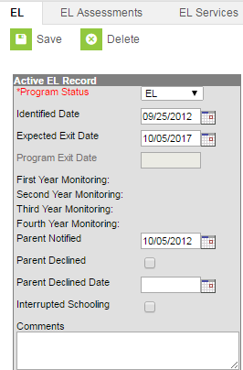
What is the definition of an English learner?
EL definition

Select EL as the option if the student is deemed eligible for EL services as a result of the WIDA Screener for KG or WIDA Screener.

What is South Dakota’s identification criterion?
The South Dakota Identification Criteria can be found here.

Creating an EL Services Record
Infinite Campus Path: | Student Information > Program Participation > English Learner

Who enters the EL Services?

School districts have the responsibility to provide English language development services to all identified English learner students. It is a requirement to enter what services are being provided on the EL Service Types tab.

If you select “Other” please indicate in the comments section of type of EL services that are being provided.

EL Record: Exited EL
Infinite Campus Path: | SD DOE inputs Exit Records
Exited EL

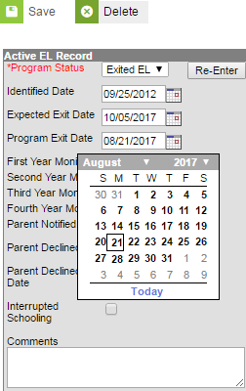

What is the definition of an Exited EL student?
Exited EL student refers to students who have met South Dakota’s exit criteria
on the ACCESS for ELLs 2.0 English language proficiency assessment.

What is South Dakota’s exit criterion?
To exit a student from EL status, the student must obtain an Overall Proficiency Level of 5.0 or
higher on the ACCESS for ELLs 2.0 Assessment or students can obtain an Overall Proficiency Level of 4.0 on ACCESS for ELLs 2.0 or higher AND either a 3.0 or 4.0 on ELA SD State Assessment.

Who inputs the exit date for the student?
SD DOE submits a file to Infinite Campus with a list of students who are deemed proficient on the ACCESS for ELLs 2.0 English language proficiency assessment. Infinite Campus will exit all students from the EL program and will populate an Exit Date.

What is the First, Second, Third, and Fourth year monitoring?
The Exited date record will calculate:
First Year Monitoring- A read-only field calculated exactly one year from

Program Exit Date
Second Year Monitoring- A read-only field calculated as exactly two years from the Program Exit Date.
Third Year Monitoring- A read-only field calculated as exactly three years from the Program Exit Date.
Fourth Year Monitoring- A read-only field calculated as exactly four years from the Program Exit Date.

How long are LEAs required to monitor Exited EL students?
LEAs are required to monitor Exited EL students for two consecutive years after the student has tested proficient on the ACCESS for ELLs 2.0 assessment. LEAs are responsible for evaluating the progress made by children in meeting challenging State academic content and student academic achievement standards for each of the two years after the student is no longer receiving EL services.

If we are only required to monitor Exited students for two years, why does it populate for four years?
Under ESSA, LEAs are required to report on the achievement of Exited EL students for four
Creating an EL Record: Re-Entry
Infinite Campus Path: | Student Information > Program Participation > EL
EL Re-Entry

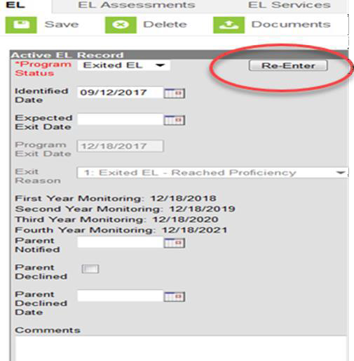
Why is an EL student re-entered into the EL program?

Exited EL students are to be monitored for two consecutive years after testing proficient in English. School districts are responsible for evaluating the progress made by students in meeting challenging State academic content and student academic achievement standards for each of the two years after the student is no longer receiving services. Items such as a teacher referral, a parent referral, test scores, and mainstream classroom success might indicate a need to discuss the possibility that the student needs to be re-integrated into the EL program.

The LEA has monitored the student and there is enough evidence that the student is still struggling due to language, what should the LEA do?

If the school district has determined that the student is still struggling due to a language barrier, then the school district may re-enter the student back into the EL program. The student would need to enter the program the same way they entered the very first time. The school district would need to administer the WIDA Screener assessment again.

Creating First Year in Country Record
Infinite Campus Path: | Index > Census > People
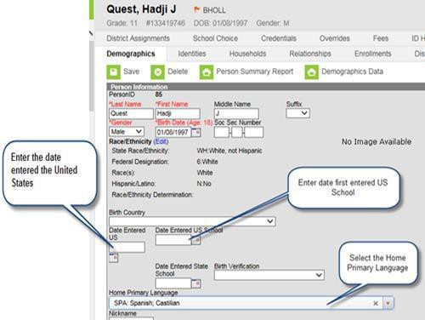

The first year in country box can be found by clicking on the student’s enrollment and going to State Reporting Fields

What is a first year in country criteria?

- must be an identified EL student
- have been enrolled in a school in one of the 50 states in the United States or the
District of Columbia for less than 12 months
- Must participate in ACCESS for ELL 2.0 English language proficiency assessment
if enrolled during the testing window
- For students arriving after the ACCESS for ELLs 2.0 testing window, the WIDA Screener
must be administered to provide evidence for SD ELA assessment exemption
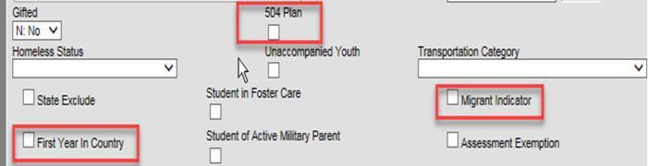

If the student meets the above criteria, then…

The student is exempted from participating in the ELA portion of the SD state assessment; however, the student is required to participate in Math and Science. Scores are not included in accountability.

What do we need to indicate in Infinite Campus if the student meets the First Year in Country criteria?

The LEA will need to include the Date Entered U.S., Date Entered U.S. school, and First Year in Country check box.

Does a student need to be an EL student?

Yes, the student needs to be an EL student.

Do students from Puerto Rico get this first-year exemption?

Yes, if the student is from Puerto Rico and is an identified EL student and has not attended a
U.S. school for more than 12 months.

Qualifying Dates for ELA Exemption for School Year 2024-2025
May 2, 2024 – May 1, 2025

Creating an Immigrant Children and Youth Record
Infinite Campus Path: | Student Enrollment > State Reporting Fields
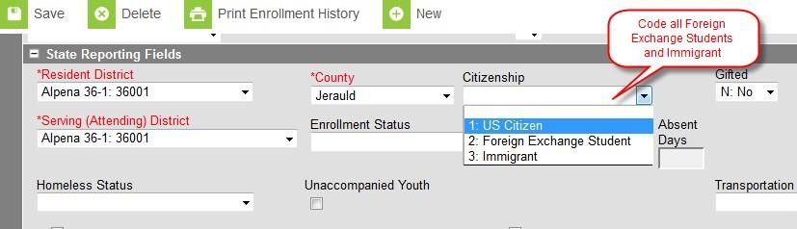

What is the definition of an Immigrant Children and Youth student?
Immigrant Children and Youth

What do we need to indicate in Infinite Campus if the student meets the Immigrant Children and Youth definition?
The LEA will need to include the Date Entered U.S., Date Entered U.S. school, and select
Immigrant under State reporting fields.

Why do we collect this information?
This information is collected because there is a Title III-Immigrant Children and Youth Grant that LEAs can qualify for if they have a significant impact of Immigrant Children and Youth students.

Please note that the term “immigrant” as used in Title III is not related to an
individual’s legal status in the United States.

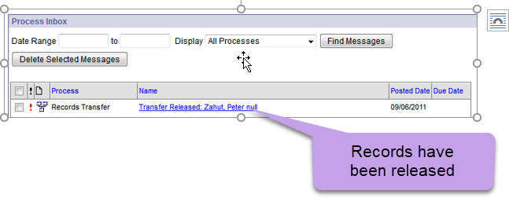

Requesting Records

When a student transfers into your district, a request for records will need to be sent to the student’s previous district. That district will then release the records to your district. When the former district selects the Release Records option, records are sent to the requesting district. The new district will receive a message link in its Process Inbox containing the student’s records and the former district’s contact information.

Record transfers can be accessed in three areas of Infinite Campus, when the appropriate user rights have been assigned:

- Process Inbox (until deleted)
- Student Information > General > Student Records Transfer (permanent record)
- System Administration > Data Utilities > Student Records Transfer
(permanent record)

A released records transfer message will contain two methods of receiving the transferred student records.

It is the responsibility of the new district to complete the records transfer by importing and/or entering the relevant data. The Data Imports method directly writes the former district's data to the new district database using Data Import Wizards.

To execute a data import, click the hyperlinked blue text. An Import Wizard will open.

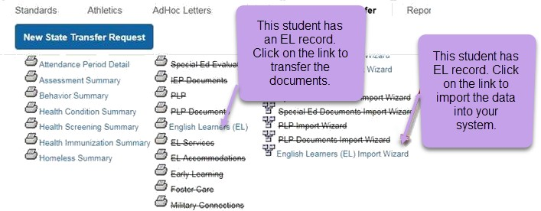

Crossed-out items may appear on the release page of both the new and former district. When an item in the Transfer Documents or Data Imports section is crossed out, it indicates that the student did not have any relevant records for that transfer type.

Definitions

English Learner

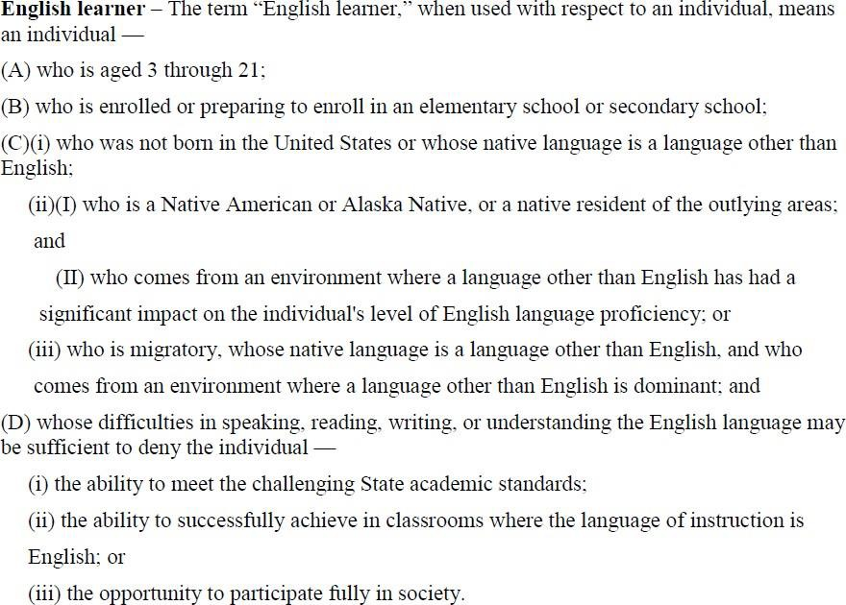

Immigrant Children and Youth
Definition of Immigrant Children and Youth
The term ‘Immigrant children and youth’ means individuals who-
“(A) are aged 3 through 21;
“(B) were not born in any State; and
“(C) have not been attending one or more schools any one of more States for more than 3 full academic years.
“Three full academic years” = cumulative

First Year in Country
- must be an identified EL student

- has not attended schools in the United States (not including Puerto Rico) for less than 12months

- Must participate in ACCESS for ELL 2.0 English language proficiency assessment if enrolled during the testingwindow

- If the student arrives after the ACCESS for ELLs 2.0 testing window, then the student must participate in the WIDA Screener assessment

Resources

SD DOE Title III page | http://doe.sd.gov/title/el.aspx
SD DOE Infinite Campus- Student  Information Management System | http://doe.sd.gov/ofm/sims.aspx

Contact Information

Shari Lord

Title III English Language Acquisition Coordinator Shari.Lord@state.sd.us
605-280-4011

Teri Jung

Management Analyst Teri.Jung@state.sd.us
605-773-8197

