Individual Language Acquisition Plan

General Information
Student’s Name: |  |  | Date of Birth:
Pronounced As:
Age: | Grade: |  | School:
HLS Date Completed:  (Home Language Survey) |  |  | EL Screener Date: | EL Identified Date:
Language Spoken at Home:

Academic History
TAT referral? ☐ No ☐ Yes Explain:
Special Education referral? ☐ No ☐ Yes Explain:
Title I Services? ☐ No ☐ Yes Explain:

Assessments
Kindergarten WIDA Screener or WIDA Screener
Listening | Speaking | Reading | Writing | Overall Composite

Student-Level Goals Based on First SD-ELP (Access) Assessment in SD
First SD-ELP Score | Years to Exit
1.0 to 1.9 | 5 Years
2.0 to 2.9 | 5 years
3.0 to 3.9 | 4 Years
4.0 to 4.9 | 3 Years
4.0 to 4.9 AND 3 or 4 on SD-ELA | Exit
5.0 to 6.0 | Exit

SD Exit Criteria: 2 ways
Obtain an Overall Proficiency Level of 5.0 or higher on the SD-ELP or SD ELP-Alternate assessment (WIDA ACCESS or WIDA Alternate)

Obtain an Overall Proficiency Level of 4.0 on the SD-ELP or SD-Alternate ELP assessment and demonstrate English Language Arts proficiency by earning:
  - A Level 3 or 4 on the South Dakota ELA State Assessment, or
  - A Level 3 or 4 on ACT assessment (high school juniors)

WIDA ACCESS 2.0
Year | Listening | Speaking | Reading | Writing | Oral | Literacy | Comp. | Overall  Composite | Composite Score Expectation *Data found in SD Stars

State Academic Assessments
Year | English Language Arts:  3-8, 11 | Math:  3-8,11 | Science:  5, 8, 11

District Progress Monitoring Assessments
Year | English Language Arts | Math | Science
Section 3: English Language Development
According to the Dear Colleague Letter of 2015 - A key component in ensuring that EL students acquire the tools needed for success in the general education classroom, is through meaningful access within a reasonable length of time. It is important that ELs receive full access to grade-appropriate core curriculum from the start of the EL program and that age-appropriate language assistance strategies are used so EL students can participate meaningfully as they acquire English skills.

Reading  Annual Goal: | Writing  Annual Goal:
Required Supports: | Required Supports:

Speaking  Annual Goal: | Listening  Annual Goal:
Required Supports: | Required Supports:

English Language Development Services

Program of Services
ELD Related Services (match what is in Infinite Campus) | ☐ Developmental Bilingual  ☐ Dual Language  ☐ SD Test new federal EL service  ☐ Heritage Language  ☐ Pull Out ESL  ☐ Special Academic Instruction Delivered in English  ☐ Sheltered English Instruction  ☐ Structured English Immersion  ☐ Other _____  ☐ Parent Refuses EL Services
Related Services | ☐ Title I Support  - Reading  - Math  ☐ IEP  ☐ 504 Plan  ☐ Gift & Talented
Description of Services | Student will Receive:  - Services within the grade-level content classroom with EL teacher and classroom teacher collaboration in their instructional practices  - Small group pullout English language instruction daily  - Small group Title I support for reading within the classroom  (example of what could be written)
Minutes/Hours of Services | Content Based EL: 60-90 min/day  Pullout EL: 60 min/day  Title I Support: 30 min, 4 times/week  (example of what could be written)
Frequency of Services | Content Based EL: every day  Pullout EL: every day  Title I Support: 4 times/week  (example of what could be written)

District and State Assessments - Designated Supports
*Tools = Available to ALL students (embedded (digitally delivered) or nonembedded (separate from it))
*Supports = Available to SOME students. Districts must mark these in TIDE for state assessment
*Accommodations = Available ONLY to EL students on an IEP or 504 Plan

Key:
(L = Listening Domain S = Speaking Domain R = Reading Domain W = Writing Domain)

Support Not Available
Support is Available
Support only available for ELs with an IEP or 504 Plan
Supports | SD-ELP (ACCESS)
Bilingual Dictionaries or access to computer translated programs
Reading aloud Reading items
Responses in languages other than English
Speech to Text
Repeat/Simplified Directions
Translated Directions
Provide word banks, sentence starters, outlines or study guides
Allow notes/and or reference sheet on test
Test in Non-School Setting
Allow Alternative form of assessment | Marked in Infinite Campus
Repeat Human Reader | L, S, R, W
Braille | L, S, R, W
Extended Speaking Time | S
Extended Testing (Multiple Days) | L, S, R, W
Human Reader (non-reading items) | L, S, W
ASL for Directions | L, S, R, W
Large Print (notify state) | L, S, R, W
Low-Vision Script (notify state) | L, S, R, W
Manual Control of Audio | L, S, W
Repeat Item Audio | L, S, W
Scribe | R, W
Recording/Transcription Device | W
Word Processor | W
Medical help devices | L, S, R, W
Audio Aids (headphones, amplification)
Color Overlays and Screen color contrast Options
Scratch paper, highlighters, colored pencils, crayons
Keyboard Navigation
Line guide or tracking tool
Low-vision aids or magnification

To determine the appropriate supports for state assessment please follow these steps:
- Go to “doe.sd.gov/assessment”
- Scroll down to and select “Special Education – accommodations and supports”
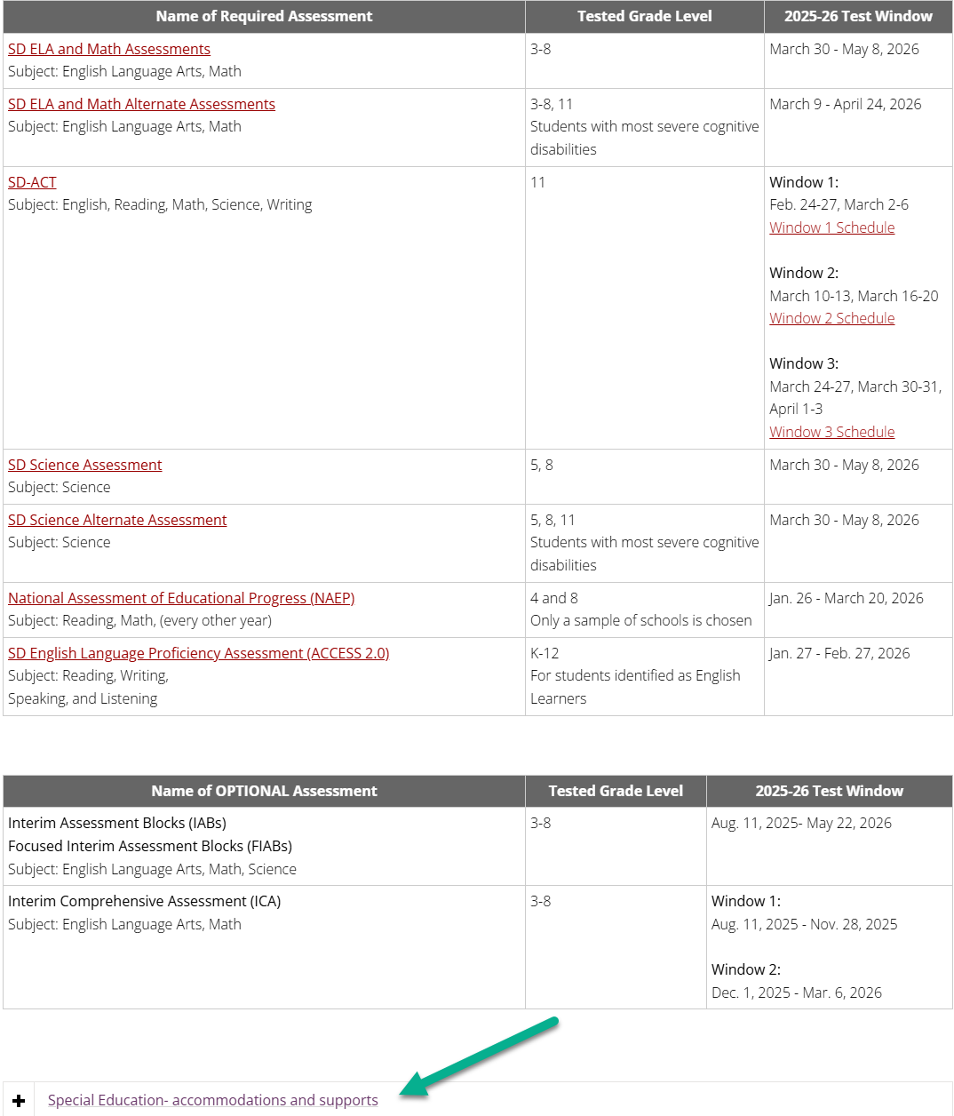
3. Select “Accommodations Summary”
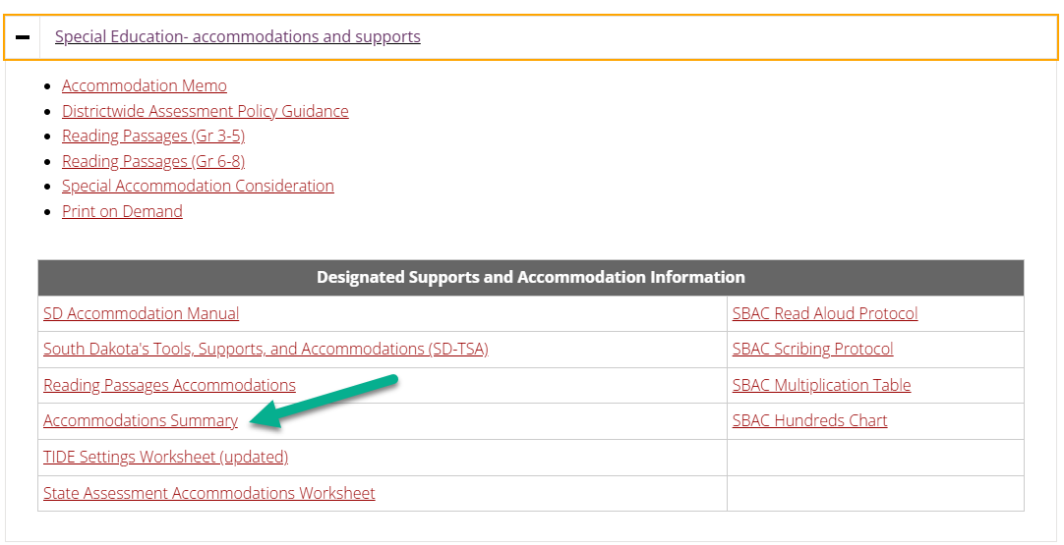
You will find a one-page help guide for Universal Tools, Designated Supports and Accommodations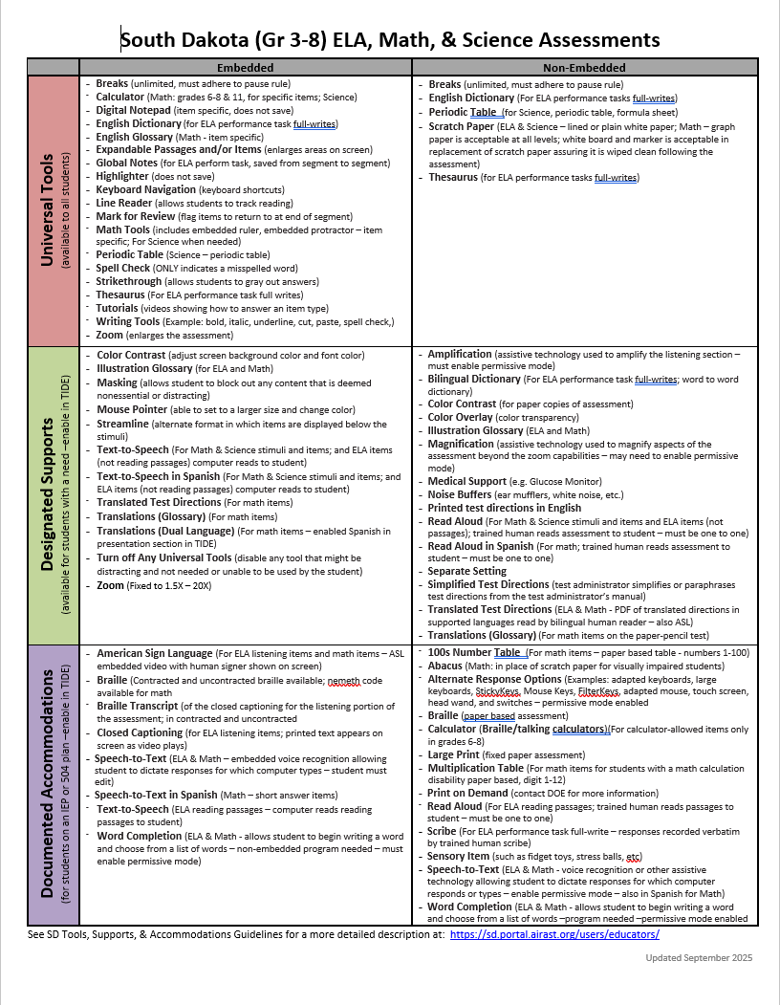

To determine the appropriate support for ACT please follow these steps:
- Go to “doe.sd.gov/assessment”
- Scroll down and select “SD-ACT”
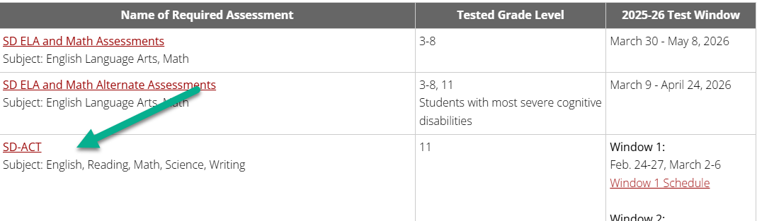

- Select “Accessibility” Drop-down menu and then “SD-ACT Tools, Supports, and Accommodations”
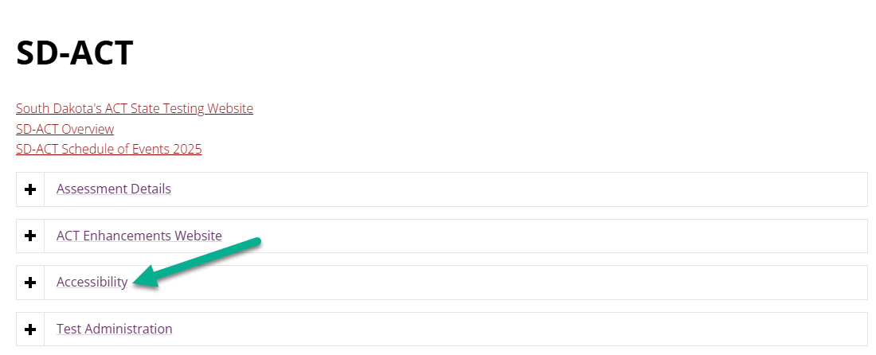

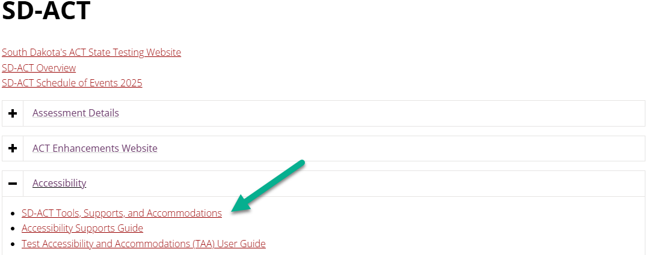

This will then pull up a list of all supports, tools, and accommodations that are allowed for the ACT assessment.

Language Acquisition Reviewed by the Following Team Members:
Role | Name | Signature | Date
Parent/Guardian
Student
Principal
Content Area Teacher(s)
Content Area Teacher(s)
EL Teacher
EL Coordinator
Interpreter

