

**WIDA Alternate Screener**

**Getting started**

Keep in mind that WIDA Alternate Screener

* Is given to new students with the most significant cognitive disabilities in grades K–12
* Helps educators identify if students with the most significant cognitive disabilities are English learners
* Can be administered at any time during the school year
* Takes no more than 30 minutes total testing time (there are a total of nine test items)
* Reports proficiency level scores for each language domain and for four composite scores: Oral Language, Literacy, Comprehension, and Overall

**WIDA Alternate Screener Decision Tree:**

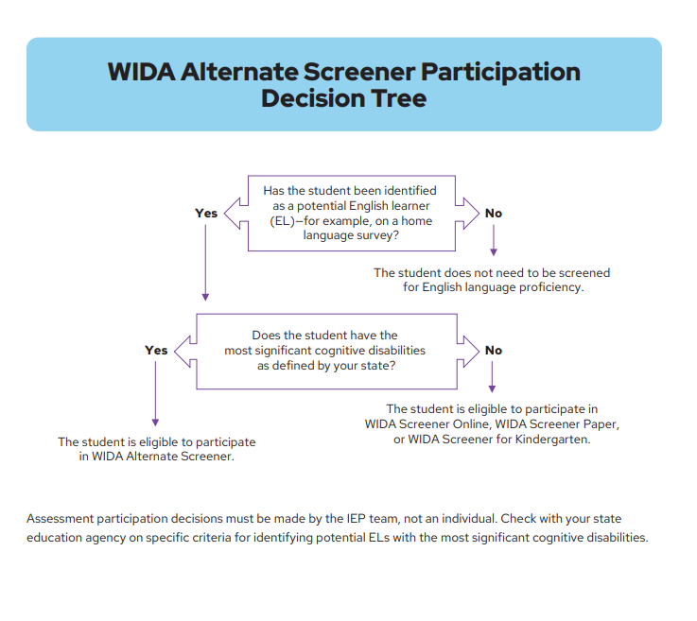

**What If:**

* Potential EL Student already comes with an IEP that has determined Alternate Assessment Participation?
  + Use the current IEP information and administer the WIDA Alternate Screener
* Potential EL student does not come with an IEP that determines Alternate Participation?
  + Consider the following:
    - Historical evidence
    - Cognitive/ability evaluations
    - Adaptative behavior evaluation
    - Academic/Achievement evaluations
    - Informal assessments
    - Does the student require extensive instruction and support to acquire and maintain skills

**Please note evidence for determining alternate assessment participation is NOT based on the following**

* Specific disability category such as Cognitive or Autism
* Percent of time in specialized services
* Educational placement or instructional setting
* Low reading or achievement level
* Need for accommodations or assistive technology on the regular assessment
* Anticipated disruptive behavior or emotional distress
* Expected poor performance on regular assessment
* Impact of student scores on accountability system
* Administrator decision
* Poor attendance
* Extended absences